Circular Economy in Digital Systems
Learner Handbook

Copyright © 2024 Digital4Sustainability. The project resources contained herein are publicly available under the Creative Commons license 4.0 B.Y.

Project | Digital4Sustainability
Project number | 101140316
Document Title | Circular Economy in Digital Systems – Information document
Authors | Dietmar Janetzko, National College of Ireland
Reviewers | Mahmood Al-Doori, Universität Koblenz
Editor | Katarina Cicvarić, Profil Klett
Instructional Designer | Kristina Ferara Blašković, Profil Klett
Digital Content Manager | Ivana Bošnjak, Profil Klett  Andra Punjek, Profil Klett

This handbook serves as the comprehensive learning material for the entire upskilling curriculum, covering all modules in a single document. It is structured into Modules and thematic Topics, each designed to achieve specific learning outcomes. The learning content is supported by multimedia elements, self-assessment quizzes, and additional learning resources.

Disclaimer
Funded by the European Union. Views and opinions expressed are however those of the author(s) only and do not necessarily reflect those of the European Union or the European Education and Culture Executive Agency (EACEA). Neither the European Union nor EACEA can be held responsible for them.

Table of Contents
Introduction to Upskilling Curricula: Circular Economy in Digital Systems 4
MODULE 1: Circular Economy Foundations 6
Topic 1.1: Circular Economy Principles and Frameworks 7
Topic 1.2. Digital Technologies as Circular Economy Enablers 10
Topic 1.3. EU Circular Economy Policy and Digital Product Passports 13
Module 1: Conclusion and Self-Assessment 16
MODULE 2: Circular Economy Data & Metrics 17
Topic 2.1. Material Flow Accounting and Analysis 18
Topic 2.2. Product Lifecycle Data Management 20
Topic 2.3. Digital Product Passport Implementation 22
Topic 2.4. Circular Economy Metrics and KPIs 24
Module 2: Conclusion and Self-Assessment 26
MODULE 3: ESG Data Management for Circularity 27
Topic 3.1. ESG Data Principles Applied to Circular Economy 28
Topic 3.2. Data Quality for Circular Economy Applications 30
Topic 3.3. Data Governance Frameworks for Circular Supply Chains 32
Topic 3.4. Traceability Systems for Supply Chain Transparency 35
Module 3: Conclusion and Self-Assessment 38
References: 39

Table of Figures:
Figure 1. The Butterfly Diagram 8
Figure 2. IoT architecture for circular economy 11
Figure 3. EU policy hierarchy based on COM 14
Figure 4. Sankey diagram of polyester flows in Indonesia’s T&C manufacturing chain 18
Figure 5. PLM integration architecture 20
Figure 6. DPP implementation roadmap 22
Figure 7. CE Performance dashboard simulation 25
Figure 8. Global ESG reporting frameworks 28
Figure 9. Data quality improvement cycle — PDCA loop 31
Figure 10. Data Sharing Governance framework and RACI Matrix 33
Figure 11. Traceability system architecture 36

List of tables:
Table 1. Business case summary with examples (Source: Author) 8
Table 2. Technology comparison matrix 10
Table 3. MFA Metrics (Source: Author) 18
Table 4. Lifecycle Data Requirements (Source: Author) 20
Table 5. Resource Efficiency Metrics (Source: Author) 24
Table 6. Quality Dimensions (Source: Author) 30
Table 7. RACI Matrix (Source: Author) 32
Table 8. Chain of Custody Models (Source: Author) 35

Introduction to Upskilling Curricula: Circular Economy in Digital Systems

Overview:
This 2.5-week programme equips professionals with the knowledge and skills to apply ESG data management principles to circular economy implementation. Designed for EQF Level 6 learners working in product management, sustainability, and innovation roles, the curriculum bridges the gap between circular economy strategy and the data systems required to operationalise circular practices.
The circular economy represents one of the most significant business transformations of our time. As the European Union implements increasingly stringent requirements—from the Circular Economy Action Plan to Digital Product Passports—organisations must develop new capabilities in data management, metrics design, and multi-stakeholder governance. This programme addresses these needs directly, combining theoretical foundations with practical application.
Learners explore how digital technologies—from IoT sensors to blockchain traceability—enable organisations to transition from linear "take-make-dispose" models to circular approaches that design out waste, keep products in use, and regenerate natural systems. Through hands-on exercises, participants design data frameworks for material flow tracking, implement Digital Product Passport specifications, and develop governance structures for circular supply chains..
Learning Outcomes (LO) for this UC:
The learner will be able to:
- Explain circular economy principles (design out waste, keep materials in use, regenerate systems)
- Apply ESG data management principles to circular economy tracking and reporting
- Design circular business models (product-as-service, sharing platforms, reverse logistics)
- Assess data quality requirements for circular economy metrics (material flows, product lifecycles)
- Evaluate digital technologies as circular economy enablers (IoT tracking, digital product passports)
- Implement data governance frameworks for circular economy supply chain transparency.
Structure of the handbook
This handbook is divided into Modules and topics.
Module 1: Circular Economy Foundations
T1.1. Circular Economy Principles and Frameworks
T1.2. Digital Technologies as Circular Economy Enablers
T1.3. EU Circular Economy Policy and Digital Product Passports.

Module 2: Circular Economy Data & Metrics
T2.1. Material Flow Accounting and Analysis
T2.2. Product Lifecycle Data Management
T2.3. Digital Product Passport Implementation
T2.4. Circular Economy Metrics and KPIs.
Module 3: ESG Data Management for Circularity
T3.1. ESG Data Principles Applied to Circular Economy
T3.2. Data Quality for Circular Economy Applications
T3.3. Data Governance Frameworks for Circular Supply Chains
T3.4. Traceability Systems for Supply Chain Transparency.

MODULE 1: Circular Economy Foundations
Module Overview:
This module aims to establish foundational understanding of circular economy principles and how digital technologies and EU policy drive transformation.
Module learning outcomes:
- Explain circular economy principles and distinguish circular from linear models
- Identify digital technologies that enable circular business models
- Describe EU circular economy policy including DPP requirements
- Evaluate the business case for circular economy adoption.
Estimated workload:
Lecture hours (F2F): 5 hours
Self-study: 8 hours
Practical application (if applicable): 4 hours
Assessment link: Deliverable 2: Business model innovation proposal
Practical focus / deliverable:
Business model innovation proposal

Topic 1.1: Circular Economy Principles and Frameworks
Short introduction:
The circular economy represents a systemic shift from traditional linear models to a regenerative system designed to eliminate waste. This foundational topic establishes the concepts underpinning all subsequent learning.
Theory & Knowledge:
- The Linear Economy and Its Limitations
The industrial economy operates on a linear pattern: extract raw materials, manufacture products, sell to consumers, dispose at end-of-life. This "take-make-dispose" paradigm has delivered material prosperity but rests on increasingly untenable assumptions.

Resource Constraints
The linear model assumes unlimited resources. Reality differs:
- The Ellen MacArthur Foundation estimates maintaining current consumption requires nearly three planets' resources by 2050
- Critical materials face supply concentration (China controls ~60% of rare earth production)
- High-grade ore deposits are exhausted, requiring more energy for extraction.
Waste Accumulation
The scale of waste has become impossible to ignore:
- Global municipal solid waste projected to reach 3.40 billion tonnes by 2050
- Only 9% of plastics ever produced have been recycled
- Electronic waste is the fastest-growing waste stream (53.6 million tonnes in 2019)
Climate Impact
Material extraction and processing accounts for ~45% of global greenhouse gas emissions through mining, processing, transportation, manufacturing, and waste decomposition.

- The Circular Economy Alternative
The Ellen MacArthur Foundation defines circular economy through three principles:
Principle 1: Design Out Waste and Pollution
- Waste is a design flaw, not an inevitability. Strategies include:
- Material selection for safe cycling
- Design for disassembly
- Elimination of hazardous substances
- Packaging optimisation.
Principle 2: Keep Products and Materials in Use
Preserve embedded value through the R-hierarchy:
- Refuse/Rethink
- Reduce
- Reuse
- Repair
- Refurbish
- Remanufacture
- Repurpose
- Recycle.
Each step down loses embedded value—a remanufactured engine retains more value than recycled metal.
Principle 3: Regenerate Natural Systems
Move beyond "less harm" to actively improving natural systems through biological nutrient cycling, renewable energy, and ecosystem restoration.

- The Butterfly Diagram
The Ellen MacArthur Foundation's Butterfly Diagram visualises circular flows:
Technical Cycle (Right): Metals, plastics, synthetics kept in circulation through sharing, maintenance, reuse, refurbishment, remanufacturing, and recycling.
Biological Cycle (Left): Organic materials returned to earth through cascading use, composting, and anaerobic digestion.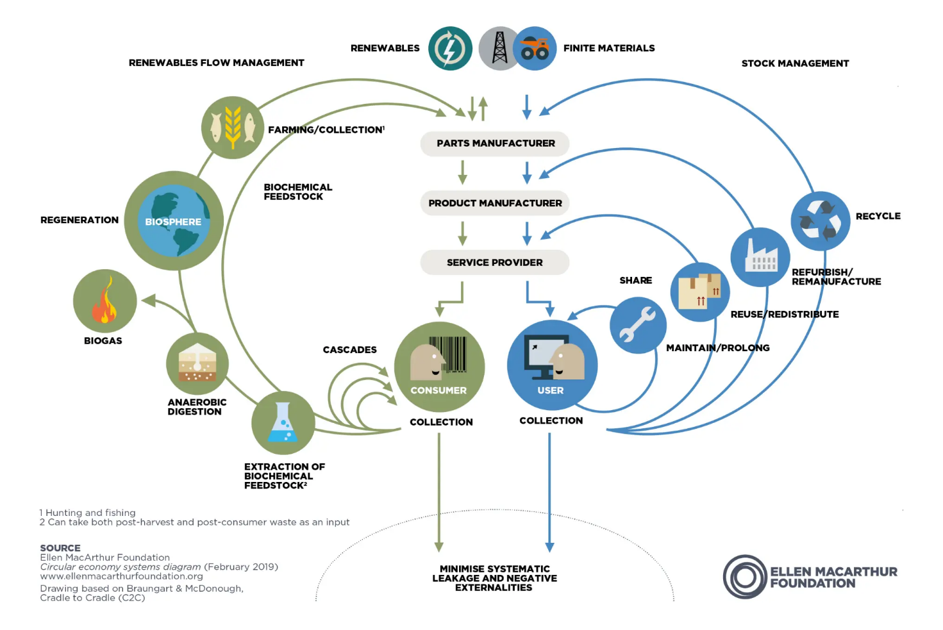
Figure 1. The Butterfly Diagram (Source: Ellen MacArthur Foundation)
The image above displays the Ellen MacArthur Foundation's Circular Economy Systems Diagram, also known as the "butterfly diagram," which illustrates how materials flow through a regenerative system. The diagram highlights the distinction between biological and technical nutrient cycles to eliminate waste and restore natural capital.

- Business Case for Circularity
Table 1. Business case summary with examples (Source: Author)
Benefit | Mechanism | Example
Cost reduction | Material efficiency, waste reduction | Renault remanufacturing: 50-80% cost savings
New revenue | Service models, resale, material recovery | Caterpillar: >$1B annual remanufacturing
Risk mitigation | Supply security, regulatory readiness | Reduced commodity price exposure
Competitive advantage | Customer preference, procurement | Preferred supplier status
Micro-Activity:
Circular Opportunity Identification (15 minutes)
Select a product your organisation produces or uses. Apply the three principles:
- How could it be redesigned to eliminate waste?
- What strategies could extend its useful life?
- Are there opportunities to benefit natural systems?
Document 4-5 sentences. This informs PBL-1.

Additional Reading:
- Ellen MacArthur Foundation (2019). "Completing the Picture: How the Circular Economy Tackles Climate Change." https://ellenmacarthurfoundation.org/completing-the-picture
- European Commission (2020). "A new Circular Economy Action Plan." COM (2020) 98 final.

Key Takeaways:
- Linear economy faces resource, waste, and climate constraints
- Three principles: Design out waste, keep materials in use, regenerate systems
- Butterfly Diagram distinguishes technical and biological cycles
- Value hierarchy: Reuse > Repair > Refurbishment > Remanufacturing > Recycling
- Business benefits: Cost, revenue, risk, competitive advantage.

Quick Check:
- True or False: Circular economy focuses primarily on improving recycling rates.

- Correct value retention order (highest to lowest)?
- Recycling → Remanufacturing → Repair → Reuse
- Reuse → Repair → Refurbishment → Remanufacturing → Recycling

- Name two business benefits of circular economy.

Answer key: 1) False—CE starts with design; recycling is lowest-value strategy. 2) b. 3) Cost reduction, new revenue, risk mitigation, competitive advantage

Topic 1.2. Digital Technologies as Circular Economy Enablers

Short introduction:

Circular economy requires sophisticated information systems to operate at scale. This topic explores how IoT, blockchain, AI, and cloud platforms enable circular practices.

Theory & Knowledge:
- The Information Challenge
Circular decisions depend on information availability:
Design: What materials enable circular outcomes?
Use: When repair vs. replace?
End-of-life: Which circular pathway?
Challenges include visibility gaps, data fragmentation, trust deficits, and temporal discontinuity across long product lifecycles.

- IoT for Tracking and Monitoring
Identification Technologies
Table 2. Technology comparison matrix
Technology | Capabilities | CE Applications
QR Codes | Visual ID, low cost | Product info, recycling instructions
RFID | No line-of-sight, read/write | Reusable packaging, component tracking
GPS/Cellular | Location tracking | Fleet management, reverse logistics

Condition Monitoring
Sensors monitor usage, performance, environmental exposure, and predictive indicators, enabling:
- Extended product life through predictive maintenance
- Service model support
- Informed circular routing decisions.

Case Study: Rolls-Royce TotalCare
Rather than selling engines, Rolls-Royce sells "power by the hour." Thousands of sensors enable predictive maintenance, optimised operation, and closed-loop recovery.

3. Blockchain for Transparency
Capabilities: Immutability, distributed consensus, transparency, smart contracts.
Applications:
- Provenance verification (recycled content claims)
- Chain of custody documentation
- Automated deposit-return systems.
Example: Circular tracks cobalt and recycled materials through automotive supply chains.
Limitations: Energy consumption, garbage-in-garbage-out, complexity, governance requirements.

4. AI for Optimisation
Applications:
- Demand forecasting (reducing overproduction)
- Quality assessment (sorting returns, waste)
- Matching platforms (connecting material supply/demand)
- Predictive maintenance
Example: Grey parrot uses computer vision AI to improve waste sorting accuracy.

5. Cloud Platforms for Service Models
Capabilities:
- Product-as-a-service operations (usage tracking, billing, maintenance)
- Sharing economy marketplaces
- Material exchange platforms.
Example: Rheaply enables organisations to share and exchange assets.

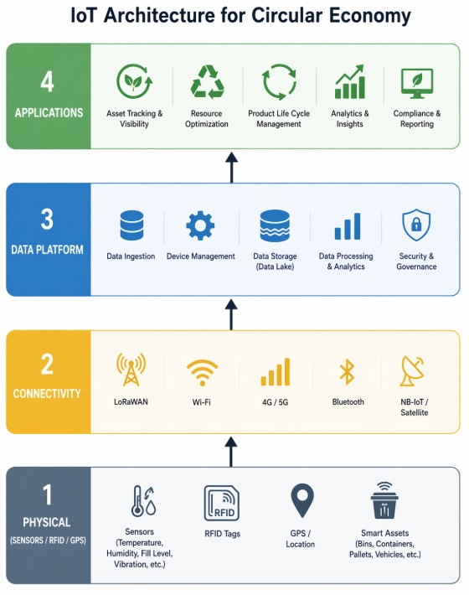
Figure 2. IoT architecture for circular economy (source: AI generated)
The image above displays a four-layer Internet of Things (IoT) system architecture diagram, showing how data moves from physical devices to end-user applications.
Layer 1 - Physical: Contains sensors, RFID tags, GPS trackers, and smart assets that generate data.
Layer 2 - Connectivity: Includes communication technologies like LoRaWAN, Wi-Fi, 4G/5G, Bluetooth, and satellite to transmit data.
Layer 3 - Data Platform: Handles data ingestion, management, storage, processing, and security.
Layer 4 - Applications: Utilizes the processed data for specific use cases such as asset tracking, analytics, and reporting.

Micro-Activity:

Technology Matching (10 minutes)
Match technologies to challenges:
Challenge | Technology | Justification
Verify 50% recycled content
Predict equipment failure
Operate equipment rental platform
Sort mixed plastic waste
Answers: Blockchain; IoT+AI; Cloud; AI/ML.

Additional Reading
- World Economic Forum (2019). "Harnessing the Fourth Industrial Revolution for the Circular Economy."
- Antikainen et al. (2018). "Digitalisation as an Enabler of Circular Economy." Procedia CIRP, 73.

Key Takeaways
- Information availability enables circular decisions
- IoT provides visibility through tracking and monitoring
- Blockchain creates trusted records for provenance
- AI optimises through prediction and matching
- Cloud enables service models at scale
- Match technology to objective—not all CE needs all technologies.

Quick Check
- True or False: Blockchain is essential for all CE implementations.

- Best technology for "power by the hour" service?
- Blockchain only
- IoT + Cloud platform
- Short Answer: One blockchain limitation for CE.
Answers: 1) False. 2) b. 3) Energy consumption, data input quality, complexity, scalability, governance.

Topic 1.3. EU Circular Economy Policy and Digital Product Passports
Short introduction:
The EU has established the world's most comprehensive circular economy policy framework. This topic examines key initiatives, focusing on Digital Product Passports.
Theory & Knowledge:
- EU Circular Economy Action Plan
Adopted March 2020 as part of the European Green Deal, targeting:
Making sustainable products the norm
Empowering consumers
Focusing on high-impact sectors
Reducing waste
Priority Value Chains: Electronics, batteries/vehicles, packaging, plastics, textiles, construction, food.

- ESPR (Ecodesign for Sustainable Products Regulation)
Extends ecodesign requirements to nearly all products with:
Performance Requirements: Durability, reliability, reusability, reparability, recyclability, recycled content, environmental footprint.
Information Requirements: Material composition, environmental data, repair information—delivered via Digital Product Passports.
Unsold Goods Prohibition: Cannot destroy unsold consumer products in specified categories.

- Digital Product Passport Architecture
Component | Function | Options
Data Carrier | Physical link to digital info | QR code, RFID, NFC, digital watermark
Unique Identifier | Global product identification | GS1 Digital Link, GTIN+Serial, DIDs
Data Repository | Information storage | Centralised, distributed, blockchain
Access Layer | Authorised access | Public, authenticated, regulated
- DPP Data Requirements
Category | Elements | Purpose
Identification | GTIN, serial, manufacturer | Traceability
Composition | Materials, hazardous substances | Recycling, safety
Footprint | Carbon, environmental impacts | Consumer info, compliance
Durability | Expected lifetime, warranty | Quality comparison
Repairability | Repair score, spare parts, instructions | Supporting repair
End-of-life | Disassembly, recycling guidance | Proper treatment
Compliance | Certifications, declarations | Regulatory verification

- Implementation Timeline
Date | Category | Regulation
2027 | Batteries | Battery Regulation
2028-2030 | Textiles, electronics, furniture | ESPR delegated acts
2030+ | Additional categories | ESPR delegated acts
- Related Requirements
Right to Repair: Spare parts, repair information, repair scoring
EPR: Producer responsibility for end-of-life
CSRD: Corporate reporting on circular economy (ESRS E5).

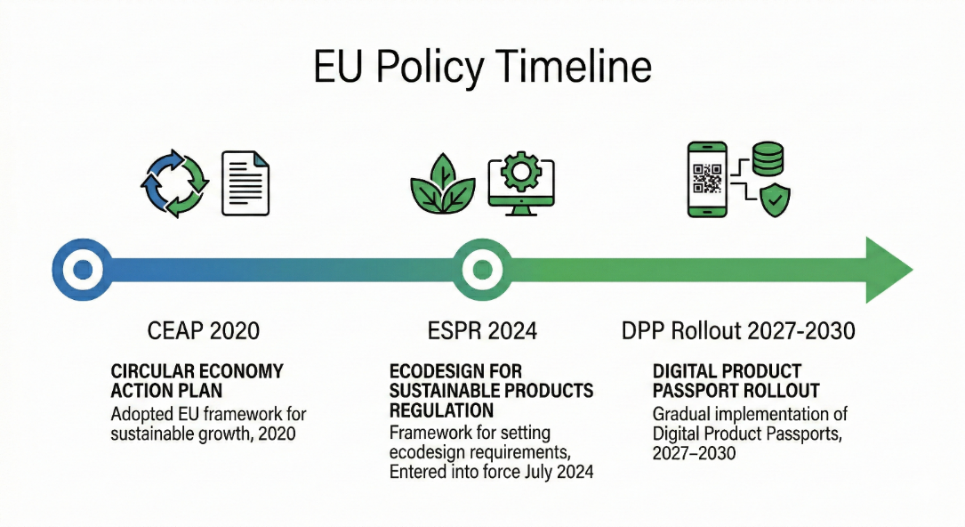
Figure 3. EU policy hierarchy based on COM (2020) 98; Regulation EU 2024/1781; CIRPASS project
The image above outlines the European Union's timeline for implementing sustainable product policies, focusing on the transition to a circular economy.
- 2020: The Circular Economy Action Plan (CEAP) was adopted as the framework for sustainable growth.
- 2024: The Ecodesign for Sustainable Products Regulation (ESPR) entered into force in July to set sustainability requirements.
- 2027–2030: A gradual rollout of Digital Product Passports (DPP) will take place to enhance product transparency and sustainability

Micro-Activity:

DPP Readiness (15 minutes)
For a relevant product category:
- When do DPP requirements apply?
- List 5-7 likely required data elements
- Which do you currently have? (Yes/Partial/No)
- Biggest data gap?

Additional Reading
- European Commission (2022). "Proposal for ESPR." COM(2022) 142 final.
- CIRPASS Project. "DPP Standards and Implementation." https://cirpassproject.eu/

Key Takeaways
- CEAP provides strategic framework for seven priority sectors
- ESPR establishes product requirements including DPP mandate
- DPP architecture: Data carrier, identifier, repository, access layers
- Data categories: Identification, composition, footprint, durability, repairability, end-of-life
- Timeline: Batteries 2027; other categories 2028-2030
- Related regulations create comprehensive compliance landscape.

Quick Check
- True or False: DPPs are currently mandatory for all EU products. True or False
- Which regulation mandates DPPs?
  - GDPR
  - CSRD
  - ESPR
- Short Answer: Name three DPP data categories.

Answer key: 1) False—phased implementation from 2027. 2) c. 3) Identification, composition, footprint, durability, repairability, end-of-life, compliance

Module 1: Conclusion and Self-Assessment
Module Summary:
Module 1 established foundations for circular economy digital transformation:
Principles: Linear economy faces constraints; circular economy offers systematic alternative through three principles (design out waste, keep in use, regenerate)
Technologies: IoT, blockchain, AI, and cloud enable circular practices at scale
Policy: EU CEAP, ESPR, and DPPs create comprehensive regulatory framework.

Module Knowledge Quiz
- What are the three core circular economy principles?
- Explain technical vs. biological cycles in the Butterfly Diagram.
- Name three digital technologies enabling CE and their contributions.
- What is a Digital Product Passport's purpose?
- Which regulation mandates DPPs?
- List four DPP data categories.
- True or False: CE focuses primarily on recycling.
- Order by value retention: Recycling, Reuse, Repair, Remanufacturing.

Answer Key:
- Design out waste; keep materials in use; regenerate natural systems
- Technical: manufactured materials (metals, plastics) circulating through reuse/recycling. Biological: organic materials returning to earth as nutrients.
- IoT (tracking, monitoring), Blockchain (provenance), AI (optimisation), Cloud (service models)
- Provide structured sustainability information enabling informed choices, repair, recycling, and compliance
- ESPR
- Identification, composition, footprint, durability, repairability, end-of-life, compliance
- False—starts with design
- Reuse → Repair → Remanufacturing → Recycling.

MODULE 2: Circular Economy Data & Metrics
Module Overview:
This module aims to develop technical competences in data systems and metrics for CE measurement.
Module learning outcomes:
- Apply material flow accounting methods to track resources through circular systems
- Manage product lifecycle data across design, production, use, and end-of-life phases
- Implement Digital Product Passport data requirements using appropriate standards
- Design circular economy metrics frameworks and performance dashboards.
Estimated workload:
Lecture hours (F2F): 8 hours
Self-study: 10 hours
Practical application (if applicable): 8 hours
Assessment link: Deliverable 1: Circular economy data framework design
Practical focus / deliverable:
Circular economy data framework design

Topic 2.1. Material Flow Accounting and Analysis
Short introduction:
Material Flow Analysis (MFA) provides methodology for tracking resources through circular systems, essential for identifying opportunities and measuring progress.
Theory & Knowledge:
- MFA Fundamentals
MFA systematically assesses material flows and stocks, applying mass conservation: inputs must equal outputs plus stock changes.
System Boundaries
- Product level: Single product lifecycle
- Organisation level: Company inputs/outputs
- Sector level: Industry flows
- Regional level: Economy-wide accounts.

- Key MFA Metrics
Table 3. MFA Metrics (Source: Author)
Metric | Definition | CE Relevance
Direct Material Input | Total mass entering production | Efficiency baseline
Resource Productivity | Output per material unit | Decoupling indicator
Circular Material Use Rate | Recycled % of input | Circularity measure
Waste Generation Rate | Waste per production unit | Efficiency indicator
- Data Sources
Internal: Procurement records, inventory, production records, waste manifests External: Supplier declarations, industry databases, national statistics
Quality challenges: Unit conversions, allocation, temporal matching, completeness.

- Mass Balance
Equation: Inputs = Products + By-products + Emissions + Waste + Stock Change
Mass balance validates data and estimates unknown flows. Discrepancies indicate measurement errors or hidden losses.
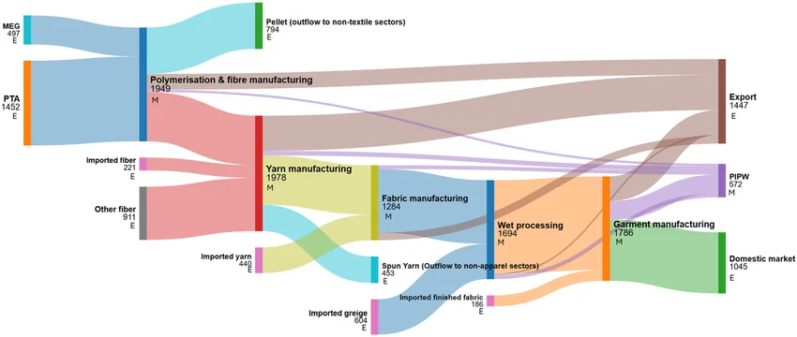
Figure 4. Sankey diagram of polyester flows in Indonesia’s T&C manufacturing chain in 2023. (source: ResearchGate)
This image is a Sankey diagram illustrating the polyester material flows within Indonesia's textile and clothing manufacturing chain.
- Production Stages: The diagram tracks the flow from raw materials like MEG and PTA through polymerization, yarn manufacturing, and fabric manufacturing to the final garment.
- Data Types: The nodes labelled with "E" represent empirical data sourced from national industrial production and trade statistics.
- Outflows: The diagram highlights outflows to non-textile sectors, such as pellets and spun yarn, as well as imported materials.
- Final Destination: The materials flow toward either the export market or the domestic market.

Micro-Activity:

Mass Balance (15 minutes)
Textile manufacturer data:
- Cotton: 500t, Polyester: 300t
- Fabric output: 680t, Recycled waste: 80t, Stock increase: 15t
Calculate unaccounted material. What explains it?
Answer: 500 + 300 = 800t input. 680 + 80 + 15 = 775t accounted. 25t unaccounted (evaporation, measurement error, unrecorded waste).

Additional Reading:
- Brunner & Rechberger (2016). "Handbook of Material Flow Analysis." CRC Press.
- Eurostat (2018). "Economy-wide Material Flow Accounts Handbook."

Key Takeaways:
- MFA applies mass conservation to track resources
- System boundaries must be clearly defined
- Multiple data sources required
- Mass balance validates data, estimates unknowns
- Quality challenges include conversions, allocation, completeness.

Quick Check:
1. True or False: MFA only applies to manufacturing.
2. Circular Material Use Rate measures:
a) Total materials used
b) Recycled % of input
3. Calculation: 100 in, 75 product, 20 waste. Unknown?

Answers: 1) False. 2) b. 3) 5 units.

Topic 2.2. Product Lifecycle Data Management
Short introduction:
Circular economy requires data across entire product lifecycles. This topic examines requirements at each stage and integration approaches.
Theory & Knowledge:
- Lifecycle Data Requirements

Table 4. Lifecycle Data Requirements (Source: Author)
Stage | Key Data | Systems | CE Use
Design | BoM, material selection, DfX specs | PLM, CAD | Circularity by design
Production | Batch tracking, quality, yield | MES, ERP | Traceability
Distribution | Serialisation, sales | ERP, CRM | Recovery planning
Use | Usage, condition, service | IoT, FSM | Life extension
End-of-Life | Collection, assessment | Reverse logistics | Recovery optimisation
- PLM for Circular Economy
Traditional PLM focuses on design-to-production. CE extends to:
- Material passports
- End-of-life routing rules
- Lifecycle links
- Supplier sustainability data.

- Integration Challenges
- Different data models
- Varying granularity
- Ownership boundaries
- Temporal gaps.
Approaches: Point-to-point, ESB, API-based, Data lakes.
- Standards
GS1: Product/location identification, event data (EPCIS)
IEC 62474: Material declaration
ISO 22095: Chain of custody
Catena-X: Automotive data ecosystem.
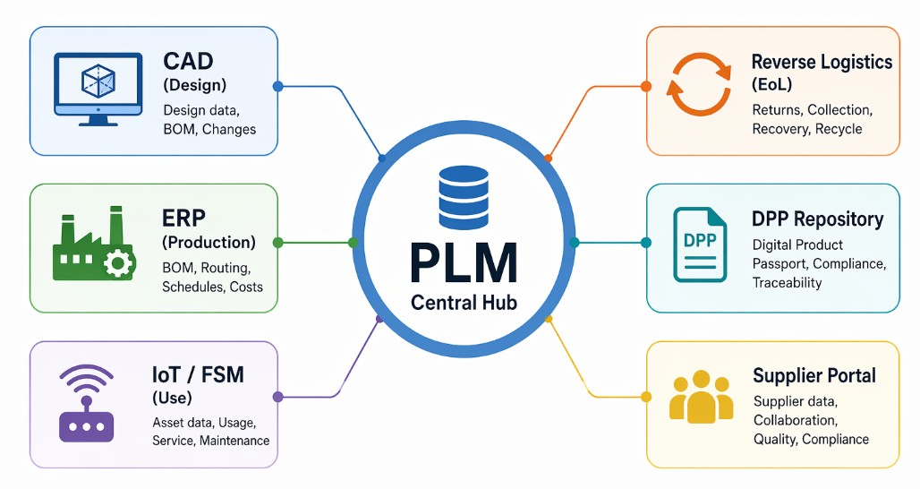
Figure 5. PLM integration architecture (AI generated)
This diagram illustrates the role of a Product Lifecycle Management (PLM) system as a central hub connecting various business functions and data systems. It highlights how PLM integrates the entire product lifecycle, from initial concept to retirement.
- Core Systems Integrated: The diagram connects CAD (Design), ERP (Production), IoT/FSM (Use), Supplier Portals, and Reverse Logistics (End-of-Life) to a central PLM database.
- Data Management: It streamlines the management of Bills of Materials (BOM), design data, production schedules, asset usage, and compliance documentation.
- Cross-Functional Collaboration: PLM connects internal teams and external supply chain partners, facilitating improved cooperation and data traceability.
- Operational Efficiency: The system aims to accelerate innovation, reduce time-to-market, and manage product complexity.

Micro-Activity:

Data Mapping (15 minutes)
For a selected product, map: lifecycle stage → key data element → current system → access needs.

Additional Reading:
- Stark (2020). "Product Lifecycle Management." 4th Ed., Springer.
- Plociennik et al. (2022). "Digital Lifecycle Passport." Procedia CIRP.

Key Takeaways:
- Each lifecycle stage has specific data requirements
- Design stage determines 80% of impact
- PLM must extend beyond traditional scope
- Integration challenging across different systems
- Standards facilitate exchange.

Quick Check:
1. True or False: PLM traditionally supports end-of-life data well.
2. Multiple Choice: Most important for refurbish-vs-recycle decision?
a) Original BoM
b) Current condition
3. Short Answer: Name two integration challenges.

Answer key: 1) False. 2) b. 3) Data models, granularity, ownership, temporal gaps.

Topic 2.3. Digital Product Passport Implementation
Short introduction:
DPP represents convergence of CE policy and data management. This topic provides implementation guidance.
Theory & Knowledge:
- Technical Architecture
Data Carrier: QR (~3KB, line-of-sight), RFID (no line-of-sight, read-write), Digital watermark (invisible)
Identifier: GS1 SGTIN, UUID, Decentralised IDs
Repository: Centralised, distributed, blockchain, hybrid
Access: Public, authenticated, regulated.

- Data Model (CIRPASS)
Core: Product ID, manufacturer, description, footprint Sector-specific: Additional by product category Voluntary: Manufacturer discretion.

- Implementation Steps
- Gap assessment
- Data model design
- System integration
- Supply chain onboarding
- Testing and validation
- Deployment.

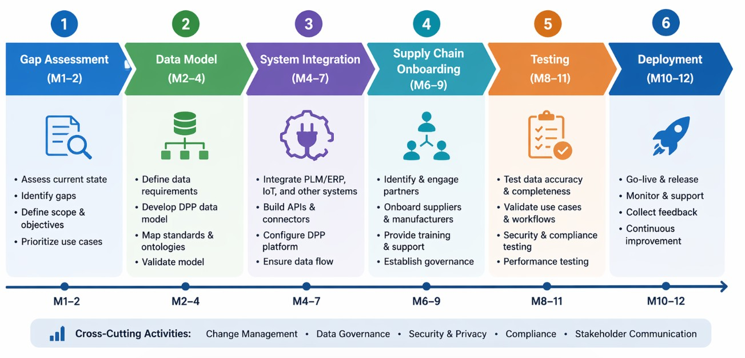
Figure 6. DPP implementation roadmap (AI generated)

The image above outlines a six-step process for implementing a Digital Product Passport (DPP), a framework used for enhancing supply chain transparency and product sustainability.
Phases 1-2 (Months 1-4): Conduct a gap assessment to identify scope and objectives, followed by defining data requirements and developing the DPP data model.
- Phases 3-4 (Months 4-9): Integrate systems like PLM and ERP, build necessary APIs, and onboard supply chain partners including suppliers and manufacturers.
- Phases 5-6 (Months 8-12): Perform testing for data accuracy, security, and performance, culminating in deployment, go-live, and continuous monitoring.
- Cross-Cutting Activities: Continuous efforts include Change Management, Data Governance, Security & Privacy, Compliance, and Stakeholder Communication.

- Standards
CIRPASS: EU reference specifications
GS1 EPCIS: Event data sharing
W3C Verifiable Credentials: Authenticated claims
ISO/IEC 15459: Unique identification.

Micro-Activity:

Gap Analysis (15 minutes)
For selected product: list required elements, current sources, gaps, priorities.

Additional Reading:
- CIRPASS Project. https://cirpassproject.eu/
- GS1 Digital Link Standard.

Key Takeaways:
- Architecture: Carrier, identifier, repository, access
- Core data across categories; extensions sector-specific
- Implementation requires gap assessment, integration, onboarding
- Standards enable interoperability.

Quick Check:
1. True or False: QR codes store complete DPP data directly.
2. Multiple Choice: CIRPASS provides:
a) Blockchain infrastructure
b) Reference specifications
3. Short Answer: Three architecture components.

Answer key: 1) False—QR links to data. 2) b. 3) Carrier, identifier, repository, access.

Topic 2.4. Circular Economy Metrics and KPIs
Short introduction:
Metrics translate CE principles into measurable performance. This topic covers indicators, calculations, and dashboard design.
Theory & Knowledge:
- Material Circularity Indicator (MCI)
Ellen MacArthur Foundation metric (0-1 scale):
- Linear Flow Index: Virgin input + unrecoverable waste
- Utility Factor: Lifetime and use intensity vs. average
Formula: MCI = 1 - (LFI × Utility Factor) Higher = more circular.

- Resource Efficiency Metrics

Table 5. Resource Efficiency Metrics (Source: Author)
Metric | Calculation | Purpose
Material Productivity | Revenue / Material Input | Decoupling
Waste Intensity | Waste / Output | Efficiency
Recycled Input Rate | Recycled / Total Input | Input circularity
Recovery Rate | Recovered / End-of-Life | Output circularity

- Product Metrics
- Durability: MTBF, warranty claims
- Repairability: Score, spare parts availability
- Recyclability: % recoverable, disassembly time
- Recycled Content: % by material type.

- Dashboard Design
Principles:
- Align with strategic objectives
- Balance leading/lagging indicators
- Enable drill-down
- Match update frequency to decisions.
Structure: Executive summary, category views, trends, benchmarking

Micro-Activity:

Metrics Selection (15 minutes)
- Identify 3 priority CE objectives
- Select metric for each
- Define data source and frequency
- Sketch dashboard layout.

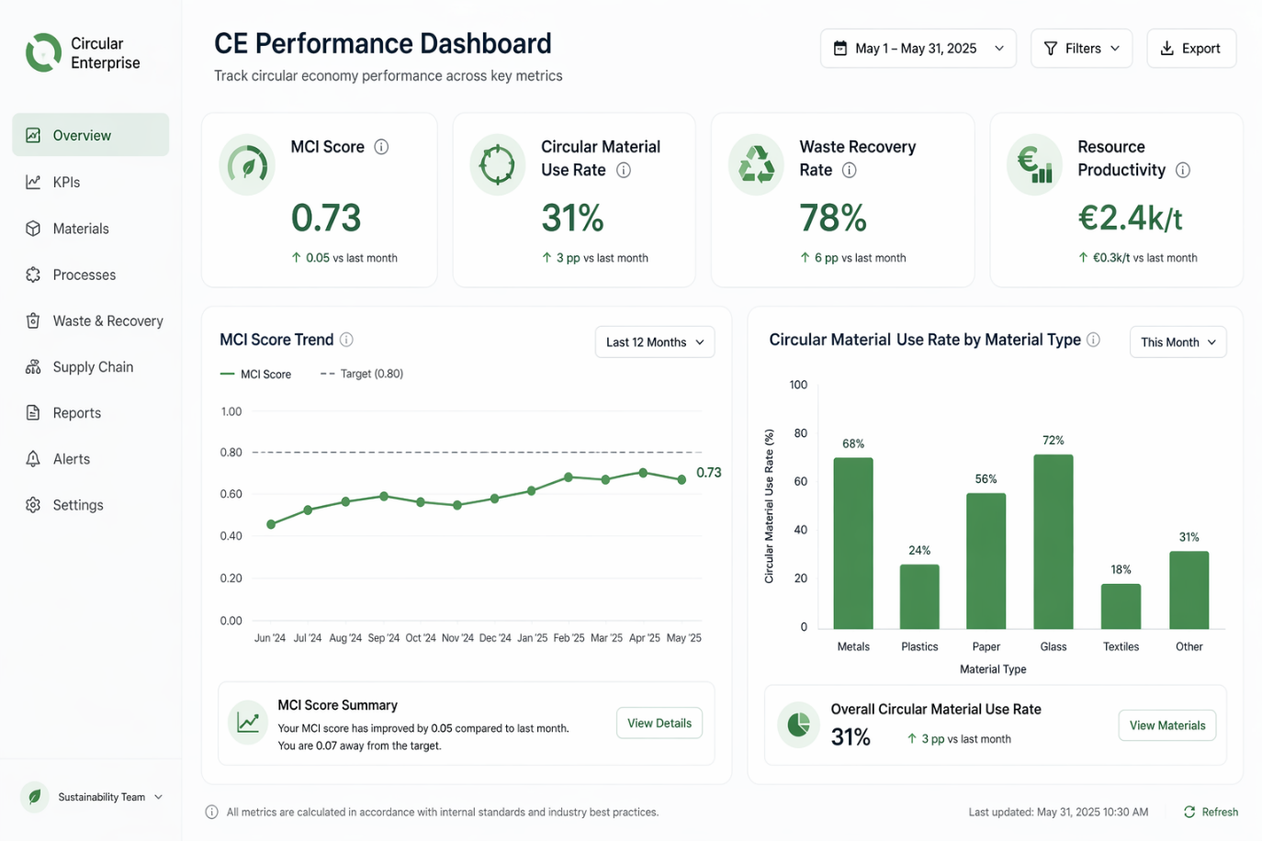
Figure 7. CE Performance dashboard simulation (AI generated)

The image above displays a "CE Performance Dashboard" for tracking circular economy metrics.
- MCI Score: 0.73, which indicates a 0.05 improvement since last month.
- Circular Material Use Rate: 31%, with a 3-percentage point increase compared to the previous month.
- Waste Recovery Rate: 78%, showing a 6-percentage point increase from last month.
- Resource Productivity: €2.4k/t, an increase of €0.3k/t over the last month.

Additional Reading:
- Ellen MacArthur Foundation. "Circulytics Methodology."
- WBCSD (2020). "Circular Transition Indicators."

Key Takeaways:
- MCI provides standardised measurement (0-1)
- Resource efficiency tracks productivity and waste
- Product metrics: durability, repairability, recyclability
- Dashboards align with strategy, balance indicators.

Quick Check:
1. True or False: Higher MCI indicates more linear flows.

2. Multiple Choice: Material Productivity measures:
a) Waste per output
b) Revenue per material input.

3. Short Answer: Two product-level CE metrics.

Answer key: 1) False. 2) b. 3) Durability, repairability, recyclability, recycled content.

Module 2: Conclusion and Self-Assessment
Module Summary:
Module 2 developed technical competences:
- MFA provides methodology for tracking resources
- Lifecycle data spans design through end-of-life
- DPP implementation requires architecture, standards, integration
- Metrics translate principles into measurement

Module Knowledge Quiz
- What is the mass balance principle?
- Name four lifecycle stages and key data for each.
- What are DPP architecture components?
- How is MCI calculated (conceptually)?
- What standards support DPP exchange?
- Name three resource efficiency metrics.
- Key principles for dashboard design?
- Why is design-stage data critical?

Answer Key
- Inputs = Outputs + Stock Change; validates data, estimates unknowns
- Design (BoM), Production (batch tracking), Use (condition), End-of-life (assessment)
- Data carrier, unique identifier, repository, access layer
4. MCI = 1 - (Linear Flow Index × Utility Factor); 0-1 scale
5. CIRPASS, GS1 EPCIS, W3C VC, ISO 15459
6. Material productivity, waste intensity, recycled input rate, recovery rate
7. Align with objectives, balance indicators, enable drill-down
8. Determines 80% of impact; enables circular outcomes.

MODULE 3: ESG Data Management for Circularity
Module Overview:
Apply ESG data management to CE; ensure quality; implement governance.
Module learning outcomes:
- Apply ESG data management principles to circular economy tracking and reporting
- Assess and assure data quality for circular economy metrics and indicators
- Implement data governance frameworks for multi-stakeholder circular supply chains
- Design traceability systems that enable supply chain transparency.
Estimated workload:
Lecture hours (F2F): z hours
Self-study: 6,5 hours
Practical application (if applicable): 6 hours
Assessment link: Deliverables 1, 3, 4
Practical focus / deliverable:
Deliverables 1, 3, 4

Topic 3.1. ESG Data Principles Applied to Circular Economy
Short introduction:
ESG frameworks provide established structures for sustainability data. This topic examines application to circular economy.
Theory & Knowledge:
- Categories for CE
Environmental: Material inputs, waste outputs, efficiency, footprint Social: Supply chain practices, community impact, just transition Governance: CE policies, oversight, transparency.
- Reporting Frameworks
GRI Standards:
- GRI 301: Materials
- GRI 306: Waste
ESRS (European):
- ESRS E5: Resource use and circular economy (dedicated standard)
SASB: Industry-specific metrics.
- CSRD Requirements
Corporate Sustainability Reporting Directive requires:
- CE policies and targets
- Material use and waste data
- Circularity actions
- Resource efficiency measures
ESRS E5 addresses resource inflows, outflows, waste management.

- EU Taxonomy
CE is one of six environmental objectives. Activities must:
- Substantially contribute to CE
- Do no significant harm to others.
- Meet minimum social safeguards.
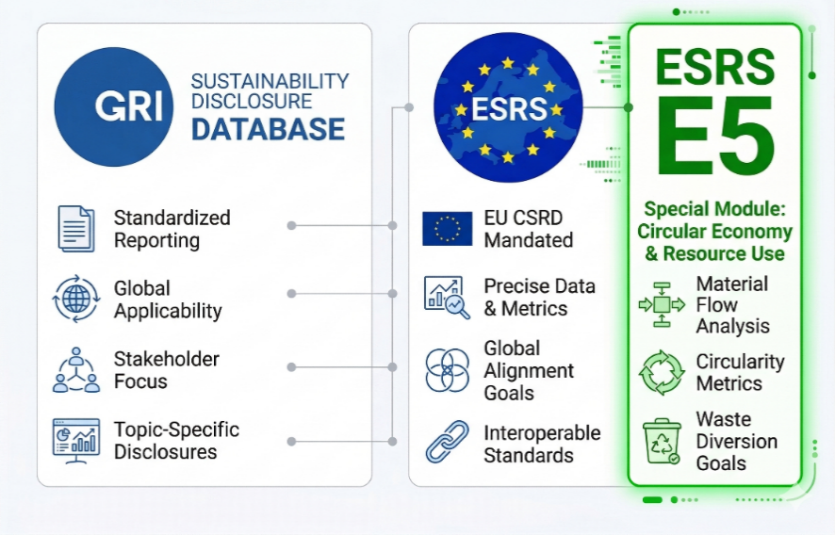
Figure 8. Global ESG reporting frameworks (based on GRI Standards; ESRS E5 (EFRAG 2022); SASB - AI generated)
The image above provides a visual overview of how different sustainability reporting frameworks align, specifically highlighting the relationship between the Global Reporting Initiative (GRI), the Corporate Sustainability Reporting Directive (CSRD), and the European Sustainability Reporting Standards (ESRS).

Micro-Activity:

Framework Mapping (15 minutes)
Select three CE metrics from Module 2:
- Which framework(s) align?
- Specific disclosure requirements?
- Additional data needs?

Additional Reading
  - EFRAG (2022). "ESRS E5 Resource Use and Circular Economy."
  - GRI (2020). "GRI 306: Waste 2020."
Key Takeaways
- All ESG categories have CE relevance
- Multiple frameworks (GRI, ESRS, SASB) address CE
- CSRD creates mandatory disclosure
- ESRS E5 provides dedicated CE standard
- EU Taxonomy includes CE as objective.

Quick Check
1. True or False: CE data only relevant to Environmental category.
2. Multiple Choice: Which ESRS addresses CE?
a) E1
b) E5
3. Short Answer: Two GRI standards for CE.

Answers: 1) False. 2) b. 3) GRI 301, GRI 306.

Topic 3.2. Data Quality for Circular Economy Applications
Short introduction:
CE decisions depend on data quality. This topic covers dimensions, assessment, and improvement.
Theory & Knowledge:
- Quality Dimensions

Table 6. Quality Dimensions (Source: Author)
Dimension | Definition | CE Example
Accuracy | Correctly represents reality | Weight matches actual
Completeness | All required data present | Full BoM available
Timeliness | Current when used | Condition data reflects now
Consistency | Same data yields same values | Units standardised
Validity | Conforms to rules | Codes from controlled list
Uniqueness | No unintended duplicates | Each ID appears once

- CE-Specific Challenges
Material Composition: Incomplete supplier declarations, undocumented historical products Supply Chain: Multiple handoffs, limited visibility beyond tier 1 End-of-Life: Informal channels, long time gaps.

- Assessment Methods
- Data profiling (completeness, outliers)
- Validation rules (ranges, formats, logic)
- Source verification (audits, testing).

- Improvement
- Root cause analysis
- Process improvements
- Data cleansing
- Ongoing monitoring.

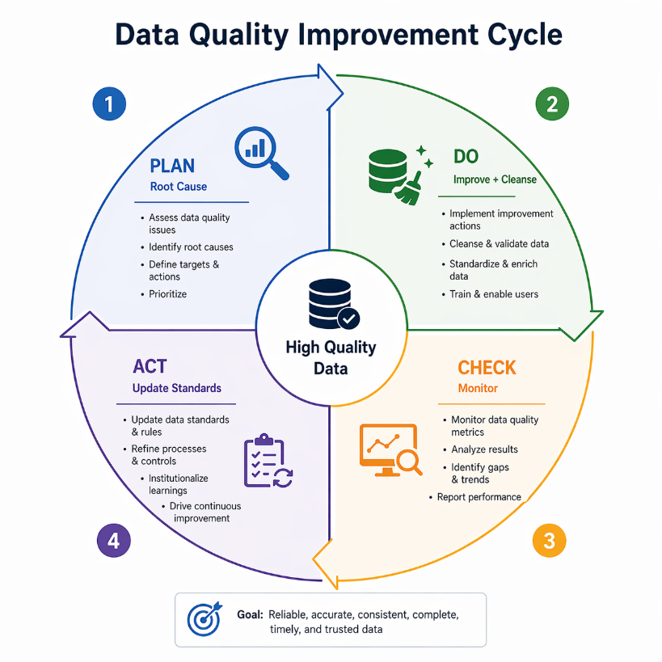

Figure 9. Data quality improvement cycle — PDCA loop (AI generated)

The image above illustrates a "Data Quality Improvement Cycle" designed to ensure reliable, accurate, consistent, complete, timely, and trusted data.
- Plan: Assess issues, identify root causes, define targets, and prioritize actions.
- Do: Cleanse, validate, improve, and standardize data while training users.
- Check: Monitor quality metrics, analyse results, identify gaps, and report performance.
- Act: Update standards and rules, refine processes, and institutionalize learnings for continuous improvement.

Micro-Activity:

Quality Assessment (15 minutes)
Select one CE data element:
- Rate on each dimension (H/M/L)
- Most critical gap
- One improvement action.

Additional Reading:
- DAMA (2017). "DAMA-DMBOK." 2nd Ed.
- ISO 8000 series on data quality.

Key Takeaways:
- Six dimensions define quality
- CE challenges: Composition gaps, supply chain visibility, EoL tracking
- Assessment: Profiling, validation, verification
- Improvement: Root cause, process, cleansing, monitoring.

Quick Check
1. True or False: Timeliness means data was collected quickly.
2. Multiple Choice: CE-specific quality challenge:
a) File format compatibility
b) Limited visibility beyond tier 1.
3. Short Answer: Two assessment methods.

Answer key: 1) False—current when used. 2) b. 3) Profiling, validation, verification.

Topic 3.3. Data Governance Frameworks for Circular Supply Chains
Short introduction:
CE requires data sharing across organisations. Governance establishes policies and responsibilities enabling trusted exchange.
Theory & Knowledge:
- Governance Challenges
- Multi-stakeholder complexity
- Data sensitivity (competitive, pricing, personal)
- Trust requirements.

- Framework Components
Policies: Collection, quality, access, retention, security Processes: Onboarding, QA, access requests, escalation Organisation: Governance bodies, roles, decision rights Technology: Policy enforcement, access control, audit.

- RACI Matrix
Table 7. RACI Matrix (Source: Author)
Activity | Owner | Steward | IT | Users
Define standards | A | R | C | I
Ensure quality | A | R | C | I
Grant access | A | R | R | I
R=Responsible, A=Accountable, C=Consulted, I=Informed

Data Sharing Mechanisms:
- Bilateral agreements
- Industry data spaces (Catena-X, GAIA-X)
- Federated approaches.
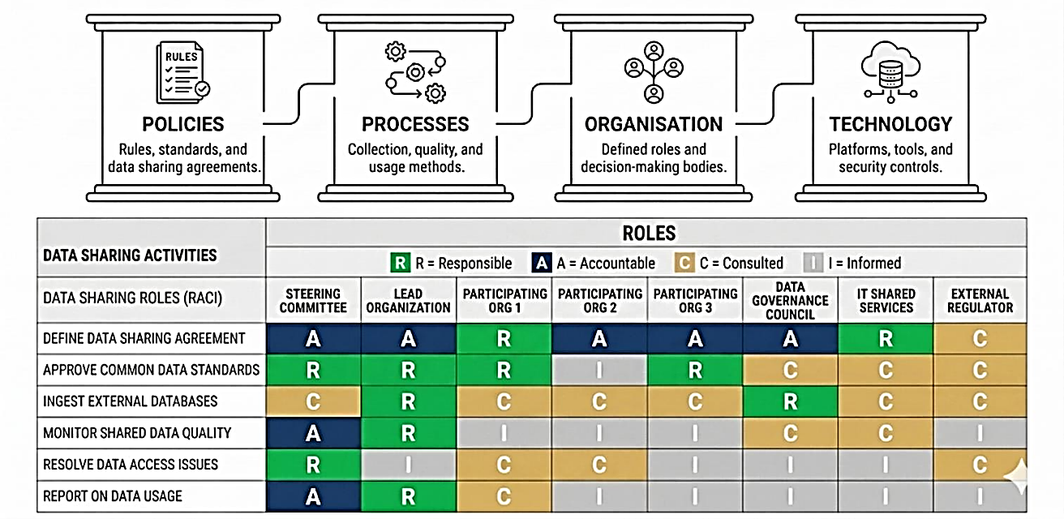
Figure 10. Data Sharing Governance framework and RACI Matrix (AI generated)
The image above displays a RACI matrix illustrating the responsibilities of different stakeholders in data sharing activities, categorized under policies, processes, organization, and technology.
- RACI Roles: The matrix defines roles as Responsible (R), Accountable (A), Consulted (C), and Informed (I) for various tasks.
- Data Sharing Activities: Activities include defining agreements, approving standards, ingesting databases, monitoring quality, resolving issues, and reporting usage.
- Stakeholders: Columns represent entities like Steering Committees, Lead Organizations, participating organizations, Data Governance Councils, and External Regulators.

Micro-Activity:

Governance Design (15 minutes)
For CE data sharing scenario:
- Key stakeholders
- Sensitive data elements
- Three policies
- RACI for "maintain quality".

Additional Reading
- DAMA (2017). "Data Governance" in DMBOK.
- International Data Spaces Association. "Reference Architecture."

Key Takeaways
- Multi-stakeholder complexity distinguishes CE governance
- Components: Policies, processes, organisation, technology
- RACI clarifies responsibilities
- Mechanisms: Bilateral to data spaces
- Balance openness with protection
Quick Check
1. True or False: Governance is primarily IT responsibility.

2. Multiple Choice: In RACI, who has final accountability?
a) R
b) A
3. Short Answer: Two framework components.

Answer key: 1) False—business responsibility. 2) b. 3) Policies, processes, organisation, technology.

Topic 3.4. Traceability Systems for Supply Chain Transparency
Short introduction:
Traceability enables transparency—tracking materials and products through supply chains. This topic covers system design.
Theory & Knowledge:
- Chain of Custody Models

Table 8. Chain of Custody Models (Source: Author)
Model | Description | Rigour
Identity Preserved | Physical separation maintained | Highest
Segregated | Certified kept separate, may blend within category | High
Mass Balance | Tracked administratively, physical mixing allowed | Medium
Book and Claim | Credits traded separately | Lowest

- System Architecture
Identification: Unique IDs, data carriers, standards Event Capture: What/when/where/to what; EPCIS standard Storage: Centralised, distributed, blockchain Query: Trace-forward, trace-back, compliance.

- Supplier Onboarding
- Requirements definition
- Capability assessment
- Phased approach (tier 1 first)
- Training and support.

- Implementation
- Start focused, expand
- Adopt standards (GS1)
- Plan interoperability
- Balance granularity with cost.

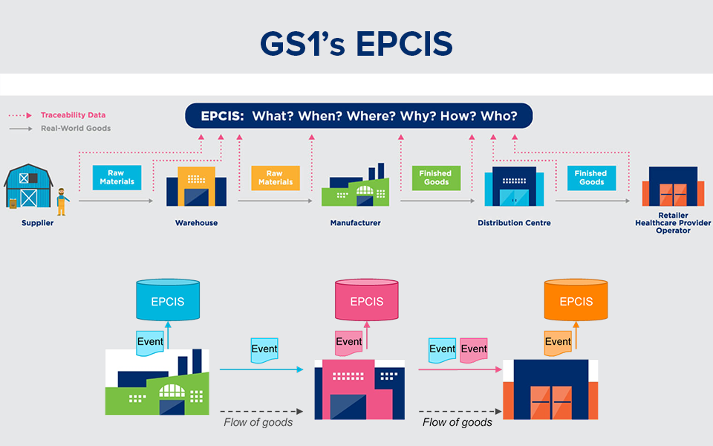
Figure 11. Traceability system architecture (source: AtlasRFID)
The image above illustrates the GS1 Electronic Product Code Information Services (EPCIS) standard, which provides a consistent framework for describing and sharing data about physical objects as they move through a supply chain. It facilitates visibility by capturing detailed event data that answers key questions about product movement.

Micro-Activity:

Traceability Design (15 minutes)
For selected product:
- Three traceability questions stakeholders would ask
- Appropriate CoC model with rationale
- Events to capture
- Main challenges.

Additional Reading
- GS1 (2017). "Global Traceability Standard."
- ISO 22095:2020. "Chain of custody models."

Key Takeaways
- CoC models range from identity preserved to book and claim
- Architecture: Identification, events, storage, query
- EPCIS standardises event data
- Onboarding requires phased approach
- Start focused, expand based on learning.

Quick Check
1. True or False: Mass balance allows physical mixing.

2. Multiple Choice: EPCIS standardises:
a) Product identification
b) Supply chain event data.

3. Short Answer: Two CoC models.

Answer key: 1) True. 2) b. 3) Identity preserved, segregated, mass balance, book and claim.

Module 3: Conclusion and Self-Assessment
Module Summary:
Module 3 connected CE with ESG data management:
- Frameworks (GRI, ESRS) require CE disclosure
- Quality determines data trustworthiness
- Governance enables multi-stakeholder sharing
- Traceability provides transparency foundation

Module Knowledge Quiz
- Which ESG categories are relevant to CE?
- What does ESRS E5 address?
- Name three quality dimensions.
- What are governance framework components?
- Explain RACI matrix purpose.
- What is chain of custody? Name two models.
- What does EPCIS standardise?
- Why is supplier onboarding challenging?

Answer Key:
- All three (Environmental, Social, Governance)
- Resource use and circular economy
- Accuracy, completeness, timeliness, consistency, validity, uniqueness
- Policies, processes, organisation, technology
- Clarifies who is Responsible, Accountable, Consulted, Informed
- Method for tracking materials; Identity preserved, segregated, mass balance, book and claim
- Supply chain event data sharing
- Different capabilities, need for training, phased approach required.

References:
- Ellen MacArthur Foundation (2019). Completing the Picture: How the Circular Economy Tackles Climate Change.
- European Commission (2020). Circular Economy Action Plan. COM(2020) 98.
- European Commission (2022). Ecodesign for Sustainable Products Regulation (ESPR) Proposal. COM(2022) 142.
- World Economic Forum (2019). Harnessing the Fourth Industrial Revolution for the Circular Economy.
- Paul H. Brunner & Helmut Rechberger (2016). Handbook of Material Flow Analysis.
- Eurostat (2018). Economy-Wide Material Flow Accounts Handbook.
- John Stark (2020). Product Lifecycle Management (4th ed.).
- Ellen MacArthur Foundation. Circulytics Methodology.
- CIRPASS Project. Available at: https://cirpassproject.eu/
- EFRAG (2022). European Sustainability Reporting Standards (ESRS E5: Resource Use and Circular Economy).
- Global Reporting Initiative (2020). GRI 306: Waste.
- DAMA International (2017). DMBOK: Data Management Body of Knowledge (2nd ed.).
- GS1 (2017). Global Traceability Standard.
- ISO 22095:2020 (2020). Chain of Custody — General Terminology and Models.

