Cybersecurity for Sustainable Systems
Learner Handbook

Copyright © 2024 Digital4Sustainability. The project resources contained herein are publicly available under the Creative Commons license 4.0 B.Y.

Project | Digital4Sustainability
Project number | 101140316
Document Title | Cybersecurity for Sustainable Systems – Learner handbook
Authors | Enrico Frumento, CEFRIEL  Alessia Libertucci, CEFRIEL  Valentina Ferrarese, CEFRIEL
Reviewers | Delia Radziuk, ClujIT
Editor | Katarina Cicvarić, Profil Klett
Instructional Designer | Kristina Ferara Blašković, Profil Klett
Digital Content Manager | Ivana Bošnjak, Profil Klett  Andra Punjek, Profil Klett

This handbook serves as the comprehensive learning material for the entire upskilling curriculum, covering all modules in a single document. It is structured into Modules and thematic Topics, each designed to achieve specific learning outcomes. The learning content is supported by multimedia elements, self-assessment quizzes, and additional learning resources.

Disclaimer
Funded by the European Union. Views and opinions expressed are however those of the author(s) only and do not necessarily reflect those of the European Union or the European Education and Culture Executive Agency (EACEA). Neither the European Union nor EACEA can be held responsible for them.

Table of Contents
Introduction to Upskilling Curricula: Cybersecurity for Sustainable Systems 5
MODULE 1: Cybersecurity Fundamentals 7
Topic 1.1: CIA Triad and its role within cybersecurity 8
Topic 1.2: Modern and up-to-date Threat Landscape 14
Topic 1.3: Modern Cybersecurity tactics and techniques 18
Topic 1.4: Introduction to the role of Cyberisk 22
Module 1: Conclusion and Self-Assessment 26
MODULE 2: Sustainable Systems Security 29
Topic 2.1: Threat Landscape of Energy Management Systems 30
Topic 2.2: Threat Landscape of IoT sensors 37
Topic 2.3: Threat Landscape of Smart Grids 42
Topic 2.4: Introduction to ESG platforms 49
Topic 2.5: Security framework 54
Module 2: Conclusion and Assessment 59
MODULE 3: Data Protection & Compliance 61
Topic 3.1: Introduction to the Access Controls 62
Topic 3.2: Introduction to Encryption Technologies 66
Topic 3.3: Introduction to GDPR alignment and its evolution 70
Topic 3.4: Audit trails 75
Module 3: Conclusion and Self-Assessment 79
References: 81

Table of Figures:
Figure 1. Confidentiality, integrity, and availability 8
Figure 2. Examples of confidentiality, integrity, and availability risks in energy and ESG data systems 12
Figure 3. Overview of the modern cyber threat landscape. 14
Figure 4. Overview of the MITRE ATT&CK framework. 18
Figure 5. Attack paths in ESG digital infrastructures. 19
Figure 6. Cyber risk assessment model 22
Figure 7. Cascading impacts of cyber incidents. 23
Figure 8. Layered architecture of an energy management system. 31
Figure 9. Smart metering network architecture connecting HAN, LMN, and WAN 31
Figure 10. Typical attack path in an Energy Management System. 33
Figure 11. Mapping EMS components to ATT&CK for ICS tactics 34
Figure 12. IoT sensor ecosystem in sustainable infrastructure 37
Figure 13. Typical IoT attack chain. 39
Figure 14. Smart grid architecture 43
Figure 15. Example of a cascading cyber attack in a smart grid 44
Figure 16. Smart meter gateway acting as a secure communication hub 45
Figure 17. Typical ESG platform architecture integrating IoT sensors, enterprise systems, and supply chain data 50
Figure 18. Example attack chain targeting an ESG platform 51
Figure 19. NIST Cybersecurity Framework 54
Figure 20. Application of cybersecurity frameworks to smart grid infrastructures 56
Figure 21. Access control workflow 62
Figure 22. Access Control Mechanisms across infrastructure domains 64
Figure 23. Basic encryption process 66
Figure 24. End-to-end encryption across IoT, network, and cloud layers 68
Figure 25. The seven core principles of GDPR 71
Figure 26. GDPR principles across domains 72
Figure 27. Example structure of an audit log entry 75
Figure 28. Audit tral functions across key domains 76

List of tables:
Table 1. CIA Triad 10
Table 2. Security priorities for specific technological assets 11
Table 3. Various types of cybersecurity threats 15
Table 4. Various cybersecurity threats 34

Introduction to Upskilling Curricula: Cybersecurity for Sustainable Systems

Overview:
The Cybersecurity for Sustainable Systems curricula is an intensive upskilling programme designed to equip professionals with the knowledge and practical competencies required to secure digitally enabled sustainable infrastructure Targeted at technical specialists, sustainability consultants, system administrators, and IT security professionals at EQF Level 6, the course moves beyond foundational cybersecurity concepts to their strategic application in energy, IoT, and ESG-driven environments. The learning journey is structured into three modules, subdivided into specific Topics. Learners progressively move from core cybersecurity principles (CIA Triad, threat landscape analysis, cyber risk fundamentals) to sector-specific threat modelling and regulatory alignment. The programme adopts a blended learning structure combining lectures, self-study, and 20 hours of Project-Based Learning (PBL). While lectures and self-study provide theoretical foundations, practical application is ensured through a Capstone Project developed throughout the course.
Learning Outcomes (LO) for this UC:
The learner will be able to:
- Identify cybersecurity risks specific to sustainable digital systems (energy management, IoT sensors, ESG platforms)
- Apply security principles (CIA triad, defence in depth) to sustainability infrastructure design.
- Implement access controls and authentication mechanisms for ESG data systems.
- Evaluate security vulnerabilities in renewable energy systems and smart grid technologies.
- Design incident response procedures for sustainability-critical infrastructure.
- Assess compliance requirements for data protection in sustainability reporting systems.
Structure of the handbook
This handbook is divided into Modules and topics.
Module 1: Cybersecurity Fundamentals
T1.1. CIA Triad and its role within cybersecurity
T1.2. Modern and up-to-date Threat Landscape
T1.3. Modern Cybersecurity tactics and techniques
T1.4. Introduction to the role of Cyber-risk

Module 2: Sustainable Systems Security
T2.1. Threat Landscape of Energy Management Systems
T2.2. Threat Landscape of IoT sensors
T2.3. Threat Landscape of Smart Grids
T2.4. Introduction to ESG platforms
T2.5. Security framework

Module 3: Data Protection & Compliance
T3.1. Introduction to the Access Controls
T3.2. Introduction to Encryption Technologies
T3.3. Introduction to GDPR alignment and its evolution
T3.4. Audit trails

MODULE 1: Cybersecurity Fundamentals
Module Overview:
This module sets out the core cybersecurity principles needed to protect sustainable digital systems. It introduces the CIA Triad as the central protection model, explores the modern threat landscape and attacker tactics, and presents cybersecurity as a risk-driven discipline that supports prioritised and sustainable security decisions.
Module learning outcomes:
- Analyse the role and limitations of the CIA Triad and differentiate between threats, vulnerabilities, and risks within sustainable digital systems.
- Apply fundamental threat modelling principles to identify attack surfaces and assess cyber risks in ESG-related environments.
- Examine cybercrime concepts, including threat actors, tactics, techniques, and procedures (TTPs), and their relevance to sustainable infrastructures.
- Interpret key cyber risk definitions and identify relevant EU legislative references and recognised cybersecurity best practices.
Estimated workload:
Lecture hours (F2F): 6 hours
Self-study: 6 hours
Practical application (if applicable): 8 hours
Assessment link: This module establishes the core analytical framework, asset identification, threat analysis, and risk-based prioritisation that constitute the first structured section of the Capstone Project.
Practical focus / deliverable:
Learners build a preliminary cybersecurity baseline for the assigned case study, including asset mapping, identification of key threats and TTPs, and an initial qualitative cyber risk assessment to inform subsequent mitigation design.

Topic 1.1: CIA Triad and its role within cybersecurity
Short introduction:
The CIA Triad (Confidentiality, Integrity, Availability) sets the baseline for cybersecurity. It clarifies what any digital system is meant to protect and why that protection matters, including in sustainable infrastructures such as energy management systems, IoT deployments, and ESG data platforms.
Theory & Knowledge:
Cybersecurity starts with a simple question: what are we actually protecting?
At its core, the primary asset is data. Information must be protected both when it is stored in systems (data at rest) and when it is transmitted across networks (data in transit).
Firewalls, encryption algorithms, and intrusion detection systems all come later. Before any tool, there is an objective. The CIA Triad, Confidentiality, Integrity, Availability, names that objective and gives it structure. It defines the three conditions every digital system must preserve, regardless of scale, industry, or technical sophistication.
In sustainable digital infrastructures, from energy management systems to IoT sensor networks, smart grids, and ESG reporting platforms, this model stops being theory and becomes operational. It shapes resilience, compliance, and trust. When something goes wrong, you can usually trace the failure back to one of these three properties.
Seen this way, cybersecurity is less a toolbox and more a discipline of protection. Each incident is a breach of confidentiality, integrity, or availability, or a combination of them.
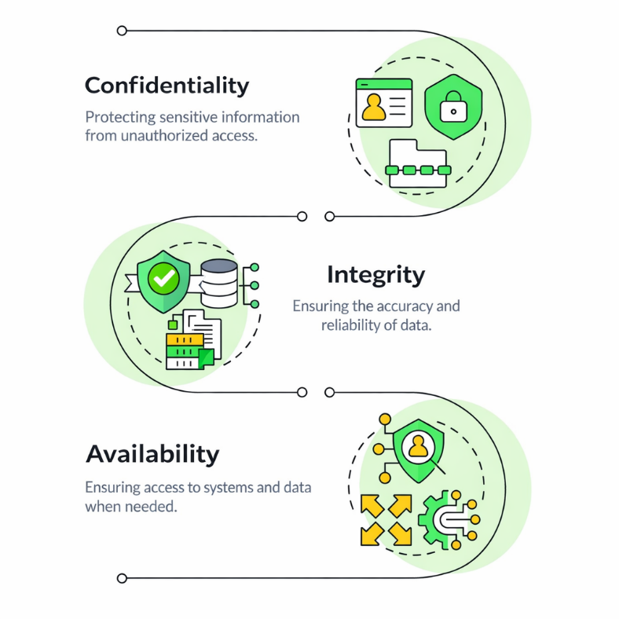
Figure 1. Confidentiality, integrity, and availability. The three core principles of the CIA triad that guide information security management and system protection (source: Vectorstock)

The image above illustrates the CIA Triad, the foundational model for information security designed to guide policies for data protection.
Confidentiality: Ensures sensitive information is only accessible to authorized individuals.
Integrity: Maintains the accuracy, reliability, and trustworthiness of data throughout its lifecycle.
Availability: Guarantees that systems, applications, and data are accessible to users when needed.

- Confidentiality: protecting sensitive information
Confidentiality concerns access. It asks who can see a piece of information and under what conditions, and ensures that everyone else cannot.
In sustainable systems, the data at stake is often commercially delicate or legally protected. Think of an ESG reporting platform that stores emissions figures, supply chain data, and sustainability indicators. Those numbers influence investor decisions, public narratives, and regulatory scrutiny. If they are exposed too early or accessed without authorisation, the consequences extend from reputational damage to sanctions and competitive loss.
The scope of confidentiality goes beyond personal data. In energy management systems, operational settings, consumption profiles, and infrastructure configurations can reveal weaknesses that a malicious actor might later exploit. Guarding that information narrows the attack surface.
Technically, confidentiality relies on authentication, authorisation, symetric/asymetric encryption, and network segmentation. Conceptually, the question is more direct: who should have access, and when? If that boundary is vague, breaches follow.

- Integrity: ensuring accuracy and trustworthiness
Integrity deals with correctness. Data must remain accurate, complete, and unchanged except through authorised processes.
In many sustainable infrastructures, integrity carries particular weight. Smart grids depend on real-time measurements to balance supply and demand. Slight manipulation of those measurements can distort distribution, destabilise the system, or even damage physical assets.
The same applies to ESG disclosures. Investors and regulators assume that sustainability metrics correspond to reality. When figures are altered or corrupted, whether by malice or error, the credibility of the reporting framework erodes quickly.
Trust rests on integrity. Decisions drawn from compromised data are unreliable, and in environmental contexts, the effects spill into safety, compliance, and measurable outcomes. Hashing, digital signatures, logging, and disciplined change management help defend this property, yet the underlying test remains straightforward: can we rely on this information to be intact?

- Availability: ensuring operational continuity
Availability concerns timing. Authorised users must be able to access systems and data when needed.
A system can preserve secrecy and accuracy perfectly and still fail if it goes offline at a critical moment. In sustainability-oriented infrastructures, availability aligns with operational resilience. An energy management dashboard that disappears during peak demand undermines optimisation efforts. A smart grid interface disrupted by a denial-of-service attack can interrupt essential services. An ESG portal that crashes near a disclosure deadline introduces compliance risk.
Threats to availability are not limited to deliberate attacks, such as distributed denial-of-service or ransomware. Misconfiguration, hardware failure, and insufficient capacity planning can produce the same result. In environments where sustainability depends on continuous monitoring and control, downtime rarely remains isolated; it cascades.

Redundancy, backups, failover architectures, and incident response planning all support availability. The core issue, however, is practical: will the system be there when it is required?
In energy and infrastructure contexts, especially, that question often takes priority.

Table 1. CIA Triad (source: Author)
Security Objective | Primary Question | Example in Sustainable Systems | Typical Controls
Confidentiality | Who can see the data? | ESG emissions database | Encryption, RBAC
Integrity | Has the data been altered? | Smart grid telemetry | Hashing, logging
Availability | Is the system accessible when needed? | Energy management dashboard | Redundancy, backups

- The CIA Triad as a Risk-Oriented Framework
The CIA Triad is most useful as an analytical tool. It gives you a simple, repeatable way to assess assets and decide which security properties matter most in practice.
When cybersecurity teams review a sustainable system, they usually start by mapping the assets: databases, control systems, sensor networks, reporting platforms, and communication channels. Then each asset is tested against the CIA lens:
- Which information must stay confidential?
- Which data must remain accurate and protected from unauthorised change?
- Which services need to be available without interruption?

Priorities differ by asset. A smart meter’s firmware often prioritises integrity. An ESG database usually needs confidentiality and integrity. A load-balancing control system may prioritise availability. Those priorities shape risk assessment and, in turn, control selection. Controls are not deployed evenly across the board; they are chosen to protect the CIA property that would have the most significant impact if it failed. Used this way, the CIA Triad serves as a practical foundation for threat modelling and cyber risk management.

Table 2. Security priorities for specific technological assets based on the Confidentiality, Integrity, and Availability (CIA) triad framework (source: Author)
Asset | CIA Priority | Reason
Smart meter firmware | Integrity | Tampering may cause grid instability
ESG reporting portal | Confidentiality + Integrity | Sensitive disclosures
Energy load balancer | Availability | Real-time operational requirement

- CIA in the Context of Sustainable Digital Transformation
As organizations digitize sustainability work by connecting IoT devices, cloud platforms, analytics, and AI optimisation, their dependence on digital infrastructure grows. As that dependence grows, clarity about security objectives becomes non-negotiable.
The CIA Triad acts as a steady reference point even as the technology stack shifts. Whether the system is a smart grid, a renewable energy platform, an ESG analytics environment, or a carbon tracking tool, the same three objectives apply.
Cybersecurity sits inside this picture as a risk-driven discipline. It protects the confidentiality of sensitive sustainability data, the integrity of environmental measurements, and the availability of the systems that keep green operations running.
Understanding the CIA Triad is the first move away from reactive defence and toward structured, risk-based cybersecurity management.

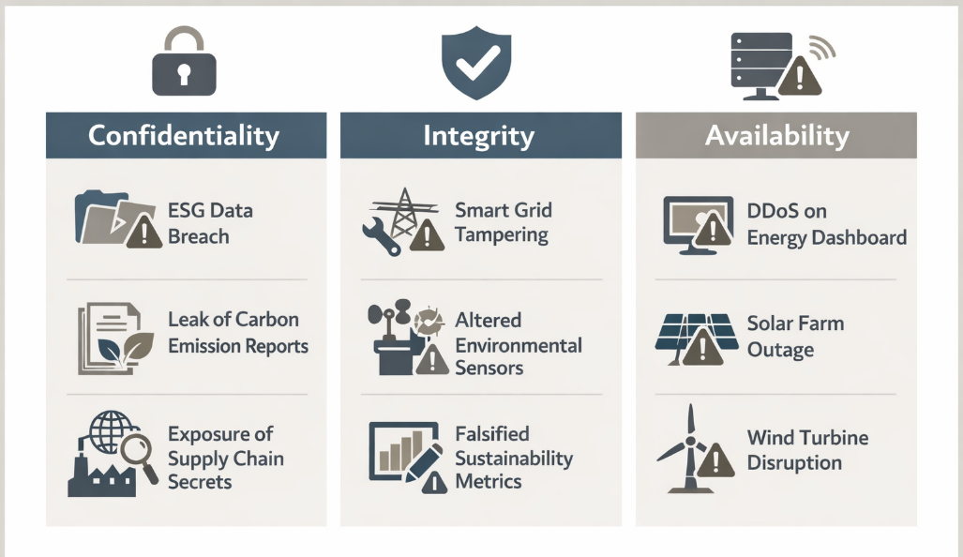
Figure 2. Examples of confidentiality, integrity, and availability risks in energy and ESG data systems, including data breaches, sensor tampering, and service disruptions (source: Author)

The image above illustrates the CIA triad of cybersecurity (Confidentiality, Integrity, and Availability) applied to energy sector risks.
- Confidentiality: Risks include data breaches, leaked reports, and exposed supply chain secrets.
- Integrity: Threats involve tampering with smart grids, altering sensors, and falsifying sustainability metrics.
- Availability: Potential disruptions include DDoS attacks on dashboards and outages at solar or wind farms.

Micro-activity:
CIA Mapping Exercise
Choose one of the following sustainable systems:
- Smart building energy management system
- IoT-based environmental monitoring platform
- ESG data reporting portal.
Learner task:
- Identify three key assets.
- Assign a primary CIA objective to each asset.
- Justify your selection in 2–3 sentences.
Reflect: Which objective appears most critical in your example and why?

Additional resources:
- ENISA – Information Security Principles and Good Practices
- NIST FIPS 199 – Standards for Security Categorisation of Federal Information and Information Systems
- Confidentiality Integrity Availability (CIA Triad) in Sustainability Context .

Key Takeaways:
- The CIA Triad defines the three core objectives of cybersecurity: Confidentiality, Integrity, and Availability.
- Sustainable digital infrastructures rely on all three to maintain operational stability and meet compliance requirements.
- Mapping systems against the CIA framework is the starting point for structured cyber risk analysis.
- Each asset carries its own priority within the triad.
Threat modelling and control selection ultimately rest on this foundation.

Quick Check:
  - True or False: The CIA Triad focuses only on preventing external cyberattacks.

  - Which objective ensures that smart grid measurement data cannot be modified without authorisation?
a) Confidentiality
b) Integrity
c) Availability.

  - Which of the following primarily supports Availability?
a) Encryption
b) Redundancy
c) Hashing.
Answer key: 1. False, 2. b), 2. b).

Topic 1.2: Modern and up-to-date Threat Landscape
Short introduction:
The modern threat landscape is dynamic, complex, and highly organised. Understanding current threat actors, Tactics, Techniques, and Procedures (TTPs) is essential for protecting sustainable digital infrastructures such as energy management systems, IoT deployments, smart grids, and ESG platforms.

Theory & Knowledge:
The term “threat landscape” describes the environment in which cyber threats take shape, adapt, and affect organisations. It includes the actors involved, what drives them, the tools and techniques they rely on, and the weaknesses they exploit. In sustainable systems, that environment extends well beyond traditional IT to operational technology, smart grids, IoT sensors, and ESG data infrastructures.
Today’s threat landscape has three visible traits: professionalisation, automation, and a focus on critical infrastructure. Cybercrime no longer looks like an isolated activity. It operates as an organised ecosystem, often labelled Cybercrime-as-a-Service, where ransomware kits, phishing frameworks, and exploit tools are rented on underground markets. This model lowers the barrier to entry and increases both the frequency and scale of attacks.

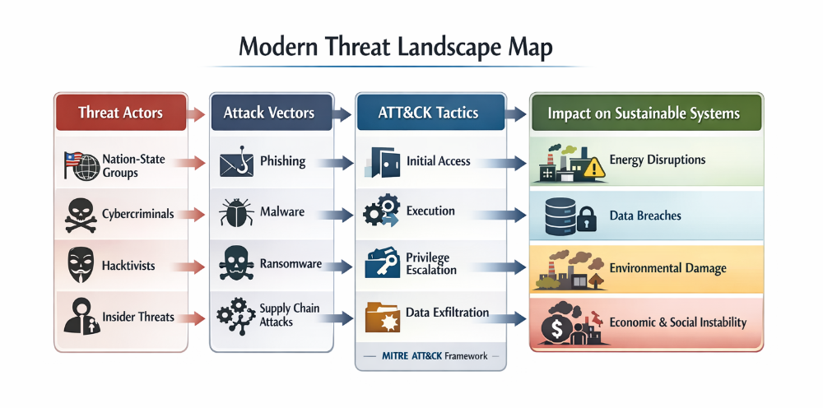
Figure 3. Overview of the modern cyber threat landscape. It links threat actors, attack vectors, and MITRE ATT&CK tactics to impacts on sustainable and energy systems (source: Author)

This image illustrates a "Modern Threat Landscape Map," highlighting the flow from threat actors to the potential impact on sustainable systems.
Threat Actors: Identifies who is responsible for attacks, including nation-state groups, cybercriminals, hacktivists, and insider threats.
- Attack Vectors: Lists methods used to initiate attacks, such as phishing, malware, ransomware, and supply chain attacks.
- ATT&CK Tactics: Outlines steps in a cyberattack, from initial access and execution to privilege escalation and data exfiltration based on the MITRE framework.
- Impact on Sustainable Systems: Details the consequences of these attacks, including energy disruptions, data breaches, environmental damage, and economic/social instability.

Threat actors typically fall into four broad groups:
- Cybercriminal organisations driven by financial gain, including ransomware and fraud.
- State-sponsored actors pursuing geopolitical or strategic objectives.
- Hacktivists acting on ideological motives.
- Insiders, whether malicious or simply negligent.
The boundaries between these groups are less rigid than they once were. Motivations overlap, and hybrid operations are becoming more common.
Table 3. Various types of cybersecurity threats specifically targeted at sustainable systems and organizations (source: Author)
Threat Actor Type | Primary Motivation | Typical Techniques | Relevance to Sustainable Systems
Cybercriminal groups | Financial gain | Ransomware, phishing, extortion | Target energy/ESG data platforms
State-sponsored actors | Strategic/geopolitical | Supply chain compromise, espionage | Target critical infrastructure
Hacktivists | Ideological | DDoS, defacement | Target sustainability narratives
Insiders | Personal/financial | Data theft, sabotage | Access to sensitive ESG data

Ransomware remains one of the most visible features of this landscape. What began as opportunistic campaigns has evolved into carefully targeted operations aimed at organisations that provide essential services, including energy providers and sustainability reporting platforms. Double extortion has become standard practice: attackers encrypt data and extract copies, increasing pressure on victims to pay.

Phishing and social engineering form another dominant attack path. Rather than relying solely on technical flaws, attackers focus on human behaviour. Spear-phishing campaigns now incorporate detailed personalisation, enabling credential theft and movement across internal networks.

Supply chain attacks add further complexity. Instead of targeting a specific system, adversaries compromise a trusted supplier, a software update channel, or a third-party provider. In sustainable digital ecosystems, where IoT devices, cloud services, and ESG platforms depend on layered vendor relationships, this indirect route creates systemic exposure.
To analyse attacker behaviour more systematically, security teams often use the MITRE ATT&CK framework. It offers a shared knowledge base of adversary tactics and techniques, structured around the stages of the attack lifecycle: initial access, privilege escalation, lateral movement, and exfiltration. The framework supports a shift from general awareness to structured threat modelling and detection planning.

Sustainable infrastructures also face sector-specific risks. Energy management systems and smart grids combine IT and OT components. OT environments frequently prioritise availability and safety over rapid patching cycles, which leaves legacy vulnerabilities in place. In these contexts, an attack may disrupt operations both physically and digitally.
Cloud adoption reshapes exposure in its own way. Misconfigured storage, weak identity controls, and excessive permissions remain common drivers of breaches. ESG platforms that consolidate sustainability metrics often contain sensitive operational and financial data, making them attractive targets.

The expansion of IoT devices introduces additional surface area. Sensors used in energy and environmental monitoring often lack robust built-in security. Weak authentication, unencrypted communication, and infrequent updates widen potential entry points.
Artificial intelligence and automation now influence both sides. Attackers use AI to craft convincing phishing content and accelerate vulnerability discovery. Defenders rely on behavioural analytics and anomaly detection to spot suspicious activity. The result is a faster, more adaptive threat environment.

Understanding this landscape involves more than compiling a list of threats. It requires asking who the actors are, what drives them, which techniques they deploy, and how sector characteristics such as energy systems, IoT deployments, and ESG infrastructures reshape risk exposure.

That analytical lens underpins effective threat modelling and cyber risk management in the sections that follow.

Micro activity:
Select one sustainable system example (e.g., smart grid, ESG reporting platform, IoT-based environmental monitoring).
- Identify one likely threat actor.
- Identify one likely attack vector.
- Map the attack to one stage of the MITRE ATT&CK lifecycle (e.g., initial access, lateral movement, exfiltration).
- Briefly describe the potential impact.
Write your answers in 5–6 sentences.

Additional readings:
- MITRE ATT&CK Framework
- CISA Secure-by-Design Guidance
- Zscaler ThreatLabz 2026 Predictions: AI-powered attacks, ransomware supply-chain, IoT/OT/5G come battleground. Up-to-date as of 2026
- Sustainability Directory - Cyber Threat Landscape: Evoluzione rischi cyber nel contesto sostenibilità (ESG pillar),
- MITRE ATT&CK in ESG Context: Applicazioni per threat-informed defence in sustainability tech

Key takeaways:
- The modern threat landscape is dynamic, professionalised, and increasingly targeted at critical infrastructures.
- Threat actors include cybercriminals, state actors, hacktivists, and insiders, each with distinct motivations.
- Ransomware, phishing, and supply chain attacks are dominant contemporary threats.
- Sustainable digital systems (energy, IoT, ESG platforms) expand the attack surface due to IT/OT integration and cloud dependencies.
- Structured frameworks such as MITRE ATT&CK support systematic threat analysis and defence planning.

Quick Check:
  - True or False: Modern ransomware attacks often include both data encryption and data exfiltration.

  - Which of the following best describes a supply chain attack? [b]
- An attack targeting only internal employees
- An attack exploiting a trusted third-party supplier or software provider
- An attack limited to phishing emails
- An attack that affects only physical hardware.

  - What is the primary purpose of the MITRE ATT&CK framework?
- To replace antivirus software
- To classify software vulnerabilities by severity
- To provide a structured knowledge base of adversary tactics and techniques
- To encrypt sensitive data.

Answer key: 1. true, 2. b), 2. c).

Topic 1.3: Modern Cybersecurity tactics and techniques
Short introduction:
Modern cybersecurity is no longer just about dealing with isolated attacks or fixing single vulnerabilities. It calls for a clear understanding of how adversaries actually operate, the tactics they use to achieve their goals, and the techniques they employ at every stage of an attack. This topic explores current attacker methodologies and defensive responses, with a specific focus on sustainable digital infrastructures such as energy systems, IoT environments, and ESG data platforms.

Theory & Knowledge:
Modern cybersecurity analysis no longer views attacks as isolated incidents but as organised campaigns built from coordinated actions. Threat actors — from cybercriminal groups to state-sponsored operators — tend to follow recognisable patterns known as Tactics, Techniques, and Procedures (TTPs). Understanding these patterns helps defenders anticipate, detect, and mitigate attacks more consistently and effectively.
A tactic refers to the adversary’s high-level goal, such as gaining initial access or exfiltrating data. A technique describes how that goal is carried out, for example, through phishing emails or by exploiting public-facing applications. The procedure is the specific implementation observed in an actual campaign.
This structured perspective is formalised in frameworks such as the MITRE Corporation’s MITRE ATT&CK Framework, which maps adversary behaviour across the attack lifecycle.
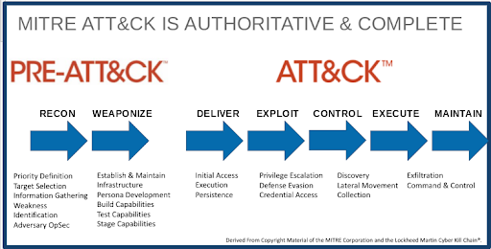
Figure 4. Overview of the MITRE ATT&CK framework. It outlines attacker activities from reconnaissance and preparation to execution, control, and data exfiltration (source: Infoblox)

The image above illustrates how the MITRE ATT&CK® framework maps to the stages of a cyberattack, specifically aligning with the Lockheed Martin Cyber Kill Chain®. Historically, MITRE divided the framework into two main sections to cover the full lifecycle of an intrusion: PRE-ATT&CK (This phase focuses on activities that happen before an adversary gains access to the target network) and ATT&CK (Enterprise; This phase covers the "left of exploit" and "right of exploit" actions taken once an adversary attempts to interact with the target. Deliver: Initial access and establishing a foothold.).

- The Modern Attack Lifecycle
While attacks differ depending on the context, many tend to follow a recognisable sequence:
- Initial Access – entering the environment through phishing, stolen credentials, or exposed services.
- Execution – running malicious code inside the system.
- Persistence – keeping access even after reboots or credential changes.
- Privilege Escalation – gaining higher-level permissions.
- Lateral Movement – moving between systems within the network.
- Exfiltration or Impact – stealing data or disrupting operations.
In sustainable infrastructures, these tactics can have amplified effects. For instance, lateral movement within a smart energy management network could enable attackers to disrupt load-balancing systems, potentially impacting operational resilience.

- Common Modern Techniques
Today’s attackers commonly rely on:
- Phishing and spear-phishing aimed at ESG reporting staff.
- Credential stuffing targeting weakly protected cloud services.
- Exploitation of IoT firmware vulnerabilities in sensors and gateways.
- Living-off-the-land techniques, where legitimate administrative tools are misused to reduce the risk of detection.
- Ransomware deployment directed at energy or sustainability-critical infrastructure.
These techniques are not chosen at random; they are selected based on perceived weaknesses in the target environment. Sustainable systems often create broader attack surfaces because of distributed sensors, cloud platforms, and third-party integrations.
The figure below illustrates how IoT devices, cloud ESG platforms, and operational technology increase potential entry points.

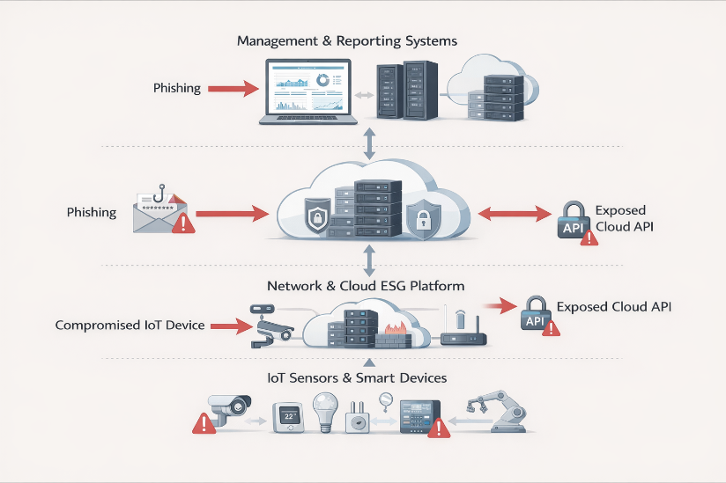
Figure 5. Attack paths in ESG digital infrastructures. Phishing, compromised IoT devices, and exposed cloud APIs can affect sensors, cloud platforms, and management systems (source: Author)

This diagram above illustrates a security architecture for a Network & Cloud ESG Platform, highlighting potential attack vectors and vulnerabilities.
- Attack Vectors: The system is vulnerable to phishing attacks targeting management systems and cloud infrastructure, as well as compromised IoT devices.
- Vulnerabilities: Exposed Cloud APIs represent a significant security risk, acting as entry points for unauthorized access.
- IoT Security: The platform connects various IoT Sensors & Smart Devices, which, if compromised, can threaten the entire network.
- Defence Layers: Security is managed through central reporting systems and cloud-based platforms designed to monitor and protect data traffic.

- Defensive Techniques and Counter-Tactics
Understanding how attackers operate enables a more structured defence. Modern cybersecurity typically follows a defence-in-depth approach, combining preventive, detective, and responsive measures.
Key defensive techniques include:
- Multi-Factor Authentication (MFA) to lower the risk of credential compromise.
- Network segmentation to restrict lateral movement.
- Endpoint Detection and Response (EDR) to identify malicious execution.
- Security monitoring aligned with ATT&CK techniques.
- Incident response playbooks designed for ESG-critical systems.
The OWASP Foundation offers guidance on common application-layer attack techniques, particularly relevant to ESG reporting platforms exposed through web interfaces.
At the same time, the Cybersecurity and Infrastructure Security Agency promote secure-by-design and resilience principles that apply to critical infrastructure, including energy and sustainability environments.

- TTPs and the Sustainable Risk Context
In ESG-driven and energy-related environments, the consequences of modern tactics can go beyond financial loss. Attacks may:
- Disrupt renewable energy monitoring systems.
- Manipulate sustainability performance data.
- Undermine regulatory compliance.
- Erode stakeholder trust.
For this reason, analysing tactics and techniques is more than a purely technical task. It supports structured risk modelling and contributes directly to the Capstone Project’s threat modelling and risk assessment components.

Micro activity:
Select a hypothetical ESG cloud reporting platform that includes:
- User login portal
- API integration with IoT sensors
- Cloud-hosted database.

Learner task:
- Identify one likely attacker tactic.
- Identify one specific technique that could implement that tactic.
- Propose one defensive control aligned with that technique.
Write your answer in 6–8 sentences.

Additional readings:
- MITRE Corporation – MITRE ATT&CK Framework
- OWASP Foundation – OWASP Top 10
- European Union Agency for Cybersecurity (ENISA) – Threat Landscape Reports
- Sustay On Track – Cybersecurity as a Core ESG Sustainability Component.

Key takeaways:
- Modern cybersecurity focuses on structured attacker behaviour through tactics and techniques.
- The ATT&CK framework provides a systematic way to analyse adversary actions.
- Sustainable digital infrastructures expand the attack surface through IoT and cloud integration.
- Defensive strategies must align directly with known attacker techniques.
- Understanding TTPs supports effective threat modelling and risk assessment.

Quick Check:
1. True or False: If an organisation successfully prevents lateral movement during an intrusion, the overall business impact of the attack may be significantly reduced even if initial access was achieved.

2. An attacker exploits weak authentication on a remote maintenance interface of an Energy Management System and then modifies control parameters.
- Tactic: Compliance breach – Technique: ESG reporting manipulation
- Tactic: Impact – Technique: Credential stuffing
- Tactic: Initial Access – Technique: Exploitation of weak authentication
- Tactic: Risk assessment – Technique: Remote monitoring.

3. Which pairing correctly identifies the attacker’s tactic and technique? A cloud-based ESG platform stores sustainability performance data. The system has a known vulnerability, but exploitation would only expose anonymised, non-critical test data. How should this risk most likely be prioritised?
- High, because all vulnerabilities are equally critical
- Medium, because cloud systems are always high risk
- Low, because the impact on business and compliance is minimal
- Critical, because ESG platforms cannot tolerate any weakness.

Answer key: 1. true, 2. c), 3. c).

Topic 1.4: Introduction to the role of Cyberisk
Short introduction:
Cybersecurity is, at its core, a discipline driven by risk. Tactics, techniques, and controls explain how attacks happen and how systems are defended, but cyber risk clarifies why some threats carry more weight than others and how organisations decide where to focus their security efforts. This topic introduces the concept of cyber risk and its importance in protecting sustainable digital infrastructures, including energy systems, IoT environments, and ESG platforms.
Theory & Knowledge:
Cyber risk refers to the potential for loss or harm when a cyber threat exploits a vulnerability within a system. It is not determined solely by the presence of a threat, nor simply by a vulnerability, but by the combination of likelihood and impact.

In sustainable digital systems, such as smart grids, IoT-based environmental monitoring, and ESG reporting platforms, the consequences of cyber incidents can go beyond financial loss. They may disrupt critical infrastructure, compromise regulatory compliance, or weaken stakeholder trust. For this reason, cybersecurity should be understood not as a purely technical function, but as a structured risk management discipline.

- Defining Cyber Risk
Cyber risk can be expressed in simple conceptual terms as:
Risk = Threat probability × Vulnerability score x Impact.
Threat probability is the likelihood that a threat actor will successfully exploit a vulnerability. Vulnerability score refers to the potential damage a vulnerability could cause to the system if exploited. Impact describes the extent of harm if that exploitation takes place, including operational disruption, financial loss, reputational damage, or regulatory penalties.
A threat on its own, without a vulnerability, does not create immediate risk. Similarly, a vulnerability without an active threat represents only latent risk. Cyber risk emerges when both conditions coexist within a specific business context.
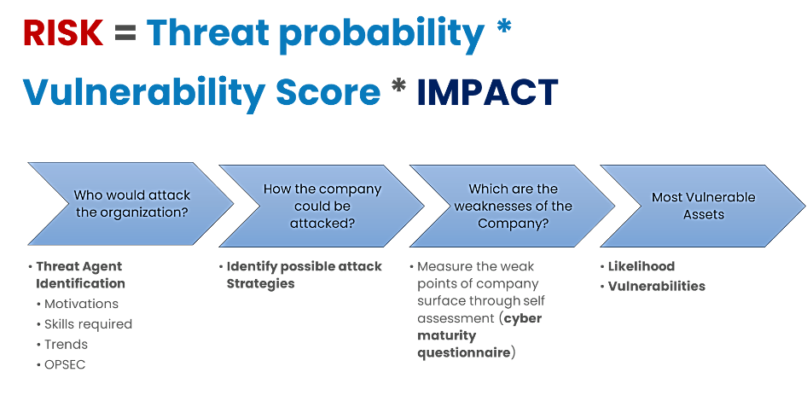
Figure 6. Cyber risk assessment model where risk results from threat probability, vulnerability level, and potential impact on organizational assets (source: Author)
The infographic above outlines a fundamental formula for assessing cybersecurity risk and the strategic process used to evaluate it. The Risk Equation. At the top, the image defines Risk as a product of three critical factors: RISK = Threat probability * Vulnerability score * IMPACT. Risk Assessment Process: The diagram breaks down the evaluation into four sequential stages: 1. Threat Agent Identification. Question: Who would attack the organization?
Key Factors: Understanding the attacker's motivations, required skills, current industry trends, and their operational security (OPSEC). 2. Attack Strategies. Question: How could the company be attacked? Focus: Identifying possible methods and vectors an adversary might use to breach the system. 3. Weakness Analysis. Question: Which are the weaknesses of the company? Method: Measuring vulnerabilities via self-assessment, often through a cyber maturity questionnaire. 4. Asset Prioritization. Focus: Identifying the Most Vulnerable Assets.
Key Factors: Evaluating the Likelihood of an exploit and the specific Vulnerabilities associated with those assets.

- Cyber Risk in Sustainable Systems
Sustainable infrastructures bring distinct risk characteristics:
- Distributed attack surfaces, including IoT sensors, smart meters, and APIs.
- Integration between IT and Operational Technology (OT).
- Regulatory exposure, such as ESG reporting accuracy and data protection obligations.
- High societal impact in the event of disruption.
For instance, a compromised ESG data platform may not only expose sensitive information but could also lead to inaccurate sustainability disclosures, potentially resulting in regulatory sanctions or reputational damage.
For this reason, cyber risk assessment needs to account not only for technical severity, but also for organisational and societal consequences.

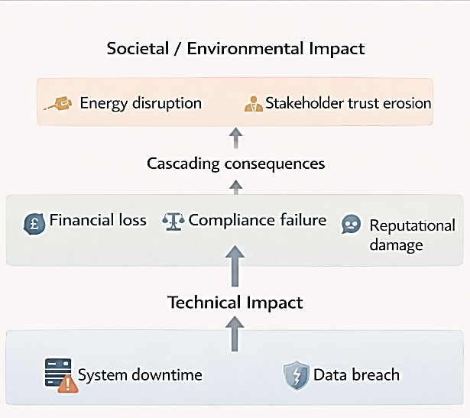
Figure 7. Cascading impacts of cyber incidents. Technical failures such as downtime or data breaches can lead to financial loss, compliance issues, and broader societal or environmental effects (source: Author)
The image above displays a diagram illustrating how technical issues can escalate into broader societal and environmental impacts. Technical Impact: Initial issues like System downtime and Data breaches.
Cascading consequences: These technical issues lead to intermediate effects such as financial loss, Compliance failure, and Reputational damage. Societal / Environmental Impact: Ultimately, these consequences result in broader issues like Energy disruption and Stakeholder trust erosion.

- Risk Assessment and Prioritisation
Since resources are limited, organisations cannot remove every risk. Instead, they prioritise them through structured assessment methods. These typically involve:
- Identifying critical assets.
- Identifying threats and vulnerabilities.
- Estimating likelihood.
- Evaluating impact.
- Determining the level of risk, for example, low, medium, or high.
Frameworks such as those promoted by the National Institute of Standards and Technology through the NIST Risk Management Framework, along with guidance from the European Union Agency for Cybersecurity, support structured risk analysis processes. These approaches help align cybersecurity decisions with organisational objectives and regulatory requirements.
Risk-based prioritisation ensures that high-impact risks affecting the resilience of sustainable infrastructure are addressed before lower-severity technical issues.

- Cyber Risk and Strategic Decision-Making
Cyber risk influences:
- Investment decisions in security controls.
- Architecture design choices.
- Incident response planning.
- Compliance strategy.
Within this curriculum, cyber risk acts as the link between:
- The CIA Triad and threat landscape analysis (Topics 1.1 and 1.2),
- Modern attacker TTPs (Topic 1.3), and
- The structured risk assessment required for the Capstone Project.
Cybersecurity, therefore, is not only about stopping attacks; it is about enabling informed, risk-based decisions that support sustainable and resilient digital systems.

Micro activities:
Consider a smart energy management platform that:
- Collects real-time sensor data
- Stores it in a cloud database
- Generates ESG performance reports.

Learner task:
- Identify one critical asset.
- Identify one credible threat.
- Identify one relevant vulnerability.
Briefly describe the potential impact (2–3 sentences).
Conclude by stating whether you consider this a high, medium, or low risk, and justify your reasoning.

Additional readings:
- National Institute of Standards and Technology – Risk Management Framework
- European Union Agency for Cybersecurity – Risk Management Guidelines,
- ENISA Risk Management.

Key takeaways:
- Cyber risk emerges from the interaction between threats, vulnerabilities, and impact.
- Sustainable digital systems introduce complex, high-impact risk scenarios.
- Risk assessment enables structured prioritisation of security controls.
- Cybersecurity decisions must align with business, regulatory, and societal objectives.
- Risk-based thinking underpins effective cybersecurity governance.

Quick Check
- True or False: If a vulnerability exists in a critical energy control system but there is currently no evidence of active exploitation, the cyber risk can automatically be classified as negligible.

- An organisation identifies a vulnerability in its cloud-based ESG reporting platform. Exploitation is moderately likely due to internet exposure, and successful compromise could result in regulatory penalties and reputational damage. Which definition of cyber risk best applies in this scenario?
- The number of technical weaknesses identified during a security scan
- The balance between the likelihood of exploitation and the magnitude of business impact
- The financial cost required to remediate the vulnerability
- The presence of malicious software within the system.

- Why does cyber risk assessment require particular attention in Energy Management Systems integrated with smart grids and IoT devices? v
- Because sustainable infrastructures are isolated from public networks
- Because technical disruption may cascade into operational, economic, and societal consequences
- Because ESG data is rarely subject to regulatory scrutiny
- Because renewable energy technologies eliminate cybersecurity concerns.

Answer key: 1. false; 2. b); 3. b).

Module 1: Conclusion and Self-Assessment
Module Summary:
Module 1 presented cybersecurity as a structured, risk-driven discipline essential to protecting sustainable digital infrastructure. It opened with the CIA Triad, positioning confidentiality, integrity, and availability as the core security objectives for energy systems, IoT deployments, and ESG platforms. Grasping these principles allows professionals to clarify what needs protection before considering how it might be attacked.
The module then explored the modern threat landscape, highlighting the evolving capabilities of threat actors and the increased exposure resulting from digital transformation, cloud adoption, and distributed sensor networks. Focus was placed on sustainable infrastructures, where operational disruption or data manipulation can lead to financial, regulatory, and societal consequences.
In Topic 1.3, attention turned to modern attacker tactics and techniques (TTPs), highlighting structured adversary behaviour and frameworks such as the ATT&CK model. Learners examined how attacks unfold through identifiable stages and how defensive strategies can be aligned accordingly.
Finally, Topic 1.4 introduced cyber risk as the unifying concept that links threats, vulnerabilities, and impacts. Cybersecurity decisions need to be prioritised based on risk, ensuring that protection efforts remain aligned with business objectives, regulatory requirements, and sustainability goals.
Taken together, these components provide the analytical foundation necessary for asset identification, threat modelling, and risk assessment within the Capstone Project.

Module Knowledge Quiz
- Which of the following scenarios represents a violation of integrity rather than confidentiality?
- An attacker steals employee passwords
- Sensor data is altered before being included in an ESG report
- A denial-of-service attack blocks access to a smart grid dashboard
- A firewall blocks incoming malicious traffic
- Which factor most significantly increases the attack surface in sustainable digital infrastructures?
- Use of printed sustainability reports
- Isolation from external networks
- Integration of IoT devices with cloud-based platforms
- Manual record-keeping systems.

- Which of the following best illustrates lateral movement?
- Sending phishing emails to gain first access
- Encrypting files to demand ransom
- Moving from a compromised user workstation to a production server
- Scanning a public website for vulnerabilities.

- True or False: Risk prioritisation ensures that organisations allocate cybersecurity resources to the most impactful threats first.

- An organisation identifies a vulnerability in a non-critical internal system with minimal business impact. The likelihood of exploitation is low. How would this risk most likely be classified?
- Critical
- High
- Medium
- Low.

- Which of the following is the primary objective of threat modelling?
- To eliminate all possible vulnerabilities
- To identify and evaluate potential attack paths against critical assets
- To reduce IT operating costs
- To ensure software development speed.

- Why is cyber risk management particularly relevant for ESG reporting platforms?
- Because ESG systems never connect to external users
- Because inaccurate or manipulated data may lead to regulatory and reputational consequences
- Because ESG data is not subject to compliance obligations
- Because ESG systems are technically simple.

- Which action best reflects a risk-based cybersecurity decision?
- Purchasing every available security product
- Focusing exclusively on technical vulnerabilities
- Implementing stronger controls on systems supporting critical energy operations
- Applying identical controls to all assets regardless of importance.

Answer key: 1. b); 2. c); 3. c); 4. true; 5. d); 6. b); 7. b); 8. c).

Applied Scenario
Scenario 1:
A regional energy provider has deployed:
- IoT-enabled smart meters across its distribution network
- A cloud-based ESG reporting platform
- Remote maintenance access for operational staff
Recently, the organisation identified phishing attempts targeting ESG analysts and unusual traffic between smart meters and the cloud API.

Learner Task
- Identify two critical assets within this environment.
- Describe one possible attacker tactic and one related technique.
- Explain the potential business and societal impact if the attack were successful.
- Indicate whether you would classify the risk as low, medium, or high, and justify your reasoning.
Write a structured response (10–12 sentences) integrating concepts from:
- CIA Triad (Topic 1.1)
- Threat Landscape (Topic 1.2)
- TTPs (Topic 1.3)
- Cyber Risk (Topic 1.4)

Scenario 2:
Use Case Threat Modelling Exercise
In addition to the previous scenario, review the example use case and threat modelling document provided by the trainer (Example of a use case threat modelling 1.pdf). The example illustrates how a business process can be modelled as a use case and how its attack surfaces, threats, and attack vectors can be identified.

MODULE 2: Sustainable Systems Security
Module Overview:
This module explores cybersecurity challenges that are specific to sustainable digital infrastructures, including energy management systems, IoT environments, smart grids, and ESG platforms. It provides learners with sector-focused threat analysis and risk-modelling approaches to assess vulnerabilities and apply appropriate security frameworks in sustainability-driven contexts.
Module learning outcomes:
- Analyse sector-specific cybersecurity scenarios (e.g., energy systems, IoT, ESG platforms) and assess associated threat landscapes.
- Select and apply appropriate threat modelling techniques to evaluate risks within sustainable system environments.
- Identify and assess cyber risks affecting ESG-related platforms and digital infrastructures.
- Select and justify suitable cybersecurity frameworks and implement a structured cyber risk modelling process for ESG contexts.
Estimated workload:
Lecture hours (F2F): 8 hours
Self-study: 8 hours
Practical application (if applicable): 6 hours
Assessment link: This module contributes the sector-specific threat analysis, vulnerability evaluation, and framework alignment components required for the Capstone Project.
Practical focus / deliverable:
Learners carry out a structured threat landscape analysis for the assigned sustainable system case study, identify sector-specific vulnerabilities, and align mitigation measures with an appropriate cybersecurity framework.

Topic 2.1: Threat Landscape of Energy Management Systems
Short introduction:
Energy Management Systems (EMS) play a central role in monitoring, controlling, and optimising energy production and consumption across industrial facilities, smart grids, and renewable energy infrastructures. As these systems continue to integrate IoT devices, cloud platforms, and remote access capabilities, their exposure to cyber threats increases significantly. Understanding the threat landscape surrounding EMS is therefore essential to maintaining operational resilience, sustainability, and regulatory compliance.
Theory & Knowledge:
Energy Management Systems combine Information Technology (IT) components, such as cloud dashboards and analytics platforms, with Operational Technology (OT), including smart meters, Programmable Logic Controllers (PLCs), and supervisory control systems. This convergence improves efficiency and sustainability, but it also introduces more complex attack surfaces.
Unlike traditional IT systems, EMS environments often operate in real time and support critical infrastructure. Any disruption can directly affect energy distribution, industrial processes, or renewable energy generation. For this reason, the threat landscape should be assessed not only from a technical perspective but also in terms of safety, environmental stability, and broader societal impact.
- Structural Characteristics of EMS Environments
Energy Management Systems typically include:
- Field devices, such as sensors, smart meters, smart meter gateways, and actuators.
- Control systems, including SCADA components and PLCs.
- Communication networks, often based on legacy protocols.
- Centralised monitoring and analytics platforms.
- Remote maintenance interfaces.
The coexistence of legacy OT technologies and modern IP-based systems creates hybrid environments that may lack consistent security controls. Legacy devices often rely on limited authentication mechanisms or unencrypted communication, increasing overall vulnerability.
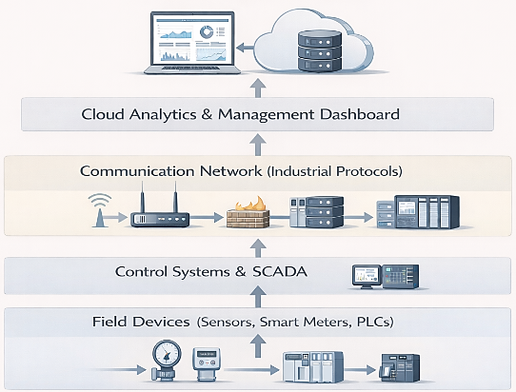

Figure 8. Layered architecture of an energy management system. Field devices, control systems, networks, and cloud analytics interact to support monitoring and operational management (source: Author)

This diagram above illustrates the hierarchical architecture of an Energy Management System (EMS), detailing the data flow from physical hardware to cloud analytics. The Hierarchical Layers. Field Devices: Sensors, smart meters, and PLCs collect raw data on utility usage and local machine operations. Control Systems (SCADA): The "local brain" that monitors data in real-time and provides a human-machine interface for on-site equipment control. Communication Network: Bridges hardware to the internet using industrial protocols (Modbus/BACnet) and secure routing. Cloud & Dashboard: Processes data for long-term storage and advanced analytics, visualizing performance through reports and alerts.

The network types of an EMS are several, as shown in the picture below
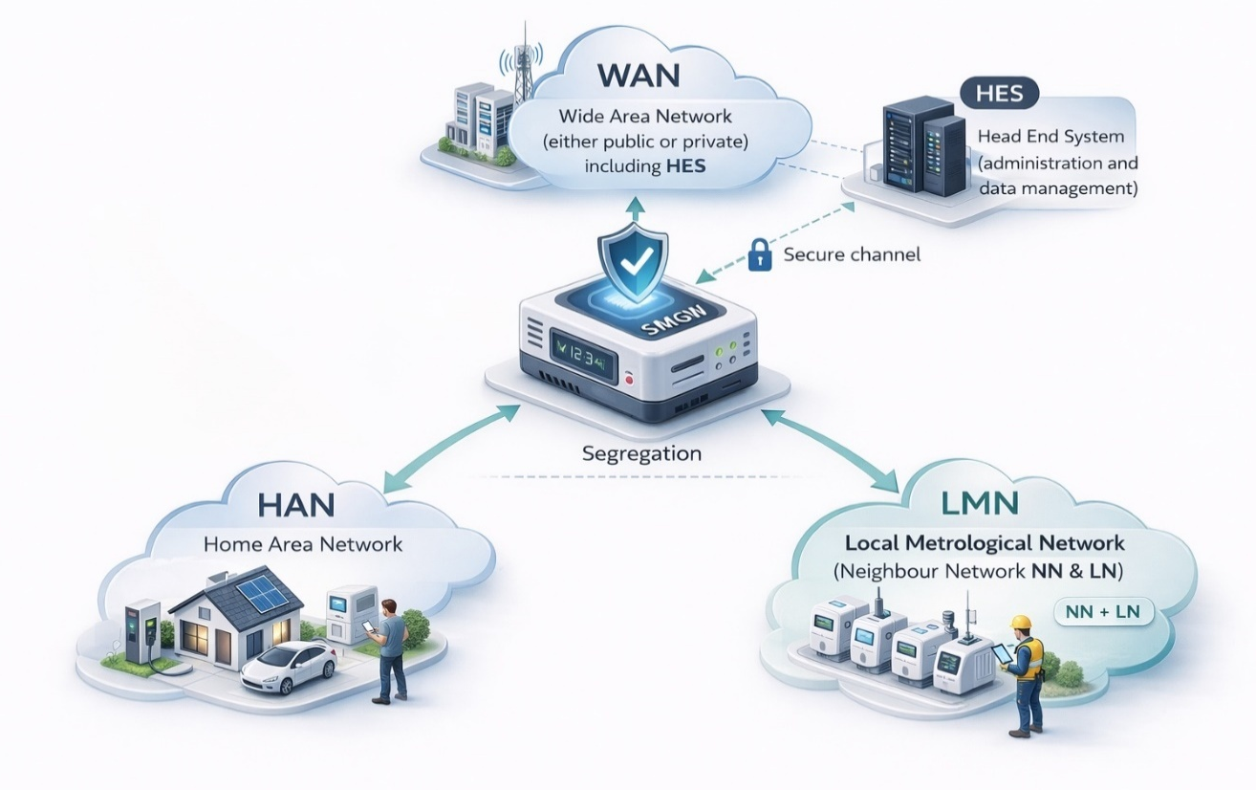
Figure 9. Smart metering network architecture connecting HAN, LMN, and WAN through a secure smart meter gateway for data exchange and management (source: Author)

- WAN: Wide Area Network (either public or private), including HES
- LMN: Local Metrological Network (Neighbour Network NN & Local Network LN)
- HAN: Home Area Network
- HES: Head End System (administration and data management)
The diagram outlines the communication stack of a smart metering infrastructure, moving from wide-area connectivity down to devices within a home. At the top sits the WAN, which can operate over public or private networks and links distributed field components with the Head End System, the platform that handles device administration and centralised data management.
Between the WAN and the smart metering gateway, data flows through a secure channel designed to preserve confidentiality and integrity, ensuring that what travels upstream and downstream remains protected in transit. The gateway then marks a clear boundary inside the local environment. It separates the Home Area Network, where residential loads and energy assets communicate within the customer premises, from the Local Metrological Network, which includes the Neighbour Network and the Local Network that interconnects the metering devices.
This layered segmentation defines how information can move. It limits lateral exposure, supports incremental scaling as more devices come online, and enables controlled data exchange across the broader smart energy ecosystem.

- Primary Threat Actors Targeting EMS
Energy infrastructures represent attractive targets for:
- State-sponsored actors, seeking geopolitical leverage.
- Cybercriminal groups, pursuing ransomware or extortion.
- Hacktivists, driven by political or environmental motives.
- Insider threats, including negligent or malicious employees.
ENISA identifies critical infrastructure as a high-priority target due to its systemic importance. In a similar way, the Cybersecurity and Infrastructure Security Agency recognise energy systems as part of national critical infrastructure sectors.
These actors may exploit vulnerabilities for disruption, espionage, or financial gain.

- Common Attack Vectors and Techniques
EMS are exposed to several recurring attack vectors:
- Remote Access Exploitation: Unsecured remote maintenance interfaces or VPN gateways can provide attackers with a path for initial access.
- Phishing and Credential Compromise: Administrative personnel responsible for monitoring dashboards may be targeted through spear-phishing campaigns.
- Malware and Ransomware Deployment: Ransomware aimed at control systems can interrupt operations and demand payment.
- Supply Chain Compromise: Compromised firmware updates or third-party components can introduce malicious code into the environment.
- Exploitation of Legacy Protocols: Industrial protocols that lack encryption or authentication may allow command injection or traffic interception.
The MITRE Corporation ATT&CK for ICS (Industrial Control Systems) matrix offers a structured way to map these techniques to attacker tactics specific to industrial environments.

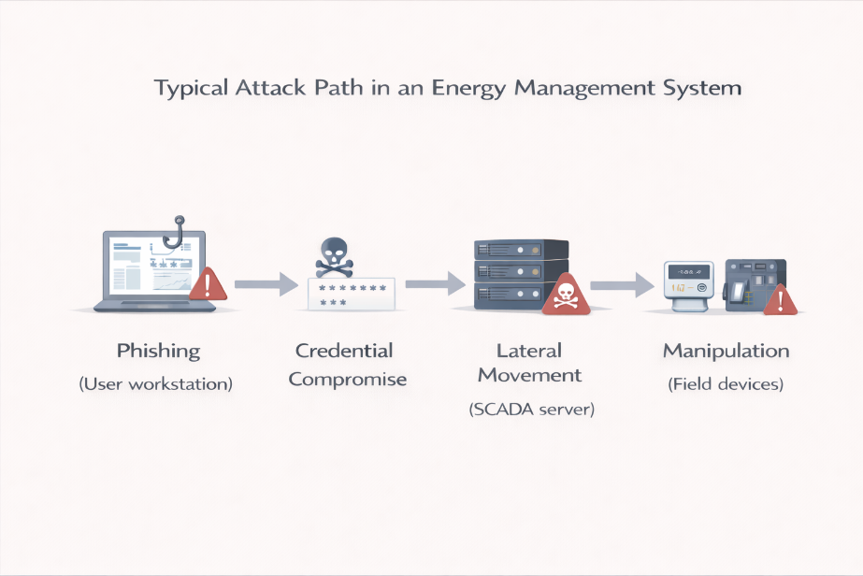
Figure 10. Typical attack path in an Energy Management System (source: Author).

The diagram above illustrates a typical four-stage attack path targeting an Energy Management System (EMS). It shows how a breach often begins with a single user and scales into physical infrastructure disruption. Stages of the Attack: Phishing (User Workstation); Credential Compromise; Lateral Movement (SCADA Server); Manipulation (Field Devices).

A useful analytical lens for understanding these threats is the MITRE ATT&CK framework, and specifically ATT&CK for ICS, which maps adversarial tactics and techniques targeting industrial control systems. Unlike enterprise IT attacks focused primarily on data exfiltration, ICS-oriented attacks may aim to manipulate physical processes, disrupt energy distribution, or degrade system integrity.

MITRE ATT&CK for ICS structures adversarial behaviour across tactics such as:
- Initial Access
- Execution
- Persistence
- Privilege Escalation
- Lateral Movement
- Command and Control
- Inhibit Response Function
- Impair Process Control
In the context of EMS, examples include:
- Exploiting remote access services used for maintenance.
- Compromising engineering workstations to inject malicious logic into PLCs.
- Manipulating setpoints to alter energy production or consumption patterns.
- Disabling safety alarms to conceal malicious activity.

These techniques are particularly relevant for renewable energy installations and smart grids, where distributed architectures and IoT-connected components increase exposure.
Recent attack patterns affecting energy systems include ransomware targeting control environments, supply-chain compromises of industrial software, and credential abuse through poorly segmented IT/OT networks. In sustainable infrastructures, the impact extends beyond operational disruption: it can affect ESG reporting accuracy, carbon accounting data integrity, and regulatory compliance.

Table 4. Various cybersecurity threats within Operational Technology (OT) environments and their cascading effects on business operations and ESG (Environmental, Social, and Governance) goals (source: Author)
Threat Type | Example | Operational Impact | ESG/Data Impact
Ransomware | Encrypted HMI systems | Monitoring disruption | Delayed sustainability reporting
PLC Manipulation | Altered setpoints | Process instability | Inaccurate consumption data
Credential Abuse | Compromised admin account | Lateral movement in OT | Data integrity loss

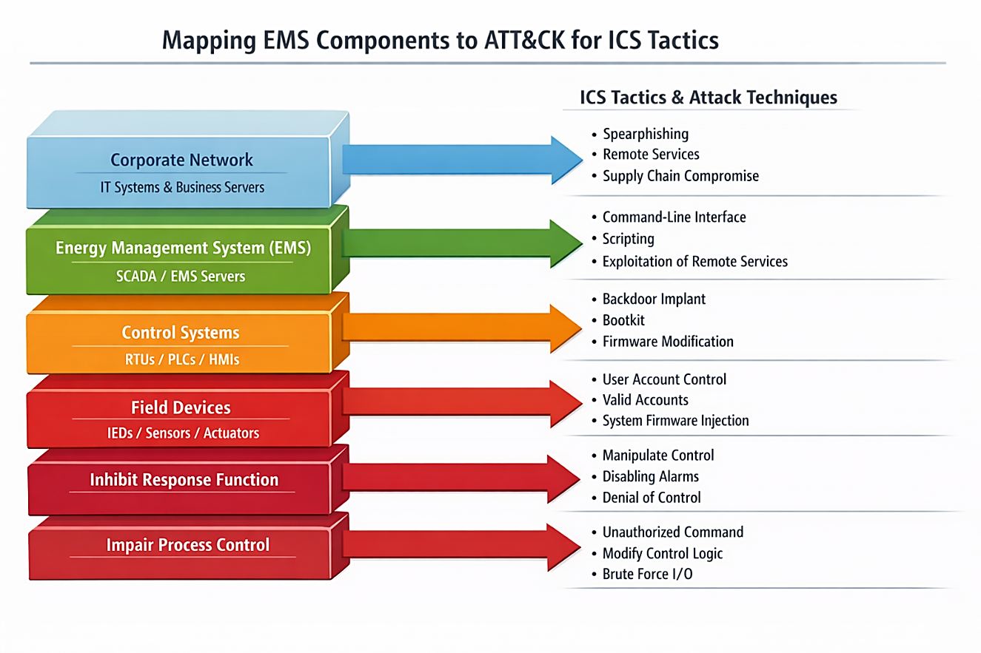
Figure 11. Mapping EMS components to ATT&CK for ICS tactics (source: Author)

The infographic above illustrates the mapping of different layers within an Energy Management System (EMS) to corresponding adversarial tactics and techniques defined in the MITRE ATT&CK for Industrial Control Systems (ICS) framework.
- Corporate Network: Vulnerable to initial access methods like phishing and supply chain compromises.
- Control Systems (SCADA/PLCs): Targets for technical actions such as firmware modifications and backdoor implants.
- Field Devices & Process Control: Susceptible to direct manipulation, including unauthorized commands and brute forcing I/O to inhibit responses.
- Impact Dimensions in EMS Environments
Cyber incidents affecting EMS can result in:
- Operational disruption or grid instability.
- Financial losses linked to downtime.
- Environmental impact, such as the mismanagement of renewable resources.
- Regulatory penalties.
- Public safety risks.
Since energy systems support economic and societal stability, risk evaluation needs to account for cascading effects that extend beyond immediate technical damage.
The risk profile of EMS environments is therefore defined by potentially systemic, high-impact consequences, even when the likelihood of exploitation is only moderate.

Micro-activity:
Consider using renewable energy operators:
- Remote SCADA monitoring
- Smart meters connected via industrial protocols
- Cloud-based performance analytics.

Learner task:
- Identify one likely attack vector.
- Identify the corresponding attacker tactic (e.g., initial access, lateral movement).
- Identify one possible ATT&CK for ICS tactic that could apply.
- Describe one potential operational consequence.
- Suggest one basic mitigation measure (e.g., network segmentation, MFA, monitoring).
- Describe one potential operational impact.
- Propose one mitigation measure appropriate for EMS environments.
Provide your response in 8–10 structured sentences.
Additional reading:
- Critical infrastructure and cybersecurity
- CEN/CLC/ETSI/TR 50572 «Functional reference architecture for communications in smart metering systems»
- MITRE ATT&CK for ICS Matrix (official site)
- CISA: Recommended Practices for Industrial Control Systems Security (official guidance).

Key Takeaways:
- Energy Management Systems integrate IT and OT components, increasing system complexity.
- Critical infrastructure status makes EMS high-value targets.
- Common attack vectors include remote access exploitation, phishing, ransomware, and legacy protocol weaknesses.
- ATT&CK for ICS provides a structured framework to analyse adversarial techniques targeting control environments.
- EMS cyber incidents can generate operational, environmental, financial, and societal consequences.
Quick Check:
- True or False: Even if legacy industrial protocols were originally designed for isolated environments, their deployment within modern IP-connected Energy Management Systems can significantly increase cyber risk due to the absence of native security controls.

- A coordinated cyber campaign targets a national energy grid during a period of geopolitical tension. The objective appears to be destabilisation rather than financial gain. Which actor profile is most consistent with this motivation?
- Independent hobbyists seeking technical recognition
- State-sponsored actors pursuing strategic influence
- Local commercial competitors
- Internal IT support teams.

- An Energy Management System receives a routine firmware update from a trusted hardware vendor. The update contains hidden malicious code that later enables remote command execution on field devices. Which classification best describes this incident?
- A social engineering attack targeting management staff
- A distributed denial-of-service attack
- A supply chain compromise affecting trusted components
- An insider threat originating from operations personnel.

- An organisation operating a renewable energy plant integrates its EMS with a cloud-based ESG reporting platform. Remote engineers access PLCs through a VPN concentrator connected to the corporate IT network. Which of the following scenarios represents the most critical systemic risk from an ATT&CK for an ICS perspective?
- An attacker performs phishing against ESG analysts and steals sustainability report drafts.
- An attacker gains access to the IT network, pivots laterally into the OT segment due to insufficient network segmentation, deploys malicious logic to PLCs, and inhibits alarm responses to conceal manipulation of energy output data.
- A Distributed Denial-of-Service (DDoS) attack temporarily slows down the public sustainability dashboard website.
- An attacker brute-forces a cloud account password but does not gain access to operational systems.

Answer key: 1. true; 2. b); 3. c); 4. b).

Topic 2.2: Threat Landscape of IoT sensors
Short introduction:
IoT sensors are key components of sustainable digital infrastructures. They gather environmental, operational, and performance data that supports energy optimisation, ESG reporting, and smart infrastructure management. However, their distributed deployment, limited computing resources, and frequent connections to public or semi-public networks make them particularly vulnerable to cyber threats. Understanding the threat landscape surrounding IoT sensors is therefore crucial to preserving data integrity, maintaining operational continuity, and meeting sustainability compliance requirements.
Theory & Knowledge:
IoT sensors differ from traditional IT systems in several important respects. They are typically deployed in large volumes, operate with limited computational resources, and often rely on lightweight communication protocols. In sustainable systems, such as smart buildings, renewable energy plants, and environmental monitoring platforms, these devices generate real-time data that directly informs operational and regulatory decisions.
Although IoT deployments improve efficiency and transparency, they also significantly expand the attack surface. Each individual sensor can serve as a potential entry point into wider networks.

- Structural Characteristics of IoT Sensor Environments
IoT sensor ecosystems generally include:
- Physical sensors and embedded devices.
- Local gateways or edge computing nodes.
- Wireless communication protocols, such as MQTT, Zigbee, or LoRaWAN.
- Cloud-based data aggregation platforms.
- Analytics and ESG reporting interfaces.
Many IoT devices are built with a primary focus on functionality and cost efficiency rather than strong security controls. Limitations in processing power and memory can restrict encryption capabilities or the ability to implement reliable update mechanisms.
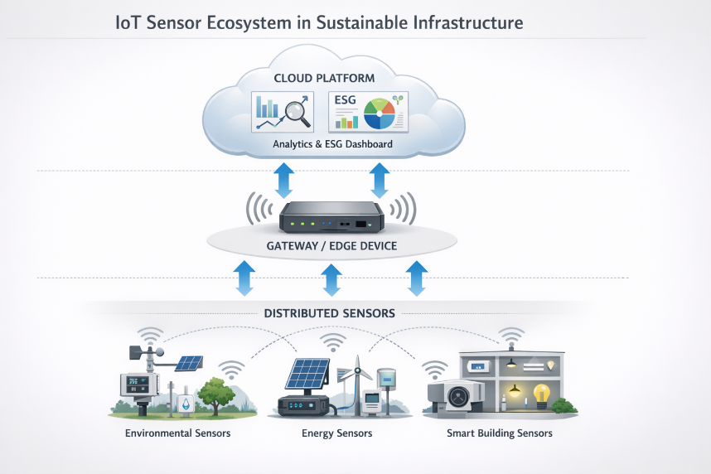
Figure 12. IoT sensor ecosystem in sustainable infrastructure (source: Author)

The diagram above illustrates a three-layered IoT sensor ecosystem designed for sustainable infrastructure.
- Distributed Sensors: The foundation includes environmental sensors (air quality, weather), energy sensors (solar, wind), and smart building sensors (security, lighting) that gather real-time data.
- Gateway / Edge Device: A central hub collects this data, providing local processing and filtering before securely transmitting it to the cloud.
- Cloud Platform: Data is analysed to generate insights and ESG (Environmental, Social, and Governance) reports for informed decision-making.

- Common Vulnerabilities in IoT Sensors
IoT sensors often present:
- Weak or default credentials.
- Insecure firmware update mechanisms.
- Unencrypted communication channels.
- Limited logging and monitoring capabilities.
- Physical exposure to tampering.
The OWASP Foundation IoT Top 10 highlights insecure network services, weak authentication, and unsafe update mechanisms as recurring risk areas.
These weaknesses frequently arise from design trade-offs that prioritise performance, cost, and energy efficiency over robust security controls.

- Primary Threat Actors and Motivations
IoT sensors within sustainable environments may attract:
- Cybercriminal groups are looking for entry points into larger corporate networks.
- State-sponsored actors targeting energy or environmental infrastructure.
- Hacktivists seeking to disrupt sustainability narratives.
- Insiders exploiting poorly monitored edge devices.
Because sensors are often connected to cloud platforms and operational systems, attackers can use them as pivot points to move laterally across the network.

- Typical Attack Scenarios
- Botnet Recruitment: Compromised IoT sensors can be absorbed into botnets and used to launch distributed denial-of-service (DDoS) attacks.
- Data Manipulation: Attackers may alter sensor readings, such as energy production metrics, leading to inaccurate ESG reporting or flawed operational decisions.
- Gateway Compromise: A vulnerable gateway can allow attackers to escalate privileges and gain access to internal systems.
- Physical Tampering: Direct interference with exposed devices may result in the installation of malicious firmware.

The MITRE Corporation ATT&CK framework, particularly ATT&CK for ICS, provides a structured mapping of relevant tactics, such as initial access, persistence, and impact, within embedded and industrial environments.
In IoT-enabled energy environments (smart meters, sensors, edge gateways), MITRE ATT&CK for ICS helps analyse threats as adversary behaviours rather than isolated device vulnerabilities. It is especially useful to model how an attacker could compromise an IoT gateway (Initial Access), alter firmware/configuration (Execution/Persistence), and tamper with telemetry feeding the EMS or optimisation logic (Impair Process Control / Modify Control Logic), leading to wrong control decisions and unreliable sustainability metrics. This mapping supports clearer prioritisation of monitoring and mitigation for the IoT-to-OT “bridge,” where segmentation and remote management are common weaknesses.

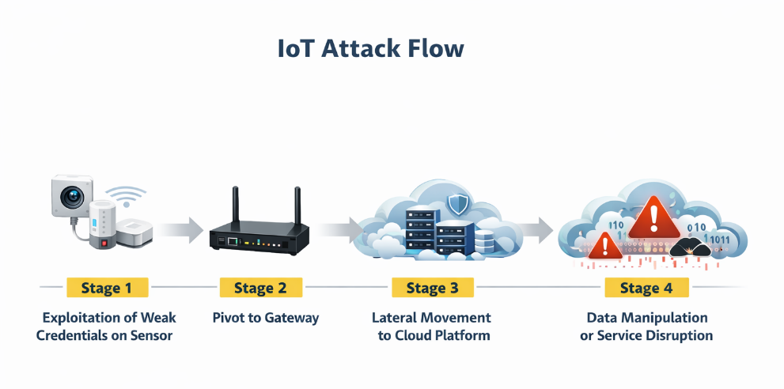
Figure 13. Typical IoT attack chain. Compromise of a sensor can allow pivoting to the gateway, lateral movement to cloud services, and manipulation of data or service disruption (source: Author)

The diagram above illustrates a four-stage IoT attack flow, showing how vulnerabilities in connected devices can lead to widespread system disruption.
Stage 1 - Sensor Compromise: Attackers exploit weak credentials on IoT sensors or cameras to gain initial access.
Stage 2 - Pivot to Gateway: The attacker moves from the compromised device to the network gateway, taking control of local communications.
Stage 3 - Cloud Lateral Movement: The attacker moves laterally into the associated cloud platform, compromising the server infrastructure.
Stage 4 - Impact: The final stage involves manipulating data or disrupting services, potentially leading to botnets or ransomware

- Impact in Sustainable Contexts
The consequences of an IoT sensor compromise can include:
- Inaccurate sustainability metrics.
- Disruption of energy optimisation algorithms.
- Higher operational costs.
- Regulatory non-compliance.
- Loss of stakeholder trust.
Because ESG reporting and energy management rely heavily on accurate data, breaches of integrity can carry strategic consequences that extend beyond purely technical disruption.

As an additional example, consider this scenario. An attacker compromises an IoT edge gateway connected to smart meters within a renewable energy installation. Through this foothold, the adversary gains access to the PLC's programming interface and alters the control logic governing load-balancing thresholds. As a result, energy output is artificially constrained during peak demand periods, leading to operational instability and inaccurate consumption data that feed ESG reporting systems.

Micro-Activity:
Consider a smart building equipped with:
- Temperature and energy usage sensors
- A central IoT gateway
- Cloud-based ESG analytics
Learner task:
- Identify one likely vulnerability in the sensor layer.
- Identify one attacker tactic that could exploit it.
- Describe the possible business or sustainability impact.
- Suggest one mitigation strategy (technical or organisational).
- Identify which TTPs from the ATT&CK for ICS framework apply
Respond in 8–10 structured sentences.

Additional Reading:
- ENISA (2020). Guidelines for Securing the Internet of Things
Provides structured recommendations for IoT device lifecycle security, risk assessment, authentication, update mechanisms, and secure-by-design principles. Particularly relevant for analysing IoT sensor exposure in energy and smart grid environments,
- ENISA (Latest Edition). ENISA Threat Landscape
Includes updated threat actor profiles and attack patterns affecting IoT and critical infrastructure sectors, useful for contextualising sector-specific risk in sustainable systems
- MITRE ATT&CK for ICS
Techniques Relevant to Field Devices. Focus on techniques such as:
  - T0859 – Valid Accounts
  - T0865 – Spearphishing Attachment
  - T0842 – Modify Parameter
  - T0855 – Modify Control Logic
These are applicable when IoT devices bridge IT and OT environments,
- CISA (2022). Securing Industrial Control Systems: Recommended Practices
Offers practical defensive measures for segmentation, monitoring, remote access control, and firmware integrity—highly relevant for IoT-connected EMS components,
- OWASP (Latest Edition). OWASP IoT Top 10
Identifies common IoT vulnerabilities such as weak authentication, insecure network services, and a lack of secure update mechanisms, directly applicable to IoT sensor risk analysis in sustainable infrastructures.

Key Takeaways:
- IoT sensors significantly expand the attack surface of sustainable digital infrastructures.
- Resource constraints often limit built-in security mechanisms.
- Common vulnerabilities include weak authentication and insecure update processes.
- Compromised sensors can serve as pivot points into broader IT/OT environments.
- Integrity of IoT data is critical for ESG reporting and operational optimisation.

Quick check:
- True or False: An IoT sensor deployed in a smart building uses weak default credentials but is connected only to an internal gateway. Because it is not directly exposed to the internet, it does not significantly contribute to the organisation’s attack surface.

- A compromised IoT temperature sensor is used as a pivot point to access the gateway and then the cloud-based ESG dashboard. Which sequence best describes the attacker’s progression?
- Impact → Initial Access → Discovery
- Initial Access → Lateral Movement → Impact
- Persistence → Compliance breach → Encryption
- Risk acceptance → Exfiltration → Recovery
- An organisation prioritises patching its cloud dashboard but delays firmware updates for field IoT sensors due to operational inconvenience. From a risk perspective, what is the most accurate assessment?
- The decision is justified because cloud systems are always at risk higher than edge devices
- IoT firmware vulnerabilities may still represent a significant risk if they provide a pivot into critical systems
- Firmware updates are unnecessary if devices operate in isolated environments
- IoT devices cannot materially affect ESG reporting accuracy.
Answer key: 1. false; 2. b), 3. b).

Topic 2.3: Threat Landscape of Smart Grids
Short introduction:
Smart grids represent the transformation of traditional electricity networks into digitally connected, data-driven energy ecosystems. They combine advanced metering infrastructure, distributed renewable energy sources, automated control systems, and real-time communication technologies. While these capabilities enhance efficiency, resilience, and sustainability, they also create complex cybersecurity risks. Understanding the threat landscape surrounding smart grids is therefore critical to maintaining energy stability, regulatory compliance, and public safety.
Theory & Knowledge:
Smart grids differ fundamentally from conventional power grids because they depend on bidirectional communication, decentralised generation, and continuous real-time data exchange. This digital shift enables predictive load balancing, renewable energy integration, and demand-response optimisation. At the same time, it broadens the attack surface across generation, transmission, distribution, and consumer-level endpoints.
A smart grid typically combines IT systems, such as cloud analytics and billing platforms, with OT systems, including SCADA systems, substations, and control devices, as well as IoT components such as smart meters and sensors. The close interconnection between these layers means that a cyber incident in one area can quickly spread across the wider infrastructure.

- Structural Complexity of Smart Grids
A smart grid environment generally includes:
- Generation systems, including renewable sources such as wind and solar farms.
- Transmission and distribution substations.
- Advanced Metering Infrastructure (AMI).
- Control centres and SCADA systems.
- Communication networks, often hybrid in nature, combining fibre, wireless, and industrial protocols.
- Consumer-side smart devices.
The integration of distributed energy resources increases decentralisation, but it also multiplies the number of potential entry points.
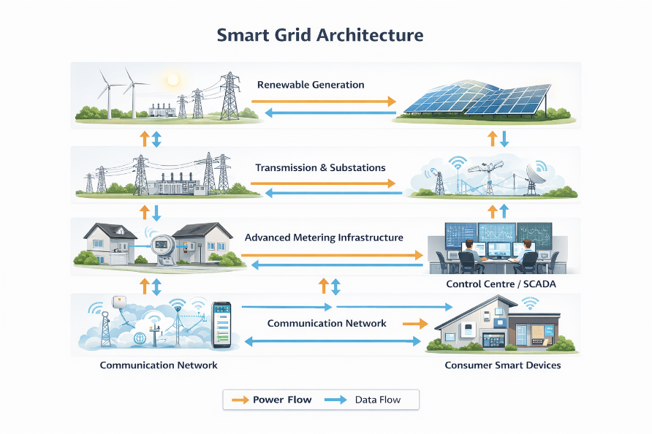
Figure 14. Smart grid architecture showing interactions between renewable generation, transmission systems, metering infrastructure, communication networks, and control centres (source: Author)

The image above illustrates the architecture of a smart grid, which is a modernized electrical grid that utilizes digital technology for two-way communication and control.
Components: The system integrates renewable energy sources (wind and solar), transmission substations, advanced metering infrastructure, control centres (SCADA), and consumer smart devices.
Flow Types: It features bidirectional flows, allowing for both the transmission of electricity (power flow) and the exchange of data (data flow) between producers and consumers.
Functionality: This infrastructure enables automated monitoring, efficient load balancing, and the integration of distributed energy resources, improving grid reliability and efficiency.

- Primary Threat Actors
Smart grids are classified as critical national infrastructure and, as a result, attract a broad range of adversaries:
- State-sponsored actors pursuing geopolitical objectives.
- Cybercriminal groups deploying ransomware.
- Hacktivists targeting energy policy.
- Insider threats with privileged access.
ENISA recognises energy systems as high-priority targets due to their systemic importance. Similarly, the Cybersecurity and Infrastructure Security Agency identify the energy sector as a critical infrastructure domain that requires enhanced resilience.
State-sponsored campaigns may focus on grid destabilisation or espionage, while criminal actors are generally motivated by financial extortion.

- Common Attack Vectors in Smart Grids
Common attack vectors in Smart Grids are:
- Compromise of Advanced Metering Infrastructure (AMI): Large-scale manipulation of smart meters and smart meter gateways (SMGW) can disrupt billing accuracy or overload distribution systems.
- SCADA and Control System Exploitation: Unpatched vulnerabilities in control software may enable remote command execution.
- Ransomware Targeting Control Centres: Operational downtime can force organisations to suspend grid management functions.
- Supply Chain Compromise: Malicious components introduced during hardware manufacturing or firmware updates.
- Distributed Denial-of-Service (DDoS): Attacks against communication networks can interfere with real-time grid monitoring.

The MITRE Corporation ATT&CK for ICS framework offers structured mapping of tactics and techniques relevant to industrial control systems, including those used in smart grids.

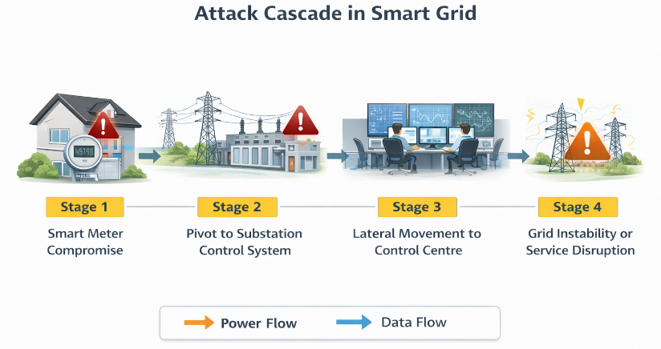
Figure 15. Example of a cascading cyber-attack in a smart grid. A compromised smart meter can enable lateral movement to control systems and lead to grid instability or service disruption (source: Author)

The image illustrates an Attack Cascade in Smart Grid, showing how a cyberattack can propagate from a single point to affect the entire infrastructure.
Stage 1: Smart Meter Compromise - The attack begins by breaching a residential smart meter.
Stage 2: Pivot to Substation Control System - The breach is used to gain access to a local substation's control system.
Stage 3: Lateral Movement to Control Centre - Attackers move laterally from the substation to the central control center.
Stage 4: Grid Instability or Service Disruption - The final stage results in a significant disruption or failure of the power grid.

- Focused Contribution: Security Implications of Smart Meter Gateways
Smart meter gateways represent a critical security component within smart grid architectures. As defined in the EU regulatory context, they are digital products that control communication between components in smart metering systems and authorised third parties, including utility providers. Functionally, they collect, process, and store meter data—including personal data—while supporting cryptographic operations, such as encryption and decryption, and firewalling capabilities, as well as remote control of connected devices.
From a cybersecurity perspective, smart meter gateways operate at a highly sensitive convergence point: they bridge household or industrial metering devices, grid operators, and external service providers. This makes them both data-aggregation nodes and communication-control hubs. Compromise of such a gateway may therefore impact:
- Data confidentiality, by exposing granular consumption patterns that reveal behavioural information.
- Data integrity, by altering measurement values used for billing or ESG reporting.
- System availability, by disrupting communication between smart meters and grid operators.
- Process reliability, where gateways enable remote control functions or demand-response mechanisms.

In smart grids, gateways are not limited to electricity systems but may also support gas or heat metering infrastructures. This multi-utility integration increases systemic risk, as a single gateway vulnerability could propagate across multiple energy domains.

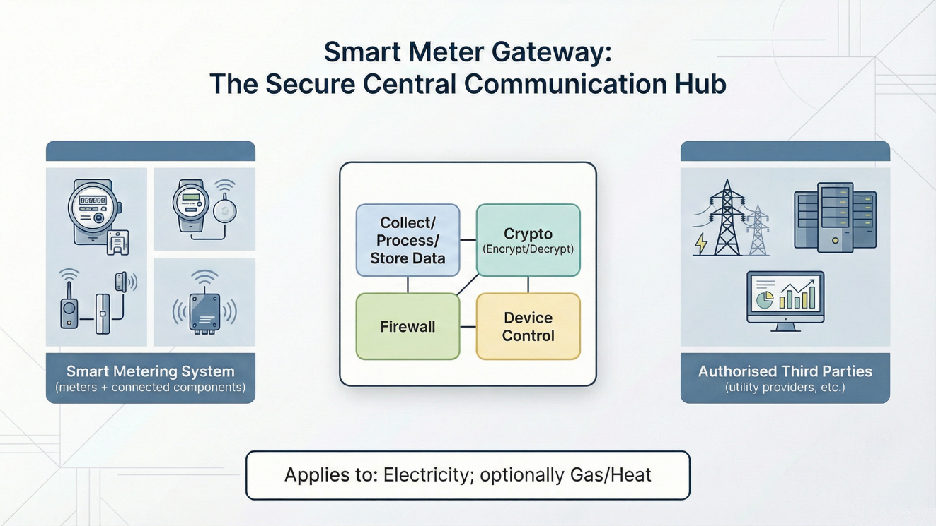
Figure 16. Smart meter gateway acting as a secure communication hub between smart metering devices and authorized external systems (source: Author)

The diagram above illustrates the function of a Smart Meter Gateway, which acts as a secure communication hub between utility meters and authorized third parties.
Smart Metering System: Collects, processes, and stores data from various meters and connected components.
Gateway Hub: Features built-in security including a firewall, cryptographic functions for encryption/decryption, and device control.
Authorised Third Parties: Securely receives data to communicate with utility providers and other entities.
Applications: The system primarily applies to electricity metering, with optional support for gas and heat monitoring.

From an ATT&CK for ICS perspective, smart meter gateways may be targeted through techniques such as Valid Accounts (credential abuse), Exploitation of Remote Services, or Modify Parameter/Modify Control Logic if the gateway supports control functions. Given their cryptographic and firewalling roles, misconfiguration or weak key management may undermine the entire trust model of the metering ecosystem.
For sustainable systems, the risk extends beyond operational disruption. Manipulated smart meter data can distort energy optimisation models, carbon accounting processes, and regulatory compliance reporting. Consequently, smart meter gateways must be analysed not only as communication devices but as security-critical control points within modern smart grids.

- Risk Dimensions in Smart Grids
Cyber incidents affecting smart grids can lead to:
- Power outages that disrupt critical services.
- Economic losses at a regional or national level.
- Environmental disruption, such as the mismanagement of renewable energy integration.
- Regulatory penalties.
- Public safety risks.
Because smart grids form the backbone of modern economies, cyber risk assessment must consider cascading and systemic effects, not just isolated technical damage.
The convergence of IT, OT, and IoT layers, therefore, demands coordinated governance, continuous monitoring, and well-integrated incident response capabilities.

Micro-Activity:
Consider a national smart grid integrating renewable generation, AMI, and centralised SCADA control.
Learner task:
- Identify one high-value asset within this ecosystem.
- Identify one realistic attack vector targeting that asset.
- Describe a potential cascading impact across the grid.
- Propose one technical and one organisational mitigation strategy.
Respond in 8–10 structured sentences.

Additional Reading:
- CEN/CLC/ETSI/TR 50572 Functional reference architecture for communications in smart metering systems
- ENISA (Latest Edition). Cybersecurity in the Smart Grid – Good Practices
Offers structured guidance on risk assessment, secure communication architectures, and protection of smart metering infrastructures within European smart grids,
- CISA. Recommended Practice: Improving Industrial Control Systems Cybersecurity with Defense-in-Depth Strategies
Relevant for understanding segmentation, remote access protection, and layered security controls applicable to smart meter gateways as boundary devices between IT and OT
- MITRE ATT&CK for ICS – ICS Matrix (Field Device & Gateway Techniques)
Useful for mapping techniques such as:
  - Valid Accounts (T0859)
  - Exploitation of Remote Services (T0866)
  - Modify Parameter (T0842)
  - Modify Control Logic (T0855)
These techniques are particularly relevant where gateways support remote control or configuration updates.
- IEC 62443 Series – Security for Industrial Automation and Control Systems
Provides internationally recognised requirements for secure development, deployment, and lifecycle management of control components, including communication gateways within smart grids
- NISTIR 7628 – Guidelines for Smart Grid Cybersecurity
A comprehensive reference on smart grid architecture, privacy considerations, cryptographic protection, and secure interoperability across metering infrastructures,
Key Takeaways:
- Smart grids integrate IT, OT, and IoT components, increasing complexity and exposure.
- Critical infrastructure status makes smart grids high-value targets.
- Common attack vectors include AMI compromise, SCADA exploitation, ransomware, and supply chain attacks.
- Cyber incidents may generate cascading operational and societal impacts.
- Risk assessment must consider systemic and national-level consequences.
- Critical components such as SM and SMGWs

Quick check:
- True or False: Because smart grids distribute energy generation across multiple renewable sources, cyber-attacks on individual components cannot significantly affect overall grid stability.

- An attacker compromises thousands of smart meters and manipulates demand data to create artificial load imbalances. Which impact dimension is most directly affected?
  - Only confidentiality of billing data
  - Operational stability and load balancing
  - Employee productivity
  - Physical isolation of substations.

Which control strategy most effectively reduces cascading risk within a smart grid architecture?
  - Relying solely on perimeter firewalls
  - Implementing network segmentation between AMI, substations, and control centres
  - Increasing the number of connected smart devices
  - Removing renewable energy integration.

An attacker compromises a third-party maintenance account with valid credentials and pushes a malicious firmware update that subtly alters consumption values while preserving normal communication behaviour. Which of the following best characterises the primary systemic risk in this scenario?
  - A confidentiality breach limited to personal data exposure under GDPR.
  - A denial-of-service attack affecting the availability of metering services only.
  - A combined integrity and process-control compromise that may distort billing, energy balancing, and ESG reporting while remaining operationally stealthy.
  - A local device malfunction with no broader grid-level implications.

Answer key: 1. false; 2. b), 3. b), 4. c).

Topic 2.4: Introduction to ESG platforms
Short introduction:
ESG platforms are digital systems built to collect, process, analyse, and report sustainability-related data. They play a central role in supporting regulatory compliance, investor transparency, and informed sustainability decision-making. As ESG reporting becomes more mandatory and increasingly data-driven, these platforms have become critical digital assets that require strong protection against cyber threats. Understanding their architecture and associated threat landscape is therefore essential to securing sustainable digital systems.
Theory & Knowledge:
ESG platforms operate as integrated digital ecosystems that bring together data from multiple sources, including IoT sensors, Enterprise Resource Planning (ERP) systems, energy management systems, supply chain databases, and external reporting frameworks. They convert raw operational data into structured sustainability indicators, often aligned with regulatory obligations and international reporting standards.
As ESG disclosures play an increasing role in shaping investor confidence, regulatory positioning, and corporate reputation, the integrity and availability of ESG platforms carry clear strategic importance.

Core Functional Components of ESG Platforms
An ESG platform generally includes:
- A data ingestion layer, incorporating APIs, IoT integration, and manual uploads.
- Data storage systems, typically cloud-based databases or hybrid environments.
- Analytics and calculation engines.
- Reporting dashboards and visualisation tools.
- Access control and identity management systems.
These components frequently run in cloud-native environments and depend on third-party integrations. While APIs and distributed data sources improve flexibility, they also widen the attack surface.
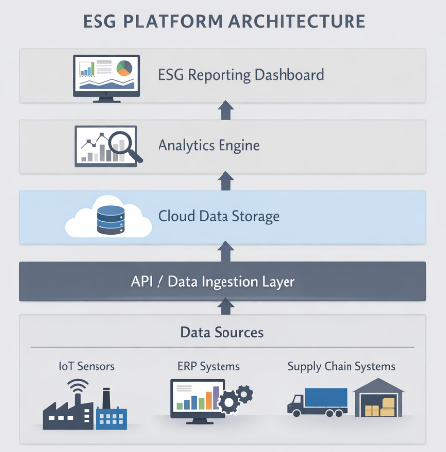
Figure 17. Typical ESG platform architecture integrating IoT sensors, enterprise systems, and supply chain data through APIs, cloud storage, analytics, and reporting dashboards (source: Author)

The diagram above illustrates the architecture of an Environmental, Social, and Governance (ESG) platform designed to consolidate data for sustainability reporting. It maps the flow of information from initial data sources up to a final reporting dashboard.
Data Ingestion: Information is gathered from diverse sources, including IoT sensors, ERP systems, and supply chain management tools.
Storage and Processing: Collected data is stored in the cloud and analysed using an analytics engine to identify patterns and metrics.
Reporting: The analysed data is visualized on an ESG Reporting Dashboard, providing insights for stakeholders and ensuring compliance.

- Why ESG Platforms Are High-Value Targets
ESG platforms can attract attackers because they store:
- Sensitive operational data.
- Sustainability metrics that influence public disclosures.
- Regulatory compliance documentation.
- Strategic corporate performance indicators.
Manipulating ESG data could result in:
- Misleading sustainability reporting.
- Regulatory penalties.
- Reputational damage.
- Loss of investor confidence.
- Legal liabilities.
The European Union Agency for Cybersecurity identifies data integrity and compliance systems as high-impact targets within digital transformation environments.

- Common Threat Vectors Affecting ESG Platforms
The common threat vectors affecting ESG platforms are:
- API Exploitation: Weakly secured APIs connecting IoT or ERP systems can enable unauthorised access to data.
- Credential-Based Attacks: Phishing campaigns targeting ESG analysts or compliance officers may lead to dashboard compromise.
- Data Manipulation and Integrity Attacks: Altering stored sustainability metrics can directly affect official disclosures.
- Cloud Misconfiguration: Incorrect access control settings may expose databases to public access.
- Insider Threats: Privileged users may deliberately or inadvertently modify ESG data.
The OWASP Foundation Top 10 offers guidance on web application vulnerabilities that are particularly relevant to ESG dashboards and reporting portals.

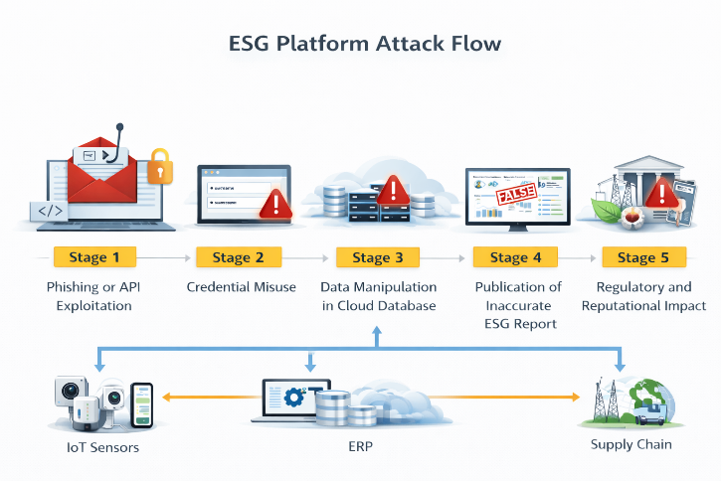
Figure 18. Example attack chain targeting an ESG platform. Initial access through phishing or APIs can lead to data manipulation and inaccurate ESG reporting with regulatory consequences (source: Author)

The diagram above illustrates a five-stage cyberattack flow targeting an organization's Environmental, Social, and Governance (ESG) platform, highlighting how malicious actions can manipulate data and cause significant business impact.
Initial Compromise: The attack begins with phishing or API exploitation to gain unauthorized access.
Data Manipulation: Attackers misuse credentials to alter data within cloud databases and integrated systems like ERP and IoT sensors.
Consequence: This results in the publication of inaccurate ESG reports, leading to regulatory penalties and severe reputational damage.

- Risk Considerations for ESG Systems
Risk assessment for ESG platforms needs to reflect how these systems are used: they consolidate sustainability metrics, supporting evidence, approvals, and publication workflows that may be examined by auditors, regulators, investors, and customers. The security objective is therefore broader than service continuity. It includes protecting the reliability of reported figures and the organisation’s ability to demonstrate how those figures were produced.
A practical assessment starts from the ESG data lifecycle. Many ESG values are derived from multiple sources, including IoT telemetry, energy management tools, ERP data, supplier declarations, and manual inputs. Each interface introduces opportunities for data alteration, loss, or misattribution. For this reason, integrity controls are often as important as confidentiality controls. Examples include controlled data ingestion, validation checks, segregation of duties for changes, and preservation of evidence for calculations and adjustments.
ESG platforms also carry governance and compliance risk. Where ESG reporting obligations apply, a cyber incident can affect deadlines, completeness of disclosures, and the availability of supporting records. This is relevant even when there is no obvious data leak. Security governance should therefore align with reporting cycles and approval processes, ensuring appropriate access control for contributors and approvers, clear accountability for changes, and audit-ready logging.
Finally, stakeholder trust is a direct risk factor. If reported sustainability information is later found to be inaccurate or unsubstantiated, the impact can include reputational damage, contractual disputes, and increased regulatory scrutiny. For this reason, ESG security planning should explicitly consider the quality and traceability of data alongside traditional technical risk metrics.

Micro-Activity
Consider an organisation using a cloud-based ESG platform that aggregates:
- IoT energy consumption data
- Supply chain carbon metrics
- Manual sustainability disclosures
Learner task:
- Identify one critical asset within the ESG system.
- Identify one realistic threat vector.
- Describe the potential regulatory or reputational consequences.
- Suggest one preventive control and one detective control.
Respond in 8–10 structured sentences.

Additional Reading:
- European Commission – Corporate Sustainability Reporting Directive (CSRD)
Provides the regulatory framework governing sustainability reporting obligations in the EU, including requirements for reliability, traceability, and auditability of ESG data,
- EFRAG – European Sustainability Reporting Standards (ESRS)
Defines structured disclosure requirements and data points that organisations must report under CSRD. Particularly relevant for understanding data governance and internal control implications,
- ENISA – Threat Landscape for the Finance and Investment Sector (latest edition)
Useful for understanding risks related to financial and non-financial reporting systems, including data manipulation and supply chain exposure,
- CISA – Secure by Design Principles
Offers guidance on embedding security controls in digital systems from the outset, applicable to ESG platform architecture and lifecycle management,

Key Takeaways:
- ESG platforms are strategic digital assets central to sustainability reporting.
- They integrate multiple data sources, increasing architectural complexity and attack surface.
- Data integrity and regulatory compliance are primary risk dimensions.
- Common threats include API exploitation, phishing, cloud misconfiguration, and insider abuse.
- Cybersecurity governance must align with sustainability and compliance objectives.

Quick check:
      - True or False:: If an ESG platform maintains full system availability but sustainability metrics are subtly altered before publication, the organisation may still face significant regulatory and reputational risk.

      - An attacker gains access to an ESG dashboard using stolen analyst credentials and modifies carbon emission data to artificially improve sustainability performance before an investor report is released. Which combination best describes the primary security and governance implications?
- Availability breach with no compliance impact
- Integrity violation with potential regulatory and reputational consequences
- Confidentiality breach affecting only internal IT teams
- Network performance issue without strategic relevance.

      - An ESG platform integrates multiple third-party APIs to collect supply chain emissions data. One API has weak authentication and allows unauthorised data injection. From a risk perspective, what is the most critical concern?
- Reduced system speed due to API calls
- Increased electricity consumption in the cloud
- Manipulation of externally sourced sustainability metrics affecting official disclosures
- Temporary inconvenience for developers.

Answer key: 1, True; 2. b), 3. c)

Topic 2.5: Security framework
Short Introduction:
Sustainable digital infrastructures, such as energy management systems, IoT ecosystems, smart grids, and ESG platforms, require structured, systematic cybersecurity approaches. A security framework provides a structured approach for identifying risks, selecting appropriate controls, implementing safeguards, and continuously strengthening resilience. This topic introduces the role of recognised cybersecurity frameworks and explains how they support structured risk management within sustainable systems.
Theory & Knowledge:
As sustainable infrastructures become more complex and subject to greater regulatory scrutiny, ad hoc security measures are no longer adequate. Organisations need consistent governance models to ensure that cybersecurity controls remain aligned with operational priorities, compliance obligations, and sustainability goals. Security frameworks provide this necessary structure.
A cybersecurity framework generally defines:
- Core security functions or domains.
- Control categories.
- Risk management processes.
- Mechanisms for continuous improvement.
Rather than prescribing particular technologies, frameworks deliver structured guidance that supports risk-based decision-making.

- Core Functions of a Security Framework
Many recognised frameworks organise cybersecurity activities around high-level functions. For instance, the National Institute of Standards and Technology Cybersecurity Framework (NIST CSF) is built around five core functions:
- Identify – Understand assets, risks, and organisational context.
- Protect – Implement safeguards to reduce or contain impact.
- Detect – Develop capabilities to identify cyber events.
- Respond – Take action in response to detected incidents.
- Recover – Restore capabilities and services following disruption.
This lifecycle-oriented approach is especially relevant for sustainable infrastructures, where maintaining service continuity is essential.
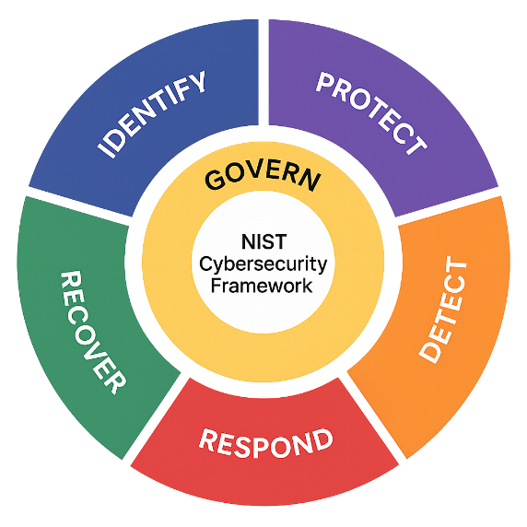
Figure 19. NIST Cybersecurity Framework (source: Cyber Second Line Of Defence)
The image above illustrates the NIST Cybersecurity Framework (CSF) 2.0, which is a widely recognized set of guidelines for managing and reducing cybersecurity risk. This updated version (2.0) centres around six core functions:
- GOVERN (Yellow): The core function that informs how an organization makes decisions to support its cybersecurity strategy. It covers organizational context, risk management strategy, and oversight.
- IDENTIFY (Blue): Focuses on understanding the organizational environment to manage cybersecurity risks to systems, people, assets, data, and capabilities.
- PROTECT (Purple): Outlines safeguards to ensure the delivery of critical infrastructure services and limit the impact of a potential cybersecurity event.
- DETECT (Orange): Defines the appropriate activities to identify the occurrence of a cybersecurity event in a timely manner.
- RESPOND (Red): Includes the actions taken once a cybersecurity incident is detected to contain its impact.
- RECOVER (Green): Identifies activities to maintain plans for resilience and to restore any capabilities or services that were impaired due to a cybersecurity incident.

- Frameworks Relevant to Sustainable Systems
Several frameworks are especially relevant in sustainable environments:
- National Institute of Standards and Technology – NIST Cybersecurity Framework and Risk Management Framework.
- International Organization for Standardization – ISO/IEC 27001 Information Security Management Systems.
- European Union Agency for Cybersecurity – ENISA guidelines for critical infrastructure.
- MITRE Corporation – ATT&CK for ICS, focused on mapping attacker behaviour.

These frameworks serve complementary roles:
- NIST CSF provides a high-level governance structure.
- ISO/IEC 27001 supports the implementation of formal information security management systems.
- ENISA guidance addresses sector-specific risk considerations.
- ATT&CK strengthens threat modelling and defensive alignment.

- Applying Frameworks in Sustainable Infrastructure
When applied to energy systems, IoT networks, and ESG platforms, frameworks help organisations to:
- Catalogue critical assets, such as smart grid control centres.
- Prioritise risks according to impact and likelihood.
- Align technical controls with regulatory requirements.
- Structure incident response and recovery planning.
- Ensure traceability and auditability for compliance reporting.

For example, in a smart grid environment:
- The Identify function involves mapping substations and AMI components.
- The Protect function may include network segmentation and strong authentication.
- The Detect function requires monitoring aligned with ATT&CK techniques.
- The Respond function includes incident response playbooks for grid disruption.
- The Recover function focuses on restoring operational stability.
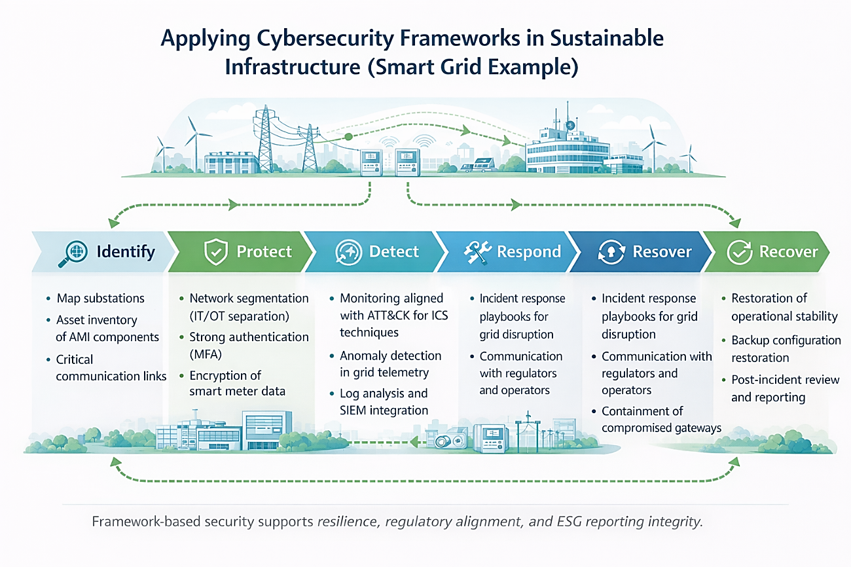
Figure 20. Application of cybersecurity frameworks to smart grid infrastructures, covering identification, protection, detection, response, and recovery processes (source: Author)

The diagram above illustrates the cybersecurity framework for sustainable infrastructure, specifically applied to a smart grid example.
Cybersecurity Phases: The framework outlines six continuous phases: Identify, Protect, Detect, Respond, and Recover. Key Actions: Key actions include asset inventory, network segmentation, anomaly detection, incident response playbooks, and containment of compromised gateways. Benefits: Implementing this framework supports infrastructure resilience, regulatory alignment, and ESG reporting integrity.
Grid Security: The smart grid's digital transition requires modern security to handle complex threats to power networks.

- Governance, Compliance, and Continuous Improvement
Security frameworks are not static checklists; they are designed to support ongoing assessment and improvement. In sustainable systems, this is particularly important because:
- Threat landscapes evolve quickly.
- Regulatory requirements for ESG reporting continue to expand.
- Technology integration increases overall system complexity.

Adopting a framework strengthens governance by:
- Clarifying roles and responsibilities.
- Making security maturity measurable.
- Supporting audit and certification processes.
- Aligning cybersecurity strategy with broader sustainability objectives.
A practical way to make governance and continuous improvement work in sustainable systems is to run the framework as a recurring management cycle aligned with the business's cadence and reporting obligations. That means scheduling periodic risk reviews whenever the operating context shifts, such as after a new IoT rollout, a grid integration, or the onboarding of a key supplier, and timing those reviews alongside ESG reporting checkpoints. The output of each review should feed a clearly defined improvement backlog, with named owners and realistic deadlines. Over time, this rhythm builds a defensible trail of evidence: controls are documented, yes, but they are also exercised, challenged, and adjusted as conditions change. The result is steady audit readiness and visible progress in system maturity, grounded in practice rather than policy alone.
Micro-Activity
Consider a regional energy provider operating:
- Smart grid infrastructure
- IoT-based monitoring systems
- A cloud ESG reporting platform.
Learner task:
- Choose one framework function (Identify, Protect, Detect, Respond, or Recover).
- Describe two concrete actions relevant to that function in this environment.
- Explain how these actions reduce cyber risk or improve resilience.
Respond in 8–10 structured sentences.

Additional Reading:
- European Commission – Corporate Sustainability Reporting Directive (CSRD)
Establishes mandatory sustainability reporting requirements in the EU, reinforcing the need for reliable, traceable, and auditable ESG data governance
- EFRAG – European Sustainability Reporting Standards (ESRS)
Defines detailed ESG disclosure requirements and structured data points under CSRD, relevant for internal control and cybersecurity alignment
- COSO – Internal Control over Sustainability Reporting (ICSR) Guidance
Provides a governance-oriented framework for designing and evaluating controls over sustainability reporting processes

Key Takeaways:
- Security frameworks provide structured governance for sustainable digital systems.
- Frameworks support risk-based prioritisation and regulatory alignment.
- NIST CSF, ISO/IEC 27001, ENISA guidance, and ATT&CK serve complementary roles.
- Framework mapping ensures controls align with operational infrastructure components.
- Continuous improvement is essential for resilient, sustainable systems.

Quick check
- True or False: An organisation that has formally adopted a recognised cybersecurity framework but has not aligned it to its specific smart grid and ESG architecture can still be considered framework-compliant in a risk-based sense.

- A regional energy provider has mapped all critical assets under the “Identify” function of the NIST Cybersecurity Framework, but has not implemented monitoring aligned to known attacker techniques. Which systemic weakness is most evident?
- Overinvestment in recovery planning
- Underdeveloped detection capability affecting resilience
- Excessive regulatory compliance
- Redundant asset documentation.
- An organisation implements ISO/IEC 27001 controls for documentation and policy management but fails to integrate OT-specific controls for substations and SCADA systems. What is the most accurate risk implication?
- Full coverage is achieved because ISO certification guarantees operational security
- Governance maturity exists, but sector-specific technical risks may remain insufficiently mitigated
- OT systems are automatically secured by IT policies
- Certification eliminates the need for continuous monitoring.

Answer key: 1. false; 2. b), 3. b).

Module 2: Conclusion and Assessment
Module Summary:
Module 2 explored the cybersecurity challenges unique to sustainable digital infrastructures, with particular focus on Energy Management Systems (EMS), IoT sensor ecosystems, smart grids, ESG platforms, and the application of structured security frameworks.
The module opened with an analysis of the threat landscape affecting Energy Management Systems, emphasising the convergence of IT and OT environments and the risks linked to legacy protocols, remote access exposure, and control system vulnerabilities. Learners examined how cyber incidents in EMS contexts can produce operational, environmental, and broader societal impacts.
The second topic focused on the threat landscape surrounding IoT sensors, highlighting their distributed deployment, limited computational capacity, and potential role as entry or pivot points into wider infrastructures. Special attention was given to data integrity risks that may affect sustainability analytics and reporting.
The third topic addressed smart grids, concentrating on systemic and cascading risk. The integration of renewable generation, Advanced Metering Infrastructure (AMI), and centralised control systems increases both complexity and exposure, requiring structured governance and resilience-oriented strategies.
Topic 2.4 introduced ESG platforms as strategic digital assets that underpin regulatory compliance and investor confidence. Learners assessed risks related to API exposure, cloud misconfiguration, credential compromise, and data manipulation.
Finally, Topic 2.5 presented security frameworks as structured governance models that support risk-based prioritisation, lifecycle management, and continuous improvement across sustainable infrastructures. Frameworks such as NIST CSF, ISO/IEC 27001, ENISA guidance, and ATT&CK for ICS were presented as complementary tools for strengthening resilient system design.
Taken together, Module 2 enhanced the learner’s ability to conduct sector-specific threat analysis, align controls with sustainable infrastructure contexts, and develop structured inputs for the Capstone Project’s risk assessment and mitigation design components.

Module Knowledge Quiz
- A smart grid operator segments its Advanced Metering Infrastructure (AMI) from substations but allows shared authentication mechanisms across both domains. Which risk remains most significant?
- Physical isolation of renewable assets
- Credential-based lateral movement across segmented environments
- Elimination of insider threats
- Removal of supply chain exposure.

- In an Energy Management System, a vulnerability in a non-critical monitoring interface may still represent high systemic risk if it provides indirect access to control system components.
- An ESG platform integrates third-party supply chain emissions data through APIs. A compromised partner injects manipulated carbon metrics that are later disclosed in regulatory reports. Which risk dimension is most directly affected?
- Availability of cloud infrastructure
- Integrity of sustainability disclosures and regulatory compliance exposure
- Physical safety of substations
- Performance of IoT sensor.

- Which scenario best illustrates a cascading risk within a smart grid environment?
- A temporary slowdown in a public sustainability dashboard
- Compromise of a smart meter leading to unauthorised commands reaching substation controllers
- A localised password reset failure
- Delayed patching of a non-networked training server.

- An organisation adopts a recognised cybersecurity framework but applies identical controls to IoT sensors, SCADA systems, and ESG dashboards without risk differentiation. What is the most accurate assessment?
- The framework is fully and correctly implemented
- Risk-based prioritisation is lacking despite formal framework adoption
- Overprotection eliminates systemic vulnerability
- Compliance obligations are automatically satisfied.

- In sustainable infrastructures, data integrity breaches may create strategic risk even in the absence of service interruption.

- A renewable energy operator strengthens perimeter firewalls but does not implement internal monitoring aligned to ATT&CK for ICS techniques.Which framework function is most critically underdeveloped?
- Identify
- Protect
- Detect
- Recover.
Answer key: 1. b); 2. true; 3. b); 4. b); 5. b); 6. true; 7. c).

Applied Scenario:
Scenario
A national energy operator manages:
- Smart grid infrastructure with distributed renewable generation
- Thousands of IoT-enabled smart meters
- A cloud-based ESG reporting platform
A vulnerability assessment reveals:
- Weak authentication on several IoT gateways
- Limited monitoring capability in substations
- Incomplete framework mapping for ESG data integrity controls
Learner Task:
- Identify two high-priority risks in this environment.
- Explain how these risks could generate cascading operational or regulatory impact.
- Propose one mitigation aligned with a recognised security framework function (Identify, Protect, Detect, Respond, or Recover).
- Briefly justify why your selected mitigation reduces systemic risk.
Write a structured response (10–12 sentences) integrating concepts from Topics 2.1–2.5.

MODULE 3: Data Protection & Compliance
Module Overview:
This module explores the legal, regulatory, and governance aspects of data protection within sustainable digital infrastructures. It introduces the core principles of data protection, outlines key compliance obligations, and explains accountability mechanisms relevant to energy systems, IoT environments, and ESG platforms operating in regulated settings.
Module learning outcomes:
- Compare and evaluate different access control models (e.g., RBAC, ABAC, policy-based) and assess their suitability for ESG-driven digital systems.
- Analyse encryption and key management principles, identifying common attack patterns, implementation pitfalls, and governance implications.
- Interpret and apply core GDPR principles, including lawful basis, purpose limitation, and pseudonymisation, within sustainable system contexts.
- Assess the interaction between cybersecurity, ESG governance, and evolving regulatory frameworks (including AI-related legislation), identifying common compliance risks and mitigation strategies..
Estimated workload:
Lecture hours (F2F): 6hours
Self-study: 8.5 hours
Practical application (if applicable): 6 hours
Assessment link: This module contributes the regulatory and compliance analysis section of the Capstone Project, requiring learners to assess data protection risks, identify relevant legal obligations, and align technical controls with governance and accountability requirements.
Practical focus / deliverable:
Learners conduct a structured compliance assessment for the assigned sustainable system case study, mapping data flows, identifying personal and sensitive data categories, assessing regulatory exposure, and proposing governance-aligned mitigation measures.

Topic 3.1: Introduction to the Access Controls
Short introduction:
Access control is a core element of both cybersecurity and data protection compliance. It defines who can access specific systems, data, and functionalities, and under what conditions. In sustainable digital infrastructures such as smart grids, IoT ecosystems, and ESG platforms, well-designed access control mechanisms are critical to safeguarding sensitive information, meeting regulatory requirements, and preserving operational integrity.
Theory & Knowledge:
Access control refers to the set of policies, procedures, and technical mechanisms that govern how users and systems gain access to resources. It puts core security principles such as confidentiality, integrity, and accountability into practice by ensuring that only authorised entities can access specific assets.
In regulated environments, access control goes beyond being a technical safeguard; it also serves as a compliance requirement that supports data protection, auditability, and governance responsibilities.

- Core Components of Access Control
Access control mechanisms generally consist of three essential elements:
- Identification: The act of claiming an identity, such as a username or device ID.
- Authentication: Verifying that the claimed identity, for example, through a password, token, or biometric factor.
- Authorisation: Defining which actions the authenticated entity is allowed to perform.
These processes are reinforced by logging and monitoring mechanisms that ensure traceability and accountability.
The National Institute of Standards and Technology offers structured guidance on identity and access management through its cybersecurity and digital identity frameworks.
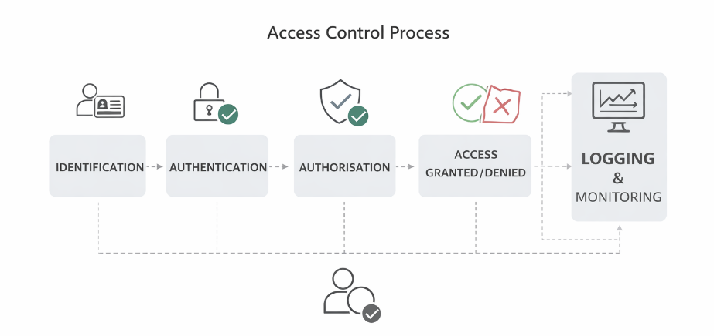
Figure 21. Access control workflow showing identification, authentication, authorization, and decision steps, supported by logging and continuous monitoring (source: Author)

The diagram above illustrates the Access Control Process, a security mechanism used to regulate who can access specific resources, systems, or data.
- Identification & Authentication: The process begins by identifying the user (e.g., via an ID card) and verifying their identity (e.g., with a password or biometric data).
- Authorization: Once authenticated, the system determines the specific permissions or resources the user is allowed to access.
- Access Granted/Denied: Based on authorization, the system permits or restricts entry to the requested resource.
- Logging & Monitoring: All access attempts, whether granted or denied, are recorded and monitored to maintain security records and detect suspicious activity.

- Access Control Models
Several conceptual models define how permissions are assigned:
- Discretionary Access Control (DAC): Access rights are determined by the resource owner.
- Mandatory Access Control (MAC): Access is governed by centralised security policies and classification levels.
- Role-Based Access Control (RBAC): Permissions are assigned according to predefined organisational roles.
- Attribute-Based Access Control (ABAC): Access decisions are based on attributes such as user characteristics, contextual factors, or environmental conditions.
These access control models are commonly implemented and managed through Identity and Access Management systems (IAM), which provide the infrastructure for managing digital identities, authentication processes, and the enforcement of access policies across information systems.In ESG platforms and energy systems, RBAC is often implemented to align permissions with organisational roles, such as ESG analyst, system administrator, or compliance officer. In more complex IoT and smart grid environments, ABAC may be necessary to incorporate contextual factors such as location or device trust levels.

- Principle of Least Privilege and Separation of Duties
Two core governance principles support secure access management:
- Least Privilege: Users are granted only the minimum level of access required to perform their responsibilities.
- Separation of Duties: Critical tasks are distributed among multiple individuals to reduce the risk of misuse or fraud.
These principles are especially relevant in ESG reporting contexts, where unauthorised modification of sustainability metrics could trigger regulatory consequences.
The International Organisation for Standardisation ISO/IEC 27001 underscores the importance of structured access control policies within information security management systems.

- Access Controls in Sustainable Infrastructure
Within sustainable systems, access control must account for diverse operational environments:
- Energy Management Systems (EMS): Limit administrative access to control functions.
- IoT Sensor Networks: Require device authentication before permitting data transmission.
- Smart Grids: Separate operational roles between substations and control centres.
- ESG Platforms: Apply granular permissions to data editing and report publication.
Weak access management can lead to:
- Unauthorised data manipulation.
- Operational disruption.
- Regulatory non-compliance.
- Reputational damage.
For this reason, access control connects technical safeguards with governance and compliance frameworks.
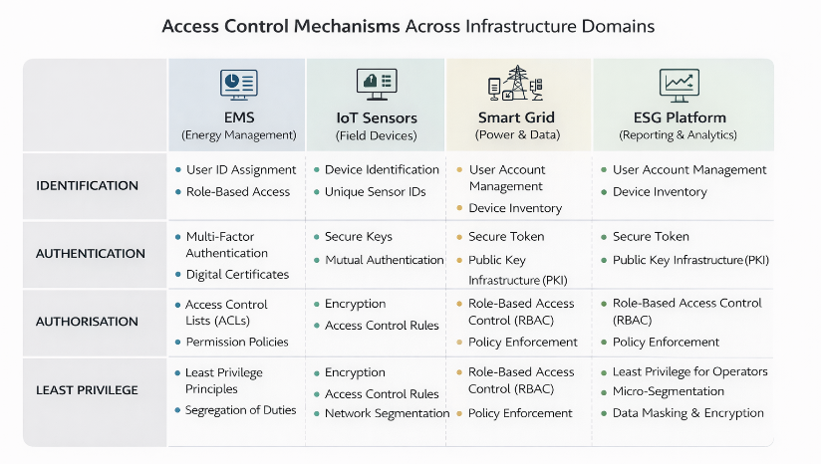
Figure 22. Access Control Mechanisms across infrastructure domains (source: Author)

The image above is a chart titled "Access Control Mechanisms Across Infrastructure Domains," outlining various security measures used in different technological systems.
Identified Domains: The chart compares security mechanisms across four key domains: Energy Management Systems (EMS), IoT Sensors, Smart Grids, and ESG Platforms.
Security Pillars: It lists specific implementations for four fundamental security pillars within these domains: Identification, Authentication, Authorisation, and Least Privilege.
Access Control Methods: Specific methods mentioned include Role-Based Access Control (RBAC), Multi-Factor Authentication, Access Control Lists (ACLs), Public Key Infrastructure (PKI), and Encryption.

Micro-activity:
Consider a cloud-based ESG reporting platform integrated with IoT energy sensors and a smart grid control interface.
Learner task:
- Identify two distinct user roles within this environment.
- Define the minimum permissions required for each role (least privilege).
- Identify one risk arising from excessive privileges.
- Propose one technical control and one governance control to mitigate that risk.
Respond in 8–10 structured sentences.
Additional reading:
- NIST SP 800-63 Digital Identity Guidelines
- ENISA – Good Practices for Security of IoT
- Guide to Operational Technology (OT) Security.
Key Takeaways:
- Access control regulates identification, authentication, and authorisation.
- RBAC and ABAC are particularly relevant for sustainable digital infrastructures.
- Least privilege and separation of duties support compliance and integrity.
- Access control failures may create regulatory, operational, and reputational risk.
- Governance and technical controls must operate together to ensure accountability.

Quick Check:
- True or False: An organisation implements multi-factor authentication for all ESG platform users but allows unrestricted role escalation after login. From a risk and compliance perspective, access control can still be considered effectively enforced.

2. A smart grid operator assigns a single administrator the ability to:
- Modify access permissions
- Approve firmware updates
- Validate operational logs
Which risk is most directly introduced?
- Reduced encryption strength
- Violation of the separation of duties and increased fraud or abuse potential
- Increased network latency
- Automatic regulatory compliance.

- An IoT gateway authenticates connected sensors using shared credentials embedded in firmware. Which risk implication is most significant?
- Simplified device onboarding
- Inability to attribute actions to individual devices, reducing accountability
- Increased battery consumption
- Automatic segmentation of the IoT network

Answer key: 1. false; 2. b); 3. b).

Topic 3.2: Introduction to Encryption Technologies
Short introduction:
Encryption is a core technology for protecting data confidentiality, integrity, and authenticity within sustainable digital infrastructures. In settings such as smart grids, IoT ecosystems, Energy Management Systems, and ESG platforms, encryption helps secure sensitive operational and personal data against unauthorised access and potential regulatory non-compliance. This topic introduces the fundamental concepts of encryption, outlines key technologies, and explains their relevance to data protection and compliance frameworks.

Theory & Knowledge:
Encryption converts readable data, known as plaintext, into an unreadable form called ciphertext using cryptographic algorithms and keys. Only authorised parties who possess the correct key can decrypt and access the original information.
In regulated environments, encryption goes beyond being a technical control; it is frequently required to demonstrate compliance with data protection principles such as confidentiality, integrity, and security of processing.
The NIST publishes internationally recognised guidance on cryptographic standards and recommended best practices.
- Core Cryptographic Concepts
Encryption technologies rely on several fundamental elements:
- Plaintext – The original readable data.
- Ciphertext – The encrypted output.
- Encryption algorithm – The mathematical function used to transform the data.
- Cryptographic key – The secret value that controls encryption and decryption.
The overall level of security depends not only on the strength of the algorithm but also on effective, secure key management.

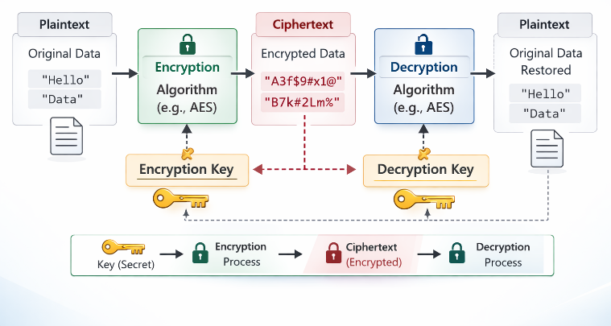
Figure 23. Basic encryption process. The encryption and decryption keys may be identical in symmetric cryptography or different in asymmetric cryptography (public and private key pairs) (source: Author)
The image above illustrates the fundamental process of Symmetric Encryption, where the same secret key is used for both securing and unlocking data. 1. Plaintext (Input) - The process begins with Plaintext, which is the original, readable data (e.g., "Hello"). 2. Encryption - An Encryption Algorithm (like AES) uses a specific Encryption Key to scramble the plaintext. This transforms the readable data into Ciphertext, which appears as a random string of characters (e.g., "A3f$9#x1@"). 3. Decryption - To make the data readable again, the Decryption Algorithm uses the corresponding Decryption Key (which, in symmetric encryption, is the same as the encryption key) to reverse the process. 4. Plaintext (Output) - Once decrypted, the data is restored to its original format, allowing the recipient to read the "Hello" message exactly as it was sent. Key takeaway: Without the correct secret key, the ciphertext remains unreadable, ensuring the data's confidentiality during transmission or storage.

- Symmetric and Asymmetric Encryption
Two main encryption models are commonly used:
- Symmetric Encryption: Uses a single shared secret key for both encryption and decryption. Efficient and well-suited for handling large volumes of data. Requires secure distribution and protection of the shared key.
- Asymmetric Encryption: Uses a pair of keys, a public key and a private key. Enables secure key exchange and digital signature mechanisms. It is computationally more resource-intensive. In practice, modern secure communication protocols combine both approaches. Asymmetric cryptography is typically used to establish a shared secret key through key exchange mechanisms such as Diffie–Hellman key exchange, while symmetric encryption is then used to efficiently encrypt the actual data transmitted between parties.

- Encryption in Sustainable Systems
Encryption is applied at multiple layers within sustainable infrastructures:
- Data in transit: Securing communication between IoT sensors, gateways, and cloud platforms, for example, through TLS-based encryption.
- Data at rest: Encrypting databases that store ESG metrics or operational logs.
- Device-level encryption: Protecting firmware and embedded credentials within IoT devices.
- End-to-end encryption: Securing communication across distributed smart grid components.
The International Organisation for Standardisation ISO/IEC 27001 identifies encryption as a key control within information security management systems.

- Encryption and Data Protection Compliance
Encryption contributes to compliance by:
- Reducing the impact of data breaches.
- Protecting personal and sensitive operational data.
- Demonstrating the implementation of appropriate technical safeguards.
- Supporting secure cross-border data transfer mechanisms.
However, encryption by itself does not guarantee compliance. Weak key management practices, misconfigured certificates, or inadequate access controls can significantly reduce its effectiveness.
ENISA highlights the importance of robust cryptographic governance across digital transformation initiatives and critical infrastructure protection.

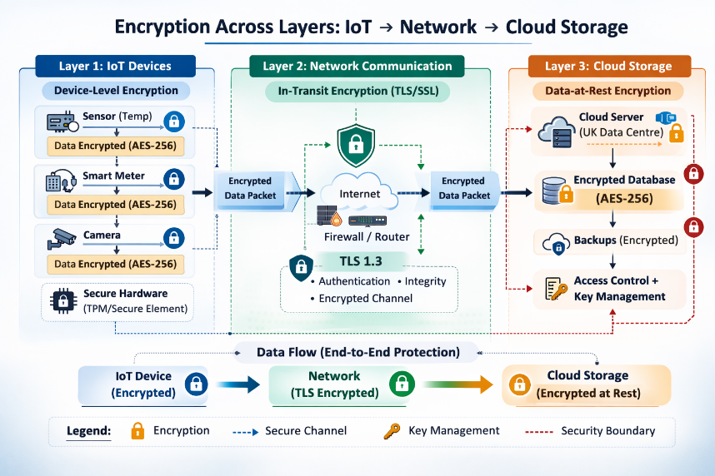
Figure 24. End-to-end encryption across IoT, network, and cloud layers, protecting data in transit and at rest through TLS channels and AES-256 encryption (source: Author)

The diagram above illustrates a secure end-to-end architecture for protecting Internet of Things (IoT) data as it travels from devices through a network to cloud storage. IoT Device Layer: Data is encrypted directly on devices (like sensors, smart meters, and cameras) using AES-256 and protected by secure hardware. Network Communication Layer: Data is transmitted securely across the internet using TLS 1.3 to ensure an encrypted channel, authentication, and integrity. Cloud Storage Layer: Data is stored in a secure cloud server and encrypted database using AES-256, with key management for access control. Data Flow: The process ensures comprehensive protection from the initial data generation to final storage.

- Risks and Limitations of Encryption
Encryption can fail if:
- Cryptographic keys are inadequately protected.
- Outdated or weak algorithms are used.
- Certificates are incorrectly configured.
- Key lengths are insufficient for modern security requirements. Encryption is implemented without proper integrity verification.
For this reason, encryption must be embedded within broader governance frameworks that include strong access control, continuous monitoring, and well-defined incident response processes.

Micro-activity:
Consider a cloud-based ESG platform connected to IoT energy sensors and smart grid control systems.

Learner task:
- Identify one scenario requiring encryption of data in transit.
- Identify one scenario requiring encryption of data at rest.
- Explain one key management risk.
- Propose one governance measure to strengthen cryptographic oversight.
Respond in 8–10 structured sentences.

Additional reading:
- Cryptographic Standards and Guidelines
- ENISA Cryptographic Guidance
- EUCC Certification Scheme
- OWASP – Cryptographic Storage Cheat Sheet.

Key Takeaways:
- Encryption protects confidentiality and supports data integrity and authenticity.
- Symmetric and asymmetric encryption serve complementary purposes.
- Encryption must be applied to data in transit, at rest, and across distributed systems.
- Strong key management is critical to maintaining cryptographic security.
- Encryption supports regulatory compliance but must be integrated within broader governance structures.
Quick Check:
      - True or False: If an organisation encrypts ESG data both in transit and at rest but fails to implement secure key rotation and access restrictions to cryptographic keys, the confidentiality risk may remain significantly elevated.

      - A smart grid operator uses strong symmetric encryption to protect communication between substations. However, the shared secret key is hardcoded in device firmware and identical across all installations. Which risk is most critical?
- Increased encryption latency
- Single-point compromise enabling large-scale decryption
- Reduced interoperability between devices
- Improved key distribution efficiency.

      - An ESG platform uses asymmetric encryption to exchange session keys and symmetric encryption for data transfer. However, certificate validation is not properly implemented. Which threat becomes most plausible?
- Data compression failure
- Man-in-the-middle attack during key exchange
- Reduced database performance
- Automatic compliance certification.

Answer key: 1. true; 2. b); 3. b).

Topic 3.3: Introduction to GDPR alignment and its evolution
Short introduction:
The General Data Protection Regulation (GDPR) is one of the most comprehensive data protection frameworks in the world. It sets out clear legal obligations for organisations that process personal data and introduces strong principles of accountability, transparency, and risk-based compliance. Within sustainable digital infrastructures, such as smart grids, IoT ecosystems, and ESG platforms, alignment with GDPR is essential to ensure lawful data processing, safeguard individuals’ rights, and reduce regulatory risk. This topic outlines the core principles of GDPR, traces its development, and explains its relevance to security in sustainable systems.
Theory & Knowledge:
The European Union General Data Protection Regulation (GDPR) (Regulation (EU) 2016/679) entered into force in May 2018. It replaced the Data Protection Directive 95/46/EC and introduced a harmonised, risk-based regulatory framework applicable across all EU Member States.
GDPR applies to organisations that process the personal data of individuals located within the European Union, regardless of where the organisation itself is established. Its extraterritorial reach significantly expanded global compliance responsibilities.
- Core GDPR Principles
GDPR is built around a set of fundamental data protection principles:
- Lawfulness, fairness, and transparency.
- Purpose limitation.
- Data minimisation.
- Accuracy.
- Storage limitation.
- Integrity and confidentiality.
- Accountability.
These principles require organisations to implement appropriate technical and organisational measures to protect personal data effectively.
The European Data Protection Board issues interpretative guidance to support the consistent application of GDPR principles across Member States.
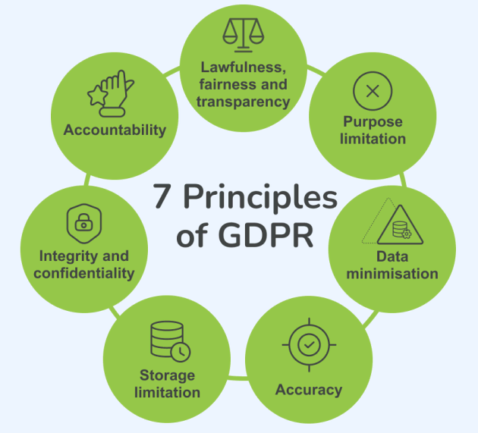

Figure 25. The seven core principles of GDPR governing lawful, transparent, and secure processing of personal data (Source: https://matomo.org/)

The image above outlines the 7 core principles of the General Data Protection Regulation (GDPR), which is an EU law governing data protection and privacy. These principles dictate how organizations must handle personal data. Lawfulness, fairness, and transparency: Data must be processed legally, fairly, and openly. Purpose limitation: Data should only be collected for specific, legitimate purposes and not used for other reasons. Data minimisation: Organizations must only collect the minimum amount of data necessary for their purpose. Accuracy: Personal data must be kept accurate and up to date.
Storage limitation: Data should only be stored for as long as necessary. Integrity and confidentiality: Data must be kept secure using appropriate technical or organizational measures. Accountability: Organizations are responsible for complying with all these principles and must be able to demonstrate their compliance.

- Risk-Based Approach and Accountability
One of the key developments introduced by GDPR is the move from purely prescriptive compliance toward a risk-based approach. Organisations are required to assess the risks associated with their data processing activities and implement controls that are proportionate to the likelihood and severity of potential harm to individuals.
Core accountability mechanisms include:
- Data Protection Impact Assessments (DPIAs).
- Records of processing activities.
- Appointment of a Data Protection Officer, where required.
- Demonstrable implementation of technical safeguards, such as encryption and access control.
The ENISA highlights the importance of aligning cybersecurity measures with data protection compliance in digital transformation environments.

- GDPR in Sustainable Digital Infrastructures
Sustainable infrastructures frequently process personal data, including:
- Smart meter consumption data linked to individuals.
- Employee monitoring data within energy facilities.
- ESG platform data related to workforce diversity and governance.
- IoT sensor data that may be associated with identifiable persons.
Risks can emerge when:
- Data is collected excessively, in breach of minimisation principles.
- Data is processed for purposes beyond its original disclosure.
- Access controls are inadequate.
- Encryption and integrity mechanisms are insufficient.
For this reason, GDPR alignment must be embedded within broader cybersecurity governance and risk assessment processes.
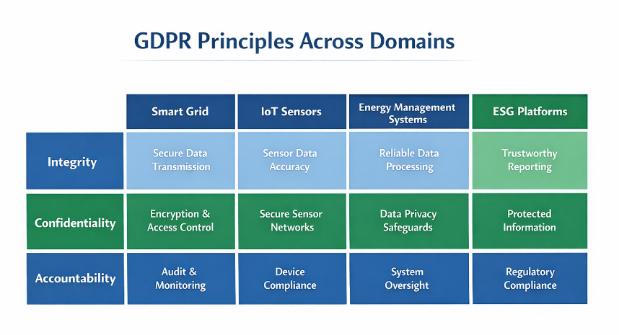
Figure 26. GDPR principles across domains (source: Author)

The chart above outlines how key GDPR principles—Integrity, Confidentiality, and Accountability—apply to specific technical domains like Smart Grids, IoT Sensors, Energy Management Systems, and ESG Platforms.
Integrity focuses on ensuring data accuracy and secure transmission across systems.
Confidentiality emphasizes protecting information through encryption, access control, and secure networks. Accountability involves maintaining regulatory compliance through audits, monitoring, and oversight.

- Evolution and Regulatory Landscape
Since its enforcement, GDPR has continued to develop through:
- Interpretative guidance issued by supervisory authorities.
- Enforcement actions and evolving case law.
- Closer integration with cybersecurity regulations, including sector-specific resilience requirements.
- Alignment with emerging data governance and digital resilience initiatives.
This progression reflects a broader movement toward integrated regulatory governance, where cybersecurity, data protection, and operational resilience are increasingly interlinked.
GDPR alignment should therefore be understood not as static compliance, but as an ongoing governance process that requires regular review and adaptation.

Micro-activity:
Consider a smart grid operator collecting detailed electricity consumption data linked to individual households.
Learner task:
Identify one GDPR principle particularly relevant to this processing activity.
Identify one compliance risk.
Propose one technical control and one organisational measure supporting GDPR alignment.
Explain how these measures demonstrate accountability.
Respond in 8–10 structured sentences.
Additional reading:
- GDPR Regulation
- Digital Identity and Data Protection
- European Data Protection Board (EDPB) – Guidelines & Recommendations,
- European Commission – Data protection rules (GDPR overview & updates).

Key Takeaways:
- GDPR establishes a harmonised, risk-based framework for personal data protection.
- Accountability and proportional safeguards are central to compliance.
- Sustainable infrastructures frequently process personal data and require integrated governance.
- Technical measures such as encryption and access control support GDPR alignment.
- Compliance is a continuous process shaped by evolving regulatory interpretation.

Quick Check:
1. True or False: If an organisation encrypts personal data processed within a smart grid environment but fails to conduct and document a Data Protection Impact Assessment (DPIA) despite high-risk processing, it may still be considered non-compliant with GDPR accountability requirements.

2. A smart grid operator collects detailed household energy consumption data for load balancing. Later, the data is analysed to profile consumer behaviour for commercial partnerships, without updating privacy notices. Which combination of GDPR principles is most clearly compromised?
- Accuracy and storage limitation
- Purpose limitation and transparency
- Availability and integrity
- Data portability and encryption

- An ESG platform processes employee diversity data across multiple EU Member States. Access controls are implemented, but processing purposes are vaguely defined, and documentation is incomplete. Which governance weakness is most critical?
- Lack of encryption at rest
- Insufficient lawfulness and accountability documentation
- Absence of network segmentation
- Over-segmentation of user roles

Answer key: 1. true; 2. b); 3. b).

Topic 3.4: Audit trails
Short introduction:
Audit trails are structured records that capture system activities, user actions, and security-relevant events. In sustainable digital infrastructures such as smart grids, IoT ecosystems, Energy Management Systems (EMS), and ESG platforms, audit trails play a central role in supporting accountability, incident investigation, regulatory compliance, and transparency in governance. This topic outlines the concept of audit trails, explains their relevance to data protection and cybersecurity, and describes how they integrate within broader compliance frameworks.
Theory & Knowledge:
An audit trail is a chronological record of events that provides verifiable evidence of system activity and user behaviour. It allows organisations to reconstruct incidents, confirm compliance, identify anomalies, and demonstrate accountability.
In data protection and compliance contexts, audit trails serve both technical and legal functions. They enable organisations to show that access to personal and operational data is properly controlled, monitored, and subject to review.
The International Organisation for Standardisation ISO/IEC 27001 recognises logging and monitoring as essential controls within information security management systems.

- Core Elements of an Audit Trail
An effective audit trail generally records:
- User identity, indicating who performed the action.
- Timestamp, specifying when the action took place.
- Action performed, describing what was done.
- Affected resource, identifying the system or dataset involved.
Outcome, indicating whether the action was successful, failed, or denied.
Additional contextual details, such as IP addresses, device IDs, or session identifiers, can further enhance traceability.
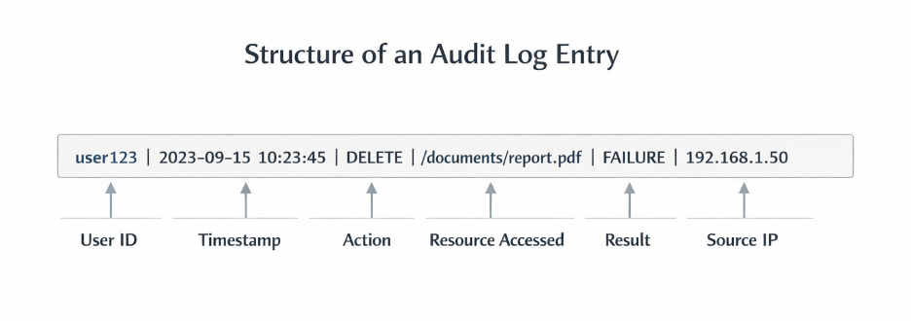
Figure 27. Example structure of an audit log entry including user ID, timestamp, action performed, accessed resource, result, and source IP address (source: Author)

The diagram above illustrates the structure of an audit log entry, which is a record of events and changes within a system used for security monitoring and compliance. It breaks down a log line into six specific components to track user activities.
User ID and Timestamp: Identifies who performed the action and exactly when it occurred.
Action and Resource: Details the specific operation performed (e.g., delete) and the file or data that was targeted.
Result and Source: Indicates whether the action succeeded or failed, along with the IP address of the device used.

- Audit Trails and GDPR Accountability
Under the European Union General Data Protection Regulation (GDPR), organisations are required to demonstrate accountability. Audit trails support this obligation by:
- Documenting access to personal data.
- Supporting the investigation of data breaches.
- Providing evidence of lawful processing.
- Facilitating audits by supervisory authorities.
The European Data Protection Board highlights the importance of traceability and proper documentation in demonstrating compliance.
In ESG platforms that process employee or consumer data, audit logs should clearly record who modified sustainability metrics and when those changes took place.

- Audit Trails in Sustainable Infrastructures
Audit trails serve different purposes across system types:
- Energy Management Systems: Track adjustments to control parameters and administrative access.
- IoT Sensor Networks: Log device authentication events and firmware updates.
- Smart Grids: Record command execution and configuration changes within substations.
- ESG Platforms: Monitor data edits, report approvals, and export activities.
In these environments, logging mechanisms must strike a balance between operational performance and security requirements.

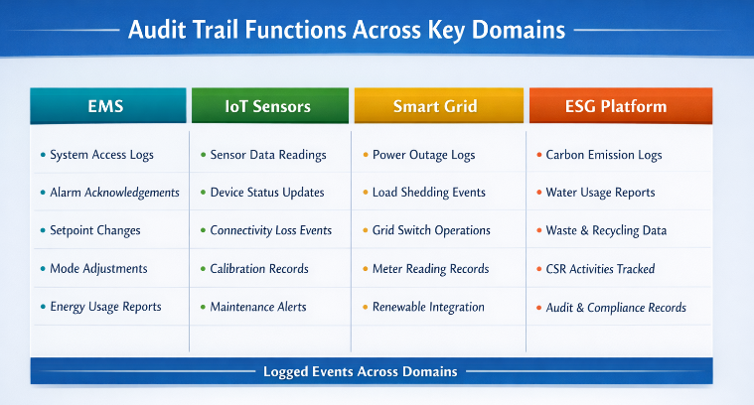
Figure 28. Audit trail functions across key domains (source: Author)

This image outlines the specific event logging functions across four technological domains: Energy Management Systems (EMS), IoT Sensors, Smart Grid infrastructure, and ESG Platforms.
EMS: Tracks system access, alarm acknowledgements, setpoint changes, mode adjustments, and energy usage reports.
IoT Sensors: Records sensor data readings, device status updates, connectivity issues, calibration records, and maintenance alerts.
Smart Grid: Logs power outages, load shedding events, grid switch operations, meter readings, and renewable integration data.
ESG Platform: Monitors carbon emissions, water usage, waste/recycling data, CSR activities, and audit compliance records.

- Security and Governance Considerations
Effective management of audit trails requires:
- Secure log storage, protected against tampering.
- Restricted and controlled access to logs.
- Log retention policies aligned with regulatory obligations.
- Continuous monitoring and analysis.
- Integration with incident response procedures.
The National Institute of Standards and Technology highlights logging, monitoring, and continuous diagnostics as core components of sound cybersecurity practice.
If not properly secured, audit logs themselves can become targets of manipulation, compromising their forensic reliability.

- Risks and Limitations
Audit trails can fail when:
- Logging is incomplete or incorrectly configured.
- Logs are not reviewed on a regular basis.
- Excessive data collection breaches data minimisation principles.
- Log retention exceeds lawful storage periods.
- Access to logs is insufficiently restricted.
For this reason, audit trail implementation must remain aligned with both cybersecurity controls and data protection requirements.

Micro-activity:
Consider a cloud-based ESG platform integrated with IoT energy sensors and smart grid control systems.
Learner task:
- Identify three critical events that must be logged.
- Explain one compliance reason for retaining these logs.
- Identify one security risk if logs are not protected.
- Propose one governance measure to ensure audit trail integrity.
Respond in 8–10 structured sentences.

Additional reading:
- NIST SP 800-92 – Guide to Computer Security Log Management
- OWASP – Logging Cheat Sheet
Key Takeaways:
- Audit trails document system and user activities for accountability and security.
- Logging supports GDPR compliance and regulatory audits.
- Sustainable infrastructures require domain-specific logging strategies.
- Logs must be protected from tampering and unauthorised access.
- Audit trail governance integrates cybersecurity, compliance, and operational oversight.
Quick Check:
- True or False: An organisation stores comprehensive audit logs for its ESG platform but allows database administrators to modify or delete log entries without independent oversight. In such a configuration, audit trails may fail to satisfy evidentiary and GDPR accountability requirements.

- 2. A smart grid operator logs all access to substation control systems but does not record failed authentication attempts. Which risk is most directly increased?
- Reduced data storage efficiency
- Inability to detect brute-force or credential-based attack attempts
- Loss of encryption strength
- Over-compliance with GDPR.

- An ESG reporting platform retains detailed access logs indefinitely, including user identifiers and IP addresses, without a defined retention policy. Which GDPR principle is most likely at risk?
- Data minimisation and storage limitation
- Availability and resilience
- Encryption and pseudonymisation
- Network segmentation.

Answer key: 1. true; 2. b), 3. c).

Module 3: Conclusion and Self-Assessment
Module Summary:
Module 3 explored the intersection of cybersecurity, data protection, and regulatory compliance within sustainable digital infrastructures. It focuses on governance mechanisms designed to ensure lawful, accountable, and secure data processing across Energy Management Systems, IoT environments, smart grids, and ESG platforms.
Topic 3.1 presented access control as a core safeguard supporting confidentiality, integrity, and accountability. Learners examined identification, authentication, and authorisation processes, as well as role-based and attribute-based models, and governance principles such as least privilege and separation of duties.
Topic 3.2 analysed encryption technologies, distinguishing between symmetric and asymmetric approaches and assessing their application to data in transit and data at rest. Attention was given to secure key management and the link between encryption practices and regulatory compliance.
Topic 3.3 focused on GDPR alignment and its ongoing evolution, highlighting the transition toward a risk-based accountability framework. Learners reviewed core principles, Data Protection Impact Assessments (DPIAs), and the integration of technical safeguards within broader governance structures.
Topic 3.4 introduced audit trails, emphasising traceability, evidentiary reliability, and compliance documentation. The role of logging in incident response, forensic investigation, and supervisory authority audits was examined.
Taken together, Module 3 enhanced learners’ ability to integrate technical safeguards, such as access control, encryption, and logging, with regulatory accountability requirements, forming the compliance and governance dimension of the Capstone Project.

Module Knowledge Quiz
- An ESG platform implements strong encryption and multi-factor authentication but does not conduct periodic access reviews for privileged users. Which governance risk remains most significant?
- Reduced encryption performance
- Excessive network segmentation
- Accumulation of unjustified privileges violating accountability principles
- Elimination of data minimisation requirements.

- True or False: Under a risk-based compliance model, technical safeguards such as encryption must be supported by documentation and demonstrable accountability mechanisms.

- A smart grid operator collects detailed household consumption data and stores audit logs indefinitely without reviewing necessity or retention requirements. Which combination of risks is most evident?
- Over-segmentation and encryption failure
- Violation of storage limitation and potential data minimisation concerns
- Reduced system availability
- Excessive pseudonymization.
- Which scenario most clearly demonstrates the failure of the separation of duties?
- An administrator configures encryption parameters
- A compliance officer reviews DPIA documentation
- A single individual both modifies ESG sustainability metrics and approves the final regulatory disclosure
- An IoT device authenticates using unique credentials

- An organisation encrypts all IoT sensor communications but does not protect cryptographic keys from administrative access. What is the most accurate assessment?
- Encryption eliminates confidentiality risk
- Weak key governance undermines cryptographic protection
- GDPR compliance is automatically achieved
- Audit trails are unnecessary.

- True or False: Audit trails that are securely stored but never analysed or correlated with monitoring systems provide limited value for proactive compliance and incident detection.

- Which combination most accurately reflects mature data protection governance in sustainable infrastructures?
- Isolated technical controls without documentation
- Integrated access management, encryption, audit logging, DPIAs, and periodic compliance reviews
- Encryption applied only to archived data
- Delegation of compliance solely to the IT department.
Answer key: 1. c); 2. true; 3. b); 4. c); 5. b); 6. true; 7. b).

Applied Scenario:
Scenario
A regional renewable energy provider operates:
- IoT-enabled smart meters
- A smart grid control centre
- A cloud-based ESG reporting platform
Recent findings reveal:
- Excessive administrative privileges in the ESG platform
- Outdated cryptographic algorithms in IoT firmware
- Incomplete audit logging in substation systems
- No documented Data Protection Impact Assessment for granular household data processing
Learner Task:
- Identify two compliance risks and two cybersecurity risks.
- Explain how these risks intersect.
- Propose one corrective action aligned with access control, one with encryption governance, and one with audit trail management.
- Justify how these actions demonstrate GDPR accountability and risk-based compliance.
Respond in 12–15 structured sentences integrating concepts from Topics 3.1–3.4.

References:
- ENISA – Cryptographic Guidance, https://www.enisa.europa.eu/topics/digital-identity-and-data-protection/cryptography
- ENISA Threat Landscape 2025, https://www.enisa.europa.eu/sites/default/files/2026-01/ENISA%20Threat%20Landscape%202025_v1.2.pdf
- European Commission – Critical Infrastructure and Cybersecurity (Energy).
https://energy.ec.europa.eu/topics/energy-security/critical-infrastructure-and-cybersecurity_en
- European Commission – Data Governance Act (Regulation (EU) 2022/868), https://eur-lex.europa.eu/eli/reg/2022/868/oj
- Framework for Improving Critical Infrastructure Cybersecurity (NIST Cybersecurity Framework), https://nvlpubs.nist.gov/nistpubs/CSWP/NIST.CSWP.29.pdf
- Legal framework of EU data protection, https://commission.europa.eu/law/law-topic/data-protection/legal-framework-eu-data-protection_en
- MITRE ATT&CK – Enterprise Matrix, https://attack.mitre.org/matrices/enterprise/
- OWASP – OWASP Top 10 (Web Applications), https://owasp.org/Top10

