Green Software Fundamentals
Learner Handbook

Copyright © 2024 Digital4Sustainability. The project resources contained herein are publicly available under the Creative Commons license 4.0 B.Y.

Project | Digital4Sustainability
Project number | 101140316
Document Title | Green Software Fundamentals – Learner handbook
Authors | Bogdan-Costel MOCANU; National University of Science and Technology POLITEHNICA Bucharest
Reviewers | Jamie Meegan; DTSL  Gillian O’Grady; DTSL  David Fitzgerald; DTSL
Editor | Katarina Cicvarić, Profil Klett
Instructional Designer | Kristina Ferara Blašković, Profil Klett
Digital Content Manager | Ivana Bošnjak, Profil Klett  Andra Punjek, Profil Klett

This handbook serves as the comprehensive learning material for the entire upskilling curriculum, covering all modules in a single document. It is structured into Modules and thematic Topics, each designed to achieve specific learning outcomes. The learning content is supported by multimedia elements, self-assessment quizzes, and additional learning resources.

Disclaimer
Funded by the European Union. Views and opinions expressed are however those of the author(s) only and do not necessarily reflect those of the European Union or the European Education and Culture Executive Agency (EACEA). Neither the European Union nor EACEA can be held responsible for them.

Table of Contents
Introduction to Upskilling Curricula: Green Software Fundamentals 4
MODULE 1: Sustainable Software Engineering 5
Topic 1.1: Introduction to Green Software and Architecture 6
TOPIC 1.2: Sustainable SOLID Principles 14
TOPIC 1.3: Design Patterns for Energy Efficiency 24
TOPIC 1.4: Measuring the Impact of Your Code 32
Module 1: Conclusion and Self-Assessment 45
MODULE 2: Energy-Efficient Architecture 47
Topic 2.1: Architectural Models: MVC and Sustainable Design 48
TOPIC 2.2: Microservices and Modern Architectures 59
TOPIC 1.3: Sustainable Cloud Computing 70
TOPIC 1.4: Carbon-Aware Computing 80
Module 2: Conclusion and Assessment 83

Table of Figures:
Figure 1. Digital pollution flowchart (source: Author) 7
Figure 2. Green Software Scopes (source: Author) 8
Figure 3. Micro-activity task 1 (source: Author) 11
Figure 4. Debate between maximalism and minimalism (source: Author) 15
Figure 5. High coupling between domain logic and user interface logic (source: Author) 16
Figure 6. Refactored version of the previous figure, specifically applying the Interface Segregation Principle (ISP). 16
Figure 7. Interface Segregation Principle (source: Author) 18
Figure 8. Dependency Inversion (source: Author) 18
Figure 9. SIngleton Pattern (source: Author) 26
Figure 10. Observer Pattern (source: Author) 27
Figure 11. Comparison of daily Co2 emissions (kg Co2e) for 2000W server based on regional energy grid intensity (source: Author) 36
Figure 12. Software Carbon Intensity (SCI) specification formula (source: Author) 37
Figure 13. Windows Task Manager and Resource Monitor (source: Author) 38
Figure 14. Mac Os Activity Monitor (source: Author) 38
Figure 15. Visual Studio Diagnostic Tools (source: Author) 39
Figure 16. Model-View-Controller (MVC) pattern (source: Author) 48
Figure 17. Optimized MVC Architecture (source: Author) 51
Figure 18. Architectural Path to Sustainability (source: Author) 53
Figure 19. Order-of-magnitude difference caused by a small per-request inefficiency (source: Author) 56
Figure 20. Java Enterprise Edition (Java EE) deployment architecture (source: Author) 59
Figure 21. UML Component Diagram for a Human Resource Management System (HRMS) (source: Author) 60
Figure 22. UML Deployment Diagram representing a Distributed Microservices Architecture for an HR or Enterprise Resource Planning (ERP) system (source: Author) 61
Figure 23. Energy savings with Microservices (source: Author) 63
Figure 24. Client -server architecture (source: Author) 64
Figure 25. Docker Containerization Architecture (source: Author) 66
Figure 26. Cloud Datacenter Energy Trends: Historical and projected energy consumption through 2030. (source: Author) 71
Figure 27. Sustainable Architecture for Green Cloud Computing (source: Author) 72
Figure 28. Sustainable Cloud Operations (source: Author) 75
Figure 29. Economic Advantages of the Cloud (source: Author) 77
Figure 30. Why Organizations Choose On-Premise (source: Author) 77
Figure 31. Four Primary Workload Types (source: Author) 80

List of tables:
Table 1. Micro activity task 1 (source: Author) 11
Table 2. GoF design patterns (source: Author) 23
Table 3. An energy perspective of Monolith/SoA/Microservice architectures 58

Introduction to Upskilling Curricula: Green Software Fundamentals

Overview:
The Green Software Fundamentals upskilling curricula is a comprehensive program designed to integrate environmental sustainability into the core of modern software engineering. Aimed at professionals at an EQF 6 level—including software developers, system administrators, and IT operations staff—the curriculum focuses on minimizing the carbon footprint of digital products through conscious design and conscious coding.

Learners will achieve a high level of proficiency in measuring software energy consumption, applying sustainable SOLID principles, and designing system architectures optimized for renewable energy usage. By the end of the course, participants will be equipped to implement green software practices across the entire development lifecycle, from initial design to IT operations.

The learning journey is logically structured into specialized Modules, which are further divided into thematic Topics. Each section concludes with a self-check quiz to ensure mastery of the material. To bridge the gap between theory and real-world application, the handbook incorporates Face-to-Face (F2F) activities and, where applicable, Project-Based Learning (PBL/lab) tasks. These hands-on components, such as code refactoring exercises and architectural modelling, empower learners to translate abstract sustainability principles into measurable, high-quality engineering results.
Learning Outcomes (LO) for this UC:
The learner will be able to:
- Apply energy-efficient coding practices to reduce software carbon footprint
- Measure and calculate carbon footprint of software applications
- Implement green software principles across development lifecycle
- Evaluate software architectures for energy efficiency and environmental impact
- Design system architectures optimized for renewable energy usage
- Apply sustainable IT operations practices
Structure of the handbook
This handbook is divided into Modules and topics.
Module 1: Sustainable Software Engineering
T1.1. Introduction to Green Software and Architecture
T1.2. Sustainable SOLID Principles
T1.3. Design Patterns for Energy Efficiency
T1.4. Measuring the Impact of Your Code

Module 2: Energy-Efficient Architecture
T2.1. Architectural Models: MVC and Sustainable Design
T2.2. Microservices and Modern Architectures
T2.3. Sustainable Cloud Computing
T2.4. Carbon-Aware Computing

MODULE 1: Sustainable Software Engineering
Module Overview:
This module aims to equip learners with the knowledge and practical skills needed to design, implement, and optimize software systems with a reduced environmental impact. Students will learn how green software principles, efficient architecture, and optimized algorithms contribute to lower energy consumption and measurable reductions in software carbon footprint across the development lifecycle.
Module learning outcomes:
- Explain the principles of green software engineering and sustainable software architecture, including their role in reducing energy consumption and software-related carbon emissions.
- Apply sustainable SOLID principles and energy-efficient design patterns to develop software that minimizes resource usage and environmental impact.
- Select and implement efficient algorithms and data structures to optimize computational performance and reduce energy consumption.
- Develop parallel and asynchronous software solutions that improve execution efficiency while minimizing unnecessary energy usage.
- Measure, analyse, and interpret the energy consumption and carbon footprint of software applications using appropriate tools and metrics.
- Integrate green software principles throughout the software development lifecycle, from design and implementation to testing and optimization.
Estimated workload:
Lecture hours (F2F): 12
Self-study: 13
Practical application (if applicable): 12
Assessment link: This module provides the core competencies for the first part of the Capstone Project (Workshop 1: The Foundation), focusing on code logic optimization and design patterns.
Practical focus / deliverable:
A refactored energy-efficient code solution and a Written Executive Briefing (PDF) justifying the applied sustainable logic.

Topic 1.1: Introduction to Green Software and Architecture
Short introduction:
Green software engineering recognizes that software has a real, measurable environmental impact through energy consumption and carbon emissions. This introduction highlights how conscious coding and architectural decisions can reduce that impact while maintaining performance and functionality.

Theory & Knowledge:
The digital age has brought unprecedented convenience, connectivity, and innovation to our lives. Yet beneath the surface of every click, stream, and download lies an invisible environmental cost. As software engineers, we tend to think of our work as inherently clean—after all, code is intangible, ethereal, existing only as patterns of electrons in silicon. But this perception obscures a fundamental truth: software is not weightless. Every line of code we write, every architectural decision we make, ripples outward into the physical world, consuming electricity and contributing to global carbon emissions. This chapter introduces the emerging field of green software engineering, exploring how our technical choices can either accelerate or help mitigate the climate crisis.
Green software represents a paradigm shift in how we approach software development. It encompasses software that is deliberately designed, developed, and deployed with the explicit goal of minimizing environmental impact, particularly carbon emissions. This isn't about sacrificing functionality or performance, but rather about making conscious, informed decisions that balance user needs with planetary health. The principles of green software challenge us to look beyond traditional metrics like speed and scalability, adding energy efficiency and carbon footprint to our definition of quality software.
To understand why green software matters, we must first recognize a crucial distinction: software itself doesn't emit carbon — it's the execution of software that creates emissions. Every time your application makes an API call, queries a database, processes a background job, or simply idles on a cloud server, it draws electrical power. In most parts of the world, that electricity comes primarily from fossil fuels, translating digital operations into atmospheric CO₂. A single database query might consume a negligible amount of energy but multiplied across millions of users and billions of requests, the cumulative impact becomes staggering.
Digital pollution manifests across four primary domains. First, data centres house the servers that power our cloud infrastructure, consuming massive amounts of electricity for computation and cooling. Second, networks route data packets across continents, with routers, switches, and cellular towers all requiring constant power. Third, end-user devices—smartphones, laptops, tablets, and desktop computers—draw energy both during use and while charging. Finally, the manufacturing of hardware carries its own substantial carbon footprint, from mining rare earth minerals to fabricating semiconductors in energy-intensive clean rooms. Each of these domains represents a point of intervention where thoughtful software design can reduce environmental impact as seen bellow.

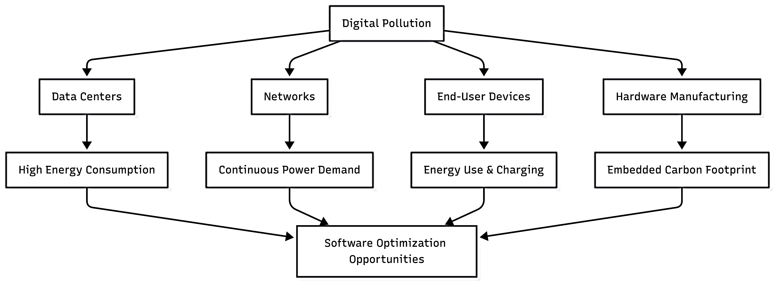
Figure 1. Digital pollution flowchart (source: Author)

The flowchart above illustrates the various sources of Digital Pollution and highlights how software optimization can help mitigate their environmental impact.
Sources of Digital Pollution -The diagram breaks down digital pollution into four primary categories:
- Data Centres: These facilities require High Energy Consumption to power servers and cooling systems 24/7.
- Networks: The infrastructure for data transmission creates a Continuous Power Demand.
- End-User Devices: Smartphones, laptops, and IoT devices contribute via constant Energy Use & Charging.
- Hardware Manufacturing: The production process involves a significant Embedded Carbon Footprint from raw material extraction and assembly.

The cumulative environmental impact of digital technology is difficult to overstate. The information and communications technology (ICT) sector currently accounts for approximately 2-4% of global CO₂ emissions, a figure roughly comparable to the entire aviation industry. More alarmingly, this percentage continues to grow as digital adoption accelerates worldwide. Consider streaming a single hour of high-definition video, which can consume as much electricity as running a refrigerator for a week. Cloud storage, seemingly infinite and effortless, requires physical servers running continuously in climate-controlled facilities. The training of large AI models can consume as much energy as several households use in a year. Background processes, often invisible to users, run 24/7 on servers worldwide, performing updates, syncing data, and maintaining connections.
What makes these emissions particularly insidious is their invisibility. When we drive a car, we see the fuel gauge drop and can intuitively grasp the resource consumption. But when we upload a photo to the cloud or stream a movie, there's no visible meter showing the energy being consumed on our behalf. These disconnects between action and consequences make software sustainability a shared responsibility that requires conscious effort and deliberate measurement. Users cannot manage what they cannot see, and developers cannot optimize what they do not measure.
The Green Software Foundation provides a useful framework for understanding carbon emissions through three scopes:
- Scope 1 encompasses operational emissions—the direct emissions from running software. This includes the electricity consumed by servers executing your application code, processing user requests, and maintaining database connections. Scope 1 represents the most immediate and measurable impact of software systems
- Scope 2 addresses embodied emissions, which stem from manufacturing the hardware on which software runs. Every server, laptop, and smartphone carries a carbon debt from its production, involving mining, manufacturing, transportation, and eventual disposal. When we write inefficient code that requires more powerful hardware or shortens device lifespan, we increase embodied emissions.
- Scope 3 captures upstream and indirect emissions from networks, cloud providers, and supply chains. This includes the energy consumed by internet routing infrastructure, the cooling systems in data centres, and the entire ecosystem supporting digital services.
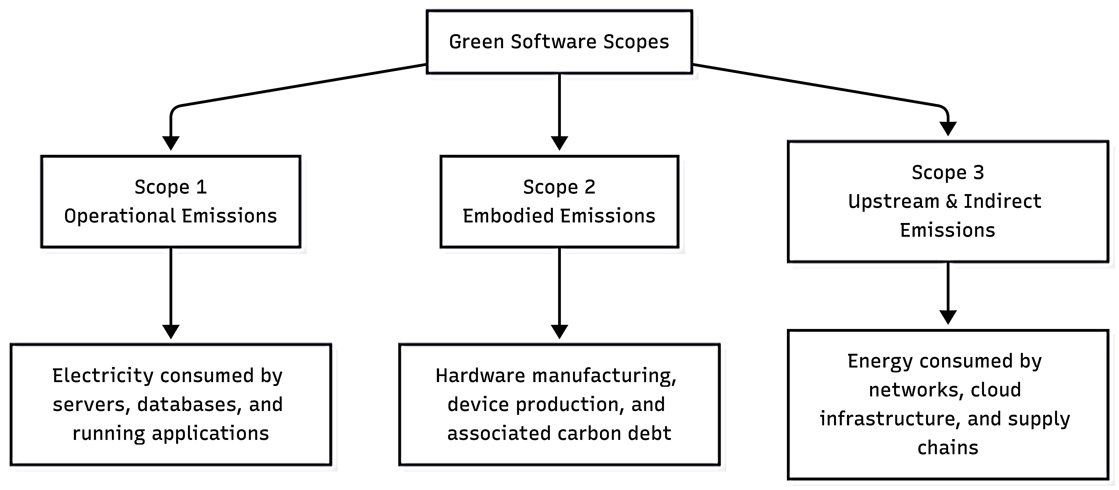
Figure 2. Green Software Scopes (source: Author)
The diagram above outlines the three primary categories, or Scopes, for measuring carbon emissions within the context of Green Software:
Scope 1: Operational Emissions. These are the direct emissions resulting from the day-to-day operation of software. It primarily includes the electricity consumed by: Servers, Databases Running applications
Scope 2: Embodied Emissions. This scope refers to the carbon debt associated with the physical infrastructure. It accounts for the emissions generated during: Hardware manufacturing, Device production (the carbon emitted before the device is even turned on), Scope 3: Upstream & Indirect Emissions. These are emissions that occur in the wider value chain, outside of the immediate control of the software developer or operator. This includes energy consumed by: External networks, Cloud infrastructure providers, Supply chains.

While developers primarily influence Scope 1 through code efficiency and architectural choices, our decisions ripple across all three scopes. Choosing a resource-intensive architecture might trigger the need for additional servers (Scope 2) and increase network traffic (Scope 3). Conversely, writing efficient code that makes optimal use of existing hardware can delay or prevent the need for upgrades, reducing embodied emissions. A mobile application that minimizes network requests not only saves battery life but also reduces the energy consumed by cellular infrastructure. These connections illustrate how software design decisions cascade through the entire technological ecosystem.
The role of the developer in climate action extends far beyond writing code. Even those without traditional engineering titles influence sustainability through their daily work. Product managers defining requirements can prioritize features that minimize energy consumption. Architects choose between monolithic and microservices architectures shaped long-term energy patterns. DevOps engineers scheduling workloads can shift processes to times when renewable energy is more abundant. Cloud architects selecting deployment regions can favour data centres powered by clean energy. In essence, developers are climate decision-makers, whether we consciously embrace that role.
Writing efficient code yields multiple benefits that align sustainability with traditional software engineering values. Energy-efficient software reduces operational costs, directly benefiting bottom lines and making green choices economically attractive. It extends hardware lifespan by reducing strain on components and minimizing heat generation, delaying the need for replacements and reducing embodied emissions. Efficient code often performs better, improving user experience while consuming fewer resources. It scales more gracefully, handling increased load without proportional increases in energy consumption. These synergies demonstrate that sustainability isn't a trade-off against quality — it's an enhancement of quality.
Understanding the distinction between architecture and design proves crucial for sustainable software engineering. Architecture refers to high-level structural decisions: monolith versus microservices, batch versus real-time processing, SQL versus NoSQL databases, synchronous versus asynchronous communication. These decisions are system-wide in scope and notoriously difficult to change once implemented. Design, by contrast, encompasses detailed implementation choices: class structures, algorithms, data structures, and coding patterns. While design decisions matter, architectural choices carry disproportionate long-term carbon impact because they establish constraints and patterns that pervade the entire system.
Consider the choice between batch processing and real-time processing. A batch architecture that processes data during off-peak hours when renewable energy is more abundant might consume the same total energy as a real-time system, but with dramatically different carbon implications depending on the energy grid's composition at different times. Similarly, choosing a serverless architecture might reduce idle server time and overall energy consumption compared to maintaining dedicated servers running 24/7. These architectural decisions create path dependencies that influence every subsequent technical choice and establish energy consumption patterns that persist for years.
The Humble Programmer mindset (https://www.youtube.com/watch?v=KtitYCdebPw), articulated by computer science pioneer Edsger Dijkstra, offers unexpected wisdom for sustainable software engineering. This approach emphasizes accepting limitations, both of our tools and our own understanding. A humble programmer measures instead of guessing, using profiling tools and energy metrics rather than relying on intuition about performance. They design for maintainability, recognizing that code will be read and modified many times, and that complexity creates both cognitive overhead and optimization barriers. Most importantly, humble programmers avoid over-engineering, resisting the temptation to add features or abstractions that might never be needed. Each unnecessary feature represents wasted energy, both in development and in the additional code paths that must be maintained and potentially executed.
This mindset aligns perfectly with sustainability because both require long-term thinking and restraint. Just as a humble programmer resists premature optimization without data, a sustainability-focused developer avoids assumptions about energy consumption without measurement. Both approaches value simplicity, understanding that simpler systems are easier to understand, maintain, and optimize. Both recognize that today's clever solution might become tomorrow's maintenance burden. The humble programmer's discipline of questioning assumptions and measuring outcomes provides exactly the foundation needed for green software engineering.
To begin practicing green software development, students should establish a functional development environment. For this course, you'll need Visual Studio Community Edition, Microsoft's comprehensive integrated development environment, available free for individual developers and small teams. You'll also need the .NET Software Development Kit (SDK), preferably the latest Long-Term Support (LTS) version, which provides the runtime and tools necessary for building and running .NET applications. No advanced configuration is required at this stage—standard installations with default settings will suffice. As we progress through subsequent chapters, we'll introduce specialized tools for measuring energy consumption and carbon emissions, but starting with familiar, accessible tools helps maintain focus on concepts rather than tooling complexity.
Understanding abstract concepts about carbon emissions becomes more meaningful through personal reflection. The chapter activity asks you to use an online carbon calculator, such as those provided by the Carbon Trust or Green Web Foundation, to estimate your personal digital carbon footprint. Calculate emissions from your typical email usage, considering both the energy consumed sending and storing messages. Estimate the carbon cost of your video streaming habits, accounting for both the data transmission and the server-side processing required for encoding and delivery. Evaluate your cloud storage usage, recognizing that every gigabyte stored requires servers running continuously. After completing these calculations, write a one-page reflection addressing what surprised you about the results, how your usage patterns compare to averages, and what changes you might consider making. This exercise transforms abstract principles into personal awareness, making the invisible impacts of digital life tangible and measurable.
As we proceed through this book, we'll build upon these foundational concepts, exploring specific architectural patterns, coding techniques, and operational practices that reduce software's environmental impact. We'll learn to measure energy consumption, optimize code for efficiency, choose appropriate architectures, and make informed decisions about deployment strategies. But all of these technical skills rest upon the fundamental recognition that software engineering is not separate from the physical world—it's deeply embedded within it, shaping energy consumption patterns and carbon emissions at a scale that matters. By accepting responsibility for these impacts and approaching our work with humility and intentionality, we can contribute to building a digital future that serves both people and planet.
Micro-activity:
Which Code Uses More Energy?
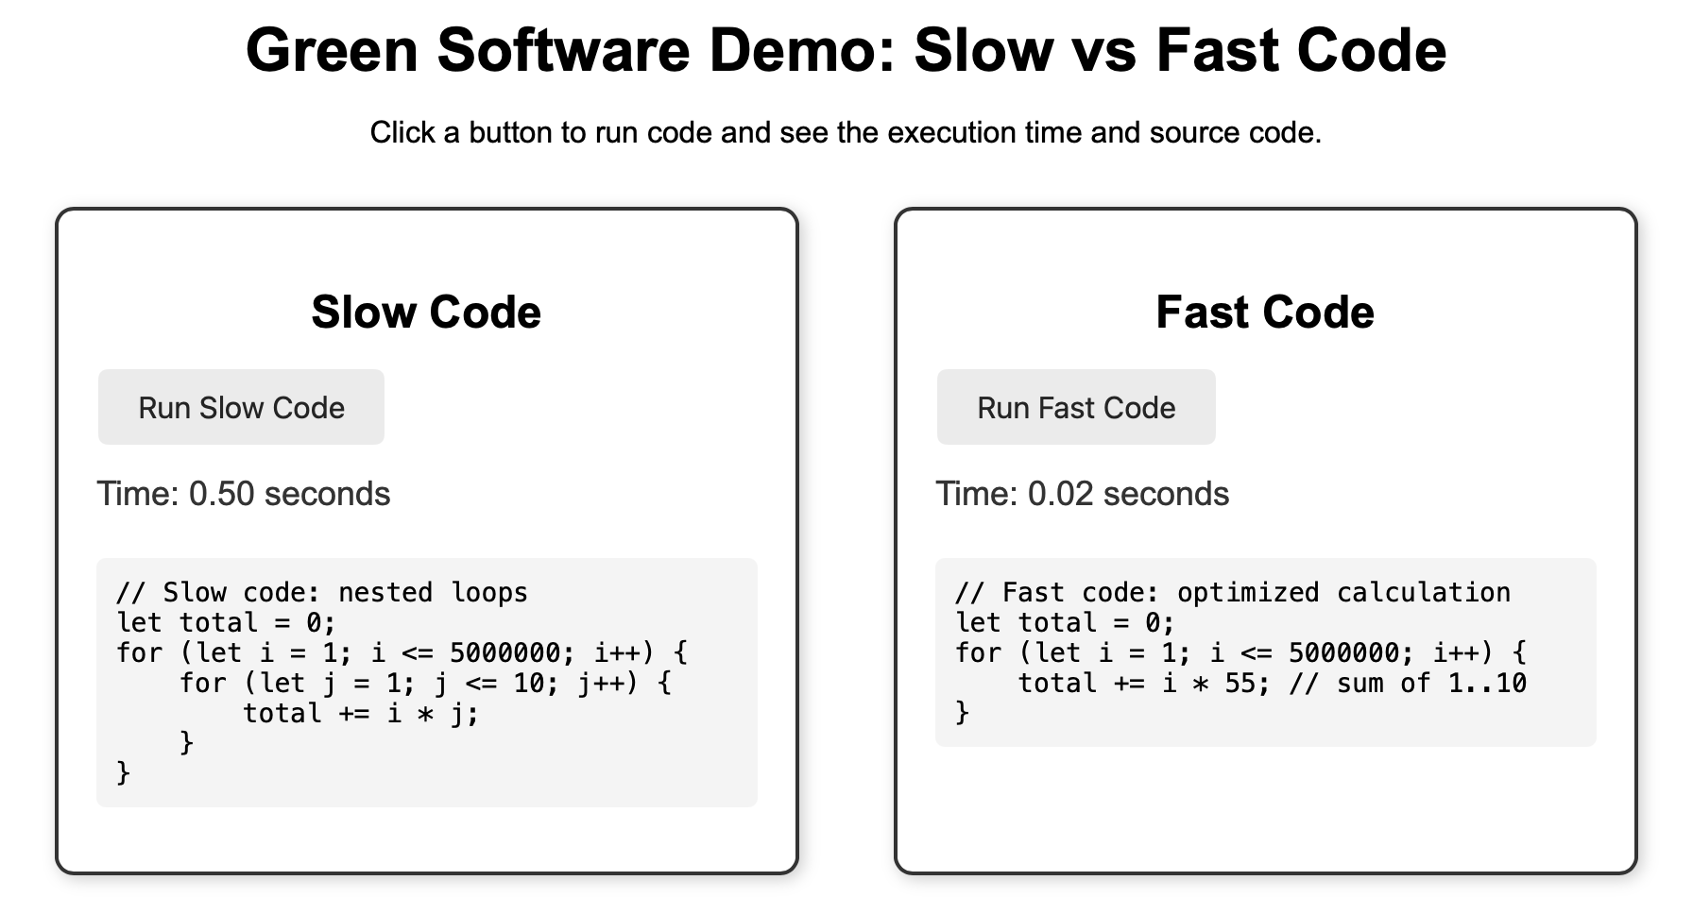
Figure 3. Micro-activity task 1 (source: Author)

The demo above illustrates how code optimization significantly impacts execution time and, by extension, energy consumption—a core principle of Green Software.
The Comparison:
Feature | Slow Code (Left) | Fast Code (Right)
Execution Time | 0.50 seconds | 0.02 seconds
Logic Type | Nested Loops | Optimized Calculation
Approach | Manually iterates through a second loop (1–10) for every increment of the first loop | Replaces the inner loop with a single mathematical constant (55).
Key Takeaway: The "Fast Code" is 25x faster because it eliminates redundant operations. In a real-world environment, this reduction in CPU cycles directly translates to: Lower electricity usage for servers and end-user devices; Reduced carbon footprint (Green Software); Improved user experience through faster response times.

Explications:
Table 1. Micro activity task 1 (source: Author)
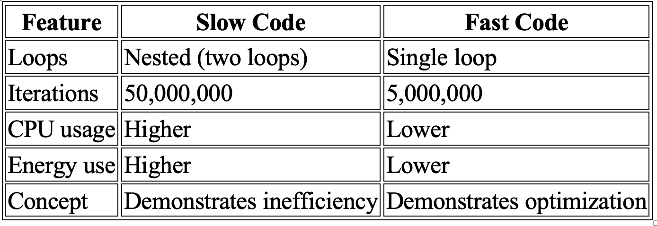
Learner task:
- Reflect on these results.
  - Compare the Two Codes
    - Identify how many loops are used in the slow code and in the fast code.
    - Compare the number of iterations executed by each version.
    - Explain briefly why the fast code runs quicker.
  - Performance and Energy Impact
    - Compare the execution times of the two codes.
    - Explain how shorter execution time can reduce CPU usage and energy consumption.
    - State why this is important for green software development.
  - Suggest one simple optimization that could improve the slow code.

Additional resources:
- The Humble Programmer by Edsger W. Dijkstra
- The Humble Programmer video
Key Takeaways:
- Although code feels intangible, every program we run consumes electricity in servers, networks, and devices. Even small inefficiencies ripple into measurable carbon emissions.
- Green software focuses on reducing energy use and carbon footprint without sacrificing functionality, performance, or user experience. Design decisions now include sustainability as a quality metric.
- The way software is structured — its algorithms, design patterns, and deployment architecture—directly affects energy consumption. Efficient architecture enables lower emissions and more sustainable computing.

Quick Check:
1. Which of the following best describes the environmental impact of software?
- Software is intangible, so it has no environmental impact
- Software can contribute to carbon emissions through energy use in hardware
- Software only impacts the environment if printed on paper
- Software reduces energy use automatically.

2. What is the main goal of green software principles?
- To make software run as fast as possible, regardless of energy use
- To minimize environmental impact while maintaining functionality
- To replace programming languages with eco-friendly ones
- To remove all features from software.

3. How does software architecture affect sustainability?
- Architecture has no effect on energy consumption
- Well-designed architecture can reduce energy use and carbon footprint
- Only the hardware matters, not the software structure
- Complex architectures always save energy.
Answer key: 1. b), 2. b), 3. c).

TOPIC 1.2: Sustainable SOLID Principles
Short introduction:
Sustainable SOLID Principles adapt traditional software design guidelines to reduce energy consumption and environmental impact, helping developers write maintainable, efficient, and eco-friendly code.
Theory & Knowledge:
The elegance of well-designed software lies not only in its functionality but in its efficiency, maintainability, and resource consumption. As we established in Topic 1.1, every architectural and design decision carries an environmental footprint. In this chapter, we explore how the SOLID principles—a cornerstone of object-oriented design—serve not only as guidelines for clean code but as powerful tools for reducing the energy consumption of our applications. By understanding and applying these principles through the lens of sustainability, we can write software that is simultaneously more maintainable, more performant, and less environmentally impactful.
The connection between code quality and energy consumption might not be immediately apparent, but it becomes clear when we examine what happens when design principles are violated. Bad design manifests in numerous ways that directly increase energy consumption. Memory leaks occur when objects are not properly released, causing applications to consume increasingly more RAM over time until the system struggles under the load, consuming maximum CPU cycles just to maintain responsiveness. Repeated computations happen when poorly structured code recalculate the same values multiple times rather than caching or structuring logic efficiently. Crashes and restarts not only frustrate users but waste enormous amounts of energy, as the entire application state must be reconstructed, dependencies reloaded, and connections reestablished.
Conversely, good design principles reduce energy consumption through several mechanisms. Well-structured code minimizes CPU cycles by ensuring that each computation happens exactly when and as often as needed, with no redundancy. It optimizes RAM usage by loading only necessary components into memory and releasing resources promptly when they're no longer needed. Perhaps most significantly, good design reduces maintenance energy—the ongoing computational cost of running, monitoring, and updating software over its lifetime. A well-designed system requires fewer patches, experiences fewer bugs, and degrades more gracefully under load, all of which translate directly into reduced energy consumption over the application's lifespan.
The SOLID principles, introduced by Robert C. Martin, provide a framework for achieving this good design. These five principles—Single Responsibility, Open/Closed, Liskov Substitution, Interface Segregation, and Dependency Inversion—were originally conceived to improve code maintainability and flexibility. However, as we'll see throughout this chapter, each principle also contributes to energy efficiency in concrete, measurable ways. By following SOLID principles, we write code that does less unnecessary work, consumes fewer resources, and requires less energy to execute and maintain.

Single Responsibility Principle (SRP)
The Single Responsibility Principle states that a class should have one, and only one, reason to change. Put differently, each class should have a single, well-defined responsibility. This principle might seem primarily about code organization, but its implications for energy consumption are profound. When a class has multiple responsibilities, changes to any one responsibility require recompiling, retesting, and potentially redeploying code that handles completely unrelated concerns. More critically, classes with multiple responsibilities tend to be loaded into memory even when only one of their functions is needed, wasting precious RAM.

Figure 4. Debate between maximalism and minimalism (source: Author)

The image above depicts a comparison between a massive, multi-functional tool and a set of individuals, specific tools. On the left is a highly complex Swiss Army knife featuring dozens of tools deployed at once. On the right are individual tools including a screwdriver, scissors, a knife, and other implements. This image highlights the contrast between all-in-one convenience and specialized functionality.

The energy benefits of this refactoring are measurable. First, memory footprint is reduced because each class loads only the dependencies it needs. If a request only requires report generation, no database or email libraries are loaded. Second, CPU efficiency improves because each class focuses on a single concern, allowing compilers and runtime optimizers to better inline methods and optimize execution paths. Third, maintenance energy decreases because changes to one responsibility don't require touching, recompiling, or redeploying unrelated code. A bug fix in email sending doesn't trigger recompilation of report generation logic.
Design that violates the SRP principle:

Figure 5. High coupling between domain logic and user interface logic (source: Author)
This diagram above illustrates an example of the Single Responsibility Principle in software design.
The central Rectangle class has two responsibilities: mathematical calculation (area ()) and graphical rendering (draw()). It is used by two different applications: a Computational Geometry Application and a Graphical Application. Because the Rectangle class handles both geometry and GUI rendering, this design tightly couples the applications to the GUI library. Modifying the draw() method to change how the rectangle looks can unintentionally affect the Computational Geometry Application.

Le's fix it.

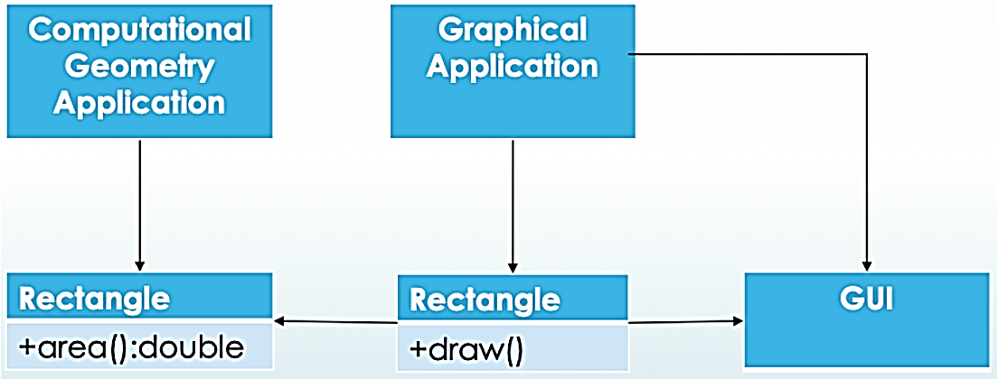
Figure 6. Refactored version of the previous figure, specifically applying the Interface Segregation Principle (ISP).
The diagram above illustrates a software design pattern, likely used to explain the Interface Segregation Principle or the Dependency Inversion Principle within Object-Oriented Design. It shows how different applications interact with specific functionalities of a Rectangle object through specialized interfaces:
Component Breakdown:
- Computational Geometry Application: Interacts with a Rectangle that focuses on mathematical properties, specifically the +area():double method.
- Graphical Application: Interacts with a Rectangle version meant for rendering, utilizing the +draw() method.
- GUI: Represents the graphical user interface component that the Graphical Application uses to facilitate the drawing process.
Key Observation: The diagram highlights the separation of concerns. Instead of one massive Rectangle class that handles both math and rendering, the design suggests splitting responsibilities so that the Computational Geometry Application isn't burdened with GUI-related code, and vice-versa.

Open/Closed Principle (OCP)
The Open/Closed Principle states that software entities should be open for extension but closed for modification. In practical terms, this means we should be able to add new functionality without changing existing code. This principle directly impacts energy consumption through its effect on deployment and compilation. Every time we modify existing code, we must recompile it, run the full test suite, and redeploy—processes that consume significant energy, especially in large applications with extensive CI/CD pipelines.
Additionally, testing becomes more efficient. Each notification channel can be tested in complete isolation. The test suite for email notifications doesn't need to run when we add SMS support. In large applications, this selective testing can reduce test execution time from hours to minutes, saving significant computational resources. The interface also enables selective loading—in memory-constrained environments, we can configure the application to instantiate only the notification channels actually needed, rather than loading all possible implementations.

Liskov Substitution Principle (LSP)
The Liskov Substitution Principle states that objects of a superclass should be replaceable with objects of its subclasses without breaking the application. More precisely, if S is a subtype of T, then objects of type T may be replaced with objects of type S without altering the desirable properties of the program. While this might sound abstract, LSP violations often lead to unexpected behaviour that forces applications to include extra error handling, validation, and recovery logic — all of which consume additional CPU cycles and memory.

Interface Segregation Principle (ISP)
The Interface Segregation Principle states that clients should not be forced to depend on interfaces they don't use. Large, monolithic interfaces force implementing classes to carry unnecessary dependencies, and client code to load functionality it never invokes. This principle has direct energy implications: smaller, more focused interfaces mean loading only the code and dependencies needed.
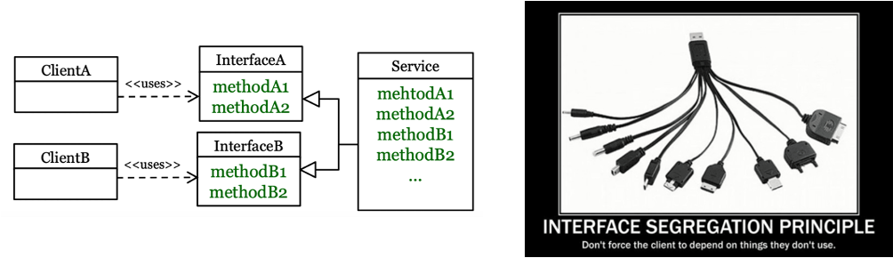
Figure 7. Interface Segregation Principle (source: Author)
The image above illustrates the Interface Segregation Principle (ISP), one of the five SOLID principles of object-oriented design. Core Concept - The principle states: "No code should be forced to depend on methods it does not use."
The Diagram (Left): Shows a "Service" that implements multiple methods. Instead of forcing Client A and Client B to interact with the entire service, the interface is split (segregated) into Interface A and Interface B. Each client only sees and depends on the specific methods it actually needs. The Analogy (Right): A multi-headed USB charging cable represents a "fat" interface. It's bulky and provides many connectors (methods) you might not need. ISP suggests providing specific, lean "plugs" instead of one giant, all-purpose tool. Key Benefits: Decoupling: Changes to methods in Interface B won't affect Client A.
Maintainability: Smaller, focused interfaces are easier to understand and implement.
Flexibility: It prevents "polluting" classes with unnecessary boilerplate code for methods they don't intend to use.
Dependency Inversion Principle (DIP)
The Dependency Inversion Principle states that high-level modules should not depend on low-level modules; both should depend on abstractions. Furthermore, abstractions should not depend on details; details should depend on abstractions. This principle enables swapping implementations without recompiling dependent code, and it facilitates testing with lightweight mock objects instead of heavy, resource-intensive real implementations.
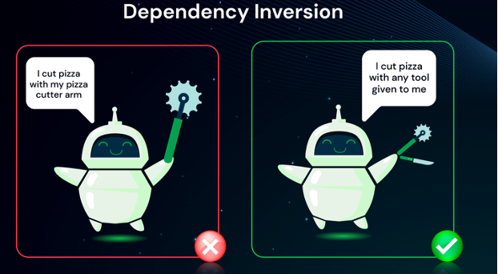
Figure 8. Dependency Inversion (source: Author)
The image above illustrates the Dependency Inversion Principle, a key software design concept within SOLID principles.
Wrong Approach (Left): The high-level module (the robot) is tightly coupled to a specific, low-level implementation (the pizza cutter arm).
Correct Approach (Right): The module depends on an abstraction (a general cutting tool interface), allowing it to use any specific tool without changing its code.
Benefits: This approach reduces technical debt, makes code more maintainable, and improves flexibility when changing functionality.

Conclusion
The SOLID principles represent more than design guidelines—they're a pathway to sustainable software engineering. By writing code that adheres to these principles, we create applications that consume fewer resources, require less energy to maintain, and adapt more efficiently to changing requirements. The Single Responsibility Principle reduces memory waste through focused classes. The Open/Closed Principle minimizes recompilation energy. The Liskov Substitution Principle eliminates defensive code overhead. The Interface Segregation Principle prevents unnecessary dependency loading. The Dependency Inversion Principle enables lightweight testing and flexible implementations.
As you continue through this course, view every design decision through this dual lens: does it improve code quality, and does it reduce energy consumption? Often, you'll find these goals perfectly aligned. Good design isn't just aesthetically pleasing or easier to maintain—it's more sustainable, consuming less of our planet's finite resources while delivering superior functionality.
Additional resources:
- SOLID Principles and Dependency Injection video
- Uncle Bob SOLID principles
- Application Design Patterns by Phil Japikse

Micro-Activity:
To solidify your understanding, complete this hands-on activity. You'll refactor a poorly designed class into multiple SRP-compliant classes while applying other SOLID principles.

public class UserManager
{
private List<User> _users = new List<User>();
private SqlConnection _connection;

public UserManager(string connectionString)
{
_connection = new SqlConnection(connectionString);
}

public void RegisterUser(string username, string email, string password)
{
// Validation logic
if (string.IsNullOrEmpty(username) || string.IsNullOrEmpty(email))
{
throw new ArgumentException("Invalid user data");
}

// Password hashing
var hashedPassword = HashPassword(password);

// Create user
var user = new User
{
Username = username,
Email = email,
PasswordHash = hashedPassword
};

// Save to database
_connection.Open();
var command = new SqlCommand(
"INSERT INTO Users (Username, Email, PasswordHash) VALUES (@u, @e, @p)",
_connection);
command.Parameters.AddWithValue("@u", username);
command.Parameters.AddWithValue("@e", email);
command.Parameters.AddWithValue("@p", hashedPassword);
command.ExecuteNonQuery();
_connection.Close();

// Send welcome email
var smtpClient = new SmtpClient("smtp.example.com");
var message = new MailMessage("noreply@example.com", email)
{
Subject = "Welcome!",
Body = $"Welcome {username}!"
};
smtpClient.Send(message);

// Log the action
File.AppendAllText("users.log", $"User registered: {username}\n");
}

private string HashPassword(string password)
{
// Simplified hashing
return Convert.ToBase64String(
System.Security.Cryptography.SHA256.HashData(
System.Text.Encoding.UTF8.GetBytes(password)));
}
}
Learner task:
Refactor this code to create the following classes, each with a single responsibility: UserValidator - validates user input. Make sure use at least one SOLID principle
Task 1 – Identify Responsibilities
- Analyze the UserManager class and list its different responsibilities.
- Identify which parts of the code are related to:
  - Validation
  - Database access
  - Email sending
  - Logging
- Explain briefly why having multiple responsibilities in one class is a problem.

Task 2 – Create UserValidator Class
- Refactor the validation logic into a new class called UserValidator.
- Move all user input checks (e.g., username, email, password) into this class.
- Ensure UserManager uses UserValidator instead of validating directly.
- Explain how this change applies the Single Responsibility Principle (SRP).

Task 3 – Apply One SOLID Principle
- Choose one SOLID principle (e.g., Single Responsibility or Dependency Inversion).
- Explain how the refactored design follows this principle.
- Describe one benefit of this refactoring (e.g., easier testing, better maintainability).

A potential solution might be:

UserValidator.cs
public class UserValidator
{
public void Validate(string username, string email, string password)
{
if (string.IsNullOrWhiteSpace(username))
throw new ArgumentException("Username is required");

if (string.IsNullOrWhiteSpace(email))
throw new ArgumentException("Email is required");

if (string.IsNullOrWhiteSpace(password))
throw new ArgumentException("Password is required");
}
}

UserManager.cs
public class UserManager
{
private readonly SqlConnection _connection;
private readonly UserValidator _validator;

public UserManager(string connectionString)
{
_connection = new SqlConnection(connectionString);
_validator = new UserValidator();
}

public void RegisterUser(string username, string email, string password)
{
// Validation (delegated)
_validator.Validate(username, email, password);

// Password hashing
string hashedPassword = HashPassword(password);

// Save user to database
_connection.Open();
var command = new SqlCommand(
"INSERT INTO Users (Username, Email, PasswordHash) VALUES (@u, @e, @p)",
_connection);

command.Parameters.AddWithValue("@u", username);
command.Parameters.AddWithValue("@e", email);
command.Parameters.AddWithValue("@p", hashedPassword);
command.ExecuteNonQuery();
_connection.Close();

// Log action
File.AppendAllText("users.log", $"User registered: {username}\n");
}

private string HashPassword(string password)
{
return Convert.ToBase64String(
System.Security.Cryptography.SHA256.HashData(
System.Text.Encoding.UTF8.GetBytes(password)));
}
}
Single Responsibility Principle (SRP)
- UserValidator → responsible only for validation
- UserManager → responsible for user registration workflow

Key Takeaways:
- Single Responsibility for Efficiency: Each module or class should have one clear responsibility, reduce unnecessary computations and making the code more energy efficient.
- Open/Closed for Sustainable Updates: Code should be open for extension but closed for modification, allowing improvements without rewriting large parts, which saves development energy over time.
- Dependency Management for Minimal Waste: Managing dependencies carefully avoids bloated code and excessive resource use, ensuring that software runs efficiently and sustainably.

Quick Check:
1. What does the “Single Responsibility Principle” (SRP) promote in sustainable software design?
- Each class should perform multiple unrelated tasks to save code
- Each class or module should have only one clear responsibility
- Classes should be as large as possible to avoid creating new ones
- Classes should depend on hardware for energy efficiency.
2. How does the “Open/Closed Principle” contribute to sustainable coding?
- It encourages rewriting existing code frequently
- It allows code to be extended without modifying existing parts
- It requires software to always remain closed to any changes
- It prioritizes speed over energy efficiency.
3. Why is careful dependency management important in green software design?
- It reduces unnecessary computations and resource use
- It allows unlimited external libraries to be included
- Dependencies have no effect on energy consumption
- It increases hardware usage for faster performance.

Answer key: 1. b), 2. b), 3. a).

TOPIC 1.3: Design Patterns for Energy Efficiency
Short introduction:
These patterns help developers make conscious choices in structuring code, managing resources, and handling data flows. By applying them, software can achieve better performance while minimizing electricity usage and carbon footprint.
Theory & Knowledge:
Software design patterns emerged in the 1990s as reusable solutions to common programming problems, codifying the collective wisdom of experienced developers into recognizable templates. While these patterns were originally conceived to improve code maintainability, flexibility, and comprehension, they carry profound—and often overlooked—implications for energy consumption. The way we instantiate objects, manage resources, handle events, and structure interactions directly translates into CPU cycles, memory allocation, and ultimately, watts of electricity consumed. In this chapter, we explore classic design patterns through the lens of sustainability, revealing how thoughtful application of these patterns can dramatically reduce the environmental footprint of our software systems.
Why Patterns Matter for Energy Efficiency
The relationship between design patterns and energy consumption operates at multiple levels of abstraction, from individual object instantiation to system-wide architectural decisions. At the most fundamental level, object creation is energetically expensive. Every time we instantiate an object, the runtime must allocate memory, initialize fields, invoke constructors, and potentially trigger garbage collection to make space. For simple objects, this overhead is negligible, but for heavyweight objects—database connections, network sockets, cryptographic providers, XML parsers, image processors—the cumulative cost becomes substantial when multiplied across thousands or millions of operations.
Design patterns address this problem by reducing duplication and improving reuse. When we reuse existing objects rather than creating new ones, we eliminate the entire energy cost of allocation, initialization, and eventual garbage collection. Patterns like Object Pool and Singleton formalize this reuse, providing tested, reliable mechanisms for sharing resources across different parts of an application. The energy savings compound over time: an application that creates one database connection and reuses it thousands of times consumes dramatically less energy than one that creates a new connection for each database operation.
Beyond object creation, patterns influence how our code executes at runtime. Reactive patterns like Observer replace polling with event-driven architectures, eliminating the wasteful CPU cycles consumed by repeatedly checking whether something has changed. Instead of a loop running continuously to monitor a condition—consuming CPU cycles even when nothing is happening—the Observer pattern allows code to sleep until an event actually occurs, reducing processor utilization and allowing aggressive power management. In a world where data centres house millions of CPU cores, the difference between constant polling and event-driven execution represents measurable megawatts of power consumption.
The GoF design patterns are:
Table 2. GoF design patterns (source: Author)
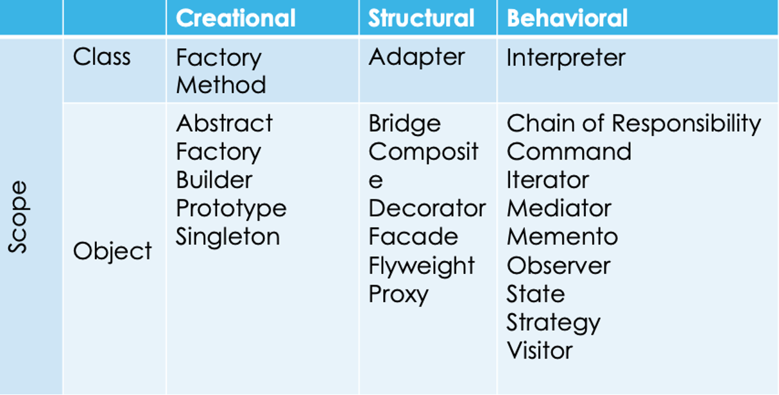

The table above categorizes the 23 classic Gang of Four (GoF) design patterns by their purpose and scope. Design Pattern Classification
Scope | Creational | Structural | Behavioural
Class | Factory Method | Adapter | Interpreter
Object | Abstract Factory, Builder, Prototype, Singleton | Bridge, Composite, Decorator, Facade, Flyweight, Proxy | Chain of Responsibility, Command, Iterator, Mediator, Memento, Observer, State, Strategy, Visitor
Key Definitions
1. Scope: a) Class: Focuses on relationships between classes and their subclasses (static, established at compile-time). B) Object: Focuses on relationships between objects (dynamic, can be changed at runtime).
2. Purpose: a) Creational: Deals with object creation mechanisms. B) Structural: Deals with object composition or how classes and objects are combined to form larger structures. c) Behavioural: Deals with communication and the assignment of responsibilities between objects.

Patterns also prevent unnecessary computation through strategic caching and lazy initialization. The Proxy pattern can cache expensive operation results, ensuring calculations happen once rather than repeatedly. The Lazy Initialization pattern defers object creation until necessary, preventing the waste of creating objects that might never be used. These patterns embody a fundamental principle of energy-efficient computing: the most sustainable computation is the one that never happens.

Singleton Pattern: Preventing Redundant Resource Creation
The Singleton pattern ensures a class has only one instance and provides a global point of access to that instance. While sometimes criticized for introducing global state, the Singleton pattern offers clear energy benefits when applied to heavyweight objects that should legitimately exist only once. Configuration managers, logging systems, connection pools, and cache managers are ideal Singleton candidates—they're expensive to create and typically need to be shared across an entire application.
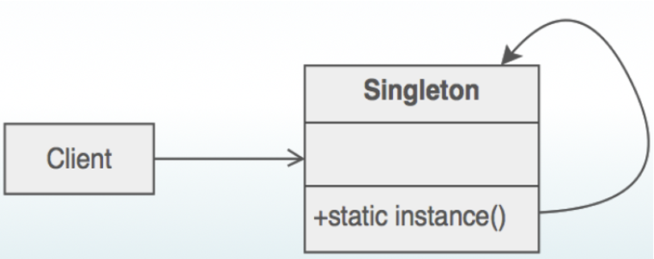
Figure 9. SIngleton Pattern (source: Author)

The image above displays a Unified Modelling Language (UML) class diagram representing the Singleton design pattern. Purpose: This pattern ensures that a class has only one instance and provides a global point of access to it. Key Components: It typically involves a private constructor, a static variable to hold the single instance, and a static method (labelled +static instance () in the diagram) to return that instance. Common Use: It is often used for managing shared resources, such as database connection pools or configuration settings. Drawbacks: The pattern can introduce global state into an application, which may make unit testing difficult and tighten coupling between classes.

PROS  - Global Access:  Provides a single, accessible instance.  - Lazy Initialization:  Instance is created only when needed.  - Thread Safety:  Can be made safe for multi-threading.  - Reduced Memory Usage:  Saves memory with one instance. | CONS  - SRP Violation:  Can violate the SRP.  - Testing Difficulty:  Makes unit testing challenging.  - Tight Coupling:  Code closely tied to Singleton instance.
The energy benefits are immediate and measurable. Configuration loads once from disk, regardless of how many services need access. Memory contains a single copy of the configuration data rather than multiple redundant copies. The Lazy wrapper ensures thread-safe initialization without the overhead of explicit locking on every access—it locks only during the initial creation, then provides lock-free access thereafter.

Observer Pattern: Event-Driven Efficiency
The Observer pattern defines a one-to-many dependency between objects so that when one object changes state, all its dependents are notified automatically. This pattern eliminates the wasteful practice of polling—repeatedly checking whether a condition has changed even when it rarely does. Polling consumes CPU cycles continuously, preventing processors from entering low-power states and wasting energy on fruitless checks.


Figure 10. Observer Pattern (source: Author)
The image above provides a definition of the Observer design pattern, which is a key concept in software engineering. What is the Observer Pattern? The Observer is a behavioural design pattern used to establish a one-to-many relationship between objects. It ensures that when one object (the Subject) changes state, all its dependents (the Observers) are notified and updated automatically.

PROS  - One-to-Many Relationship:  Handles one subject with multiple observers.  - Broadcast Notification:  Automatically informs all observers of changes.  - Event Handling:  Useful in GUIs for reacting to data changes. | CONS  - Order of Notification:  Notification order may be unpredictable.  - Debugging Complexity:  Debugging can be challenging due to distributed control flow.
The energy difference is dramatic. The event-driven Observer approach consumes virtually zero CPU when nothing is happening. The operating system's file system driver monitors changes at the hardware level, and only when a change occurs does it wake the application. Between events, the CPU can enter deep sleep states, reducing power consumption by orders of magnitude compared to constant polling.

Why pooling matters for performance, energy, and sustainability
Object pooling is an optimization pattern that reuses expensive-to-create objects instead of repeatedly creating and destroying them. In the provided example, the pooled object is a SqlConnection, which is costly in terms of CPU cycles, memory allocation, and I/O operations.
Creating and destroying a database connection for every operation, as shown in the scenario without pooling, is an expensive process. Each iteration requires allocating new memory, establishing a connection with the database through authentication and handshaking, and later releasing those resources. This constant creation and disposal of objects increase CPU workload and memory pressure, leading to more frequent garbage collection. As execution time grows, the processor remains active for longer periods, which directly results in higher energy consumption.
By contrast, object pooling significantly improves efficiency by reusing already created database connections. Instead of repeatedly allocating and deallocating objects, connections are created once and then shared across multiple operations. This reduces connection setup overhead and minimizes garbage collection activity. Consequently, operations complete faster, CPU usage becomes lower and more stable, and the energy consumed per operation is reduced. These benefits are particularly important in systems with high request rates, such as web servers, cloud platforms, and microservices architectures.
While the performance and energy differences may appear small in isolated tests, they become substantial at scale. In real-world applications, thousands or even millions of operations may be executed every hour. Inefficient object creation patterns multiply energy waste, increasing both electricity usage and cooling requirements in data centers. By applying object pooling, applications can scale more efficiently, consume less power, and contribute to the development of greener and more sustainable software systems.

Conclusion
Design patterns serve as more than organizational tools—they're instruments for energy optimization. The Singleton pattern prevents redundant object creation, ensuring heavyweight resources exist only once. Object pooling enables aggressive reuse, eliminating the repeated costs of allocation and initialization. The Observer pattern replaces wasteful polling with efficient event-driven architectures. Lazy initialization defers computation until absolutely necessary, often avoiding it entirely.
As you design systems, consider not just correctness and maintainability but also resource consumption. Ask: Does this object need to be created, or can it be pooled? Should I poll for changes, or can I react to events? Must this data be loaded immediately, or can it wait until accessed? These questions, grounded in classic design patterns, lead directly to more sustainable software.
Additional resources:
- Master Design Patterns & SOLID Principles in C#
- Refactoring guru
Micro-Activity:
To understand the real-world energy impact of these patterns, complete this hands-on exercise measuring object creation costs with and without pooling.
Scenario 1: No Pooling
public class DatabaseOperationWithoutPooling
{
public void ExecuteOperations(int operationCount)
{
var stopwatch = Stopwatch.StartNew();

for (int i = 0; i < operationCount; i++)
{
// Create new connection every time
using (var connection = new SqlConnection("connection-string"))
{
connection.Open();
// Simulate query
Thread.Sleep(10);
connection.Close();
}
}

stopwatch.Stop();
Console.WriteLine($"Without pooling: {operationCount} operations in {stopwatch.ElapsedMilliseconds}ms");
}
}

Scenario 2. With Pooling

public class DatabaseOperationWithPooling
{
private readonly ObjectPool<SqlConnection> _pool;

public DatabaseOperationWithPooling()
{
_pool = new ObjectPool<SqlConnection>(
objectFactory: () =>
{
var conn = new SqlConnection("connection-string");
conn.Open();
return conn;
},
resetAction: conn => { /* reset if needed */ },
maxSize: 10
);
}

public void ExecuteOperations(int operationCount)
{
var stopwatch = Stopwatch.StartNew();

for (int i = 0; i < operationCount; i++)
{
var connection = _pool.GetObject();
try
{
// Simulate query
Thread.Sleep(10);
}
finally
{
_pool.ReturnObject(connection);
}
}

stopwatch.Stop();
Console.WriteLine($"With pooling: {operationCount} operations in {stopwatch.ElapsedMilliseconds}ms");
}
}

Learner task:
- Measure execution time for 100, 1000, and 10000 operations
- Use a performance profiler (Visual Studio Diagnostic Tools, dotMemory, or PerfView) to measure:
- Total memory allocated
- Number of garbage collections
- CPU utilization
- Calculate energy difference: Use the formula: Energy ∝ (CPU Time × CPU Power) + (Memory Allocations × Memory Power)

Key takeaways:
- Reusable Solutions Reduce Waste: Applying well-known patterns avoids redundant or inefficient code, saving computational resources and energy.
- Optimize Resource Management: Design patterns guide efficient handling of memory, processing, and I/O, reducing unnecessary energy consumption.
- Balance Performance and Sustainability: Patterns help structure software in a way that maintains functionality and performance while minimizing carbon footprint.

Quick Check:
1. What is the main benefit of using design patterns for energy efficiency?
- They make the code look more complex
- They provide reusable solutions that reduce energy consumption
- They increase memory usage
- They guarantee zero carbon emissions.

2. How do energy-efficient design patterns help with resource management?
- By handling memory, processing, and I/O efficiently
- By duplicating computations for safety
- By ignoring CPU and memory usage
- By increasing the number of loops in code.

3. Why is balancing performance and sustainability important in software design?
- To slow down programs intentionally
- To maintain functionality while minimizing energy use
- To remove all features from software
- To prioritize only hardware efficiency.

Answer key: 1 .b), 2. a), 3. b).

TOPIC 1.4: Measuring the Impact of Your Code
Short introduction:
Measuring the impact of your code helps developers understand how software affects energy consumption and carbon emissions. It involves tracking resource usage, such as CPU, memory, and execution time, to identify inefficiencies. By quantifying the environmental footprint, developers can make informed decisions to optimize code. This process is a key step in building sustainable, eco-friendly software.
Theory & Knowledge:
In the previous chapters, we explored design principles and patterns that reduce software's environmental footprint. Yet without measurement, our optimization efforts remain speculative—we might believe we're writing greener code, but belief without data is merely hope. The fundamental challenge of sustainable software engineering is captured in a simple maxim: you cannot reduce what you do not measure. This chapter equips you with the knowledge, tools, and techniques to transform invisible energy consumption into tangible metrics, enabling you to make informed decisions about the environmental impact of your code.
Software developers have long optimized for performance metrics like response time, throughput, and latency. We profile our applications to find bottlenecks, measure memory allocations to prevent leaks, and track CPU utilization to ensure responsiveness. These traditional metrics correlate with energy consumption, but the relationship isn't always straightforward. A highly optimized algorithm that completes in milliseconds might consume more instantaneous power than a slower algorithm yet use less total energy due to its brevity. Without direct measurement, we cannot distinguish between these scenarios.
Measurement transforms abstract environmental concern into actionable engineering data. When we can quantify that a specific code changes reduced energy consumption by 30%, we can justify the refactoring effort to stakeholders who might otherwise prioritize features over efficiency. When we can demonstrate that migrating from polling to event-driven architecture eliminated 95% of idle CPU consumption, we provide concrete evidence for architectural decisions. Measurement creates accountability—both to us and to the planet.
Moreover, measurement reveals non-obvious energy consumption patterns. You might assume that microservice architecture is more efficient than a monolith because services can scale independently. But measurement might reveal that the network overhead of inter-service communication and the operational overhead of maintaining multiple service instances actually consumes more energy than a well-optimized monolithic application. Measurement challenges our assumptions and guides us toward evidence-based sustainability rather than intuition-based guesses.
The act of measurement itself drives behavior change. When development teams see real-time energy metrics alongside traditional performance indicators, energy efficiency becomes a first-class concern rather than an afterthought. Teams begin asking questions like "Why does this endpoint consume 3x more energy than similar endpoints?" and "Can we defer this computation to off-peak hours when renewable energy is more abundant?" Measurement makes the invisible visible, transforming energy consumption from an abstract externality into a concrete engineering challenge.

From Energy to Carbon: Understanding the Formula
Energy consumption and carbon emissions are related but distinct concepts, and understanding their relationship is crucial for measuring environmental impact. Energy is measured in kilowatt-hours (kWh) and represents the amount of electrical power consumed over time. A server running at 200 watts for 5 hours consumes 1 kWh of energy (200W × 5h = 1000Wh = 1kWh). Carbon emissions, measured in grams or kilograms of CO₂ equivalent (gCO₂e or kgCO₂e), depend not only on the energy consumed but on how that energy was generated.

The fundamental equation linking energy to carbon is:
Carbon Emissions (gCO₂e) = Energy Consumed (kWh) × Carbon Intensity (gCO₂e/kWh)
Carbon intensity varies dramatically by location, time, and energy source. A data centre powered entirely by solar panels during daylight hours might have a carbon intensity near zero. The same data centre at night, drawing from a grid powered primarily by coal, might have a carbon intensity exceeding 1000 gCO₂e/kWh. This variability creates both challenges and opportunities for sustainable software engineering.
Let's explore this relationship with concrete examples:
public class CarbonCalculator
{
// Carbon intensity values (gCO₂e per kWh) for different energy sources
private static readonly Dictionary<string, double> CarbonIntensityBySource = new()
{
{ "Coal", 1000.0 }, // Very high carbon intensity
{ "Natural Gas", 490.0 }, // Moderate carbon intensity
{ "Grid Average (US)", 417.0 }, // US grid average (2023)
{ "Grid Average (EU)", 295.0 }, // EU grid average (2023)
{ "Solar", 48.0 }, // Low (manufacturing emissions only)
{ "Wind", 11.0 }, // Very low
{ "Nuclear", 12.0 }, // Very low
{ "Hydroelectric", 24.0 } // Very low
};

// Calculate carbon emissions from energy consumption
public static double CalculateCarbonEmissions(
double energyKwh,
string energySource)
{
if (!CarbonIntensityBySource.TryGetValue(energySource, out double intensity))
{
throw new ArgumentException($"Unknown energy source: {energySource}");
}

double emissions = energyKwh * intensity;
Console.WriteLine($"Energy: {energyKwh:F4} kWh");
Console.WriteLine($"Source: {energySource} ({intensity:F0} gCO₂e/kWh)");
Console.WriteLine($"Emissions: {emissions:F2} gCO₂e ({emissions / 1000:F4} kgCO₂e)");

return emissions;
}

// Convert watts and time to kWh
public static double WattsToKwh(double watts, TimeSpan duration)
{
double hours = duration.TotalHours;
double kwh = (watts * hours) / 1000.0;
return kwh;
}

// Real-world example: Compare running a server in different locations
public static void CompareDataCenterLocations()
{
Console.WriteLine("=== Scenario: Running a 200W server for 24 hours ===\n");

double serverWatts = 200.0;
TimeSpan runtime = TimeSpan.FromHours(24);
double energyConsumed = WattsToKwh(serverWatts, runtime);

Console.WriteLine($"Server power: {serverWatts}W");
Console.WriteLine($"Runtime: {runtime.TotalHours} hours");
Console.WriteLine($"Total energy: {energyConsumed:F2} kWh\n");

// Compare different locations
var locations = new[]
{
("Coal-powered region", "Coal"),
("US grid average", "Grid Average (US)"),
("EU grid average", "Grid Average (EU)"),
("Iceland (renewable)", "Hydroelectric")
};

foreach (var (location, source) in locations)
{
Console.WriteLine($"Location: {location}");
CalculateCarbonEmissions(energyConsumed, source);
Console.WriteLine();
}
}

// Calculate carbon savings from optimization
public static void CalculateOptimizationSavings(
double beforeWatts,
double afterWatts,
TimeSpan duration,
string energySource,
int numberOfServers = 1)
{
Console.WriteLine("=== Optimization Impact Analysis ===\n");

double beforeKwh = WattsToKwh(beforeWatts, duration) * numberOfServers;
double afterKwh = WattsToKwh(afterWatts, duration) * numberOfServers;
double savedKwh = beforeKwh - afterKwh;

double beforeEmissions = CalculateCarbonEmissions(beforeKwh, energySource);
double afterEmissions = CalculateCarbonEmissions(afterKwh, energySource);
double savedEmissions = beforeEmissions - afterEmissions;

Console.WriteLine($"\n--- Results ---");
Console.WriteLine($"Servers: {numberOfServers}");
Console.WriteLine($"Before optimization: {beforeWatts}W per server");
Console.WriteLine($"After optimization: {afterWatts}W per server");
Console.WriteLine($"Energy saved: {savedKwh:F2} kWh ({(savedKwh / beforeKwh) * 100:F1}%)");
Console.WriteLine($"Carbon saved: {savedEmissions:F2} gCO₂e ({savedEmissions / 1000:F2} kgCO₂e)");
Console.WriteLine($"Reduction: {(savedEmissions / beforeEmissions) * 100:F1}%");
}
}

// Demonstrate the calculations
public class CarbonMeasurementDemo
{
public static void Main()
{
// Example 1: Compare data center locations
CarbonCalculator.CompareDataCenterLocations();

Console.WriteLine("\n" + new string('=', 60) + "\n");

// Example 2: Calculate savings from code optimization
// Scenario: Optimized algorithm reduces server load from 180W to 120W
CarbonCalculator.CalculateOptimizationSavings(
beforeWatts: 180.0,
afterWatts: 120.0,
duration: TimeSpan.FromDays(30), // One month
energySource: "Grid Average (US)",
numberOfServers: 10
);
}
}
Running this code produces output like:
=== Scenario: Running a 200W server for 24 hours ===
Server power: 200W
Runtime: 24 hours
Total energy: 4.80 kWh

Location: Coal-powered region
Energy: 4.8000 kWh
Source: Coal (1000 gCO₂e/kWh)
Emissions: 4800.00 gCO₂e (4.8000 kgCO₂e)

Location: US grid average
Energy: 4.8000 kWh
Source: Grid Average (US) (417 gCO₂e/kWh)
Emissions: 2001.60 gCO₂e (2.0016 kgCO₂e)
Location: Iceland (renewable)
Energy: 4.8000 kWh
Source: Hydroelectric (24 gCO₂e/kWh)
Emissions: 115.20 gCO₂e (0.1152 kgCO₂e)

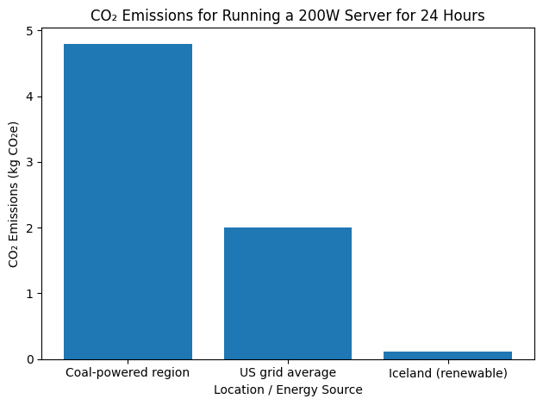
Figure 11. Comparison of daily Co2 emissions (kg Co2e) for 2000W server based on regional energy grid intensity (source: Author)

The bar chart above compares the emissions produced by running a 200W server for 24 hours across three different locations/energy sources:
- Coal-powered region: The highest emitter, producing nearly 5 kg Co2e
- US grid average: Produces exactly 2 kg Co2e, which is less than half of the coal-powered region.
- Iceland (renewable): The lowest emitter by a significant margin, producing near-zero emissions.
The data illustrates how the carbon intensity of a local power grid drastically changes the environmental impact of identical computing tasks.

This visualization highlights how the energy mix dominates environmental impact, even when energy consumption is identical (4.8 kWh).
The same energy consumption produces dramatically different carbon emissions depending on the energy source. This explains why major cloud providers increasingly locate data centres in regions with abundant renewable energy—it's not just about cost, but about reducing carbon intensity.
The Green Software Foundation developed the Software Carbon Intensity (SCI) specification to provide a standardized method for calculating software's carbon emissions. Unlike simple energy measurements, SCI accounts for multiple dimensions of software's environmental impact. The complete SCI formula is:
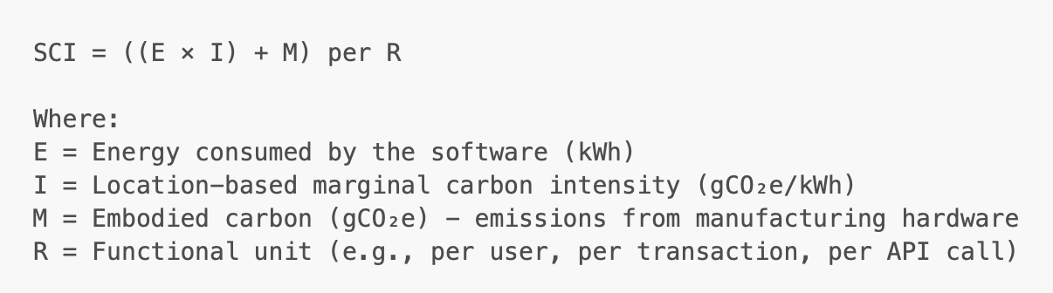
Figure 12. Software Carbon Intensity (SCI) specification formula (source: Author)
The image above shows the Software Carbon Intensity (SCI) formula: SCI = ((E × I) + M) per R. Where E is energy consumed (kWh), I is location-based marginal carbon intensity (gCO2e/kWh), M is embodied carbon from hardware (gCO2e), and R is the functional unit, such as per user or API call.

Practical Measurement Tools
Theory without practice remains abstract. To measure actual energy consumption and performance characteristics, we need tools. Fortunately, modern development environments provide robust profiling capabilities, and specialized tools enable energy-specific measurements.
Windows Task Manager and Resource Monitor

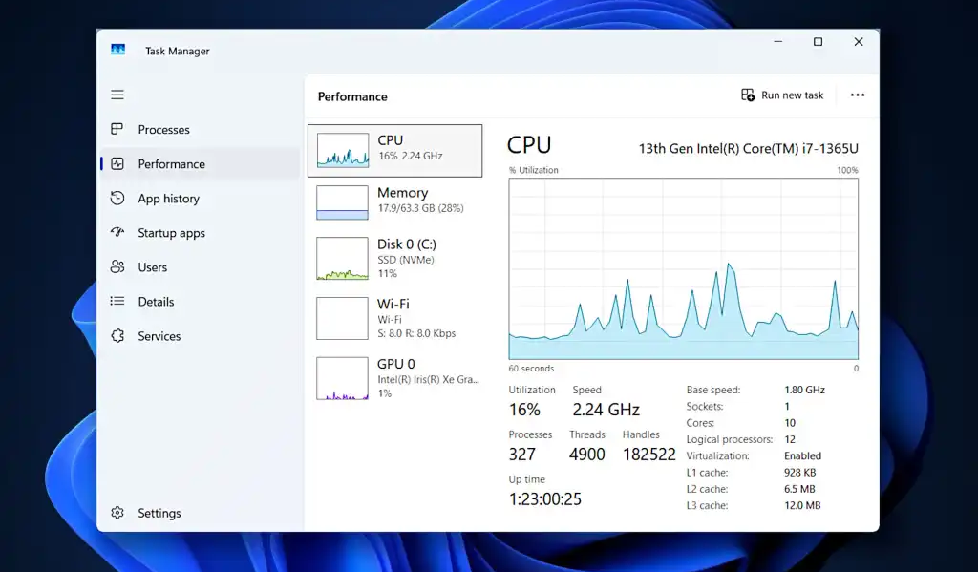
Figure 13. Windows Task Manager and Resource Monitor (source: Author)
This image above displays the Performance tab of the Windows Task Manager, showing real-time resource utilization for a computer.
- CPU: The system is powered by an Intel Core i7-1365U processor.
- Memory: 17.9 GB of RAM is currently being used out of a total capacity.
- Storage: The system disk (Disk 0) is an NVMe SSD with 11% utilization.
- GPU: Graphics performance is monitored via an Intel Iris Xe Graphics chip.

MacOS Activity Monitor
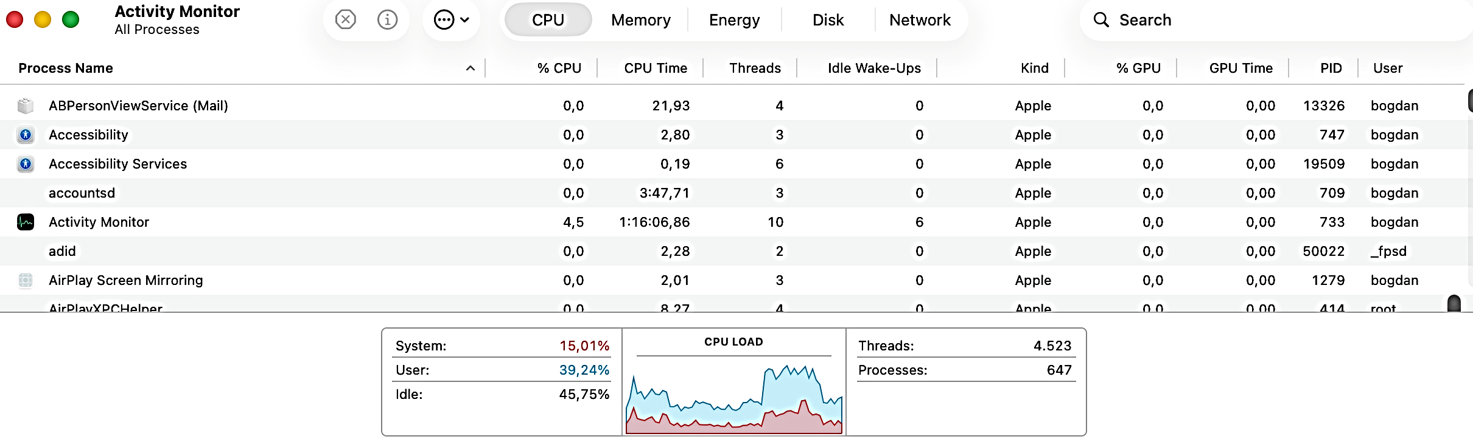
Figure 14. Mac Os Activity Monitor (source: Author)
The image above represents a screenshot of the Activity Monitor on macOS, showing the CPU tab. The top section lists active processes with columns for % CPU, CPU Time, Threads, and Idle Wakeups. Notable processes listed include Activity Monitor (using 4.5% CPU) and various background services like accounts and Accessibility. A detailed breakdown at the bottom provides a snapshot of the total CPU LOAD:
- System: 15.01%
- User: 39.24%
- Idle: 45.75%
A real-time graph visualizes the load over time, alongside a total count of 4,523 Threads and 647 Processes.
Visual Studio Diagnostic Tools

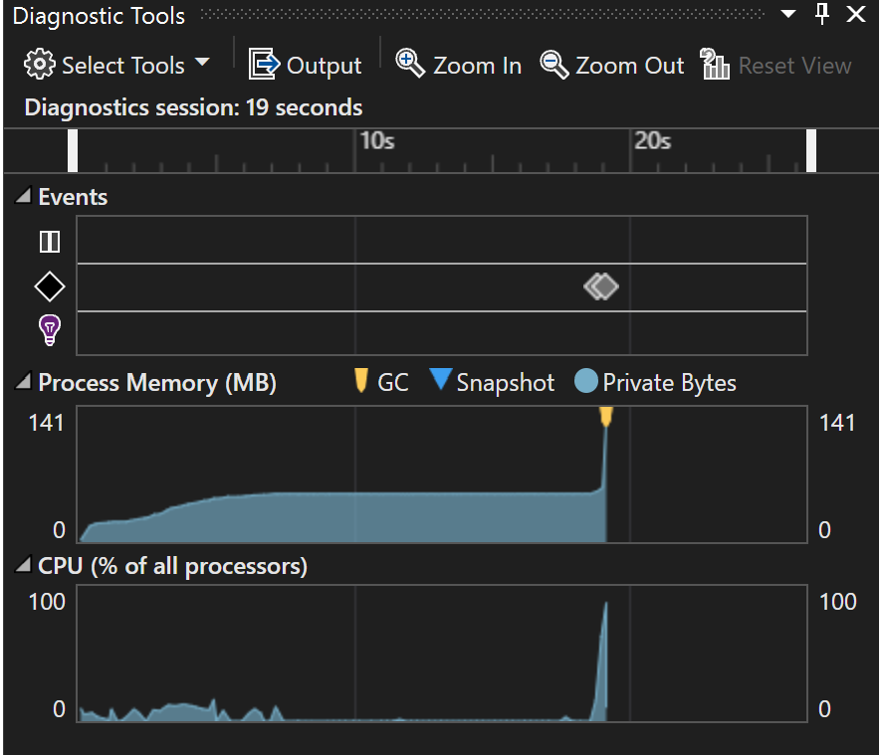
Figure 15. Visual Studio Diagnostic Tools (source: Author)
The image above shows the Diagnostic Tools window in Microsoft Visual Studio, which is used for monitoring application performance during debugging. Key features visible in the graph include:
- Process Memory: A graph tracking the memory usage in megabytes over time, including markers for Garbage Collection (GC) and snapshots.
- CPU Usage: A graph showing the percentage of processing power being used by the application.
- Events: A timeline recording debugging events like breakpoints and exceptions.
- Diagnostics Session: A timer indicating how long the current debugging session has been running.

Conclusions
Measurement transforms sustainability from aspiration to engineering discipline. By quantifying energy consumption, calculating carbon emissions, and tracking Software Carbon Intensity, we create accountability and enable continuous improvement. The tools and techniques in this chapter—from simple Task Manager observations to sophisticated SCI calculations—provide a complete toolkit for measuring and optimizing software's environmental impact.
Remember that measurement serves improvement. Every optimization begins with a baseline measurement, proceeds through targeted changes, and validates through remeasurement. This cycle of measure-optimize-remeasure creates a virtuous loop where each iteration compounds previous gains, ultimately producing software that delivers functionality while treading lightly on our planet.
Additional resources:
- Visual Studio Training - Diagnostic Tools
- How to read Activity Monitor on Mac?
- Analyzing Windows Applications: Using Task Manager & Resource Monitor.

Micro-Activity:
Measuring Object Creation Impact
To solidify your understanding of measurement techniques, complete this comprehensive exercise comparing an application before and after optimization.
Scenario 1: Image processing no-optimization
public class ImageProcessingService_Baseline
{
public byte[] ApplyGrayscaleFilter(byte[] imageData)
{
// Inefficient: Create new array for each pixel operation
var result = new List<byte>();

for (int i = 0; i < imageData.Length; i += 3)
{
byte r = imageData[i];
byte g = imageData[i + 1];
byte b = imageData[i + 2];

// Convert to grayscale
byte gray = (byte)(0.299 * r + 0.587 * g + 0.114 * b);

result.Add(gray);
result.Add(gray);
result.Add(gray);
}

return result.ToArray(); // Additional allocation
}

public async Task<List<byte[]>> ProcessImageBatch(List<byte[]> images)
{
var results = new List<byte[]>();

// Sequential processing - inefficient
foreach (var image in images)
{
results.Add(ApplyGrayscaleFilter(image));
await Task.Delay(10); // Simulate I/O
}

return results;
}
}

Scenario 2. Image processing service with optimizations

public class ImageProcessingService_Optimized
{
private static readonly ArrayPool<byte> _bufferPool = ArrayPool<byte>.Shared;

public byte[] ApplyGrayscaleFilter(byte[] imageData)
{
// Efficient: Pre-allocate exact size needed
byte[] result = _bufferPool.Rent(imageData.Length);

try
{
for (int i = 0; i < imageData.Length; i += 3)
{
byte r = imageData[i];
byte g = imageData[i + 1];
byte b = imageData[i + 2];

// Convert to grayscale
byte gray = (byte)(0.299 * r + 0.587 * g + 0.114 * b);

result[i] = gray;
result[i + 1] = gray;
result[i + 2] = gray;
}

// Return exact size (pooled array may be larger)
var exactResult = new byte[imageData.Length];
Array.Copy(result, exactResult, imageData.Length);
return exactResult;
}
finally
{
_bufferPool.Return(result);
}
}

public async Task<List<byte[]>> ProcessImageBatch(List<byte[]> images)
{
// Parallel processing - efficient use of multi-core CPUs
var tasks = images.Select(async image =>
{
await Task.Delay(10); // Simulate I/O
return ApplyGrayscaleFilter(image);
});

var results = await Task.WhenAll(tasks);
return results.ToList();
}
}
Step 3: Measurement and Comparison

public class ImageProcessingBenchmark
{
public static async Task Main()
{
// Generate test data
var testImages = GenerateTestImages(count: 50, sizeKB: 100);

var monitor = new SystemResourceMonitor();

// Measure baseline
Console.WriteLine("Measuring BASELINE version...\n");
var baseline = new ImageProcessingService_Baseline();
var baselineResult = await monitor.MeasureOperation(
async () => await baseline.ProcessImageBatch(testImages),
"Baseline Image Processing"
);
baselineResult.DisplayReport();
var baselineEnergy = baselineResult.EstimateEnergyConsumption();

Console.WriteLine("\n" + new string('=', 70) + "\n");

// Measure optimized
Console.WriteLine("Measuring OPTIMIZED version...\n");
var optimized = new ImageProcessingService_Optimized();
var optimizedResult = await monitor.MeasureOperation(
async () => await optimized.ProcessImageBatch(testImages),
"Optimized Image Processing"
);
optimizedResult.DisplayReport();
var optimizedEnergy = optimizedResult.EstimateEnergyConsumption();

// Generate comparison report
GenerateComparisonReport(baselineResult, optimizedResult, baselineEnergy, optimizedEnergy);
}

static List<byte[]> GenerateTestImages(int count, int sizeKB)
{
var images = new List<byte[]>();
var random = new Random(42); // Fixed seed for reproducibility

for (int i = 0; i < count; i++)
{
var imageData = new byte[sizeKB * 1024];
random.NextBytes(imageData);
images.Add(imageData);
}

return images;
}

static void GenerateComparisonReport(
MeasurementResult baseline,
MeasurementResult optimized,
double baselineEnergy,
double optimizedEnergy)
{
Console.WriteLine("\n" + new string('=', 70));
Console.WriteLine("\n=== OPTIMIZATION IMPACT REPORT ===\n");

double speedImprovement =
(baseline.TotalDuration.TotalMilliseconds - optimized.TotalDuration.TotalMilliseconds) /
baseline.TotalDuration.TotalMilliseconds * 100;

double energySavings =
(baselineEnergy - optimizedEnergy) / baselineEnergy * 100;

Console.WriteLine($"Execution Time:");
Console.WriteLine($" Baseline: {baseline.TotalDuration.TotalMilliseconds:F2}ms");
Console.WriteLine($" Optimized: {optimized.TotalDuration.TotalMilliseconds:F2}ms");
Console.WriteLine($" Improvement: {speedImprovement:F1}% faster\n");

Console.WriteLine($"Energy Consumption:");
Console.WriteLine($" Baseline: {baselineEnergy * 1000000:F2} µWh");
Console.WriteLine($" Optimized: {optimizedEnergy * 1000000:F2} µWh");
Console.WriteLine($" Savings: {energySavings:F1}%\n");

Console.WriteLine($"Scaling Impact:");
Console.WriteLine($" Per 1M operations: {(baselineEnergy - optimizedEnergy) * 1000000:F2} Wh saved");
Console.WriteLine($" Per day (1M ops): {(baselineEnergy - optimizedEnergy) * 1000000 / 1000:F4} kWh saved");
Console.WriteLine($" Annual (365M ops): {(baselineEnergy - optimizedEnergy) * 365000000 / 1000:F2} kWh saved");

// Calculate carbon savings
double carbonIntensity = 400; // gCO₂e/kWh (US average)
double annualCarbonSaved = (baselineEnergy - optimizedEnergy) * 365000000 * carbonIntensity / 1000;
Console.WriteLine($"\n Annual Carbon Saved: {annualCarbonSaved:F2} kgCO₂e");
Console.WriteLine($" Equivalent to: {annualCarbonSaved / 411:F2} trees planted");
}
}
Learner task:
- Implement both versions of the image processing service
- Run the benchmark and collect measurements
- Analyze the results to understand where improvements came from

Key Takeaways:
- Quantify Energy and Carbon Footprint. Measuring CPU, memory, and runtime allows developers to understand the environmental impact of their software.
- Identify Inefficiencies. Tracking resource usage highlights parts of the code that consume unnecessary energy and need optimization.
- Guide Sustainable Decisions. Data from measurements helps developers make informed choices to optimize algorithms, design patterns, and architectures for energy efficiency.

Quick Check:
1. Why is it important to measure the impact of your code?
- To make the code run slower
- To understand its energy consumption and carbon footprint
- To increase the number of lines of code
- To avoid writing comments

2. Which of the following can be measured to assess code efficiency?
- CPU usage, memory usage, and execution time
- Screen resolution
- Number of functions in the code
- D) The color of the editor theme.

Answer key: 1. b), 2. a).

Module 1: Conclusion and Self-Assessment
Module Summary:
This module introduces the emerging field of sustainable software engineering, exploring how software design decisions directly impact energy consumption, carbon emissions, and environmental sustainability. Beginning with foundational concepts in green software and architecture, students learn to recognize that software is not intangible—it runs on physical infrastructure that consumes electricity and generates heat. The module examines how architectural choices, from monolithic to microservices designs, influence resource utilization and environmental footprint, establishing the critical connection between code quality and ecological responsibility.
The curriculum then advances into practical application through sustainable interpretations of SOLID principles and energy-efficient design patterns. Students discover how classical software engineering principles like Single Responsibility and Dependency Inversion can be leveraged not just for maintainability, but for reducing computational overhead and power consumption. Through exploration of design patterns such as lazy loading, caching strategies, and efficient data structures, learners develop concrete techniques for minimizing resource waste while maintaining functionality and performance.
The module culminates with hands-on experience in measuring and quantifying software's environmental impact. Students gain proficiency with tools and methodologies for profiling energy consumption, analyzing carbon intensity of cloud deployments, and establishing metrics for sustainable software development. By course completion, participants will possess both the theoretical framework and practical skills needed to make informed decisions that balance functional requirements with environmental stewardship, positioning them to contribute to the growing movement toward greener technology practices.

Module Knowledge Quiz
1. Which of the following best describes the primary environmental impact of software?
- Software code files take up storage space on servers
- Software execution requires electricity to power physical infrastructure
- Software development requires paper for documentation
- Software updates require shipping physical media

2. What is the relationship between software architecture and carbon emissions?
- There is no relationship; only hardware affects emissions
- Architecture choices affect computational efficiency, which impacts energy consumption and emissions
- Only mobile applications contribute to carbon emissions
- Carbon emissions only occur during software deployment, not execution
3. How does applying the Single Responsibility Principle contribute to sustainable software?
- It reduces the number of developers needed on a project
- It minimizes unnecessary computations by ensuring components do only what they need to do
- It eliminates the need for testing
- It automatically reduces power consumption by 50%

4. Which SOLID principle helps reduce energy consumption by avoiding tight coupling that leads to unnecessary object instantiation?
- Single Responsibility Principle
- Open/Closed Principle
- Dependency Inversion Principle
- Interface Segregation Principle

5. What is the primary benefit of implementing lazy loading in sustainable software design?
- It makes code easier to read
- It delays resource initialization until actually needed, reducing unnecessary energy use
- It speeds up application startup time only
- It eliminates all memory usage

6. What does "carbon intensity" measure in the context of software sustainability?
- The amount of carbon in computer hardware
- The grams of CO2 emitted per unit of energy consumed
- The number of carbon-based materials used in data centers
- The carbon footprint of software developers

7. Which metric is most important when profiling software for energy efficiency?
- Lines of code written
- Number of features implemented
- CPU cycles and memory usage over time
- d) Developer productivity

MODULE 2: Energy-Efficient Architecture
Module Overview:
This module explores how architectural decisions influence the energy consumption and environmental impact of software systems. Learners will examine classical and modern architectural models, such as MVC and microservices, through the lens of sustainability, and understand how cloud and carbon-aware approaches can reduce emissions. By the end of the module, students will be able to evaluate, design, and optimize system architectures that support energy efficiency, sustainable cloud usage, and alignment with renewable energy availability.
Module learning outcomes:
- Explain how software architectural models influence energy consumption and environmental impact, with a focus on MVC and sustainable design principles.
- Evaluate microservices and modern architectures in terms of resource usage, scalability, and energy efficiency.
- Apply sustainable cloud computing strategies to optimize workload placement, resource utilization, and energy consumption.
- Design system architectures that incorporate carbon-aware computing, aligning computational workloads with low-carbon and renewable energy sources.
- Assess and improve existing system architectures by identifying architectural inefficiencies and proposing energy-efficient and environmentally sustainable alternatives.
Estimated workload:
Lecture hours (F2F): 8
Self-study: 9,5
Practical application (if applicable): 8
Assessment link: This module supports the completion of the Capstone Project (Workshop 2: Infrastructure & Impact) and the final presentation regarding architecture choice and carbon reduction calculations.
Practical focus / deliverable:
A sustainable system architecture proposal, calculated carbon reduction estimates, and a final project presentation.

Topic 2.1: Architectural Models: MVC and Sustainable Design
Short introduction:
Architectural models define how software components are structured and interact, directly influencing performance and energy consumption. This topic examines the MVC pattern through a sustainability perspective, highlighting how clear separation of concerns can improve efficiency. By applying sustainable design principles, developers can reduce unnecessary processing and resource usage. These architectural choices form the foundation for energy-efficient software systems.
Theory & Knowledge:
Software architecture transcends individual code decisions, establishing patterns that persist throughout an application's lifetime. While a poorly chosen algorithm might affect a single function's efficiency, a poorly chosen architecture affects every function, every interaction, and every future modification. Architecture determines whether your application scales linearly or exponentially, whether it can leverage caching effectively, and whether modifications require recompiling and redeploying entire systems or just isolated components. This chapter explores Model-View-Controller (MVC) architecture through the lens of sustainability, demonstrating how architectural patterns influence energy consumption at every layer of the application stack.

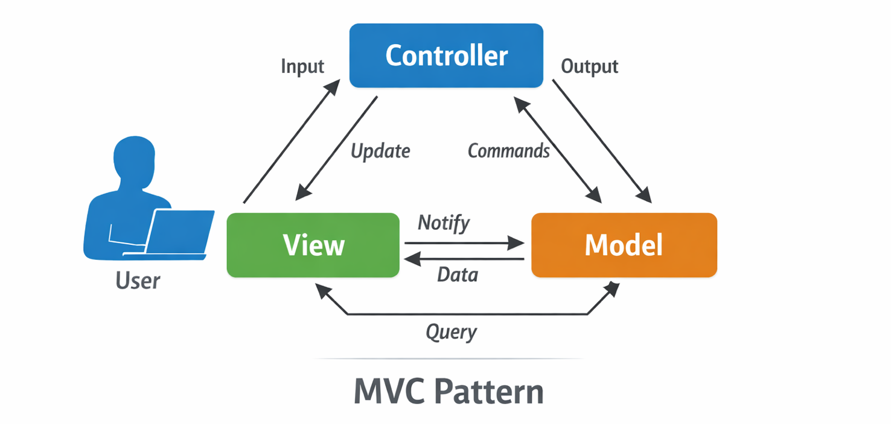
Figure 16. Model-View-Controller (MVC) pattern (source: Author)

A diagram above represents the Model-View-Controller (MVC) architectural pattern. It shows a User sending Input to and receiving Output from a central Controller. The Controller receives Updates from the View and exchanges Commands with the Model via a bidirectional arrow. The View sends Notifications to the Model, while the Model sends Data back to the View. A double-headed arrow at the bottom indicates a Query relationship between the View and Model.
The interactions in the MVC (Model–View–Controller) pattern, following the figure you generated:
- User → Controller (Input). The interaction starts with the user, who performs an action such as clicking a button, submitting a form, or triggering an event. This input is captured by the Controller, which acts as the entry point for all user actions. The Controller interprets the intent of the request but does not contain business logic itself.
- Controller → Model (Commands / Updates). Based on the user input, the Controller issues commands to the Model. These commands may request data updates, trigger computations, or modify application state. The Model encapsulates the core business logic and data, ensuring that rules and constraints are enforced independently of the user interface.
- Model → View (Notify / Data). When the Model changes its state, it notifies the View (directly or indirectly, depending on the framework). The View then retrieves the required data from the Model and prepares it for presentation. This ensures that the View always reflects the current state of the application.
- View → User (Output). The View renders the data into a visual or otherwise perceivable form—such as HTML, a GUI, or a chart—and presents it back to the user. The View contains formatting and display logic only, with no business rules.
- View → Model (Query). In many MVC implementations, the View queries the Model for the data it needs to display. This pull-based interaction keeps the View lightweight and prevents duplication of application logic.
- Controller → View (Coordination).

In web-based Model–View–Controller (MVC) frameworks, the Controller acts as the central coordinator of application flow, selecting which View to render or update in response to user actions while remaining agnostic to how data is stored or displayed. By cleanly separating interaction logic (Controller), business logic (Model), and presentation (View), MVC reduces coupling between system components, improves testability, and enables parallel development—advantages that are especially critical in large-scale systems. Beyond structural clarity, this separation also yields tangible energy-efficiency benefits: computations are centralized and reused in the Model, updates are propagated only where necessary, caching becomes more effective, and costly I/O and data transfers are minimized. As a result, MVC transforms efficiency into an architectural property, helping systems scale predictably in performance, maintainability, and energy consumption over long operational lifetimes.

The Controller may select which View to render or update, especially in web MVC frameworks. It coordinates flow without being responsible for how data is displayed or stored.
MVC cleanly separates interaction logic (Controller), business logic (Model), and presentation (View). This reduces coupling, improves testability, enables parallel development, and—crucially for large systems—helps prevent architectural inefficiencies from propagating across layers.

The Model–View–Controller (MVC) pattern delivers not only structural clarity but also measurable energy-efficiency benefits, especially in large-scale and long-lived systems. These benefits emerge from how MVC constrains where computation happens and how often it is repeated.
- Reduced Redundant Computation. By isolating business logic in the Model, MVC prevents the same computations from being duplicated across multiple views or controllers. Expensive operations—such as database queries or data transformations—are executed once and reused, reducing CPU cycles and lowering overall energy consumption.
- Efficient Change Propagation. MVC ensures that changes in application state are localized to the Model, with only affected Views being updated. Instead of recomputing or re-rendering the entire interface, MVC supports targeted updates, minimizing unnecessary processing and rendering work.
- Improved Caching Opportunities. Clear separation of concerns makes caching far more effective. Models can cache computed results, Controllers can cache routing decisions, and Views can cache rendered output. These architectural boundaries enable reuse of previously computed data, reducing repeated execution and saving energy at scale.
- Lower Data Transfer and I/O Costs. In MVC, the Controller mediates access to the Model, preventing uncontrolled data access patterns. This reduces excessive database queries, network calls, and disk I/O—operations that are among the most energy-intensive in modern systems.
- Better Scalability with Predictable Resource Use. MVC encourages stateless Controllers and well-defined Models, making it easier to scale systems horizontally. Predictable execution paths allow infrastructure to be right-sized, avoiding overprovisioning and the energy waste associated with idle or underutilized resources.
- Easier Optimization and Refactoring. Because responsibilities are clearly separated, performance and energy optimizations can be applied precisely where they matter most—usually in the Model—without triggering widespread side effects. This reduces the energy cost of repeated refactoring and large-scale architectural migrations.
- Reduced Long-Term Maintenance Energy. MVC’s modularity lowers cognitive load and development effort over time. Faster debugging, simpler testing, and fewer regressions translate into shorter development cycles and less computational overhead in CI/CD pipelines, contributing to long-term energy savings.

In essence, MVC turns energy efficiency into an architectural property rather than a per-feature concern, ensuring that as systems scale in users, data, and years of operation, their energy footprint grows more slowly and predictably.

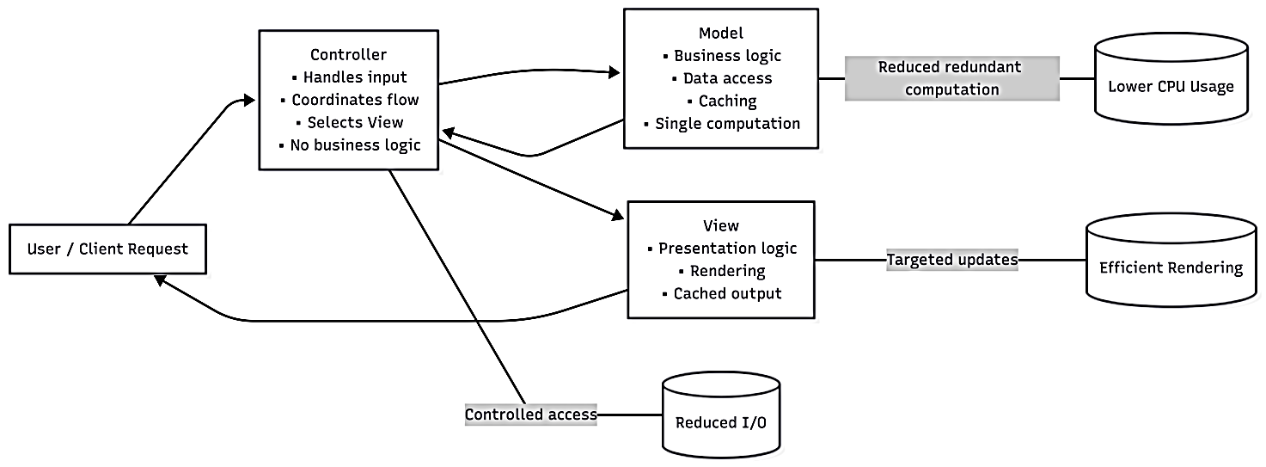
Figure 17. Optimized MVC Architecture (source: Author)

The diagram above illustrates an optimized Model-View-Controller (MVC) flow. A "User / Client Request" points to a "Controller," which handles input and coordinates flow between a "Model" and a "View." The "Model" manages business logic and caching, leading to "Reduced redundant computation" and "Lower CPU Usage." The "View" handles presentation and rendering, leading to "Targeted updates" and "Efficient Rendering." The "Controller" also has "Controlled access" to storage, resulting in "Reduced I/O." All components work together to return a response to the user.

The diagram illustrates the Model–View–Controller (MVC) interaction flow in a web application. A user request is first handled by the Controller, which coordinates the application logic without performing data processing or rendering. The Controller interacts with the Model to execute business logic, access data, and reuse cached computations, then selects the appropriate View to present the results. The View renders only the necessary output and returns it to the user. This clear separation of responsibilities reduces redundant computation, limits unnecessary data access and I/O, enables targeted updates, and ultimately improves performance, scalability, and energy efficiency.

Why Architecture Matters for Long-Term Energy Usage
The architectural decisions made in the first weeks of a project establish constraints and patterns that persist for years, sometimes decades. Unlike algorithmic optimizations that can be refactored locally, architectural changes often require wholesale rewrites. Understanding architecture's energy implications is therefore crucial—by the time problems become apparent, they're often prohibitively expensive to fix.
The Model-View-Controller (MVC) pattern exemplifies architecture's enduring power over software systems. When developers choose MVC in those critical early weeks, they're not merely organizing code—they're encoding assumptions about data flow, responsibility boundaries, and system evolution that will echo through every subsequent decision. The separation of business logic (Model), presentation (View), and coordination (Controller) create neural pathways in the codebase that become increasingly calcified over time. Teams instinctively route new features through these established channels, and the pattern becomes self-reinforcing. A system born with MVC rarely escapes it; attempting to migrate to event-driven architecture or microservices years later means untangling dependencies that have grown organic and intricate, like roots through foundation cracks.
The energy implications of architectural choices remain largely invisible until scale forces a reckoning. A poorly designed MVC implementation might require the database to be queried repeatedly for the same data, each request triggering cascading view updates that ripple across controllers. Multiply this inefficiency across millions of users, and the architectural debt manifests as data centres burning megawatts unnecessarily. Sustainable architectural design demands upfront consideration of data locality, caching strategies, and computational complexity—decisions that are trivial to implement in week one but may require team-months to retrofit later. The carbon footprint of software is ultimately determined not by algorithm choice but by whether the fundamental architecture enables or prevents efficient resource utilization at scale.
This is why architecture deserves the same rigor we apply to safety-critical systems. Teams must resist the temptation to "start coding and refactor later“ that later never comes or comes at costs that dwarf the initial savings. Architectural decisions should be treated as design constraints that will outlive the original developers, shape hiring decisions, and determine which future features are feasible versus impossible. The question is not whether architecture will constrain the system, but whether those constraints will align with long-term needs. By recognizing that architecture is indeed destiny, organizations can invest appropriately in that critical first phase, treating it not as overhead but as the foundation upon which all future flexibility—and sustainability—depends.

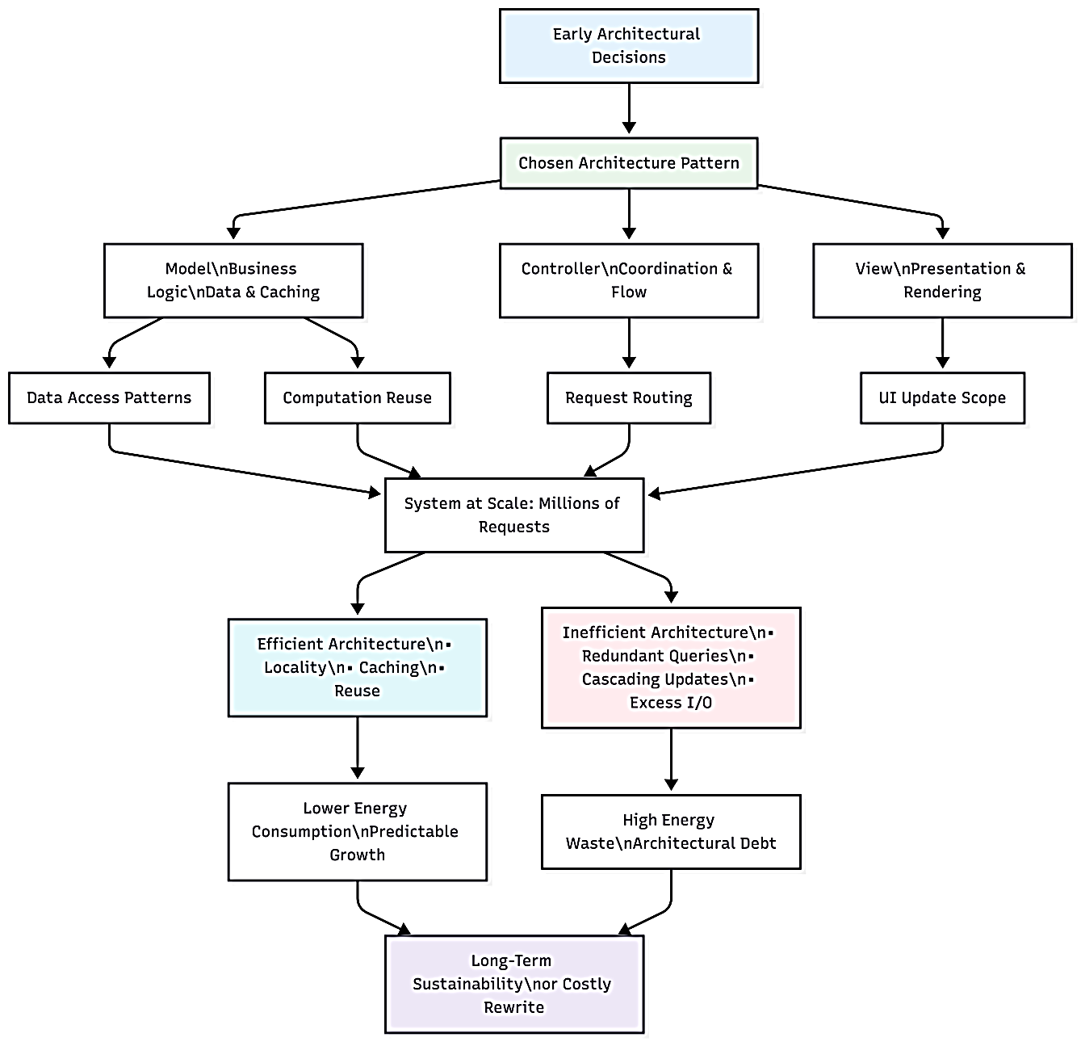
Figure 18. Architectural Path to Sustainability (source: Author)
A flowchart above titled Early Architectural Decisions illustrates how design choices impact a system's long-term viability. The flow begins with a Chosen Architecture Pattern divided into three components:
- Model (Business Logic, Data & Caching) influencing Data Access Patterns and Computation Reuse.
- Controller (Coordination & Flow) influencing Request Routing.
- View (Presentation & Rendering) influencing UI Update Scope.
When the System at Scale reaches millions of requests, the path diverges:
- Efficient Architecture: Utilizes locality, caching, and reuse, leading to Lower Energy Consumption and Predictable Growth.
- Inefficient Architecture: Characterized by redundant queries, cascading updates, and excess I/O, leading to High Energy Waste and Architectural Debt.
Both paths culminate in the outcome: Long-Term Sustainability or Costly Rewrite.

The diagram shows how early architectural decisions, such as choosing the MVC pattern, shape a system for its entire lifetime. That initial choice defines how responsibilities are divided between the Model, View, and Controller, which in turn determines data access, computation reuse, and update behaviour. As the system scales, these patterns either enable efficient reuse, caching, and locality—leading to predictable performance and lower energy consumption—or amplify inefficiencies such as redundant queries and cascading updates, resulting in high energy waste and architectural debt. Ultimately, the diagram emphasizes that architecture is destiny: decisions made early quietly but decisively determine long-term scalability, sustainability, and the cost of change.
On a scale, these architectural choices quietly but relentlessly shape the energy profile of entire systems. Design decisions around data models, caching strategies, service boundaries, and communication patterns decide whether work is reused or redundantly repeated. A poorly placed query, an unnecessary network round trip, or an over-eager abstraction can cascade through layers of software, amplifying resource consumption far beyond its original scope. Conversely, architectures that emphasize locality, reuse, and clear responsibility boundaries transform efficiency from an afterthought into a built-in property, ensuring that performance and sustainability improve together as systems grow.
public class ArchitecturalImpactAnalysis
{
// Calculate long-term energy impact of architectural decisions
public static void AnalyzeTemporalImpact()
{
Console.WriteLine("=== Long-Term Architectural Energy Impact ===\n");

// Scenario: API endpoint with architectural inefficiency
double requestsPerSecond = 1000;
double hoursPerDay = 24;
double daysPerYear = 365;

// Inefficient architecture: 10ms per request
double inefficientMs = 10.0;
double efficientMs = 1.0; // 10x improvement through better architecture

// Calculate annual request volume
double annualRequests = requestsPerSecond * 3600 * hoursPerDay * daysPerYear;

// Calculate total CPU time (simplified)
double inefficientCpuHours = (annualRequests * inefficientMs / 1000.0) / 3600.0;
double efficientCpuHours = (annualRequests * efficientMs / 1000.0) / 3600.0;

// Energy estimation (65W average CPU power)
double cpuWatts = 65.0;
double inefficientEnergy = inefficientCpuHours * cpuWatts / 1000.0; // kWh
double efficientEnergy = efficientCpuHours * cpuWatts / 1000.0;

Console.WriteLine($"Annual request volume: {annualRequests:N0}");
Console.WriteLine($"\nInefficient architecture (10ms/request):");
Console.WriteLine($" CPU time: {inefficientCpuHours:N0} hours");
Console.WriteLine($" Energy: {inefficientEnergy:N2} kWh");

Console.WriteLine($"\nEfficient architecture (1ms/request):");
Console.WriteLine($" CPU time: {efficientCpuHours:N0} hours");
Console.WriteLine($" Energy: {efficientEnergy:N2} kWh");

double energySaved = inefficientEnergy - efficientEnergy;
double carbonSaved = energySaved * 400; // 400g CO2/kWh (US average)

Console.WriteLine($"\nAnnual savings:");
Console.WriteLine($" Energy: {energySaved:N2} kWh");
Console.WriteLine($" Carbon: {carbonSaved / 1000:N2} kg CO₂e");
Console.WriteLine($" Cost: ${energySaved * 0.12:N2} (at $0.12/kWh)");

Console.WriteLine($"\n5-year impact:");
Console.WriteLine($" Energy saved: {energySaved * 5:N0} kWh");
Console.WriteLine($" Carbon saved: {carbonSaved * 5 / 1000:N0} kg CO₂e");
Console.WriteLine($" Equivalent to: {carbonSaved * 5 / 411:N0} trees planted");
}
}

If you run AnalyzeTemporalImpact(), the console output will be:
=== Long-Term Architectural Energy Impact ===
Annual request volume: 31,536,000,000
Inefficient architecture (10ms/request):
CPU time: 87,600 hours
Energy: 5,694.00 kWh

Efficient architecture (1ms/request):
CPU time: 8,760 hours
Energy: 569.40 kWh

Annual savings:
Energy: 5,124.60 kWh
Carbon: 2,049.84 kg CO₂e
Cost: $614.95 (at $0.12/kWh)

5-year impact:
Energy saved: 25,623 kWh
Carbon saved: 10,249 kg CO₂e
Equivalent to: 24,940 trees planted
This output illustrates how a seemingly small architectural improvement (10 ms → 1 ms per request) compounds into substantial energy, cost, and carbon savings at scale.

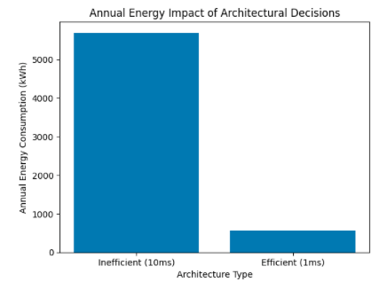
Figure 19. Order-of-magnitude difference caused by a small per-request inefficiency (source: Author)

A bar chart above titled Annual Energy Impact of Architectural Decisions. The y-axis measures Annual Energy Consumption (kWh) from 0 to 5000+, and the x-axis compares two Architecture Types:
- Inefficient (10ms): A tall blue bar reaching over 5000 kWh.
- Efficient (1ms): A much shorter blue bar reaching approximately 500 kWh.
The chart visually demonstrates that an efficient architecture can reduce annual energy consumption by roughly 90% compared to an inefficient one.

The visual clearly shows the order-of-magnitude difference caused by a small per-request inefficiency when amplified over a year at scale. If you’d like, I can also generate:
- a 5-year cumulative energy chart,
- a carbon emissions comparison, or
- a cost impact visualization.

Micro-activity:
Identifying Energy-Efficient MVC Decisions
Objective: Help participants understand how MVC supports energy efficiency by recognizing wasteful vs. efficient architectural choices.
Setup: A smart building system monitors and optimizes energy consumption using sensors and user controls. The system must:
- Collect energy usage data
- Display energy information to users
- Reduce unnecessary energy consumption automatically.
Learner task: Design a MVC architecture for this use case.
Additional resources:

Building an ASP.NET Core MVC Site
- ASP.NET MVC Pattern
- ASP.NET MVC Getting Started

Key Takeaways:
- Architecture shapes energy use: Small inefficiencies become significant at scale; MVC helps contain and localize computation.
- Do work once, reuse often: Placing logic in the Model prevents repeated calculations across Views and Controllers.
- Clear separation enables optimization: MVC makes it easier to cache, profile, and optimize high-impact components.
- Sustainability starts at design time: Energy efficiency is far cheaper to achieve upfront than through later architectural migration.

Quick Check:
1. An API handles 1,000 requests per second. Each request wastes 5 ms due to poor architecture. How much CPU time is wasted per second?
- 0.5 seconds
- 5 seconds
- 50 seconds
- 500 seconds.
2. A Model computation takes 10 ms and is reused by 5 Views instead of being recomputed for each View. How much CPU time is saved per request?
- 10 ms
- 20 ms
- 40 ms
- 50 ms.
3. A system runs 24 hours/day with a constant waste of 0.2 CPU seconds per second. How many CPU hours are wasted per day?
- 4.8 hours
- 24 hours
- 48 hours
- 120 hours.
4. If saving 1 CPU hour avoids 65 Wh of energy use, how much energy is saved by eliminating 100 CPU hours?
- 650 Wh
- 6,500 Wh
- 65,000 Wh
- 0.65 kWh.

Answer key: 1. b), 2. c), 3. a), 4. c).

TOPIC 2.2: Microservices and Modern Architectures
Short introduction:
Modern software systems increasingly rely on microservices to meet the demands of scalability, agility, and maintainability. Unlike traditional monolithic architectures, where all functionality is bundled into a single codebase, microservices break applications into small, independent services that communicate over well-defined APIs. Each service focuses on a specific business capability, allowing teams to develop, deploy, and scale components independently. This architectural style improves fault isolation, supports continuous delivery, and enables more efficient use of resources. Coupled with modern practices like containerization, orchestration, and cloud-native deployment, microservices form the backbone of flexible, resilient, and energy-conscious modern architectures.
Theory & Knowledge:
The evolution from monolithic applications to distributed architectures represents one of the most significant shifts in software engineering over the past decade. Microservices, event-driven systems, and serverless computing promise improved scalability, faster deployment cycles, and better resource utilization. Yet these architectural patterns also introduce complexity, network overhead, and new energy consumption challenges. This chapter examines modern architectural approaches through the lens of sustainability, revealing when distribution saves energy and when it wastes it, and providing practical guidance for making informed architectural decisions that balance functionality, performance, and environmental impact.
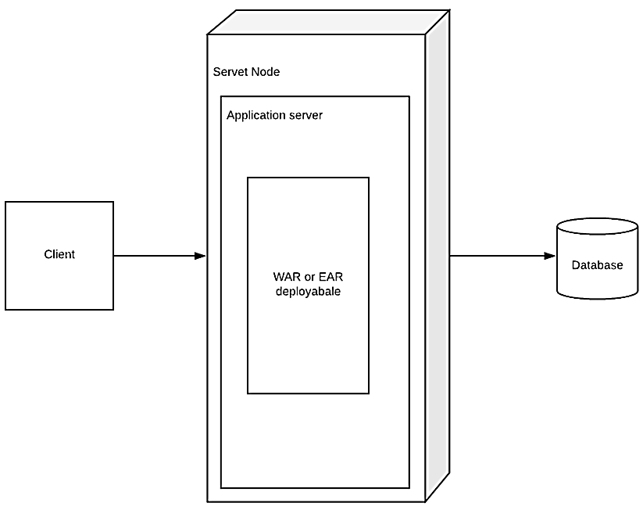
Figure 20.Java Enterprise Edition (Java EE) deployment architecture (source: Author)
A technical diagram above illustrates a server deployment architecture. An arrow points from a box labelled Client to a larger 3D box labelled Server Node. Inside the Server Node is a nested box for the Application server, which contains a final box labelled WAR or EAR deployable. An arrow points from the Server Node to a cylinder icon on the right labelled Database.
A monolithic architecture is a traditional software design approach in which an entire application is built as a single, unified unit. All core components—such as the user interface, business logic, and data access layer—are tightly integrated and deployed together as one executable or service. This architecture is often easier to develop, test, and deploy in the early stages of a project because of its simplicity and straightforward structure. However, as the application grows in size and complexity, a monolith can become difficult to maintain, scale, and update, since even small changes require redeploying the entire system. Despite these limitations, monolithic architecture remains a viable and efficient choice for small to medium-sized applications or systems with stable and well-defined requirements.

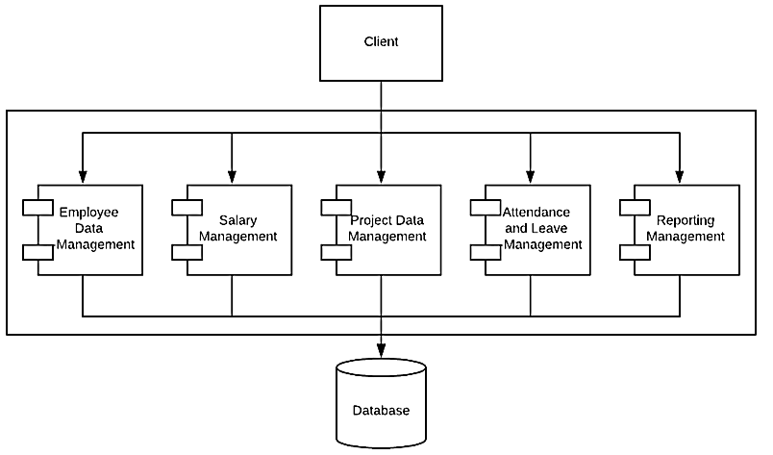
Figure 21. UML Component Diagram for a Human Resource Management System (HRMS) (source: Author)

A component diagram above illustrates a modular system architecture. A top-level box labelled Client points to a large container housing five distinct modules: Employee Data Management, Salary Management, Project Data Management, Attendance and Leave Management, and Reporting Management. Each module, represented by a standard component icon, has a flow leading to a single Database cylinder at the bottom.

Service-Oriented Architecture (SOA) is a design paradigm where an application is composed of loosely coupled, reusable services that communicate over a network using standardized protocols. Each service encapsulates a specific business function and can be discovered and invoked by other services or applications. SOA emphasizes interoperability, modularity, and scalability, enabling organizations to integrate heterogeneous systems and evolve their IT landscape without major rewrites. By promoting clear service boundaries and reusability, SOA also lays the foundation for more efficient resource use and easier maintenance, making it a precursor to modern microservices architectures.

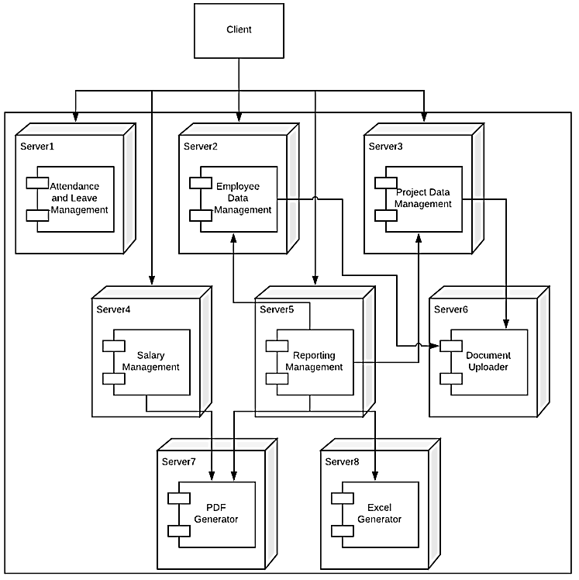
Figure 22. UML Deployment Diagram representing a Distributed Microservices Architecture for an HR or Enterprise Resource Planning (ERP) system (source: Author)

A distributed systems diagram above illustrates a microservices-style architecture across multiple server nodes. A Client box at the top connects to a cluster of eight distinct servers (Server1 through Server8), each hosting a specific functional component:
- Server1-5: Primary modules handling Attendance, Employee Data, Projects, Salary, and Reporting.
- Server6: A Document Uploader component receiving data from the Employee and Project management servers.
- Server7 & 8: Dedicated PDF and Excel Generator components that process requests from the Salary and Reporting management servers.
The diagram shows a highly decoupled system where specific tasks are offloaded to specialized server nodes.

A microservices architecture is a modern software design approach in which an application is composed of a collection of small, independent services, each responsible for a specific business function. These services communicate with one another through lightweight mechanisms, typically APIs, and can be developed, deployed, and scaled independently. This architectural style improves flexibility, scalability, and fault isolation, allowing teams to update or replace individual services without affecting the entire system. While microservices enable faster innovation and better alignment with agile development practices, they also introduce added complexity in areas such as service orchestration, monitoring, security, and data consistency. As a result, microservices are best suited for large, complex applications managed by experienced development teams.
Table 3. An energy perspective of Monolith/SoA/Microservice architectures
Architecture | Resource Reuse | Scaling Overhead | Communication Overhead | Energy Efficiency
Monolith | Low | High | Low | Low at scale
SOA | Medium | Medium | Medium (heavy protocols) | Medium
Microservices | High | Low (per service) | Low (lightweight protocols) | High

When Microservices Save Energy: Real-World Scenarios
Microservices shine in energy efficiency when workloads are dynamic or unevenly distributed across an application. For example, in an e-commerce platform, the checkout service experiences spikes during sales, while the product catalog service remains mostly idle. In a microservices architecture, only the checkout service needs additional compute resources during peak traffic, leaving the catalog service running on minimal resources. This targeted scaling avoids wasting CPU cycles, memory, and energy on parts of the system that don’t need it, a level of efficiency that a monolithic system cannot achieve without scaling the entire application.
Another scenario is compute-intensive data processing pipelines. Suppose a data analytics platform consists of multiple services: data ingestion, transformation, analysis, and reporting. Microservices allow each stage to run independently, potentially even on different types of infrastructure optimized for the specific task (e.g., GPUs for analysis, low-power CPUs for ingestion). Services can be paused or scaled down when idle, reducing energy use compared to a monolithic system where all stages must be active together. Additionally, reuse of specialized services across multiple applications further amplifies energy savings, as the same computation doesn’t need to be repeated in every context. In essence, microservices turn energy efficiency into an architectural property, leveraging modularity, scaling granularity, and workload-aware resource allocation.

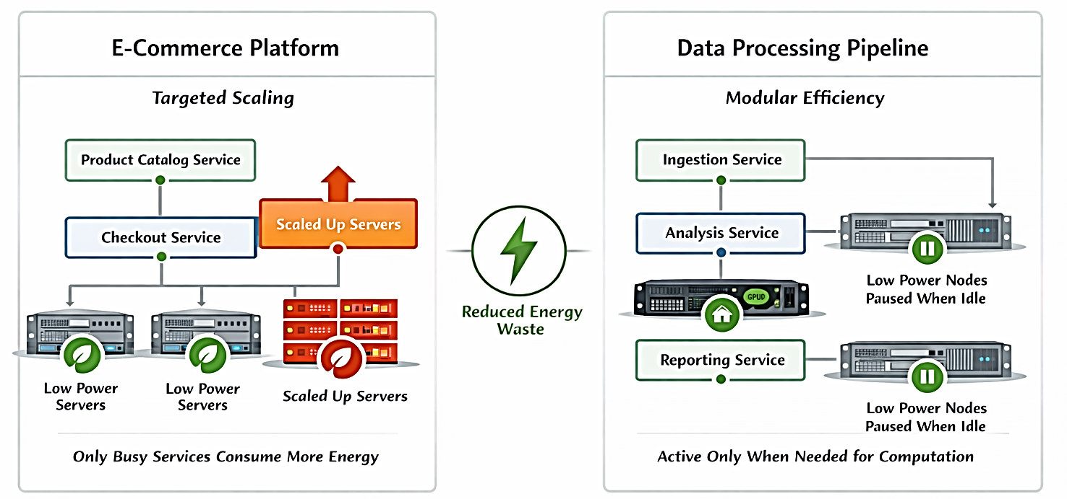
Figure 23. Energy savings with Microservices (source: Author)
An architectural comparison diagram above titled Reduced Energy Waste, shows two efficient scaling strategies for different systems.
- E-Commerce Platform (Targeted Scaling): Displays a flow where only the Checkout Service triggers Scaled Up Servers (indicated in red). Other services remain on Low Power Servers (indicated in green). The caption notes: "Only Busy Services Consume More Energy."
- Data Processing Pipeline (Modular Efficiency): Shows an Analysis Service running on an active node, while the Ingestion and Reporting services are connected to Low Power Nodes Paused When Idle (indicated by a pause icon). The caption notes: "Active Only When Needed for Computation."
Both sides are connected by a central green lightning bolt icon, emphasizing the shared goal of energy efficiency through smart resource management.

The infographic shows two real-world microservices scenarios and illustrates how microservices architectures save energy by scaling resources only where and when needed. The energy savings are highlighted by the central “Reduced Energy Waste” icon.
E-Commerce Platform (Left Side)
- Services: Product Catalog Service and Checkout Service
- Scenario: During peak activity (like a sale), only the Checkout Service experiences heavy traffic.
- Energy Behaviour:
  - Busy services scale up their servers (orange/red blocks), consuming more power.
  - Idle services, like the Product Catalog Service, continue running on low-power servers (green blocks).
- Key Insight: Only the services handling high workloads consume significant energy, preventing unnecessary resource use across the entire application.

Data Processing Pipeline (Right Side)
- Services: Ingestion Service, Analysis Service, Reporting Service
- Scenario: Computational tasks are modular and intermittent.
- Energy Behaviour:
  - Active services (e.g., Analysis Service) use high-performance servers only when needed.
  - Idle services are paused or run on low-power nodes (green blocks with pause icon).
- Key Insight: Modular services allow energy to be spent only on active computation, avoiding wasted CPU cycles and power.
- Serverless: The Ultimate Pay-Per-Use Model

Client-Server architecture
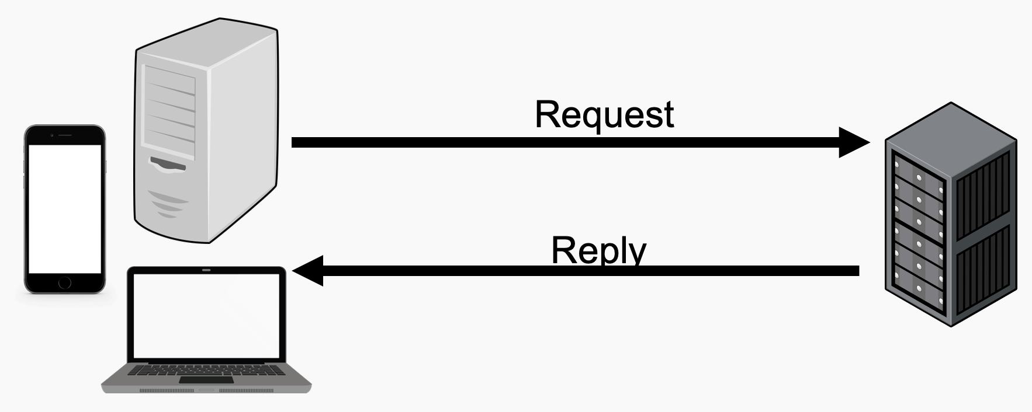
Figure 24. Client -server architecture (source: Author)
The image above shows a simple diagram illustrating a Client-Server model. On the left, several client devices—including a smartphone, a desktop tower, and a laptop—are shown. A top arrow labelled Request points from the clients to a Server rack on the right. A bottom arrow labelled Reply points from the server back to the clients.

The client–server architecture is a distributed computing model in which responsibilities are split between two roles: clients, which request services or resources, and servers, which provide them. Clients typically handle user interaction and presentation (for example, a web browser or mobile app), while servers manage shared resources such as data storage, business logic, authentication, and coordination. Communication occurs over a network using well-defined protocols (e.g., HTTP, TCP/IP), with the client initiating requests and the server responding.
This separation improves scalability, maintainability, and security. Servers can be centralized, optimized, and scaled independently of clients, while multiple heterogeneous clients can access the same services. From an efficiency and sustainability perspective, client–server architecture enables centralized caching, controlled data access, and optimized resource utilization on the server side, reducing redundant computation and unnecessary data transfer as systems grow.
Serverless computing
Represents a radical shift in how applications consume compute resources. Unlike traditional server-based architectures, where machines run continuously regardless of workload, serverless platforms only allocate resources when a function is invoked. Developers write discrete functions to handle specific tasks, and the underlying infrastructure automatically provisions, runs, and terminates the execution environment. This pay-per-use approach means that idle server costs are completely eliminated, and energy consumption is tightly coupled to actual demand rather than overprovisioned capacity.
Energy efficiency is one of the most compelling advantages of serverless architectures. Because resources are only consumed during active execution, functions avoid the persistent power draw typical of continuously running servers. For applications with highly variable or unpredictable traffic—such as event-driven workflows, IoT data processing, or API endpoints with sporadic usage—serverless platforms can drastically reduce wasted CPU cycles, memory allocation, and cooling requirements in data centres. By matching consumption directly to workload, serverless computing ensures that energy is spent only when and where it is needed, making it a sustainable alternative to traditional hosting models.
Serverless also enhances operational efficiency and scalability. Developers no longer need to manage server provisioning, patching, or scaling, allowing teams to focus solely on business logic. The automatic scaling of functions during peak demand avoids over-provisioning, while the termination of idle instances prevents unnecessary energy use. Over time, this model reduces both operational costs and the carbon footprint of applications, particularly for cloud-native workloads. In essence, serverless computing embodies an on-demand, pay-per-use philosophy that optimizes both resource utilization and environmental sustainability.

Microservice deployment
Microservices deployment commonly relies on containerization to ensure consistency, scalability, and efficient resource usage. Docker is the de facto standard for packaging microservices, allowing each service to run in its own lightweight container with its dependencies isolated. This approach simplifies deployment across environments, improves portability, and reduces the overhead compared to traditional virtual machines. Containers also start quickly and use fewer resources, which is essential for dynamic, distributed microservices architectures.

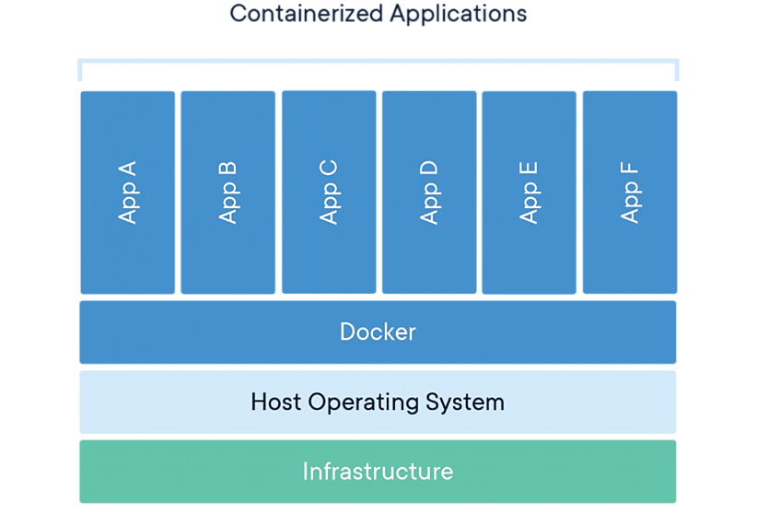
Figure 25. Docker Containerization Architecture (source: Author)

The image above shows a stack diagram titled Containerized Applications showing the layers of a container-based environment. The architecture is built from the bottom up:
- Infrastructure: The base layer (green) representing physical or virtual hardware.
- Host Operating System: The primary OS layer (light blue) running on the hardware.
- Docker: The containerization engine layer (medium blue) that manages the applications.
- Apps A through F: Six individual application containers (dark blue) sitting directly on the Docker layer, sharing the host OS resources.

For orchestrating containers across multiple hosts, platforms such as Docker Swarm and Kubernetes are widely used. Docker Swarm offers a simpler, Docker-native solution that is easy to set up and manage, making it suitable for smaller deployments or teams seeking minimal operational complexity. It provides basic features such as service replication, load balancing, and rolling updates, which are often sufficient for straightforward microservices systems.
Kubernetes, on the other hand, is the industry standard for large-scale and production-grade microservices deployments. It provides advanced capabilities such as automatic scaling, self-healing, service discovery, and fine-grained resource management. Although Kubernetes has a steeper learning curve, it enables highly resilient and efficient deployments, especially in cloud and hybrid environments. By intelligently managing container lifecycles and infrastructure resources, Kubernetes helps organizations run microservices reliably while optimizing performance, cost, and energy consumption at scale.

Conclusion
Modern architectures offer powerful tools for managing complexity and scale, but each pattern carries energy implications. Microservices enable selective scaling but introduce network and serialization overhead. Event-driven architectures eliminate polling waste but add messaging infrastructure. Serverless achieves perfect utilization but may not suit all workload patterns.
The sustainable architect must:
- Understand workload characteristics before choosing patterns
- Measure actual energy consumption, not just theoretical benefits
- Start simple (monolith) and evolve based on demonstrated need
- Avoid premature decomposition into too many services
- Leverage event-driven patterns to eliminate idle waste
- Use serverless for bursty, unpredictable workloads
- Monitor and optimize continuously.

There is no universal "green architecture." The most sustainable choice depends on your specific workload, scale, team structure, and operational constraints. Design with energy awareness, measure relentlessly, and evolve based on evidence rather than architectural fashion.

Additional resources:
- Energy-efficient microservice-based software architectures in cloud environments
- Sustainable Microservices Architecture

Micro-Activity:
Design an Energy-Efficient Architecture
You will design and analyse three different architectures for a social media platform:
Requirements:
- 10M active users
- 100M requests/day
- Features: User profiles, posts, comments, notifications, search, analytics
- Traffic pattern: 80% during 12 peak hours, 20% during 12 off-peak hours.

Part 1: Design Three Architectures
- Monolithic: Traditional single-deployment architecture
- Microservices: Service-oriented with event-driven communication
- Hybrid: Monolith + serverless for specific workloads.
For each architecture, specify:
- Service boundaries (if applicable)
- Communication patterns
- Scaling strategy
- Technology choices.
Part 2: Energy Modeling
Create energy models for each architecture considering:
- Compute resources (CPU time)
- Network transfer
- Storage access
- Idle time
- Deployment overhead.

Key takeaways:
- Targeted resource use – Microservices allow independent scaling of each service, whereas monoliths require scaling the entire application, wasting energy on idle components.
- Reduced redundant computation – Microservices isolate business logic in specific services, avoiding repeated calculations across the system; monoliths often recompute unnecessarily.
- Efficient deployment and updates – Updating a single microservice uses fewer resources than redeploying a full monolith, reducing CPU cycles, energy, and operational overhead.
- Better long-term sustainability – Modular microservices make caching, workload-aware scaling, and energy optimization easier, whereas monoliths grow increasingly inefficient as user base and traffic increase.

Quick Check:
1. A monolithic application handles 1,000 requests per second. Each request triggers 100 ms of computation, even for idle features. How much CPU time is wasted per second?
- 10 s
- 50 s
- 100 s
- 1,000 s
2. A microservice handles a specific feature and processes 200 requests/sec, each taking 5 ms. How many CPU seconds are used per second?
  - 0.5 s
  - 1 s
  - 5 s
  - 10 s
3. A monolithic system runs 24 hours/day with 2 CPU hours wasted per hour due to unnecessary computation. How many CPU hours are wasted per day?
  - 24 h
  - 36 h
  - 48 h
  - 72 h
4. If saving 1 CPU hour avoids 65 Wh of energy, how much energy is saved by eliminating 48 CPU hours from a monolithic system?
- 2.48 kWh
- 3.12 kWh
- 3.9 kWh
- 3.12 kW

Answer key: 1. Calculation: $1,000×100\text{ms}=100,000\text{ms}=100\text{s}$. Since only half the features are needed, 50 s is wasted; 2. Calculation: $200×5\text{ms}=1,000\text{ms}=1\text{s}\text{; 3.}$ Calculation: $2\text{h/hour}×24\text{hours}=48\text{CPU hours/day}\text{; 4. }$Calculation: $48×65\text{Wh}=3,120\text{Wh}=3.12\text{kWh}$.

TOPIC 1.3: Sustainable Cloud Computing
Short introduction:
Sustainable Cloud Computing focuses on designing, deploying, and operating cloud infrastructure in ways that minimize environmental impact while maintaining performance and scalability. It involves using energy-efficient data centers, optimizing workload placement, and leveraging technologies like virtualization, containerization, and serverless computing to ensure resources are consumed only when needed. Sustainable cloud practices also include renewable energy sourcing, intelligent cooling systems, and workload-aware scaling that reduces idle server time. By combining operational efficiency with eco-conscious design, sustainable cloud computing enables organizations to meet growing computational demands without proportionally increasing energy use or carbon emissions, making the cloud both economically and environmentally responsible.
Theory:
The migration to cloud computing marks one of the most significant transformations in the history of computing infrastructure. Enterprises that once invested heavily in physical servers, cooling systems, and networking equipment now rent scalable, on-demand computing power from major providers such as Amazon Web Services (AWS), Microsoft Azure, and Google Cloud Platform (GCP).
While the shift to the cloud offers scalability, cost efficiency, and global accessibility, it also brings critical environmental challenges. Cloud data centres (CDCs) consume substantial energy to power servers and maintain optimum temperature levels. The International Energy Agency (IEA) estimates that by 2030, global data centre energy usage could reach 8,000 TWh if sustainability efforts lag.
Sustainable Cloud Computing (SCC) seeks to address this concern by incorporating energy-aware architecture, renewable energy utilization, and hardware optimization strategies into every layer of the cloud ecosystem — from software design to infrastructure deployment.

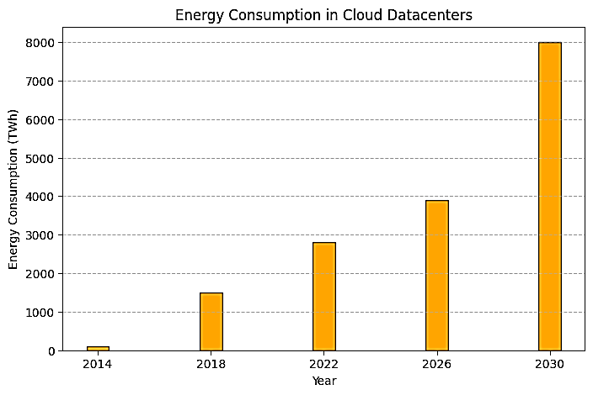
Figure 26. Cloud Datacentre Energy Trends: Historical and projected energy consumption through 2030. (source: Author)
A bar chart above titled Energy Consumption in Cloud Datacentres illustrates a rapid upward trend. The y-axis measures Energy Consumption (TWh) from 0 to 8000, and the x-axis shows the Year from 2014 to 2030 in four-year increments.
The data points are:
- 2014: Negligible (approx. 100 TWh)
- 2018: Approx. 1,500 TWh
- 2022: Approx. 2,800 TWh
- 2026: Approx. 3,900 TWh
- 2030: A significant jump to 8,000 TWh
This chart highlights the critical importance of the efficient architectural decisions and targeted scaling strategies we've been discussing to curb this projected growth.

It clearly shows how energy usage grows from 2014 to 2030, highlighting the steep rise expected by 2030 (8,000 TWh). This format makes it easier to compare yearly energy consumption visually rather than tracking it along a line.
Principles of Sustainable Cloud Design
A cloud system can be designed sustainably through careful consideration of its architecture, energy use, and operational dynamics. Below are the primary principles guiding eco-friendly cloud systems:
Energy Efficiency
- Select energy-efficient instance types and enable auto-scaling.
- Use virtualization and containerization to increase utilization per physical server.
- Implement low-power states during idle times through intelligent scheduling.

Resource Optimization
- Scale resources dynamically using serverless and microservice architectures.
- Employ load balancing algorithms that distribute workloads efficiently.
- Utilize data caching and content delivery networks (CDNs) to reduce redundant transfers.

Renewable Energy Integration
- Choose cloud regions powered by renewable sources such as wind or hydro plants.
- Track and report the carbon footprint of workloads using provider tools (e.g., AWS Carbon Footprint Tool).
- Encourage green energy procurement agreements for hybrid or private clouds.
Lifecycle Management
- Decommission underutilized instances.
- Adopt sustainable hardware lifecycle management — recycling old components and repurposing materials.
- Apply machine learning models for predictive scaling to proactively control energy use.

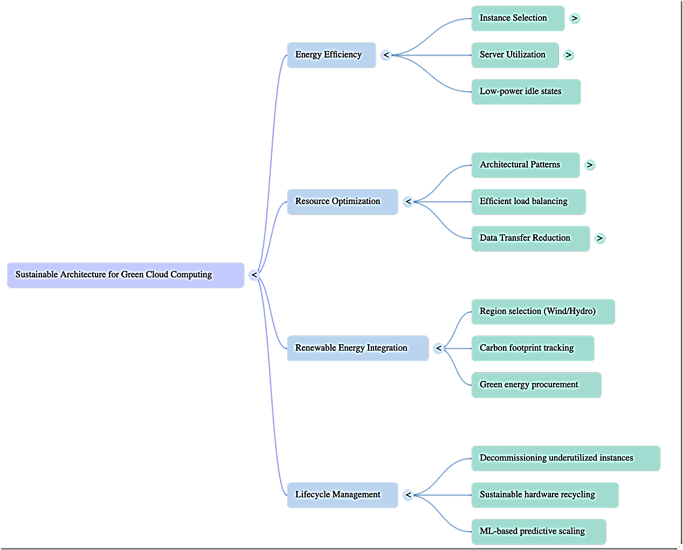
Figure 27. Sustainable Architecture for Green Cloud Computing (source: Author)
The image above shows a horizontal mind map titled Sustainable Architecture for Green Cloud Computing that branches into four primary categories, each with specific strategies:
- Energy Efficiency: Includes Instance Selection, Server Utilization, and Low-power idle states.
- Resource Optimization: Includes Architectural Patterns, Efficient load balancing, and Data Transfer Reduction.
- Renewable Energy Integration: Includes Region selection (Wind/Hydro), Carbon footprint tracking, and green energy procurement.
- Lifecycle Management: Includes Decommissioning underutilized instances, Sustainable hardware recycling, and ML-based predictive scaling.
The diagram organizes the various technical and operational decisions that contribute to reducing the environmental impact of cloud infrastructure.
The diagram shows how to design a sustainable cloud system around four key pillars: Energy Efficiency (reducing power use with efficient instances and scheduling), Resource Optimization (scaling dynamically, load balancing, and caching), Renewable Energy Integration (using green-powered regions and tracking carbon footprint), and Lifecycle Management (decommissioning idle resources, recycling hardware, and predictive scaling). Together, these practices minimize energy consumption, lower carbon footprint, and improve overall cloud efficiency.
Auto-Scaling Based on CPU Utilization
Efficient cloud applications automatically scale resources based on workload demand. Below is a simple C# snippet demonstrating resource scaling logic resembling typical auto-scaling behaviour:

using System;
using System.Threading.Tasks;

namespace SustainableCloudDemo
{
public class AutoScaler
{
public double CpuThreshold { get; set; } = 70.0;
public int CurrentInstances { get; set; } = 3;

public void MonitorAndScale(double currentCpuUsage)
{
if (currentCpuUsage > CpuThreshold)
{
ScaleUp();
}
else if (currentCpuUsage < (CpuThreshold / 2) && CurrentInstances > 1)
{
ScaleDown();
}
else
{
Console.WriteLine("Optimal instance levels maintained.");
}
}

private void ScaleUp()
{
CurrentInstances++;
Console.WriteLine($"Scaling up... Total instances: {CurrentInstances}");
}

private void ScaleDown()
{
CurrentInstances--;
Console.WriteLine($"Scaling down... Total instances: {CurrentInstances}");
}
}
}

This simplified model illustrates the principle of workload-aware scaling — a core sustainability mechanism that reduces unnecessary power use during low-demand periods.

Sustainable Cloud Operations
Sustainable Cloud Operations
They focus on minimizing energy consumption and optimizing resource usage across compute and data centre infrastructure.

Virtualization and containerization
This allows multiple workloads to share the same physical hardware efficiently. Virtual Machines (VMs) consolidate tasks onto fewer servers, reducing idle hardware, while containers—managed via platforms like Docker or Kubernetes—provide lightweight environments with minimal overhead, improving CPU and memory utilization. These technologies ensure that compute resources are used effectively, which lowers energy consumption without compromising performance.

Serverless computing
This further enhances sustainability by executing functions only when triggered, eliminating the energy costs of idle servers. In parallel, cooling and data centre efficiency play a critical role in overall energy management. Techniques such as liquid cooling, free-air cooling, and AI-driven climate control adapt cooling intensity to real-time temperature and workload demands, reducing the power drawn by HVAC systems. Together, these practices enable cloud operations that are both energy-efficient and scalable, aligning performance with environmental responsibility.
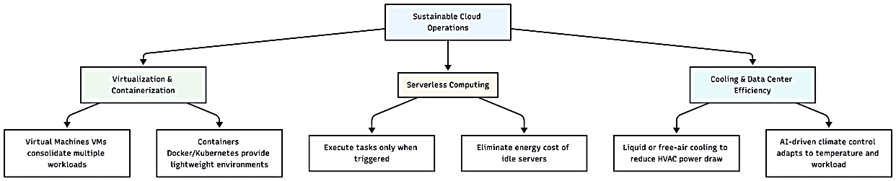
Figure 28. Sustainable Cloud Operations (source: Author)

The image above shows a hierarchical flowchart titled Sustainable Cloud Operations that breaks down three key pillars for operational efficiency:
- Virtualization & Containerization: Focuses on consolidating workloads. It includes Virtual Machines (VMs) for consolidating multiple workloads and Containers (Docker/Kubernetes) to provide lightweight environments.
- Serverless Computing: Focuses on event-driven execution. It highlights executing tasks only when triggered and eliminating the energy cost of idle servers.
- Cooling & Data Centre Efficiency: Focuses on physical infrastructure. It includes liquid or free-air cooling to reduce HVAC power draw and AI-driven climate control that adapts to temperature and workload changes.
This diagram connects the software-level decisions (containers and serverless) with the hardware-level physical environment.

Sustainable operations require visibility into environmental performance metrics
- Power Usage Effectiveness (PUE): is a key metric used to evaluate how efficiently a data centre uses energy. It is defined as the ratio between the total power consumed by the facility (including cooling, lighting, and power distribution) and the power used solely by IT equipment such as servers and storage. A PUE value closer to 1.0 indicates higher efficiency, meaning most of the energy is used directly for computing rather than overhead. PUE helps operators identify inefficiencies in infrastructure and improve cooling, airflow management, and power delivery systems.
- Carbon Usage Effectiveness (CUE): extends energy efficiency analysis by focusing on environmental impact rather than just power consumption. It measures the total carbon emissions produced by a data centre relative to the energy used by IT workloads. CUE considers the carbon intensity of the energy source, making it particularly useful for comparing cloud regions or providers that rely on different mixes of renewable and fossil fuels. This metric enables organizations to track, report, and reduce the carbon footprint of their applications and workloads.
- Energy Reuse Effectiveness (ERE): evaluates how much of a data centre’s energy is reused for secondary purposes instead of being wasted. Examples include capturing waste heat to warm office buildings, residential areas, or industrial processes. A lower ERE value indicates more effective energy reuse, contributing to overall sustainability. ERE encourages innovative designs where data centres become part of a broader energy ecosystem, improving efficiency while reducing the environmental impact of large-scale computing facilities.

Choosing Sustainable Cloud Providers
When selecting a cloud provider, evaluate:
- Energy sourcing: Does the provider operate data centres powered by renewables?
- Carbon neutrality goals: Are they publicly committed to net-zero emissions (e.g., Google Cloud since 2017)?
- Sustainability Reporting: Do they provide transparency about PUE and renewable energy percentages?

Examples
Provider | Sustainability Initiative | Renewable Energy Use
Amazon Web Services | 100% renewable by 2025 | 85% (as of 2023)
Microsoft Azure | Carbon negative by 2030 | ~77%
Google Cloud | 24/7 Carbon-free Energy | 100% matched annually

Cloud computing offers significant advantages for both cost and flexibility. Thanks to economies of scale, cloud providers buy hardware in bulk, allowing them to offer computing resources at prices even smaller companies—or sometimes even large companies—cannot match. With a pay-as-you-go model, users only pay for the resources they actually use, often billed by the hour. The cloud automates this process, so provisioning, scaling, and de-provisioning resources happen without manual intervention, making it highly convenient and efficient.
Managing your own computing cluster, on the other hand, is expensive and complex. A cluster requires a 24/7 team with diverse expertise in hardware, networking, and security. This makes it costly to operate, especially for short-term projects or small teams. For start-ups, small teams, or temporary projects, using cloud resources is often far cheaper and more practical: the cost of running a month of minimal cloud resources is typically much lower than maintaining an entire cluster.

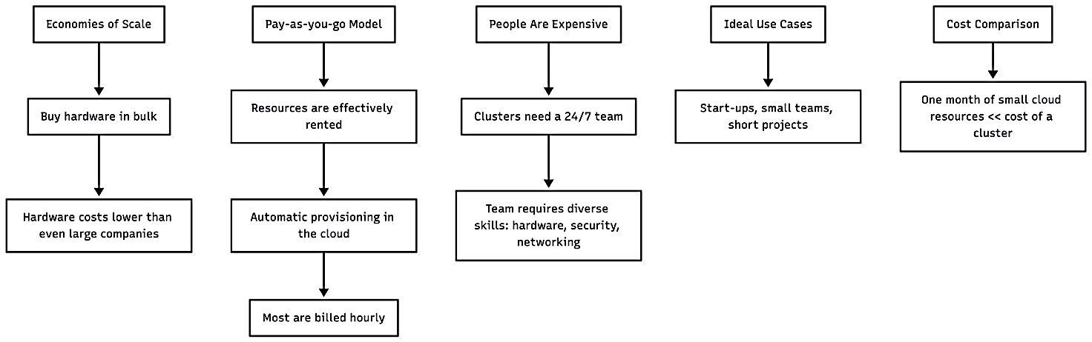
Figure 29. Economic Advantages of the Cloud (source: Author)
The image above shows a diagram featuring five vertical flowcharts outlining the economic and operational factors of cloud computing:
- Economies of Scale: Notes that buying hardware in bulk leads to costs lower than even large companies can achieve independently.
- Pay-as-you-go Model: Describes a cycle where resources are rented, automatically provisioned in the cloud, and typically billed hourly.
- People Are Expensive: Highlights that managing private clusters requires a 24/7 team with diverse skills in hardware, security, and networking.
- Ideal Use Cases: Lists start-ups, small teams, and short projects as the primary beneficiaries.
- Cost Comparison: Concludes that the cost of one month of small cloud resources is significantly lower than the cost of maintaining an entire cluster.

This diagram captures the main concerns: data sensitivity, cost for long-term projects, performance requirements, and control/guarantees.

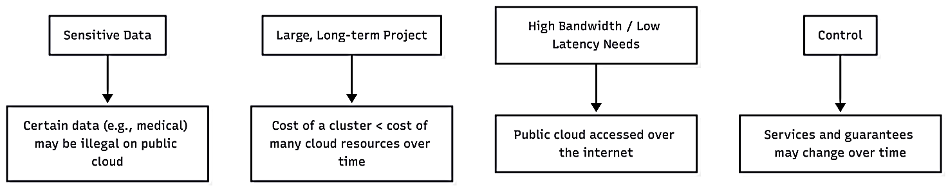
Figure 30. Why Organizations Choose On-Premises (source: Author)
The image above shows a diagram featuring four vertical flowcharts outlining the limitations or risks associated with using a public cloud:
Sensitive Data: Notes that certain data, such as medical records, may be legally restricted from being stored on a public cloud.
Large, Long-term Project: Suggests that for long-term projects, the cost of owning a private cluster can eventually be lower than the cumulative cost of cloud resources.
- High Bandwidth / Low Latency Needs: Points out that public clouds are accessed over the internet, which can be a bottleneck for applications requiring very high speeds or minimal delay.
- Control: Warns that cloud providers can change their services or terms of service over time, potentially impacting the user.

When working with sensitive data, such as medical records, storing information on a public cloud can sometimes be illegal, making data privacy a critical concern. For large, long-term projects, maintaining a dedicated cluster may be more cost-effective than relying on public cloud resources for extended periods, as the cumulative cloud costs can exceed the cost of owning and operating a cluster. Projects that require high bandwidth or low latency may also face challenges with public clouds, since these services are accessed over the internet and network performance cannot always be guaranteed. Additionally, using the cloud can limit control, as service offerings and guarantees may change over time, potentially affecting reliability, compliance, and operational planning.

Additional resources:
- Sustainable Cloud Computing: Foundations and Future Directions by Rajkumar Buyya and Sukhpal Singh Gill
- AWS Sustainability

Micro-Activity:
Run the simulation
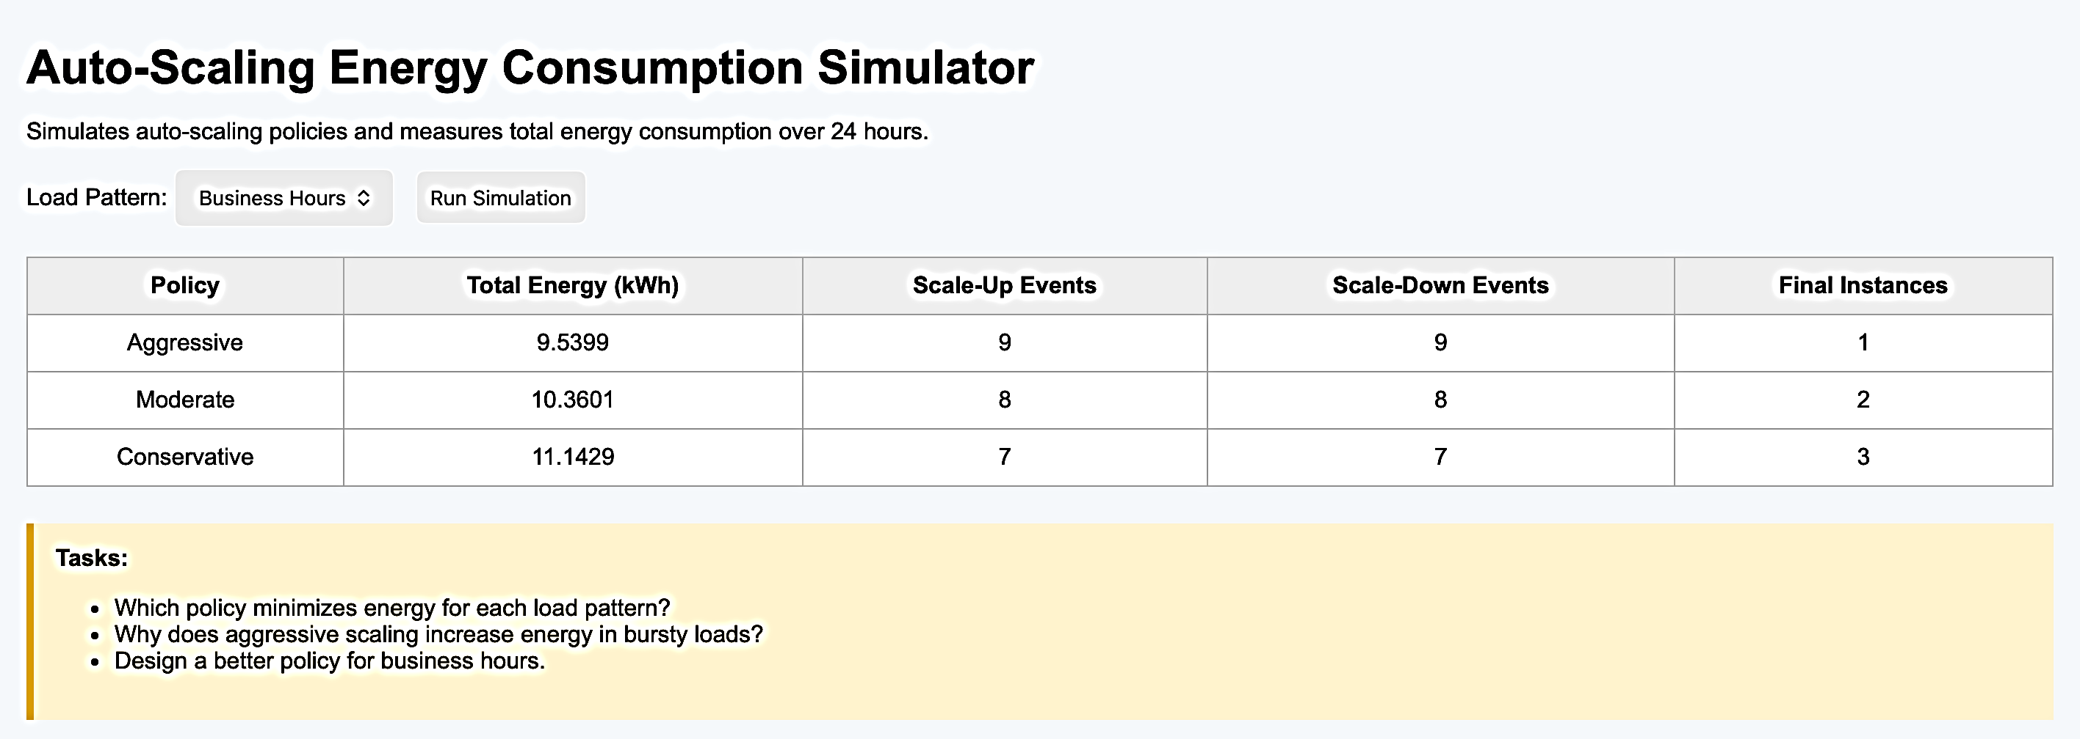
Do the tasks.
Key takeaways:
- Reusable Solutions Reduce Waste: Applying well-known patterns avoids redundant or inefficient code, saving computational resources and energy.
- Optimize Resource Management: Design patterns guide efficient handling of memory, processing, and I/O, reducing unnecessary energy consumption.
- Balance Performance and Sustainability: Patterns help structure software in a way that maintains functionality and performance while minimizing carbon footprint.
Quick Check:
1. What is the main advantage of cloud computing?
a) Requires no internet connection
- Unlimited free storage for everyone
- On-demand access to computing resources
- Runs only on personal computers.

2. Which service model provides hardware, storage, and networking over the internet?
a) SaaS (Software as a Service)
b) PaaS (Platform as a Service)
c) IaaS (Infrastructure as a Service)
d) DaaS (Data as a Service).

3. What is an example of a SaaS application?
a) Amazon EC2
b) Microsoft Office 365 online
c) Google Cloud Compute Engine
d) VMware ESXi.

4. Which of the following is a key characteristic of cloud computing?
a) Fixed resource allocation
b) High upfront hardware cost
c) Scalability and elasticity
d) Requires manual software updates for all users.
Answer key: 1. b), 2. c), 3. b), 4. c).

TOPIC 1.4: Carbon-Aware Computing
Short introduction:
Carbon-Aware Computing is an approach that aims to reduce the environmental impact of computing by aligning energy-intensive operations with times when electricity is cleaner and has a lower carbon footprint. By monitoring the carbon intensity of the power grid, cloud providers and data centres can schedule workloads, shift computing tasks, or optimize resource usage to minimize CO₂ emissions. This strategy not only helps organizations lower their carbon footprint but also promotes more sustainable and responsible use of energy in computing.
Theory:
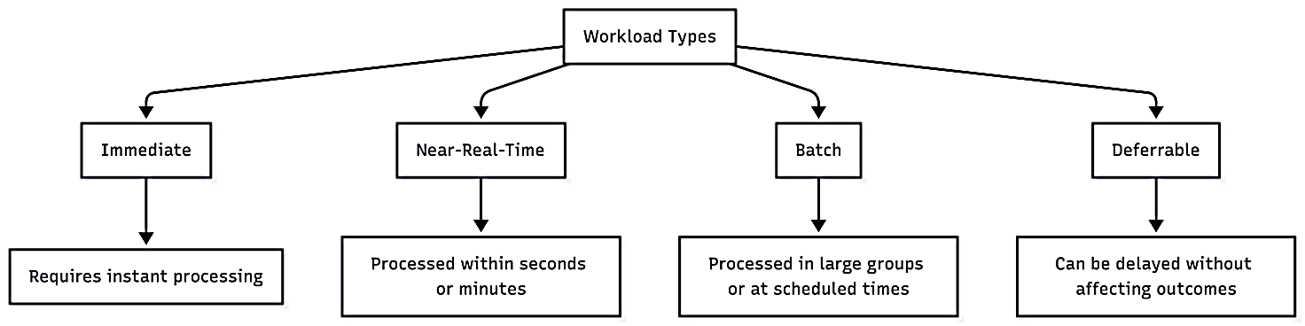
Figure 31.Four Primary Workload Types (source: Author)

The image above shows a hierarchical flowchart titled Workload Types that categorizes computational tasks based on their urgency:
- Immediate: Workloads that require instant processing.
- Near-Real-Time: Tasks that are processed within seconds or minutes.
- Batch: Data processed in large groups or at scheduled times.
- Deferrable: Tasks that can be delayed without affecting outcomes.
This classification is a key step in implementing the sustainable cloud operations and energy efficiency strategies we've been discussing.

This diagram clearly shows the four categories and their key characteristics.
Green software is designed to minimize the carbon emissions created when it runs. The Green Software Foundation (GSF) brings together people, standards, tools, and best practices to make software more environmentally friendly. A key idea in Green Software is carbon-aware computing, which means running software at times and in places where the electricity used produces less carbon.
Microsoft and UBS have been working together on this approach, partnering with the nonprofit WattTime through the GSF. They created the first enterprise-grade carbon-aware application and made the tools open source. This includes the Software Carbon Intensity (SCI) specification to measure software’s carbon impact and the carbon-aware SDK, which helps software run when and where energy is cleaner. Their work has been tested on UBS’s ACQA platform, shifting compute tasks to times and locations with lower carbon intensity. This approach allows businesses to reduce software-related emissions and encourages software engineers and organizations to contribute to GSF’s open-source projects to make software greener worldwide.
Benefits of carbon-aware computing include making decisions that are better for the environment while maintaining or even improving computing performance. It helps reduce stress on the power grid, lowers reliance on high-carbon energy sources like coal, and increases the use of clean energy such as wind and solar. It can also extend the lifespan of hardware, reduce waste, and helps organizations meet future sustainability goals and regulations.
Challenges remain because the computing industry has not always focused on energy use. Measuring the carbon footprint of devices is complex: a device may be energy-efficient but still have high carbon emissions during manufacturing or disposal. Different components like CPUs, GPUs, memory, and storage may each have their own environmental impact. Standardizing measurements and creating reliable ways to track emissions across all parts of a system are ongoing challenges that carbon-aware computing must address to achieve true carbon neutrality.
Additional resources:
- Tools & Patterns for Carbon Aware Cloud Applications
- Carbon Aware Computing
- Carbon-aware computing: Measuring and reducing the carbon footprint associated with software in execution

Micro-Activity:
Objective: Understand how scheduling computing tasks based on energy sources can reduce carbon emissions.
Instructions:
- Imagine you are running a small cloud-based application. You have the option to run tasks at three different times today:
  - Morning: High carbon intensity (mostly coal energy)
  - Afternoon: Medium carbon intensity (mixed energy sources)
  - Evening: Low carbon intensity (mostly wind and solar)
- Your task: Decide when to run each of the following workloads to minimize carbon emissions while maintaining performance:
  - Quick user queries (must be immediate)
  - Large data processing (can be delayed)
  - Scheduled backups (can run anytime overnight)
- Discuss or write down your reasoning. How does carbon-aware scheduling affect energy use and performance?

Key takeaways:
- Reduce Carbon Emissions: Carbon-aware computing helps software and workloads run when and where electricity is cleaner, lowering the overall carbon footprint of computing.
- Balance Performance and Sustainability: It is possible to maintain—or even improve—computing performance while using less energy by smartly scheduling tasks.
- Promote Use of Renewable Energy: By aligning workloads with times of high renewable energy availability, carbon-aware computing increases reliance on wind, solar, and other low-carbon sources.
- Support Long-Term Sustainability Goals: Organizations adopting carbon-aware strategies can extend hardware lifespan, reduce waste, and better meet green regulations and sustainability targets.

Quick Check:
1. What is the main goal of carbon-aware computing?
a) Increase computing speed at all costs
b) Reduce the carbon emissions of software and workloads
c) Reduce hardware costs only
d) Eliminate the need for electricity
2. How does carbon-aware computing reduce emissions?
a) By running tasks only on high-carbon energy sources
b) By scheduling workloads when and where energy is cleaner
c) By turning off all servers permanently
d) By using outdated hardware
3. Which of the following is a benefit of carbon-aware computing?
a) Extends hardware lifespan
b) Increases reliance on coal power
c) Requires less planning for workload scheduling
d) Reduces software functionality
4. What challenge does carbon-aware computing face?
a) It always reduces computing performance
b) Measuring the carbon footprint of devices and software can be complex
c) It only works for personal computers
d) It eliminates the need for renewable energy
Answer key: 1. b) Reduce the carbon emissions of software and workloads; 2. b) By scheduling workloads when and where energy is cleaner; 3. A) Extends hardware lifespan; 4. B) Measuring the carbon footprint of devices and software can be complex.

Module 2: Conclusion and Assessment
Module Summary:
This module introduced key concepts in modern software architecture and sustainable computing. Students explored Architectural Models such as MVC (Model-View-Controller), which separates data, user interface, and control logic to improve maintainability and scalability. The module also examined Microservices and Modern Architectures, highlighting how breaking applications into small, independent services allows for easier updates, better fault isolation, and more flexible deployment. Sustainable design principles were emphasized throughout, showing how thoughtful architecture can reduce energy consumption, hardware waste, and operational costs while maintaining high software performance.
The module then focused on Sustainable Cloud Computing and Carbon-Aware Computing, demonstrating how software and workloads can be optimized to minimize environmental impact. Students learned how cloud platforms can schedule workloads based on energy efficiency and carbon intensity, increasing the use of renewable energy while reducing reliance on fossil fuels. Practical strategies, such as resource optimization, time-shifting compute tasks, and monitoring carbon footprints, were discussed to illustrate how organizations can meet sustainability goals and regulatory requirements. By the end of the module, students understood both the technical and environmental considerations of designing and operating modern software systems in a greener, more responsible way.

Module Knowledge Quiz
1. What is the primary purpose of the Model-View-Controller (MVC) architecture?
a) To reduce electricity use in data centers
b) To separate data, user interface, and control logic
c) To run software only during low-carbon energy periods
d) To consolidate all application logic into a single module.
2. How does sustainable software design contribute to greener computing?
a) By increasing CPU usage at all times
b) By eliminating the need for cloud services
c) By designing software that minimizes energy consumption and hardware waste
d) By ignoring performance optimization.
3. Which of the following is a key feature of microservices architecture?
a) Breaking applications into small, independent services
b) Single monolithic application structure
c) Only works on personal computers
d) Always increases carbon emissions
4. One advantage of modern architectures like microservices is:
a) Difficult scalability
b) Easier updates and maintenance of individual components
c) Requires all components to run on the same server
d) Reduces software flexibility
5. What is a main benefit of sustainable cloud computing?
a) Always uses maximum energy regardless of workload
b) Reduces energy use and environmental impact while maintaining performance
c) Makes hardware obsolete faster
d) Requires manual scheduling of tasks by engineers
6. Which of the following practices supports sustainable cloud computing?
a) Ignoring energy efficiency
b) Running workloads only when energy is dirtier
c) Optimizing resource usage and using low-carbon energy sources
d) Using outdated hardware exclusively
7. Carbon-aware computing helps software run:
a) At the hottest times of day
b) Only on fossil fuel energy
c) When and where electricity has lower carbon intensity
d) Without considering energy sources
8. A challenge in carbon-aware computing is:
a) Measuring the carbon footprint across all components of software and hardware
b) Always reducing computing performance to zero
c) Making software slower intentionally
d) Eliminating renewable energy.

Answer key: 1. b); 2. c); 3. a); 4. b); 5. b); 6. c), 7. c); 8. a).

References:

Books and Academic Publications
- Acun, B., et al. (2023). "Carbon Explorer: A Holistic Framework for Designing Carbon Aware Datacenters." Proceedings of the 28th ACM International Conference on Architectural Support for Programming Languages and Operating Systems.
- Balalaie, A., Heydarnoori, A., & Jamshidi, P. (2016). "Microservices architecture enables DevOps: Migration to a cloud-native architecture." IEEE Software, 33(3), 42-52.
- Dodge, J., et al. (2022). "Measuring the Carbon Intensity of AI in Cloud Instances." 2022 ACM Conference on Fairness, Accountability, and Transparency.
- Fowler, M. (2018). Refactoring: Improving the Design of Existing Code (2nd ed.). Addison-Wesley Professional.
- Freeman, E., & Robson, E. (2020). Head First Design Patterns (2nd ed.). O'Reilly Media.
- Gamma, E., Helm, R., Johnson, R., & Vlissides, J. (1994). Design Patterns: Elements of Reusable Object-Oriented Software. Addison-Wesley Professional.
- Hernandez, A. C., Pérez, M. P., & Amador, M. F. (2018). "Impact of Design Patterns on Energy Consumption in Mobile Applications." IEEE Software, 35(4), 42-48.
- Hohpe, G., & Woolf, B. (2003). Enterprise Integration Patterns. Addison-Wesley Professional.
- Kleppmann, M. (2017). Designing Data-Intensive Applications. O'Reilly Media.
- Martin, R. C. (2003). Agile Software Development, Principles, Patterns, and Practices. Prentice Hall.
- Newman, S. (2021). Building Microservices (2nd ed.). O'Reilly Media.
- Pinto, G., Castor, F., & Liu, Y. D. (2014). "Mining questions about software energy consumption." In Proceedings of the 11th Working Conference on Mining Software Repositories (pp. 22-31). ACM.
- Radovanovic, A., et al. (2022). "Carbon-Aware Computing for Datacenters." IEEE Transactions on Power Systems.
- Richardson, C. (2018). Microservices Patterns. Manning Publications.
- Richter, J. (2012). CLR via C# (4th ed.). Microsoft Press.
- Wattson, C., & Joule, J. (2022). Measuring Software Energy Consumption: A Comprehensive Guide. IEEE Computer Society.

Industry Reports and Specifications
- Amazon Web Services. (2023). Customer Carbon Footprint Tool.
- Cloud Carbon Footprint. (2023). Methodology for Measuring Cloud Carbon Emissions. https://www.cloudcarbonfootprint.org/docs/methodology
- Google Cloud. (2023). Carbon Sense Suite.
- Green Software Foundation. (2023). Green Software Engineering. https://greensoftware.foundation
- Green Software Foundation. (2023). Software Carbon Intensity (SCI) Specification. https://sci.greensoftware.foundation
- Green Software Foundation. (2023). Patterns for Green Software. https://patterns.greensoftware.foundation
- Green Software Foundation. (2023). Patterns: Demand Shaping and Shifting.
- International Energy Agency. (2023). Electricity Grids and Secure Energy Transitions.
- Microsoft. (2023). Emissions Impact Dashboard for Azure.

Online Resources and Tools
- Amazon Web Services. (2023). AWS Lambda Power Tuning. https://docs.aws.amazon.com/lambda/latest/operatorguide/profile-functions.html
- Electricity Maps. (2023). Real-time Carbon Intensity of Electricity. https://app.electricitymaps.com
- Fowler, M. (2014). Microservices. https://martinfowler.com/articles/microservices.html
- Green Web Foundation. (2022). Website Carbon Calculator. https://www.websitecarbon.com
- Microsoft. (2023). Introduction to .NET. https://dotnet.microsoft.com/learn/dotnet/what-is-dotnet
- Microsoft Azure. (2023). Azure Functions Best Practices. https://learn.microsoft.com/en-us/azure/azure-functions/functions-best-practices
- Microsoft Learn. (2023). Asynchronous programming with async and await.
- Microsoft Learn. (2023). C# Interfaces.
- Microsoft Learn. (2023). Object pooling. https://learn.microsoft.com/en-us/dotnet/api/microsoft.extensions.objectpool
- Microsoft Learn. (2023). Performance Profiling in Visual Studio. https://learn.microsoft.com/en-us/visualstudio/profiling/
- Toub, S. (2019). ConfigureAwait FAQ.

