Sustainability Data Essentials
Learner Handbook

Copyright © 2024 Digital4Sustainability. The project resources contained herein are publicly available under the Creative Commons license 4.0 B.Y.

Project | Digital4Sustainability
Project number | 101140316
Document Title | Green Software Fundamentals – Learner handbook
Authors | Margus Sakk; BCS Koolitus  Virve Räni, BCS Koolitus  Katarina Cicvarić, Profil Klett
Reviewers | Francesco Abbita; ADECCO Fomazione  Filippo Chiarello; ADECCO Fomazione
Editor | Katarina Cicvarić, Profil Klett
Instructional Designer | Kristina Ferara Blašković, Profil Klett
Digital Content Manager | Ivana Bošnjak, Profil Klett  Andra Punjek, Profil Klett

This handbook serves as the comprehensive learning material for the entire upskilling curriculum, covering all modules in a single document. It is structured into Modules and thematic Topics, each designed to achieve specific learning outcomes. The learning content is supported by multimedia elements, self-assessment quizzes, and additional learning resources.

Disclaimer
Funded by the European Union. Views and opinions expressed are however those of the author(s) only and do not necessarily reflect those of the European Union or the European Education and Culture Executive Agency (EACEA). Neither the European Union nor EACEA can be held responsible for them.

Table of Contents
Introduction to Upskilling Curricula: Sustainability Data Essentials 5
MODULE 1: Sustainability Reporting Fundamentals 6
Topic 1.1: Sustainability Reporting Landscape and ESG Frameworks (CSRD, ESRS, GRI) 7
Topic 1.2: ESG Metrics and KPIs: What to Measure and Why 12
Topic 1.3: Double Materiality and Stakeholder Information Requirements 18
Topic 1.4: Reporting Architecture and Sustainability Data Flows 23
Module 1: Conclusion and Self-Assessment 28
MODULE 2: Energy-Efficient Architecture 30
Topic 2.1: Data Governance and Management 31
Topic 2.1: Data Collection Workflows 40
TOPIC 2.3: Data Quality Assurance and Validation 46
Module 2: Conclusion and Assessment 50
MODULE 3: Data Visualisation & Dashboard Design 53
Topic 3.1: Principles of Effective Data Visualization 54
Topic 3.2: Building Interactive Dashboards with BI Tools (Power BI) 62
Topic 3.3: Communicating Sustainability Performance to Stakeholders 65
Topic 3.4: Dashboard Evaluation and Performance Review 69
Module 3: Conclusion and Self-Assessment 71

Table of Figures:
Figure 1. Development of sustainability requirements in the EU 8
Figure 2. ESRS cross cuttung standards and 3 pillars of ESG ( 12
Figure 3. Visualizing the decoupling of business growth from environmental impact through Intensity Metrics 14
Figure 4. The Dual Lenses of Double Materiality: Impact and Financial Perspectives 18
Figure 5. Example of materiality assessment process 19
Figure 6. The Three-Tier Architecture of Sustainability Information Systems 23
Figure 7. Tagging Example 25
Figure 8. Data Governance and Data Management as plan and actions. 31
Figure 9. Parts of Data Governance 32
Figure 10.Data lifecycle 35
Figure 11. Steps to setting up data governance. 37
Figure 12. The five-step data collection workflow 43
Figure 13. Data quality core dimensions 46
Figure 14. The six-step data cleaning workflow). 48
Figure 15. Chart suggestions 56
Figure 16. Steps for building an interactive report. 62
Figure 17. Example of Star Schema 63

List of Tables:
Table 1. ESRS KPIs 12
Table 2. Key roles in data management 36
Table 3. Example of metadata for energy consumptio 38
Table 4. Data collection methods – descriptions and examples 40
Table 5. Data entering methods 42
Table 6. Common data collection challenges 44
Table 7. Six Core Data Quality Dimensions – Definitions, Examples and Failure Causes 46
Table 8. Data Cleaning Strategies by Issue Type 49
Table 9. Examples of sustainability reporting and recommended charts 57
Table 10. Key Stakeholder Groups and Their Needs 65
Table 11.A 10-Dimension Usability & Clarity Rubric 69
List of Videos:
Video 1. What is CSRD? 9
Video 2. Mandatory vs. Voluntary ESG Reporting 11
Video 3. How ESG creates value 15
Video 4. What us double Materiality? 20
Video 5. What is XBRL? 24
Video 6. What is data management? 32
Video 7. Data Governance 34
Video 8. Design and data visualization 54
Video 9. Building a good data visualization 60
Video 10. Building an effective dashboard 66

Introduction to Upskilling Curricula: Sustainability Data Essentials
Overview:
The Sustainability Data Essentials upskilling curriculum focuses on developing practical competencies in managing, analysing, and communicating sustainability (ESG) data in line with modern reporting requirements. It is designed for EQF Level 6 learners, including analysts, sustainability coordinators, and reporting specialists who require structured data competences.

By completing the programme, learners will be able to analyse ESG metrics, implement data collection workflows, ensure data quality, and design interactive dashboards for diverse stakeholders. The learning journey is structured into Modules and Topics that progressively build knowledge and skills. Each topic includes learning content, reflection points, micro-activities, and self-check quizzes to support understanding and continuous assessment. Modules are further supported by Face-to-Face (F2F) activities that enable discussion, collaboration, and applied problem-solving.

Theory is consistently connected to practice through topic-level exercises, F2F sessions, and applied tasks. The programme culminates in a capstone project, where learners integrate their knowledge by developing a sustainability data solution, including dashboards, metadata documentation, and data quality assessment outputs.
Learning Outcomes (LO) for this UC:
The learner will be able to:
- Analyse ESG performance metrics across environmental, social, and governance dimensions.
- Implement data collection workflows for sustainability reporting frameworks.
- Apply data quality assurance principles to sustainability datasets.
- Know roles, tasks and parts of data governance and data management
- Create meta-data documentation
- Design sustainability reporting dashboards using appropriate visualisation.
- Create interactive data visualisations for diverse stakeholder audiences.
Structure of the handbook
This handbook is divided into Modules and topics.
Module 1: Sustainability Reporting Fundamentals (20h)
T1.1. Sustainability Reporting Landscape and ESG Frameworks (CSRD, ESRS, GRI)
T1.2. ESG Metrics and KPIs: What to Measure and Why
T1.3. Double Materiality and Stakeholder Information Requirements
T1.4. Reporting Architecture and Sustainability Data Flows.

Module 2: Data Governance, Collection and Quality
T2.1. Data Governance and Management
T2.2. Data Collection Workflows
T2.3. Data Quality Assurance and Data Cleaning.

Module 3: Data Visualisation & Dashboard Design
T3.1. Principles of Effective Data Visualisation
T3.2. Designing ESG Dashboards: Structure and Information Architecture
T3.3. Building Interactive Dashboards
T3.4. Communicating Sustainability Performance to Stakeholders
T3.5. Dashboard Evaluation and Performance Review.

MODULE 1: Sustainability Reporting Fundamentals
Module Overview:
This module establishes the foundational knowledge required to navigate the modern sustainability reporting landscape. It aims to transition learners from understanding voluntary reporting to mastering the rigorous, mandatory EU regulatory frameworks, emphasizing the critical role of high-quality data.
Module learning outcomes:
- A clear understanding of the interplay between CSRD, ESRS, and GRI.
- The ability to define and categorize ESG metrics across environmental, social, and governance dimensions.
- Practical knowledge of the Double Materiality assessment process.
- Insight into the technical architecture required for robust sustainability data collection.
Estimated workload:
Lecture hours (F2F): 6 hours
Self-study: 8 hours
Practical application (if applicable): 6 hours
Assessment link: It provides fundamentals about sustainability reporting that will be used in capstone project.
Practical focus / deliverable:
Learners will as a final assessment produce capstone project that will include Interactive sustainability dashboard, Meta-data description, Short data quality audit report and Stakeholder presentation.

Topic 1.1: Sustainability Reporting Landscape and ESG Frameworks (CSRD, ESRS, GRI)
Short introduction:
This topic explores the fundamental shift in how companies communicate their non-financial performance. We move from the era of voluntary "Green Marketing" to a strictly regulated "Digital Sustainability" era. You will learn about the evolution of EU regulations (CSRD), the latest updates from the Omnibus Directive, and the internal governance structures required to transform raw data into audit-ready strategic information.
Theory & Knowledge:
The Paradigm Shift: From NFRD to CSRD
For a decade, sustainability reporting in the European Union was primarily governed by the Non-Financial Reporting Directive (NFRD). However, this framework was often criticized for being vague and inconsistent, which allowed for "greenwashing." To address these gaps, the EU adopted the Corporate Sustainability Reporting Directive (CSRD) in 2023. This legislation elevated sustainability reporting to the same level of importance as financial accounting.
- Key Change in Scope: The number of companies required to report in the EU will jump from ~11,000 to over 50,000.
- The Goal: To put sustainability reporting on the same level as financial reporting. This means reports must be digital, machine-readable, and subject to mandatory third-party assurance (auditing).

Omnibus I - Directive (EU) 2026/470
Recently, the regulatory landscape has been optimized to reduce administrative burdens. The Omnibus update has refined the original CSRD scope:
- New Mandatory Thresholds: Reporting now primarily applies to large undertakings with over 1,000 employees AND a turnover of $≥$ €450 million.
- Streamlined Data: The number of mandatory technical data points has been reduced from 1,073 to approximately 320 core points.
- Implementation: Formal reporting under these rules starts in 2027 (published in 2028/2029).
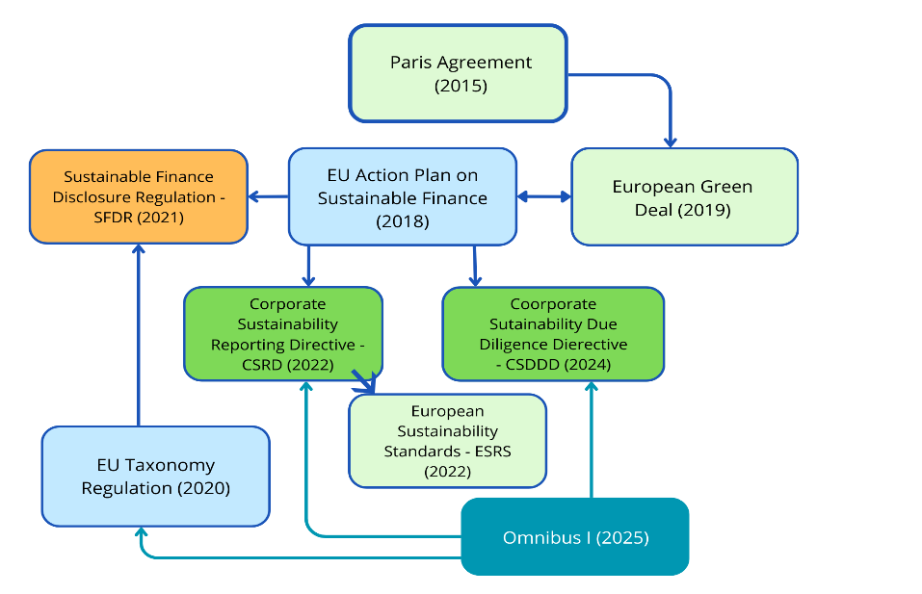
Figure 1. Development of sustainability requirements in the EU (source: Author)
The image above shows a flowchart illustrating the development and relationships of EU sustainability regulations, starting from the Paris Agreement and leading to key frameworks such as the EU Action Plan on Sustainable Finance and the European Green Deal. It includes major regulations and directives like SFDR, the EU Taxonomy, CSRD, CSDDD, and ESRS, ending with the future Omnibus I initiative.

The ESRS Structure: The Four Reporting Areas

According to the official ESRS 1, every sustainability statement must be structured into four mandatory reporting areas:
- Governance (GOV): The processes and controls used to monitor and oversee impacts, risks, and opportunities.
- Strategy (SBM): How the undertaking’s strategy and business model interact with its material impacts.
- Impact, Risk, and Opportunity Management (IRO): The process by which the undertaking identifies and manages sustainability matters.
- Metrics and Targets (MT): The quantitative data used to measure performance and track progress.

Sustainability Data Governance: Roles and Ownership
To transform raw data into audit-ready information, an undertaking must implement a formal governance model:
- ESG Controller (or Data Validator): A specialized role that coordinates the reporting process and ensures compliance with quality standards.
- Data Owners: Subject matter experts in operational departments (e.g., HR or Facilities) who are responsible for the source data (e.g., invoices) at the source.
- Reporting Frequency: Data collection is no longer an annual event; robust systems require monthly or quarterly cycles to track progress and validate data.

Defining the Scope: System Boundaries
A critical step for a data analyst is defining the system boundaries. This involves deciding which parts of the organization—subsidiaries, factories, or leased assets—are included in the data collection. Clear boundaries ensure that metrics are comparable across reporting periods.

What is CSRD?
What is ESRS?
Watch following video:

Video 1. What is CSRD? (https://www.youtube.com/watch?v=vFp60jhcb1E&t=141s)
Micro-activity:
Reflection Point (15 min)
Learner task:
Search for your own company or a well-known brand (e.g., IKEA or BMW). Look for their latest "Sustainability Report." Check the "Statement of Use" or "Index"—do they mention GRI or CSRD/ESRS? Identify which standard they currently follow.

Additional resources:
- European Commission (2023). Questions and Answers on the Adoption of European Sustainability Reporting Standards. (Read chapters "Why did the Commission adopt ESRS?" and "Who will have to apply ESRS?". These answers provide the strategic context and clarify who the entities subject to reporting requirements are.)
- EFRAG (2023). ESRS 1 General Requirements. (Read Chapter 1 : Objectives and Chapter 2: Qualitative characteristics of information. These sections define the technical quality standards that data must meet in order to be “audit-ready.”)
- GRI (2023). Interoperability Pilot: GRI and ESRS. (Read the FAQ section explaining how data collected according to ESRS aligns with GRI standards. This is particularly important for analysts working in global companies that use both frameworks.).

Key Takeaways:
- Regulatory Evolution: Sustainability reporting has transitioned from the voluntary, often inconsistent NFRD framework to the mandatory and strictly regulated CSRD. This shift elevates ESG data to the same level of legal importance as financial accounting.
- Omnibus Optimization: The Omnibus I Directive (EU 2026/470) has refined the reporting landscape by focusing on large undertakings (1,000+ employees and ≥€450m turnover) and streamlining the mandatory ESRS data points from over 1,000 to approximately 320 core metrics.
- Operational Governance: To achieve "financial-grade" data, undertakings must implement a clear governance model. This includes the appointment of ESG Controllers to oversee compliance and Data Owners within operational departments to ensure accuracy at the source.
- Reporting Frequency & Scope: Effective data management is no longer an annual event but an ongoing process. Implementing monthly or quarterly collection cycles and clearly defining system boundaries are essential for monitoring progress and ensuring verifiability.
- Digital Standards: Under the new mandate, reports must be machine-readable through iXBRL tagging. Every material data point must meet the four qualitative characteristics: Relevance, Faithful Representation, Comparability, and Verifiability.

Quick Check:
1. Under the Omnibus I Directive (EU 2026/470), what is the new primary threshold for mandatory reporting?
- 250+ employees and €50m turnover
- 500+ employees and €150m turnover
- 1,000+ employees and €450m turnover

2. Which ESRS standards are "Cross-cutting" and mandatory for all undertakings?
- ESRS E1 and S1
- ESRS 1 and ESRS 2
- ESRS G1 only.

3. Which role is responsible for the accuracy of primary data at its point of origin (e.g., HR or Facilities)?
- The Board of Directors
- ESG Auditor
- Data Owner.

4. Reflection Prompt:
Watch the video and then describe in two sentences why the transition from "voluntary" to "mandatory" reporting is important for investors.

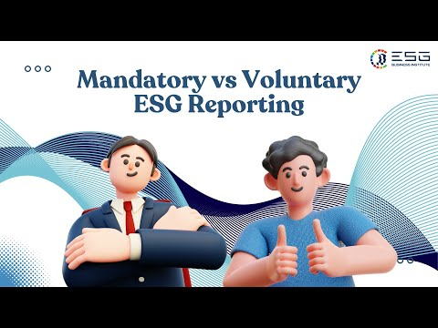
Video 2. Mandatory vs. Voluntary ESG Reporting (https://www.youtube.com/watch?v=_TKLd8vwQcA)

Answer key: 1. c), 2. b), 3. c).

Topic 1.2: ESG Metrics and KPIs: What to Measure and Why
Short introduction:
Identifying the right metrics is the core of a sustainability analyst’s role. While Topic 1.1 established the legal landscape, this topic explores the technical construction of the data. You will learn how to systematically categorize KPIs according to the ESRS pillars, understand the logic of "Intensity" versus "Absolute" indicators, and define the metadata required to ensure every data point is audit-ready and useful for decision-making.
Theory & Knowledge:
The Three Pillars of Sustainability Measurement

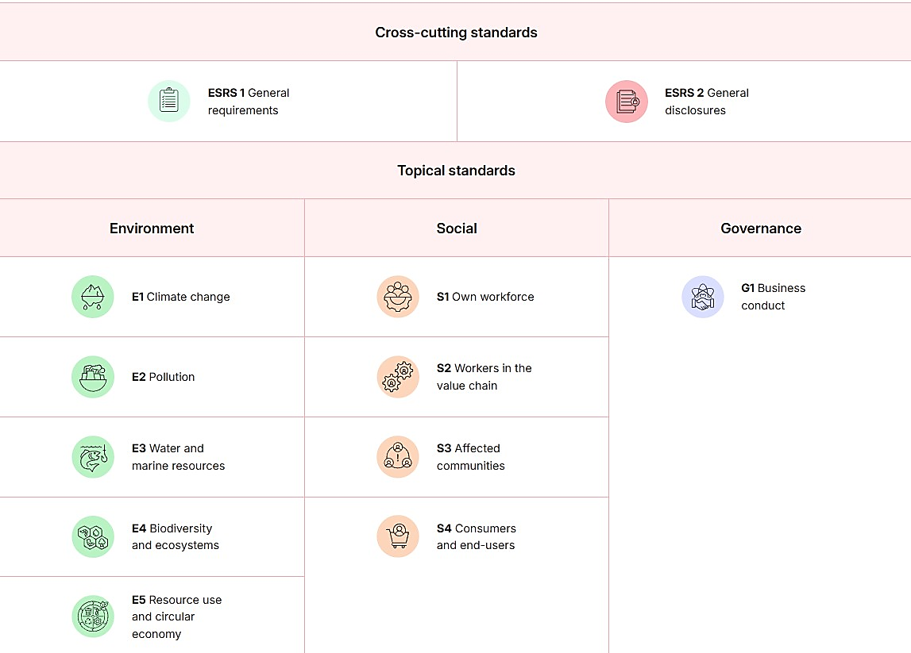
Figure 2. ESRS cross cuttung standards and 3 pillars of ESG (source: esgtool.eu)

The image above shows a structured table of ESRS standards, divided into cross-cutting standards (ESRS 1 and ESRS 2) and topical standards grouped under three pillars: Environment, Social, and Governance. The environmental pillar includes E1–E5 topics, the social pillar includes S1–S4 topics, and the governance pillar includes G1 business conduct.
To manage sustainability effectively, organizations categorize their data into three distinct dimensions.

Following the EFRAG ESRS framework, typical KPIs include:
- Environmental (E1–E5): Scope 1, 2, & 3 Emissions ($tCO_{2}e$); Energy intensity; Total water withdrawal ($m^{3}$); Waste generated (t); Land-use change (ha).
- Social (S): Gender pay gap (%); Employee turnover (%); Supplier social screening (%).
- Governance (G): Anti-corruption training (%); Confirmed incidents of bribery (#).

Table 1. ESRS KPIs (adopted from EC: Guideline for the Integration of ESG into Financial Analysis and Corporate Valuation)
Standard | Focus Area | Typical KPIs (Metrics)
E1 | Climate Change | Scope 1, 2, & 3 Emissions ($tCO_{2}e$);  Total GHG emissions  Emissions intensity (t CO₂e / revenue or / product)  Energy consumption (MWh)  Renewable energy share (%)  Energy intensity (MWh / output)  CO₂ reduction vs baseline (%)  Internal carbon price (€ / t CO₂e  CapEx aligned with climate transition (%)
E2 | Pollution | Air pollutant emissions (NOx, SOx, PM, VOC);  Pollutant emissions to water (kg);  Hazardous substances released (kg);  Soil contamination incidents (#)  Hazardous waste generated (t)  Toxic chemical use (kg)  Pollution incidents (#)  Environmental fines related to pollution (€)
E3 | Water and marine resources | Total water withdrawal (m³)  Water consumption (m³)  Water discharge (m³)  Water intensity (m³ / product or revenue)  Water use in water-stressed areas (%)  Water recycled and reused (%)  Pollutant discharge to water (kg)  Marine ecosystem impact indicators
E4 | Biodiversity and ecosystems | Operational sites in protected areas (# / %)  Land use / land conversion (ha)  Habitat restoration area (ha)  Biodiversity impact score (e.g., GBS / MSA)  Deforestation risk in supply chain (%)  Species affected (#)  Biodiversity investments (€)  Supplier biodiversity screening (%)
E5 | Circular Economy | Total material use (t)  Recycled material share (%)  Renewable material share (%)  Waste generated (t)  Hazardous vs non-hazardous waste (t)  Waste recycled (%)  Waste diverted from landfill (%)  Product recyclability (%)  Product lifetime / durability metrics  Circular revenue (%)
S1-S4 | Social | Gender Pay Gap (%)  Employee Turnover (%)  Supplier Social Screening (%).
G1 | Governance | Anti-corruption training (%)  Confirmed incidents of bribery (#)  Board Diversity (%).

Quantitative vs. Qualitative Data
A sustainability report is not just a list of numbers; it is a narrative supported by data. Analysts must manage two types of information:
- Quantitative Information (The "What"): Numerical data points like "4,500 GJ of energy used." This is essential for tracking progress against targets and creating dashboards.
- Qualitative Information (The "How"): Narrative descriptions of policies, risks, and strategies. For example, a company must describe its policy on anti-bribery alongside the number of incidents.
- The Metadata Solution: To make quantitative numbers trustworthy, analysts use a Data Dictionary. This document stores Metadata (data about data), such as:
- Metric Definition: Exactly what is being measured.
- Calculation Logic: The formula used (e.g., Consumption × Emission Factor).
- Data Owner: The person responsible for the source data.
- Reporting Frequency: How often data is collected (Monthly vs. Annually).

The Logic of Impact: Absolute vs. Intensity Indicators
To evaluate the performance of an undertaking effectively, analysts must understand the distinction between two types of quantitative logic:
- Absolute Metrics: These measure the total quantity of an impact (e.g., "Total 5,000 tonnes of $CO_{2}$"). Absolute numbers are crucial for understanding the total planetary burden and for staying within legal limits or carbon budgets.
- Intensity Indicators (Normalization): These measure efficiency by dividing the absolute impact by a business metric, such as revenue, production volume, or headcount (e.g., "$tCO_{2}e$ per million € of revenue" or "$m^{3}$ of water per unit of product").

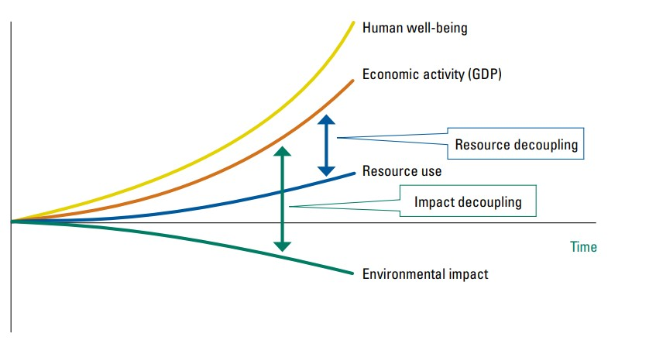
Figure 3. Visualizing the decoupling of business growth from environmental impact through Intensity Metrics (source: unep.org)

The image above shows a graph illustrating how human well-being and economic activity (GDP) increase over time, while resource use grows more slowly and environmental impact declines. It highlights the concepts of resource decoupling and impact decoupling, demonstrating how economic growth can be separated from environmental harm.

Why it matters: Intensity indicators allow investors to compare companies of different sizes. For example, a large company may have higher absolute emissions than a small one, but it might be more efficient (lower intensity), showing a more successful transition to green technologies.

Defining Time Horizons
Every material metric and target must be categorized into specific time horizons:
- Short-term: The reporting period of the financial statement (1 year).
- Medium-term: From the end of the short-term period up to 5 years.
- Long-term: More than 5 years.

Business Value and Risk Management
Sustainability metrics serve as a vital "early warning system" for the modern corporation. Organizations do not just measure these points for compliance; they do so to create business value:
- Cost Efficiency: Tracking intensity (e.g., energy per unit) directly identifies resource waste and operational costs.
- Access to Capital: Investors and banks use these metrics to determine a company's risk profile. Higher ESG scores often lead to lower interest rates on loans.
- Strategic Resilience: Tracking social metrics like employee turnover can predict future recruitment risks and potential operational shutdowns.

How ESG Metrics drive Financial Value?
Watch following video:

Video 3. How ESG creates value (https://www.youtube.com/watch?v=BKVID6bs1BE)

Micro-activities:
Activity 1: The "KPI Profile" Task
Sustainability analysts must know the technical details behind every number.
- Task: Select two metrics from the list above (one Environmental and one Social). For each, research and write a 250-word profile that includes:
- The Standard Unit of Measurement (e.g. $tCO_{2}e$ , %, or headcount).
- Primary Data Source (e.g., utility invoices, payroll software, or supplier audits).
- Two potential Data Quality Issues (e.g., missing data from a subsidiary or incorrect conversion factors).

Activity 2: The "Intensity vs. Absolute" Analysis
In sustainability reporting, "Absolute" numbers tell you the total impact, but "Intensity" tells you the efficiency.
- Scenario: Company A produced 1,000 cars and emitted 100 tons of $CO_{2}$. Company B produced 5,000 cars and emitted 250 tons of $CO_{2}.$
- Task: Calculate the "Emission Intensity" (Emissions per car) for both. Write a short paragraph (150 words) explaining why an investor might find Company B "more efficient" even though its total emissions are much higher.
- Hint: Absolute metrics show the total burden on the planet, while intensity metrics show the efficiency of the production process.

Review & Reflection
Briefly review your notes and the Key Takeaways below.

Key Takeaways:
- Systematic Framework: ESG metrics are not selected randomly; they are technical outputs derived from the ESRS E1–G1 Disclosure Requirements. This systematic link ensures that every KPI reported is directly tied to regulatory compliance and standardized reporting.
- The Metadata Mandate: To be audit-ready, every metric must be documented in a Data Dictionary. This centralized repository defines the technical metadata for each KPI, including the exact calculation formula, the unit of measurement, and the assigned Data Owner.
- Defining System Boundaries: The accuracy of sustainability data depends on clearly defined system boundaries. These boundaries establish the operational or geographic scope of the data (e.g., which subsidiaries are included), ensuring that metrics are consistent and prevent double-counting of impacts.
- Efficiency vs. Impact Logic: Analysts must distinguish between Absolute Metrics (the total environmental burden) and Intensity Indicators (normalized efficiency relative to revenue or output). Normalization is critical for comparing the performance of organizations of different sizes.
- Data Governance Roles: Reliable sustainability data is the result of a formal ownership model. Accuracy is maintained by Data Owners at the source, while the technical calculation logic and ESRS alignment are validated by the ESG Controller.

Additional reading:
- EFRAG: ESRS Data Points List (Excel Tool) Download the Excel file. Focus on the "Environmental" tab to see the hundreds of specific units of measurement (e.g. $tCO_{2}e, m^{3}$) an analyst must track.
- GRI 305: Emissions 2016 - Pages 7–12. Learn the technical difference between Scope 1, 2, and 3 emissions and the specific reporting requirements for each.
- MSCI ESG 101: What is ESG? - MSCI is one of the world’s largest providers of ESG ratings. This guide explains how investment analysts use metrics to score companies.
- IFRS S1 and S2 Summary - A high-level summary of the International Sustainability Standards Board (ISSB) standards, which are used by non-EU companies.
- EFRAG ESRS Q&A Platform Cross-Cutting Mapping of Sustainability Matters to topical Disclosures (Q&A ID 177).

Quick Check:
1. Which document serves as the centralized repository for defining the formulas, sources, and technical context of all company KPIs?
- The CSRD Directive
- The Sustainability Statement
- The Data Dictionary.

2. If a company reports its total water usage divided by its annual revenue, what type of metric is it using?
- Absolute Metric
- Intensity Indicator
- Qualitative Disclosure.

3. What is the primary purpose of defining "System Boundaries" before collecting ESG data?
- To reduce the number of pages in the report.
- To encrypt data for security purposes.
- To define the organizational scope and ensure data is consistent and comparable.

4. Reflection Point:
In your own words, explain how an environmental metric (like high energy usage) can represent a direct financial risk to a company.

Answer key: 1. c), 2. b), 3. c)

Topic 1.3: Double Materiality and Stakeholder Information Requirements
Short introduction:
Double materiality is the mandatory "decision engine" of the CSRD. It is the process by which an undertaking determines which sustainability topics are significant enough to be measured and reported. In this topic, we follow the official EFRAG methodology to move from a broad list of ESG issues to a focused, audit-ready data scope.
Theory & Knowledge:
The Foundation: The Two Lenses of Materiality

Before starting the process, an analyst must understand the dual logic of the ESRS. Double materiality requires looking through two distinct lenses simultaneously:
- Impact Materiality (Inside-Out): How the undertaking affects people and the environment (e.g., carbon emissions, labour practices).
- Financial Materiality (Outside-In): How sustainability risks and opportunities affect the undertaking's financial health (e.g., climate regulations impacting costs).

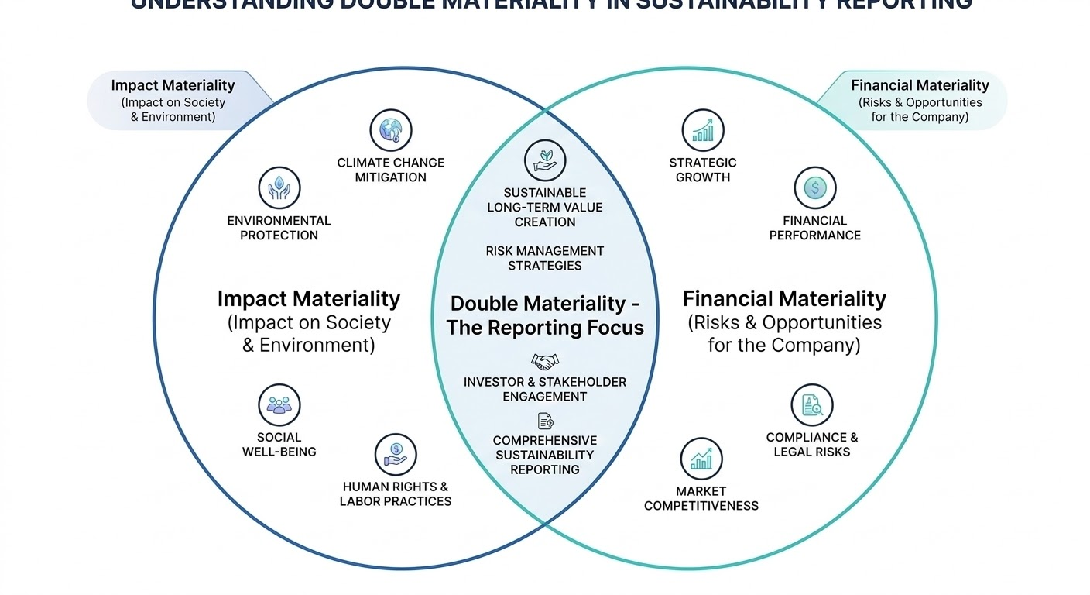
Figure 4. The Dual Lenses of Double Materiality: Impact and Financial Perspectives (AI generated)
The image above shows a Venn diagram with two overlapping circles representing impact materiality (effects on society and the environment) and financial materiality (risks and opportunities for the company). The overlapping area highlights double materiality as the reporting focus, combining both perspectives.

The 4-Step EFRAG Methodology (Steps A-D)
To ensure the assessment is verifiable, the undertaking follows the systematic process illustrated in the EFRAG IG 1 guidance:

Step A: Understanding the Context
Before identifying impacts, the undertaking must define its System Boundaries (which subsidiaries and value chain segments are included).
- Stakeholder Mapping: This is the point where the undertaking identifies its Stakeholders. These are divided into Affected Stakeholders (those impacted by the company) and Users of Information (investors and banks who need the data).
Step B: Identification of Actual and Potential IROs
The undertaking creates a "long list" of Impacts, Risks, and Opportunities (IROs).
- Data Ownership: In this phase, Data Owners from different departments (HR, Procurement, Environment) are consulted to identify where the most significant sustainability issues occur in the daily operations.
Step C: Assessment and Determination of Materiality
This is the technical "filtering" stage where each IRO is scored against a Materiality Threshold.
- Impacts are scored based on Severity (Scale, Scope, and Irremediable character).
- Financial risks are scored based on Magnitude and Likelihood.
- The Board oversees this stage to ensure the final selection aligns with corporate strategy.
Step D: Reporting
The final list of material topics defines the Reporting Scope.
- KPI Alignment: For every material topic, the analyst selects the corresponding KPIs and Data Points (as defined in Topic 1.2).
- Metadata: Every selected metric is then documented with its calculation logic in the Data Dictionary, ensuring it is ready for the digital report.

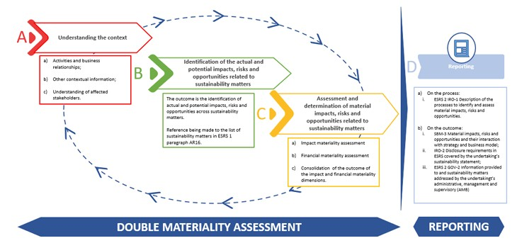
Figure 5. Example of materiality assessment process (source: EFRAG IG 1 - Materiality Assessment Implementation Guidance, pg.20)

The image above shows a step-by-step process for conducting a double materiality assessment, starting with understanding the context, followed by identifying impacts, risks, and opportunities, and then assessing their materiality. The process leads to reporting, with arrows indicating an iterative cycle of continuous evaluation and improvement.

What is a Double Materiality?
Watch the following video for better understanding.

Video 4. What us double Materiality? (https://www.youtube.com/watch?v=yEMOqR_JaqI)

Micro-activities:
Activity 1: The "Materiality & Governance" Audit
Analysts must be able to "read" the strategy and the accountability structures behind a company’s materiality choices.
- Task: Find the latest Sustainability Report of a major undertaking (e.g., Siemens, IKEA, or BMW).
- Analysis:
  - Locate the "Materiality Matrix." List the top 3 topics in the "material" zone.
  - Find the section on Governance: Does the report explicitly state that the Board (Highest Governance Body) approved the materiality assessment results?
  - Reflect: Based on their description of Step A (Context), how did the undertaking define its System Boundaries (e.g., did they include only their own operations or the entire value chain)?

Activity 2: Scoring and Data Ownership Simulation
Scenario: You are an analyst for a clothing retailer. You discover that a key Tier 2 supplier is using hazardous chemicals that are leaking into a local river.
Task: Apply the Step C (Assessment) criteria.
  - Impact Score: Rate the Scale, Scope, and Irremediable character (1 to 5 scale).
  - Financial Score: Estimate the Magnitude of potential regulatory fines or brand damage.
  - Governance Mapping: Identify which internal Data Owner (e.g., Procurement Manager or Environmental Lead) is responsible for monitoring this specific supplier's data.
Conclusion: If the combined score exceeds your Materiality Threshold, explain in 200 words how this decision changes the Reporting Scope for the ESG Controller.

Reflection Point:
Consider a global fast-food chain.
- Identify one Impact Materiality issue (how the company affects the world).
- Identify one Financial Materiality issue (how a sustainability event could cost the company money).
- Are these two issues connected? Write down a 2-sentence explanation of the link.

Additional reading:
- EFRAG IG 1: Materiality Assessment Implementation Guidance (Read pages 10–14 -Section 2.1,. Study Figure 1a (Venn diagram) and Figure 1b to understand the "Inside-out" vs. "Outside-in" logic).
- GRI 3: Material Topics 2021 (Read Page 7 (Figure 2) for the 4-step process overview and Page 12 for the definition of Severity: Scale, Scope, Irremediability).
- ESRS 1: General Requirements: ANNEX I European Sustainability Reporting Standards - ESRS (Read? Appendix E (pages 33-34) to master the mandatory logic for selecting which ESG data points must be reported and which can be omitted).

Key Takeaways:
- Algorithmic Strategic Filter: Double Materiality is the mandatory 4-step process (A-B-C-D) that systematically defines the Reporting Scope, moving an undertaking from over 1,000 potential data points to a focused set of relevant metrics.
- The Dual Perspective Mandate: Undertakings must look through two distinct lenses: Impact Materiality (the company’s effect on the world) and Financial Materiality (sustainability-related risks to the company’s value).
- Governance & Accountability: The Board holds ultimate responsibility for overseeing the assessment, while the ESG Controller ensures the materiality results are correctly translated into technical entries in the Data Dictionary.
- Objective Prioritization: Topics are filtered using a Materiality Threshold based on objective criteria—specifically the Severity (Scale, Scope, Irremediability) and Likelihood of impacts and risks.
- Foundation for Data Lineage: A successful materiality assessment provides the technical justification for every metric included in the final report, serving as the starting point for the Data Owners to begin collection.
- The Data Specialist’s Roadmap: For the analyst, the materiality assessment defines the entire technical scope of the project, determining exactly which data points must be active in the reporting database and dashboard.

Quick Check:
1. Which EFRAG Step (A-D) involves defining the geographic and operational "System Boundaries" of the undertaking?
- Step B: Identification
- Step A: Understanding the Context
- Step D: Reporting.

2. What are the three mandatory criteria used to score the "Severity" of a negative impact?
- Scale, Scope, and Irremediable character
- Cost, Time, and Reputation
- Likelihood, Magnitude, and Frequency.

3. If a topic is found to be non-material, what is the technical outcome for the reporting dashboard?
- The metrics are reported anyway "just in case."
- The data is reported but hidden in a secret file.
- The related metrics and data points are omitted from the report.

4. Reflection Prompt:
Explain why a data analyst cannot build an audit-ready dashboard without first knowing the results of the Double Materiality Assessment and the approved Reporting Threshold.

Answer key: 1. b), 2. a), 3. c),

Topic 1.4: Reporting Architecture and Sustainability Data Flows
Short introduction:
The transition from voluntary to mandatory reporting requires a shift from manual spreadsheets to robust, automated, and governed data pipelines. In this topic, we explore the "Digital Spine" of reporting. You will learn how to architect a system that ensures Data Lineage, implement internal controls through specific roles like the Data Validator, and meet the technical digital requirements set by ESMA.
Theory & Knowledge:
The 3-Tier Architecture of Sustainability Information

To ensure "financial-grade" data, an undertaking must move beyond disconnected Excel files. A professional reporting architecture consists of three governed layers:
- The Source Layer: Where raw data is born (e.g., ERP for supply chain, HRIS for social metrics, IoT sensors for energy). Every source must have a designated Data Owner.
- The Integration & Validation Layer: A central "Single Source of Truth" where data is cleaned and normalized. Here, the Data Validator performs checks to ensure the raw data matches the source (e.g., utility bills) before consolidation.
- The Reporting Layer: The final output where data is visualized and prepared for Assurance. The ESG Controller oversees this layer to ensure all disclosures align with the Data Dictionary.

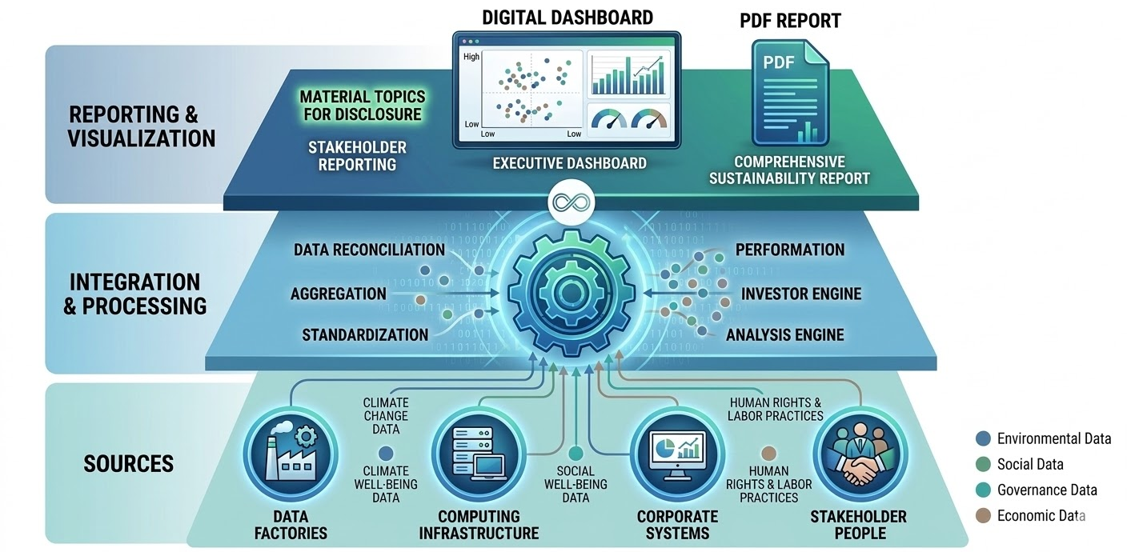
Figure 6. The Three-Tier Architecture of Sustainability Information Systems (AI generated)

The image above shows a layered architecture with three levels: data sources at the bottom (e.g., data factories, IT infrastructure, corporate systems, and stakeholders), integration and processing in the middle (including aggregation, standardization, and analysis), and reporting and visualization at the top (dashboards and sustainability reports). It illustrates how different types of sustainability data flow through the system to produce insights and reports.

Operationalizing Data: The Data Dictionary and Metadata
A metric is not useful for decision-making unless its construction is transparent. Every material KPI must be documented in a Data Dictionary using specific Metadata fields:
- Metric Definition & Calculation Logic: Precise description and the mathematical formula (e.g., Intensity = Absolute Impact / Revenue).
- System Boundaries: Definition of which subsidiaries or sites are included to ensure consistency.
- Data Collection Template Logic: Digital templates must require Data Owners to provide both the numerical value and the supporting documentation (audit trail) for every entry.

Internal Control Environment: Roles in the Data Flow
Reliability is guaranteed through a formal hierarchy of roles, ensuring the "Digital ESG Governance" described in recent frameworks (MDPI, 2025):
- Data Owner (Operational): Accountable for the accuracy of raw data at the point of origin.
- Data Validator (Control): An independent role that verifies the integrity of the data before it enters the reporting layer.
- ESG Controller (Management): Manages the overall reporting strategy and ensures that digital disclosures meet the ESRS quality characteristics (Relevance, Verifiability, etc.).
What is XBRL?
Watch the folllowing video. 
Video 5. What is XBRL? (https://www.youtube.com/watch?v=4uTrB1gQ-xM&t=110s)

Machine-Readability and ESMA Requirements

Under the CSRD, reports must comply with ESMA (European Securities and Markets Authority) standards:
- iXBRL Tagging: As shown in Figure 7, reports must be digitally tagged. This allows regulators to "scrape" data points automatically.
- Digital Transparency: This ensures that an undertaking’s ESG data is immediately comparable to its peers across the entire EU market, reaching the same transparency standard as financial reporting.
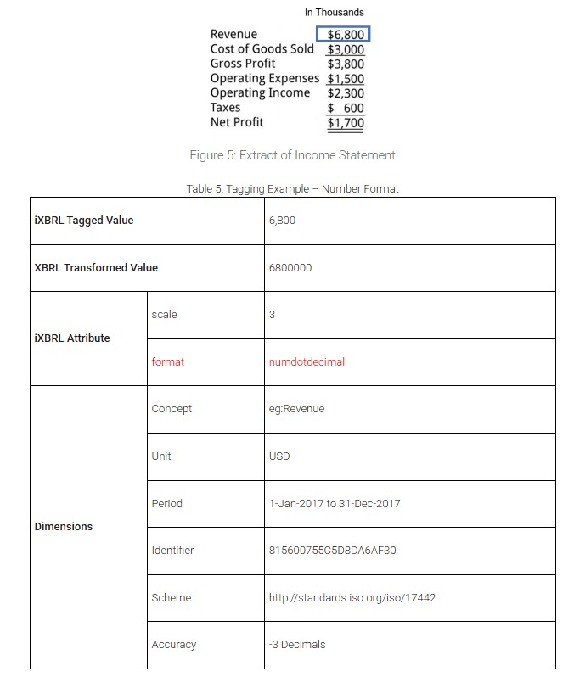

Figure 7. Tagging Example (source: xbrl.org)

This image shows a financial statement snippet with revenue and other figures, alongside a table explaining how a value is tagged using iXBRL. It illustrates how the reported value is transformed and enriched with attributes such as scale, format, concept, unit, period, and other metadata dimensions.
- Tagging: Every material data point in the report is assigned a specific "tag" from the ESRS Taxonomy.
- Purpose: This allows regulators, investors, and AI tools to automatically "scrape" the data from thousands of reports to compare performance across the entire EU market instantly.
- Impact on the Analyst: As a data specialist, you must ensure that your data structure aligns with the official ESRS taxonomy so that the tagging process is seamless and error-free.

Reflection Point:
Think about your current workplace or a company you know.
- Where is the "Energy Consumption" data currently kept? (e.g., Excel, printed bills, or a digital system?)
- If an auditor asked to see the original invoice for a bill from 18 months ago, how long would it take to find it?
This exercise highlights the difference between "reporting" and "audit-ready architecture."

Micro-activity:
Activity 1: Designing a Data Flow Map (60 minutes)
Scenario: You are tasked with reporting the "Total Water Withdrawal" for a company with three factories in different countries.
Task: Draw a flow chart (on paper or using a tool like PowerPoint/Miro) that maps the data journey. You must include:
  - The Source (Who enters the data at the factory level?).
  - The Frequency (How often is it collected?).
  - The Transformation (Where is it converted to cubic meters if the source is in different units?).
  - The Control Point (Who checks the data for errors?).
Goal: Identify at least two "weak links" in this chain where data could be lost or corrupted.

Activity 2: The Audit Readiness Checklist (45 minutes)
Task: Based on your reading of ESRS 1 Chapter 2 (Qualitative Characteristics) from the previous lessons, create a 10-point "Technical Checklist" that a data analyst should use before hitting 'publish' on a dashboard.
Hint: Include points about "Verifiability" (is there an audit trail?) and "Comparability" (did we use the same methodology as last year?).

Review: Briefly review the Topic Summary below.

Additional reading:
- ESRS 1: General Requirements: ANNEX I European Sustainability Reporting Standards - ESRS.
- Paragraph 111 (b) - legal basis for why we use XBRL tagging; The Data Blueprint (Page 32, Appendix D) and the table titled "Structure of the ESRS sustainability statement." - how you must organize your data layers (L1: General Information; L2: Environmental; L3: Social; L4: Governance). If you are building a dashboard, your menu should follow this exact structure to be compliant.
- XBRL.ORG - iXBRL Basics. Understand how iXBRL merges human-readable reports with machine-readable data.
- EFRAG Taxonomy: Illustrative Reports - Annex 1: ESRS Set 1 XBRL Taxonomy Illustrated in Excel (XLSX, 1.6 MB) and Annex 2: Illustrative examples of XBRL reports (ZIP, 5.5 MB). Browse the "Illustrative Report" to see what digital tagging looks like in a real-world example.

Key Takeaways (Topic Summary):
- Systemic Integration: Modern reporting requires an integrated architecture that connects raw data sources (ERP, HR, IoT) to a centralized "Single Source of Truth."
- The Importance of Lineage: Data lineage (the "paper trail") is essential for mandatory assurance; every reported figure must be traceable back to its origin to satisfy auditors.
- Validation and Controls: Robust data flows must include internal validation points and clear "data ownership" to prevent errors during the consolidation of global data.
- Mandatory Machine-Readability: Under CSRD, reports must be tagged using the iXBRL format, moving sustainability data from human-readable documents to machine-readable datasets.
- The Analyst as Architect: The role of the sustainability analyst is evolving into a "Data Architect" who ensures that the technical systems are as reliable and transparent as financial accounting systems.

Quick Check:
1. Which layer of the sustainability information architecture is responsible for converting raw data (e.g., liters of fuel) into standardized reporting units e.g., $tCO_{2}e$)?
- The Source Layer
- The Integration Layer
- The Reporting Layer.

2. Under the CSRD, what is the primary purpose of using iXBRL (inline XBRL) digital tagging?
- To make the PDF report look more visually appealing for marketing.
- To ensure the report is machine-readable for regulators and investors.
- To encrypt the data so it cannot be read by competitors.

3. What does "Data Lineage" refer to in the context of an audit-ready ESG system?
- The process of deleting old data to save server space.
- The ability to trace a specific figure in the final report back to its original source.
- The list of employees who have access to the sustainability dashboard.

Reflection Prompt

In your own words, explain why relying on manual data entry in disconnected Excel spreadsheets is considered a high-risk approach for meeting the "Verifiability" requirement of the ESRS.

Answer key. 1. b), 2. b), 3. b).

Module 1: Conclusion and Self-Assessment
Module Summary:
Module 1 has provided the strategic and technical blueprint for modern sustainability reporting. We have explored the shift from voluntary disclosures to a mandatory, digital, and audited accounting discipline.
- Regulatory Framework: You have learned how the CSRD and the recent Omnibus I Directive (2026) have optimized the reporting landscape, focusing on large undertakings (1,000+ employees) and streamlining requirements to approximately 320 core ESRS data points.
- Metric Construction: We moved beyond simple data collection to the logic of Metric Construction. You now understand that a KPI is only as good as its Metadata (formula, boundaries, and frequency) documented in a central Data Dictionary.
- Analytical Logic: The distinction between Absolute metrics (total impact) and Intensity indicators (efficiency) is now clear. You have learned that intensity metrics are essential for decision-making and comparing efficiency across different company sizes.
- Strategic Filtering: Through the Double Materiality (A-B-C-D) process, you have seen how an undertaking filters over 1,000 potential points into a focused reporting scope based on Severity and Likelihood.
- Governance & Digital Architecture: Finally, we established the "Digital Spine." High-quality data depends on a chain of accountability involving Data Owners, Data Validators, and the ESG Controller, all while ensuring reports are machine-readable via iXBRL tagging.

Module Knowledge Quiz
Purpose: Consolidate technical and strategic concepts from Topics 1.1 through 1.4.
1.Under the Omnibus I Directive (EU 2026/470), what is the updated employee threshold for mandatory large undertaking reporting?
- 250+ employees
- 500+ employees
- 1,000+ employees.

2. In a professional Data Dictionary, what does "Metadata" provide?
- The final numerical value of a KPI.
- The technical context, such as calculation logic, units, and data owners. (Correct)
- A list of all competitors' emissions.

3. If a factory reduces its absolute energy use by 5%, but its production volume drops by 20%, what has happened to its Energy Intensity?
- It has improved (efficiency increased).
- It has worsened (efficiency decreased).

4.Which role is responsible for coordinating the internal validation of data points before they reach external assurance?
- Data Owner
- ESG Controller / Data Validator
- The Board of Directors.

5. Under the EFRAG Materiality Process, which step involves defining the geographical and operational "System Boundaries"?
- Step A: Understanding the Context
- Step C: Assessment
- Step D: Reporting.

6. What technical standard does the ESG Controller use to ensure sustainability data is machine-readable for ESMA?
- PDF/A-1
- iXBRL Tagging (ESEF Format)
- Standard CSV files.

Answer Key: 1. c), 2. b), 3. b), 4. b), 5. a) 6. b).

Applied Scenario (not mandatory)
Scenario:
"GreenGear Corp," a large EU manufacturer of bicycle components, is preparing its first CSRD-aligned report. The CEO wants to skip the "Double Materiality" process to save time and simply report the same metrics they used for their voluntary GRI report last year. Meanwhile, the IT department is planning to keep all ESG data in a shared Excel folder, as they believe the final "machine-readability" requirement is just a suggestion.

Your Task:
Based on the Governance and Architecture principles learned in this module, identify the two most urgent steps AquaTech must take to ensure their data is "audit-ready."
(Suggested Answer logic: Step 1: Appoint an ESG Controller to centralize the reporting process and define clear Governance Roles. Step 2: Establish a Data Dictionary that documents the Metadata and System Boundaries for every material KPI to ensure consistency and verifiability.)

MODULE 2: Energy-Efficient Architecture
Module Overview:
To make correct data-driven decisions and provide accurate sustainability reporting, data first needs to be described, made accessible and its quality guaranteed. The next module will give an overview of data governance, management, collection and quality assurance.
Module learning outcomes
- Know roles, tasks and parts of data governance and data management
- Implement data collection workflows for sustainability reporting frameworks
- Apply data quality assurance principles to sustainability datasets.
- Create meta-data documentation
Estimated workload
Lecture hours (F2F): 6 hours
Self-study: 6 hours
Practical application (if applicable): 5 hours
Assessment link: This module contributes to the metadata and data quality assurance part of the final assessment.
Practical focus / deliverable:
Metadata description and short data quality audit report.

Topic 2.1: Data Governance and Management

Short introduction:
Data has become one of the most critical strategic assets in modern organizations. To have an overview of which data and how is used in an organization, data governance and data management practices need to be in place. In the next chapter, introduction to data governance and data management is provided. A through look into roles, processes, data lifecycle and metadata is provided.
Theory & Knowledge:
Data governance is a set of policies and rules which gives instructions on how data should be used in an organization. Data management is the actions taken to enforce these policies. As an analogy, data governance is the blueprint to build a house and data management is the actual steps taken to build a house.

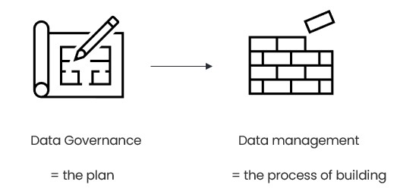
Figure 8. Data Governance and Data Management as plan and actions. (Source: created by author)

Image shows two icons: a paper with pen and a brick wall construction and an arrow between them. Below the paper icon there is a text “Data Governance = the plan” and below the bricks icon there is a text “Data management = the process of building”.

The goal of data governance and data management is to ensure that the data is described, accessible and with high-quality. Thanks to this, an organization can make better decisions, provide better services and reduce operational costs.
For better understanding of data management, check out the video “What is data management?” by Denise Harders:
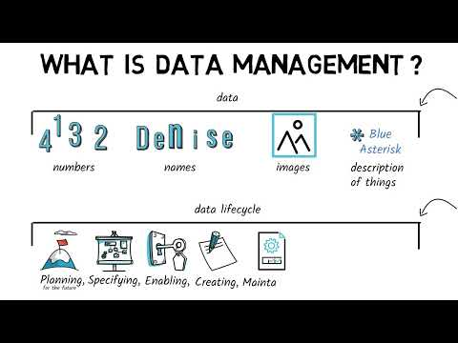
Video 6. What is data management? (https://www.youtube.com/watch?v=38nPx2rM0NU)

Parts of Data Governance
Isaac Sacolick, President of StarCIO, a digital transformation learning company, brings out eight parts of data governance (see Figure 9). Blue icons represent the organizational responsibilities, policies, documentation, and tools that enable people in the organization to understand data assets. The green icons represent hybrid business, data and technical practices that drive sourcing and managing data.
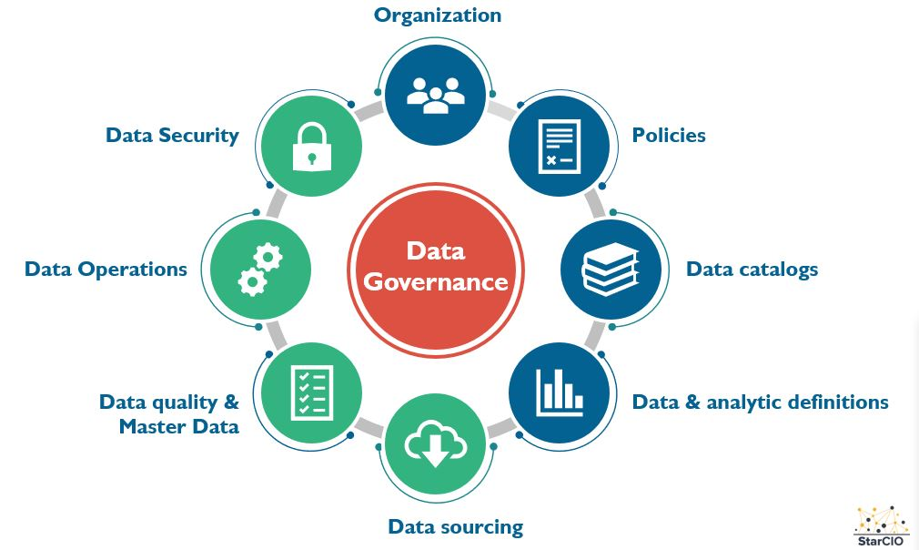
Figure 9. Parts of Data Governance (Image source: StarCIO)
Image description: Image shows one big red circle in the middle with text “Data Governance” and eight smaller circles around the middle circle with icons and texts: blue circle with text “Organization” and icon of three people; blue circle with text “Policies” and icon of a paper; blue circle with text “Data catalogues” and icon of stacked books; blue circle with text “Data & analytic definitions” and icon of a bar chart; green circle with text “Data sourcing” and an icon of cloud and down arrow; green circle with text “Data quality & Master Data” and icon of a paper with checklist; green circle with text “Data operations” and an icon of two gear wheels; green circle with text “Data security” and an icon of a padlock.

Next, each part of data governance is explained in more detail:
Organization
The organizational component of data governance refers to the people, roles, and structures responsible for overseeing and managing data across the organization. This includes establishing data governance councils, appointing data stewards, data owners and a Chief Data Officer who collectively define accountability for data assets.
Policies
Data governance policies are the formal rules, standards, and guidelines that dictate how data should be collected, stored, accessed, used, and disposed of within an organization. These policies serve as the backbone of governance, ensuring compliance with regulations, while also reflecting internal business requirements.
Data Catalogs
A data catalog is essentially a searchable inventory of an organization's data assets, providing metadata, lineage, and context that helps users understand what data exists, where it comes from, and how it can be used. Think of it as a library card system for your data — it enables data consumers across the business to discover relevant datasets quickly.
Data & Analytic Definitions
This component focuses on establishing a common business vocabulary and standardized definitions for key data elements and metrics used across the organization. When different departments define "revenue," "customer," or "active user" in different ways, it leads to conflicting reports and poor decision-making. Data and analytic definitions (captured in a business glossary) ensure that everyone is speaking the same language.
Data Sourcing
Data sourcing encompasses the processes and standards by which data is acquired, ingested and integrated into an organization's systems, whether from internal systems, third-party vendors or external data providers. Governance of data sourcing ensures that the origin, reliability and licensing of data are well understood before it is used in business decisions or analytical models.
Data Quality & Master Data
Data quality governance ensures that data is accurate, complete, consistent, timely and fit for its intended purpose. This involves defining quality standards, implementing monitoring and cleansing processes and resolving data issues at their root cause. Master Data Management (MDM) is closely related, focusing specifically on creating a single, authoritative "golden record" for key business entities such as customers, products, suppliers and employees.
Data Operations
Data operations cover the processes, workflows and technologies used to manage the day-to-day movement, transformation, storage, and monitoring of data throughout its lifecycle. This includes pipelines, scheduling, incident management and ensuring that data flows reliably from source systems to consumption points. A governance lens on data operations means applying standards and oversight to these processes so that they are auditable, repeatable and resilient.
Data Security
Data security within a governance framework involves defining and enforcing controls that protect data from unauthorized access, breaches and misuse. This includes role-based access controls, encryption, data masking, audit logging and policies around data sharing and retention.

Find out more about Data Governance in this video by Adam Finer:
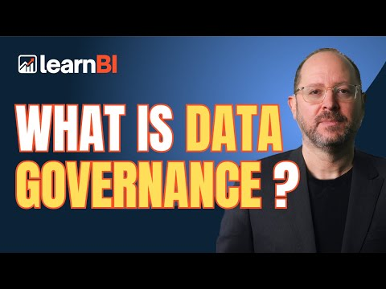
Video 7. Data Governance (https://www.youtube.com/watch?si=gByGFvZmpKm50Zsn&v=6kFByuEK1lc&feature=youtu.be)
Micro-Activity about parts of data governance
A company notices that two departments define 'active customer' differently. Which component of data governance is missing and what would you recommend fixing this?
Data Lifecycle
When it comes to data governance and data management, it is important to understand the data lifecycle (see Figure 10).

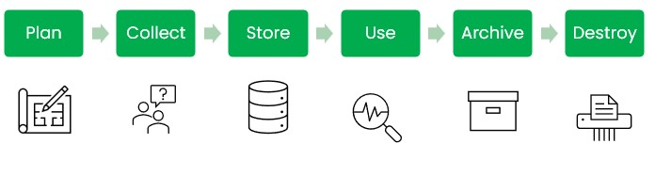
Figure 10.Data lifecycle (Image source: created by author)
Image description: Image shows six green boxes with text and icons below the boxes and arrows between the boxes. First box has text “Plan” and an icon of paper with pencil below. Second box has text “Collect” and an icon of two people with a question mark in a thought bubble. Third box has text “Store” and an icon for a database. Fourth box has text “Use” and an icon of a magnifying class. Fifth box has text “Archive” and an icon of a cardboard box. Sixth box has text “Destroy” and an icon of a paper going through a shedder.
Data lifecycle begins with a plan – what questions need answering, what data and from whom is needed to answer those questions, how can the data be collected, stored, used and when does it need to be archived and destroyed. The plan part gives the “why” and “how” for all the next steps.
Second step is data collection. In this step, data is generated or collected. A more through explanation and examples of data collection are brought out in topic 2.2. For now, it is important to know that data can be collected in numerous ways, but data quality checks should be already part of data collection.
In the store step, data is saved in a way that it is accessible to the right users. Data can be stored as files or in a database. It is important to document the access rights and log who, when and why has accessed data.
In the use step, data is analysed and decisions made based on the analysis. This is the key step to get value from the data.
In the archive step, data is moved to long-term storage. This step is important, so the non-current data is saved in a different part of the system, so users don’t end up using old data. However, the data is not yet destroyed as it might be useful in some longer analysis or data needs to be retained to compile with laws.
Final step is the destruction of data which means permanently removing data. This step is important to compile with laws and to ensure effective use of resources.
Roles in Data Management
Effective data management depends on people as much as on technology. For data management to work, employees need to know their role and tasks in the process. In Table 2, key roles for data management are brought out.
Table 2. Key roles in data management (source: Author)
Role | Primary Responsibilities | Level
Chief Data Officer | Sets data strategy; leads governance programme. | Executive
Data Owner | Accountable for quality, security, and lifecycle of a specific data domain. | Business Leader
Data Steward | Day-to-day management of data quality, glossary and lineage. | Mid-level
Data Consumer / User | Uses data for analysis, reporting, or operational tasks. | All Levels
Data Privacy Officer | Ensures compliance with data protection regulations. | Legal / Compliance

The role doesn’t need to be the main role of the employee. For example, the human resources team lead might be the owner of human resources related data as one of their work tasks, not as their main role. It is also important to note that cooperation between the roles is key to have well-managed data.
Micro-Activity about roles in data management
Review Table 2 and think of an organization you have worked in or are currently working in. Which role(s) did you fill? Who filled other roles? Were some roles missing?
Setting up Data Governance
Data governance can sound scary until you realize, we are already doing it in one way or another. An organization has data, information about that data and rules on who and for which goal can access the data. Now we just need to formalize these rules. There are three main steps that support data governance (see Figure 4).

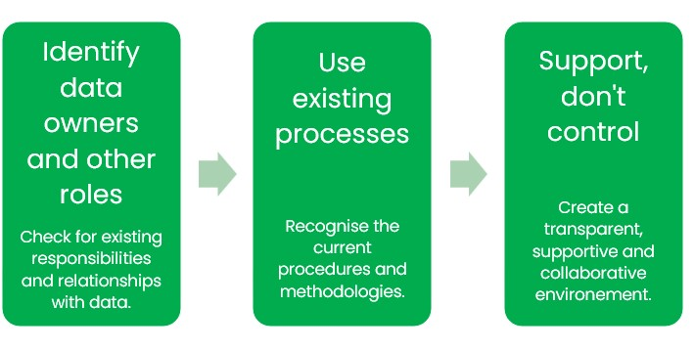
Figure 11. Steps to setting up data governance. (Image source: author)
Image description: Image includes three green boxes with text inside them and arrows between the boxes. First box reads: “Identify data owners and other roles. Check for existing responsibilities and relationships with data”. Second box reads: “Use existing processes. Recognise the current procedures and methodologies. Third box reads: “Support, don’t control. Create a transparent, supportive and collaborative environment”.
The important part of these three steps is to recognize how employees are currently working with data and build processes on top of that. To understand the current situation, employees need to be interviewed about their everyday work. As a next step, collaborative meetings need to be held to define formal processes. Finally, the policies need to be sent out for feedback and then formally introduced. After the policies have been created once, they need to be regularly overviewed and updated. Including employees from the beginning and in each step helps to create policies that will be followed. Employees are experts in their everyday work and data domain so including them in building data governance processes is crucial both for setting up high-quality processes and making sure these are followed.
Metadata – the dictionary for data
Data on its own doesn’t provide knowledge. Data points can be “5”, “yellow”, “Paris”, “20.12.2025”. Without knowing what the data points represent we can only guess what the data is about, e.g. 5 can be an age of a person, number of children, number of rooms in a house. But if we provide context to data, we can start making decisions, e.g. “Today’s date is 20.12.2025, it is 5 degrees in Paris and the leaves on trees are yellow”. Therefore, I decide to wear a jacket to go outside.
This context is called metadata – data about data. In an organization, it is important that each data table and each data point have a description. The most common way to create metadata is in tables. First, we describe what is the content of table, how and when it is updated, what is the source of data. Secondly, we describe the name, content and format of each column. See Table 2 for example on energy consumption table.
This table combines data on energy consumption.

Table 3. Example of metadata for energy consumption (source: Author)
Table name | Energy Consumption Data
Content | Monthly energy consumption by source and facility.
Update frequency | Monthly
Last updated | 2025-12-31
Data owner | Head of Sustainability, Environmental Department
Source | Utility invoices
Column Name | Description | Format | Example | Required
FacilityID | Unique identifier for each company facility | Text | FAC-001 | Yes
FacilityName | Full name of the facility | Text | Helsinki HQ | Yes
FacilityCity | City of the facility | Text | Helsinki | Yes
FacilityCountry | Country of the facility | Text | Finland | Yes
ConsumptionYear | The calendar year of consumption | Integer (YYYY) | 2024 | Yes
ConsumptionMonth | The month of consumption | Integer  (MM) | 09 | Yes
EnergySource | Type of energy consumed (electricity, natural gas, district heat, etc.) | Text | Electricity | Yes
ConsumptionAmount | Total energy consumed in the reporting period | Decimal number | 15420.50 | Yes
ConsumptionUnit | Unit of measurement for energy consumption | Text (MWh, GJ, kWh) | MWh | Yes
RenewableFlag | Indicates whether the energy source is renewable | Boolean (Yes/No) | Yes | Yes
Supplier | Name of the energy supplier | Text | Fortum | No
InvoiceReference | Reference number of the source invoice or document | Text | INV-2024-0342 | No
Metadata needs to be accessible and up to date. It is also important that if something changes then both the old and new version are saved. Usually, a data steward is responsible for creating metadata, but the task can be also assigned to another role that works closely with the data.
Additional reading
- The Data Governance Institute website: https://datagovernance.com/the-data-governance-basics/adg-data-governance-basics/ (Accessed February 2025).
- Seiner, R. 2014. Non-Invasive Data Governance. Technics Publications.
Key takeaways:
- Correct application of data governance and data management provide that organizations data is accessible, described and high-quality. This enables organization to make better data-driven decisions.
- Data governance and data management need to be part of each of the six steps of the data lifecycle.
- Roles and tasks of data governance and data management need to be clearly defined in an organization.
- Metadata is crucial to make sense of the data.
Quick check
- Which role is primarily responsible for day-to-day data quality monitoring?
- Chief Data Officer
- Data Steward
- Data Privacy Officer
- What is the first step of data lifecycle?
- Archive
- Use
- Plan
- True or False:
"Data Governance and Data Management are the same discipline and the words can be used interchangeably."
Answer key: 1) b; 2) c; 3) False

Topic 2.1: Data Collection Workflows

Short introduction:
Data collection is the second step of data lifecycle and a base stone for the next steps, including the decisions we can later make. In this chapter, an overview of data collection methods and workflows is given.
Theory & Knowledge:
Data Collection – from where and how?
The first question about data collection is „where from? “. The three places are:
- Data inside or collected by the organization itself, e.g. invoices sent
- Data from other organizations, e.g. invoices received, survey results
- Open data, e.g. electricity price in the market

We have most control over the first type of data – we can decide in which format the data is generated. For the open data and data from other organizations, we must accept the format on how they provide the data to us. However, sometimes we can order the data to be in a certain format, e.g. if we ask a survey company to create a survey to understand our organization’s reputation then we can provide the questions into the survey.

The second question about data collection is „how?“. This question defines the method of data collection. The most common data collection methods are:
- Survey
- Interview
- Observation
- Experiment
- Sensor data
- IT-system usage data

These are also called primary data collection methods. The secondary data collection method is analysis of already existing research.

In table 4, each of the six methods is explained and examples of how it can be used for sustainability reporting brought out.

Table 4. Data collection methods – descriptions and examples (source: Author)
Method | Description | Examples in Sustainability Reporting
Survey | A structured set of questions distributed to a defined group of respondents. Can be conducted online, on paper, or verbally. Allows collection of standardized quantitative and qualitative data from large samples. | Employee surveys on workplace safety, well-being, or satisfaction with sustainability initiatives. Supplier questionnaires on environmental practices, labour conditions.
Interview | A directed conversation between a researcher and one or more respondents. Can be structured, semi-structured, or unstructured. Allows in-depth exploration of topics and follow-up questions. | Stakeholder interviews with community representatives, non-governmental organizations, or investors to understand material sustainability topics. Expert interviews with environmental managers to document sustainability strategies and challenges.
Observation | Systematic watching and recording of behaviours, processes, or conditions — either in person or via monitoring tools. Can be participatory or non-participatory. | On-site inspections of factories or warehouses to assess working conditions, waste handling, or health and safety compliance. Third-party auditors observing production processes for certifications.
Experiment | A controlled investigation in which one or more variables are deliberately manipulated to measure the effect on outcomes. Allows for causal conclusions. Less common in business reporting, more common in research and development contexts. | Pilot programs testing the energy savings of a new LED lighting system before company-wide rollout. Controlled trials measuring the reduction in packaging waste when switching to a new material.
Sensor data | Automated, real-time or near-real-time data captured by physical measurement devices. Provides continuous, objective, and often highly granular data without human involvement in collection. | Smart meters measuring electricity, gas, or water consumption at facility level. GPS and telematics sensors tracking fleet vehicle mileage and fuel consumption.
IT-system usage data | Data generated as a by-product of actions taken in software. Typically, structured and already digitized. | Tracking digital document workflows to measure the reduction in paper printing over time. Monitoring video conferencing usage rates as a proxy for avoided business travel.

Secondary data collection refers to the use of already-existing data, research, and publications produced by third parties, rather than collecting new primary data. In sustainability reporting, this is not a shortcut but is a recognized and often necessary methodology, particularly for:
- Greenhouse gas emission factor databases: When an organization cannot directly measure emissions (eg, from upstream supply chain activities), it applies activity data (e.g., kilograms of material purchased) multiplied by published emission factors. Authoritative sources for emission factors include the Greenhouse Gas Protocol, DEFRA Greenhouse Gas Conversion Factor Repository and the IPCC emission factor database.
- Sector benchmarks: Industry associations and research organizations publish sustainability performance benchmarks (eg, average energy intensity per unit of output by sector). These are used to contextualize an organization’s performance in the report.
- Regulatory and statistical databases: National statistics offices, Eurostat, and environmental agencies publish data on grid emission factors, waste treatment rates, and water stress indices that organizations incorporate into their sustainability calculations.
When using secondary data, it is critical to document the source, publication date, version, and geographic scope of the data used. Emission factors in particular are updated regularly and using an outdated version can materially affect the accuracy of reported figures.

Data Entering Methods
The next step is to decide the data entering workflow. In table 5, the methods of data entering are brought out with typical error level and use cases.

Table 5. Data entering methods (source: Author)
Method | Typical Accuracy | Use case
Automated meter | ±1–3% | Energy and water consumption measured by smart meters.
Structured digital portal submission | ±3–8% | Data entered to a sustainability portal on last month energy consumption. The portal has structured and controlled data fields. Suitable for large-scale data entry.
Validated spreadsheet template | ±5–15% | Excel spreadsheet where annual energy consumption data is entered.  Suitable for low-volume data and infrequent metrics where creating a structured digital portal would be too much work.
Unstructured manual input (email, PDF) | ±10–25% | Utility invoices received as scanned PDFs — data manually extracted and keyed into the consolidation system by the local coordinator, introducing transcription risk and inconsistent unit reporting.
Deciding on which data-entry flow to build depends on how often the data is collected, in which quantities and how critical the data is. The more often, the more critical and bigger the dataset, the more time should be invested into building a data-entry workflow with higher accuracy and through data-quality checks.

Micro-activity on data entering methods
Your organization needs to collect monthly fuel consumption data from 50 company vehicles operating across 5 countries. Which data entry method would you recommend, and why?

The Five-Step Data Collection Workflow
A data collection workflow defines the sequence of steps from identifying a data need through to storing validated data ready for use. The following five-step process provides a practical framework for designing or reviewing a sustainability data collection workflow (see Figure 12).
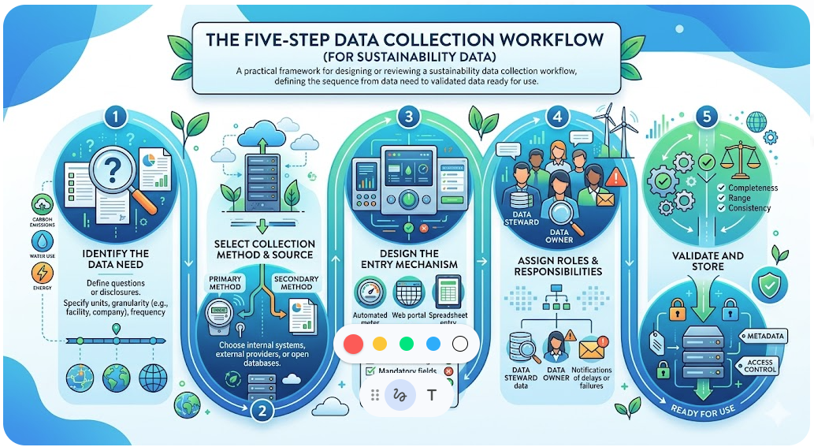
Figure 12. The five-step data collection workflow (AI generated)
Image description: This infographic illustrates the five-step data collection workflow. The process is depicted as a continuous, flowing path with steps descriptions for each of the five steps.
Next, the steps are described:
Step 1 — Identify the data need
Define what question needs to be answered or what disclosure requirement needs to be met. Specify the required unit of measurement, granularity (eg, facility-level vs. company-level), and frequency.
Step 2 — Select the collection method and source
Choose from the primary and secondary methods described above. Determine whether the data will come from internal systems, external providers or open databases.
Step 3 — Design the entry mechanism
Select the data entry method (automated meter, portal, spreadsheet, or manual). Define validation rules: permitted value ranges, mandatory fields, unit standards, and decimal precision.
Step 4 — Assign roles and responsibilities
Identify who is responsible for data collection (Data Steward or designated collector), who reviews it (Data Owner) and who is notified if data is late or fails validation.
Step 5 — Validate and store
Run automated or manual quality checks (completeness, range, unit consistency). Store the validated data with appropriate metadata and access controls.

Common data collection challenges
When collecting data, there are common challenges which affect the data precision and quality. Some common challenges and recommended mitigations are brought out in Table 6.

Table 6. Common data collection challenges (source: Author)
Challenge | Example | Impact | Recommended Mitigation
Late data | Utility invoices in some markets arrive 60–90 days after the period end. | Impossible to calculate real-time consumption figures. | Establish data-receipt service-level agreements with suppliers. Use smart meter data as a provisional estimate and reconcile with invoices when received.
Unit inconsistency | Energy reported in kWh, MWh, or GJ by different suppliers. | Decisions can be off by thousands without normalization. | Define a single unit standard in the data governance policy. Implement automated unit conversion at the point of entry.
Definitional drift | 'Active customer' is defined differently across departments. | Different numbers reported for the same metric. | Create and enforce a business glossary. Lock definitions before the reporting period begins.
Accuracy inconsistency | One clerk rounds energy to full kWh; another enters three decimal places. | Data aggregation errors and unreliable comparisons. | Specify precision rules in the data entry template or portal. Validate on submission with automated checks.

Key Takeaways:
- Data can come from three sources: internal organizational data, data from other organizations, and open/publicly available data. Each has different levels of quality control available.
- Primary data collection methods include surveys, interviews, observations, experiments, sensor data, and IT-system usage data. Secondary data (using previous research and statistics) is equally important, particularly for greenhouse gas emission calculations.
- The choice of data entry method (from automated metering (±1–3% error) to unstructured manual input (±10–25% error)) directly impacts data quality. The decision about data entry methos should be proportionate to data criticality, frequency, and volume.
Quick Check
- Which data entry method has the lowest typical error rate?
  - Validated spreadsheet template
  - Automated meter / sensor
  - Unstructured manual input (email, PDF)
  - Structured digital portal submission
- True or False – Data collection workflow starts with deciding which data collection method to use.
- An organization is calculating its greenhouse gas emissions from purchased goods. It does not have access to supplier-specific emission data. Which data collection approach is most appropriate?
- IT-system usage data from internal accounting system
- Secondary data — applying published emission factors to activity data
- Observation of supplier production facilities
- Experiment — running a pilot to measure emissions directly
Answer key: 1) b; 2) False; 3) b

TOPIC 2.3: Data Quality Assurance and Validation
Short introduction:
Data quality assurance is the systematic process of confirming that data is accurate, complete, consistent, and fit for its intended purpose. Without robust validation and cleaning practices, even the most sophisticated analyses will produce unreliable results.
Theory & Knowledge:
Data Quality Dimensions
Data quality is multidimensional. The DAMA-DMBOK defines six core dimensions, each of which has specific implications for sustainability reporting (see Figure 1).
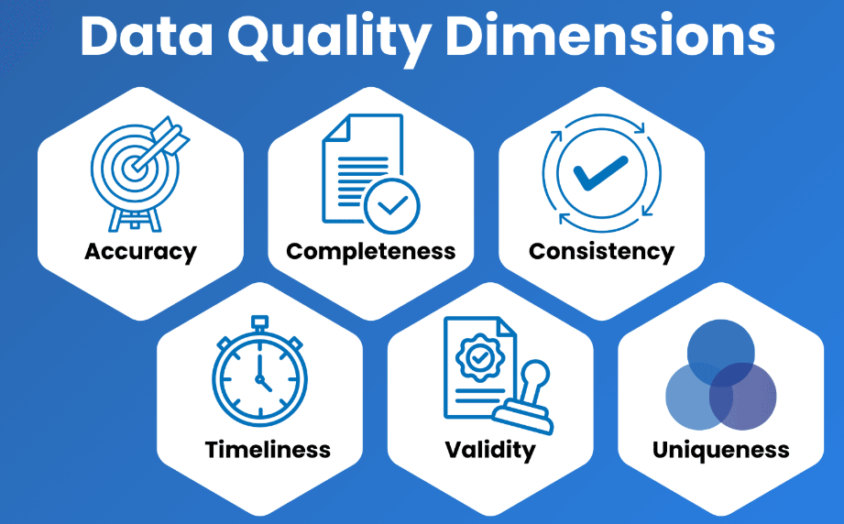
Figure 13. Data quality core dimensions (Image source: Clever Republic)

Image description: The image shows the six core data quality dimensions with icons for each of them.
In Table 7, the six core data quality dimensions are defined and examples provided.

Table 7. Six Core Data Quality Dimensions – Definitions, Examples and Failure Causes (source: Author)
Dimension | Definition | Sustainability Example | Possible Failure Cause
Accuracy | Correctly reflects the real-world value | Energy consumption matches meter readings | Manual transcription errors in invoice processing
Completeness | All required data points are present | All 47 production sites submitted water data | Missing data from recently acquired entities
Consistency | Uniform across systems and time periods | Same version of global warming potential values is used. | Business units use different versions of global warming potential values.
Timeliness | Data available when needed for reporting | Monthly energy consumption data available by the 15th | Utility invoices arriving 60+ days late.
Validity | Conforms to defined formats, units and ranges | Natural gas consumption in kWh, not m3. | Invoice has data as m3 and data entry clerk enters that value, not the kWh value.
Uniqueness | No unintended duplicates | Each facility appears once in reporting boundary | Merging of companies causes the duplication of facility IDs.

Data Quality Checks
Data quality rules should be defined before the data collection starts and then in the steps of data collection, data storage and data usage, these rules should be checked. Data quality rules can be „hard“ and „soft“. Hard rules are rules which have to be true in all cases and checks for these should make it impossible to enter the wrong value. Soft rules are rules which in most cases are true and checks for these rules should give a warning if a wrong value is detected.
Data validation in the process of data collection is the first line of defence in any data pipeline. It ensures that data entering a system meets pre-defined quality standards. Here is a list of examples in data collection for each core data quality dimension:
- Accuracy: If possible, use automatic data collection (e.g. automatic measures of electricity consumption instead of manual entrance of data from invoices). Add checks for the data entry, for example „Make sure to enter energy consumption in kWh “.
- Completeness: Determine whether all required data fields are populated. In data collection, this can be achieved by making fields mandatory.
- Consistency: Confirm that data values are logically coherent both within a single record and across related datasets. For example, if there is a field for date of birth and age of employee, these two fields should match logically.
- Timeliness: Send reminders to users who have not reported the data in a timely manner. Add data on when the data was entered for each row in the dataset.
- Validity: Ensure data conforms to defined formats, ranges, or reference values. A phone number field, for instance, must contain only digits within a plausible length range. An email field must include „@“. The energy consumption range can be maximum 1,5 times the size of last year’s same period value before giving a warning.
- Uniqueness: Define unique ID numbers for employees, customers etc. Check uniqueness by e-mail.
Additional checks for data quality can be made both in the storage and usage steps of data lifecycle.
In the storage step, specific formats can be assigned to data fields, e.g. electricity bill monetary value needs to be a decimal number with up to two decimal points. Also, checks for data ranges and consistency can be added to the database.
In usage step, data quality controls can be done during the data modelling and data profiling. For example, in the data modelling step each data column is specified to be certain format. Data profiling can be performed to check data quality, for example, if energy categories follow the pre-defined categories of „Electricity “, „Natural gas“ etc. What are the minimum, maximum, median and average values of numeric fields and if these conform to pre-set data quality rules. Sometimes during the process of data profiling, new data quality rules might emerge, and it should be considered if these can be implemented already in data collection step.
It is important to document each data quality rule and how the data corresponds to these. Separate data quality reports can be created for this.
Data Cleaning
Data cleaning is the process of detecting and correcting or removing inaccurate, corrupt, incomplete, or irrelevant records from a dataset. It is estimated that data professionals spend 60–80% of their time on data cleaning tasks, underscoring the importance of systematic, repeatable cleaning workflows.
The data cleaning lifecycle consists of six steps (see Figure 14):
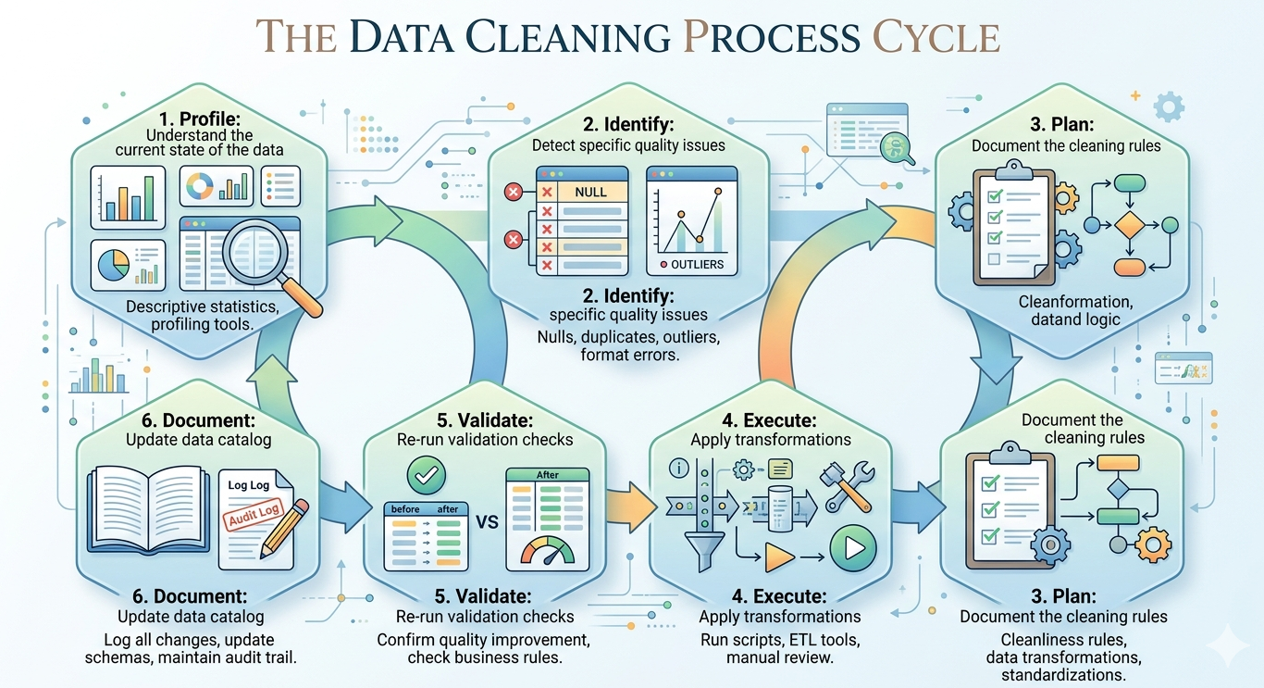
Figure 14. The six-step data cleaning workflow (Image generated with AI).

Image description: The image shows an infographic of the six-step data cleaning workflow: profile, identify, plan, execute, validate and document.

The six steps explained:
- Profile: Understand the current state of the data using descriptive statistics and data profiling tools.
- Identify: Detect specific quality issues (nulls, duplicates, outliers, format errors).
- Plan: Document the cleaning rules and transformations to be applied.
- Execute: Apply transformations using scripts, ETL tools, or manual review.
- Validate: Re-run validation checks to confirm the cleaning improved quality.
- Document: Update the data dictionary and audit log with changes made.

Some examples of data issues and cleaning strategies are brought out in Table 8.

Table 8. Data Cleaning Strategies by Issue Type (source: Author)
Issue Type | Cleaning Strategy
Missing Values | Imputation (mean/median/mode) of value or deletion of the record
Duplicate Records | Deduplication using key fields
Inconsistent Formats | Standardize via lookup tables
Outliers | Cap, remove, or flag for review
Typos | Correction
Wrong Data Types | Type casting and conversion

Micro-Activity on Data Cleaning Strategies
Look at the table of cleaning strategies above. Choose one issue type that you have encountered (or are likely to encounter) in your own work. Write 3 sentences describing: (1) what the specific data problem looked like, (2) which cleaning strategy from the table you would apply, and (3) how you would verify the cleaning was successful.

Data cleaning is a continuous, cyclical process. New data introduced to a system may contain fresh quality issues, so validation and cleaning must be repeated as part of ongoing data governance. It is best to automate as much of the process as possible.

Additional reading
- Global Reporting Initiative. 2025. Standards for sustainability reporting. https://www.globalreporting.org/how-to-use-the-gri-standards/gri-standards-english-language/ (Accessed: February 2025).
- CleverRepublic. 2025. The Six Most Used Data Quality Dimensions. https://www.cleverrepublic.com/resources/blog/the-six-most-used-data-quality-dimensions/ (Accessed: February 2025).
- IBM. Data Profiling. https://www.ibm.com/think/topics/data-profiling (Accessed: February 2025).

Key Takeaways:
- Investing in data quality upfront significantly reduces the cost and risk of downstream errors in reporting and decision-making.
- The six core data quality dimensions to check for are: accuracy, completeness, consistency, timeliness, validity and uniqueness.
- Data quality checks can be introduced in the collection, storage and usage phases of data lifecycle.
Quick Check
- Which of the following best describes a consistency check in data validation?
a) Verifying that a date field contains only numerical characters
b) Confirming that all required fields in a record have been populated
c) Checking that related values across fields are logically coherent
d) Ensuring that customer IDs are unique across the entire database

- True or False
“Data cleaning is a one-time effort and doesn’t need to be repeated when new data is introduced to the system.”

- True or False
“When data validation is introduced in the data collection phase, it can prevent erroneous data from being inserted.”

Answer key: 1) c; 2) False; 3) True

Module 2: Conclusion and Assessment
Module Summary:
Module 2 equipped you with essential competencies in data governance, collection and quality assurance. These pillars ensure that sustainability data is understandable, trustworthy, accessible and decision ready.
Data governance establishes the policies, roles, and accountability structures that guide how data is managed across its lifecycle, while data management translates those policies into operational practice. Understanding the six stages of the data lifecycle (plan, collect, store, use, archive, destroy) provides the framework for implementing governance at every step.
Data collection workflows require careful planning across five key steps: identifying data needs, selecting appropriate methods and sources, designing entry mechanisms, assigning clear responsibilities and validating before storage.
Data quality has six core dimensions: accuracy, completeness, consistency, timeliness, validity and uniqueness. Quality checks should be embedded throughout the data lifecycle, from validation rules at the point of collection, to format controls in storage systems, to profiling checks during analysis. Data cleaning is a continuous process essential for maintaining high-quality data for analysis.
High-quality sustainability data doesn't happen by accident. It results from intentional design of governance structures, collection processes and validation mechanisms. The metadata you create, the roles you assign, and the quality rules you enforce today will determine the reliability of your sustainability reporting tomorrow.

Module Knowledge Quiz
- What is the primary purpose of the 'Archive' stage in the data lifecycle?
- Data is destroyed to compile with regulations.
- Non-current data is saved in a different part of the system, so users don’t end up using old data.
- Data is archived to save resources.
- To encrypt data so it can be accessed only by the Data Privacy Officer.
- What is the correct order of the data lifecycle stages?
- Collect → Plan → Store → Use → Archive → Destroy
- Plan → Collect → Store → Use → Archive → Destroy
- Plan → Collect → Use → Store → Archive → Destroy
- Collect → Store → Plan → Use → Archive → Destroy.
- Which data entry method typically has the highest error rate?
a) Automated meter/sensor
b) Structured digital portal submission
c) Validated spreadsheet template
d) Unstructured manual input from email/PDF.
- Secondary data collection in sustainability reporting is most commonly used for:
a) Conducting employee satisfaction surveys
b) Applying emission factors to activity data
c) Recording real-time sensor measurements
d) Interviewing stakeholders about material topics
- Which data quality dimension is violated when energy consumption is reported in both kWh and MWh by different suppliers without standardization?
a) Accuracy
b) Completeness
c) Consistency
d) Uniqueness
- True or False: Metadata is optional documentation that is only necessary for very large datasets.
- In the five-step data collection workflow, what is the purpose of Step 4 (Assign roles and responsibilities)?
a) To determine which IT system will store the data
b) To identify who collects, reviews, and receives notifications about the data
c) To select the appropriate data entry method
d) To run validation checks on completed data

- Which of the following is NOT one of the six steps in the data cleaning lifecycle?
a) Profile
b) Identify
c) Aggregate
d) Execute

Knowledge quiz answer key: 1) b; 2) b; 3) d; 4) b; 5) c; 6) False; 7) b; 8) c

MODULE 3: Data Visualisation & Dashboard Design
Module Overview:
This module introduces the principles and practices of data visualization and dashboard design in the context of sustainability reporting. Learners will develop the skills to present ESG data clearly, design structured dashboards, use BI tools effectively, communicate findings to diverse stakeholders, and evaluate dashboard quality. Effective data visualisation is essential for transforming complex ESG metrics into actionable insights that drive informed decision-making across organisations.
Module learning outcomes:
- Design sustainability reporting dashboards using appropriate visualisation.
- Create interactive data visualisations for diverse stakeholder audiences.
Estimated workload
Lecture hours (F2F): 8 hours
Self-study: 8 hours
Practical application (if applicable): 9,5 hours
Assessment link: This module contributes to the final assessment through a dashboard design task in which learners build and present an interactive ESG dashboard using real or simulated sustainability data.
Practical focus / deliverable:
Learners produce a fully functional interactive sustainability dashboard in Power BI (or equivalent).

Topic 3.1: Principles of Effective Data Visualization
Short introduction:
Effective data visualization transforms complex ESG datasets into clear, credible visuals that stakeholders can quickly scan and act upon. This topic covers perceptual principles, chart selection guidelines, and design practices that underpin high-quality sustainability reporting visuals.

Theory & Knowledge:
Why Visualisation Matters for ESG Decisions
ESG data spans environmental (e.g., Scope 1–3 emissions), social (e.g., gender pay gap, safety incidents), and governance (e.g., board composition, executive pay ratio) indicators. Visualisation translates complex, heterogeneous measurements into patterns that stakeholders can quickly scan and trust. Good visuals:
- Increase signal-to-noise so the main point is obvious.
- Expose distributions and uncertainty, not just averages.
- Enable fair comparisons across entities, time, and targets.
- Reduce cognitive load so nonspecialists can understand quickly.
- Build credibility by revealing assumptions and avoiding deceptive encodings.

Visual Perception & Cognitive Principles
Design that respects human perception works with the brain, not against it. Check out this video on design and data visualization:
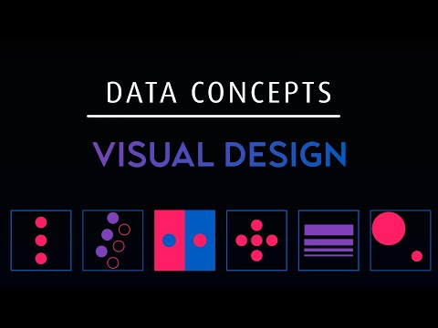
Video 8. Design and data visualization (https://www.youtube.com/watch?v=0Smgm2UTUSo)

Key principles:
Preattentive Attributes
Preattentive features are processed within ~200ms. Use them to draw attention where it matters.
- Position on a common scale (x/y location) is the most accurate visual channel for quantitative data.
- Length and angle (e.g., bars, lines) are perceived more accurately than area or colour hue.
- Colour intensity (saturation/value) can show magnitude; hue should typically encode categories, not quantity.
- Orientation, size, shape, motion can highlight outliers or statuses.

Tip: Use one or two preattentive cues for emphasis (e.g., highlight the current year’s emissions bar in bold colour), and keep the rest muted.

Gestalt Principles
People naturally group elements. Leverage:
- Proximity (closer items feel related).
- Similarity (same colour/shape groups items).
- Enclosure (subtle boxes/regions imply grouping).
- Continuity (smooth lines imply trends).
- Closure (we complete shapes—avoid ambiguous partial shapes).

Cognitive Load & Working Memory
Working memory is limited (≈4±1 chunks). Reduce overload by:
- Limiting series to ≤5–7 in one view.
- Using progressive disclosure (tooltips, detailsondemand) in interactive reports.
- Summarising with a clear headline: “Scope 2 fell 18% YoY; Scope 3 flat.”

Scale Literacy
Humans misread magnitudes when scales are inconsistent. Make scales clear, aligned, and labelled (units!). Avoid switching units midstory (e.g., tonnes CO₂e vs. kg CO₂e) without strong visual signposting.

Selecting Appropriate Chart Types for ESG Data
In the Figure 1, there is a guideline for selecting a correct chart type. You should start with a question of what you want to show (comparison, distribution, composition or relationship) and then check the type of data.

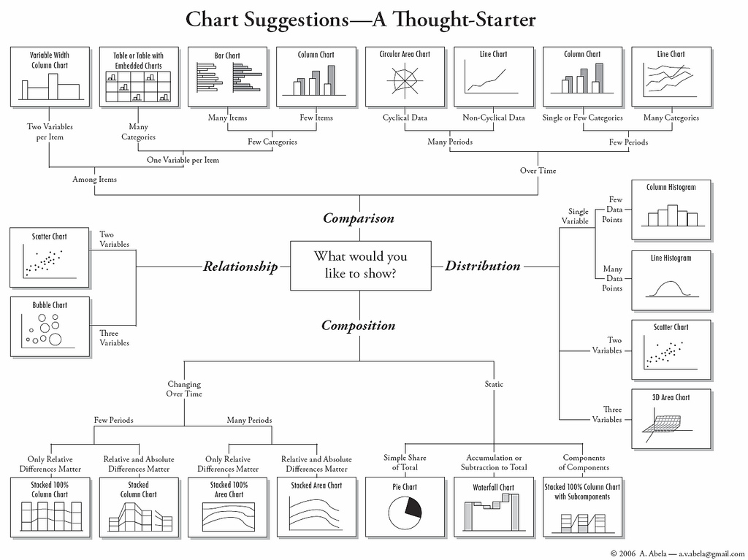
Figure 15. Chart suggestions (Source Abela, 2006)

Image description: The image shows a flowchart titled “Chart Suggestions—A Thought-Starter” that helps choose the appropriate type of chart for data visualization. It starts with the question “What would you like to show?” and branches into four categories: comparison, relationship, distribution, and composition. Each branch suggests different chart types—such as bar charts, line charts, scatter plots, pie charts, histograms, and area charts—depending on the data and the purpose of the visualization.
Next, a more through guideline is given based on what you want to show.

Comparisons & Rankings
- Bar charts (horizontal): Best for ranking companies by emissions intensity (tCO₂e per revenue). Long category labels fit better.
- Clustered bars: Compare a small number of categories across 2–3 scenarios (e.g., 2023 vs 2024 vs target). Keep clusters to ≤4 to avoid clutter.
- Dot plots / lollipop charts: Cleaner alternative to bars for rankings of many categories; dots reduce ink.
Change Over Time
- Line charts: Emissions trend, TRIR (Total Recordable Incident Rate), or board diversity share over years. Use consistent time intervals; don’t break baselines.
- Slope charts: Twopoint comparisons (e.g., 2020 vs 2025) to show changes per company, highlighting movers.
- Area charts: Use cautiously for cumulative or stacked contributions (e.g., energy mix). Keep the baseline at zero and minimise stacking layers.
Distributions & Uncertainty
- Histograms: Distribution of emissions intensity across peers.
- Box/violin plots: Spread and outliers in pay gap across business units.
- Fan charts / confidence bands: Forecast uncertainty for netzero pathways; annotate assumptions.
ParttoWhole
- Stacked bars (preferably 100%): Composition of Scope 3 categories (Purchased Goods, Use of Sold Products, etc.). Limit segments to ≈5–6; order from biggest to smallest.
- Treemaps: When many parts exist (e.g., suppliers by share of supplychain emissions). Provide labels or tooltips to avoid guesswork.
- Pies/doughnuts limit to ≤5 slices, order them, and label directly.
Relationships & Multivariate Views
- Scatterplots with regression: Correlate emissions intensity with operating margin; encode size by revenue and colour by sector.
- Bubble charts (use sparingly): Similar to scatter; ensure a legend for size and avoid overlapping points.
- Parallel coordinates: Explore trade-offs across many ESG KPIs (advanced audiences only).
Spatial
- Choropleth maps: Emissions by country normalised per capita or per GDP (never map raw counts without normalisation).
- Proportional symbol maps: Facility level emissions; size encodes magnitude.
- Cartograms/dot density: Communicate concentration (e.g., supplier locations); add basemap context.
Decision Table (Quick Guide)
Check the table 9 for examples on sustainability reporting and recommended charts.

Table 9. Examples of sustainability reporting and recommended charts (source: Author)
Task | Recommended Chart | Notes
Rank emissions intensity | Horizontal bar / dot plot | Order descending; show units
Trend to targets | Line + target band | Highlight current year; annotate target
Scope 3 composition | 100% stacked bars | Limit segments; sort by size
Pay gap distribution | Box/violin | Show sample size, median, IQR
Risk vs return | Scatter with fit | Consider log scales if skewed
Facility map | Proportional symbols | Include legend, zoom, and clustering

Avoiding Misleading or Biased Visualisations
Common Pitfalls
- Truncated axes (nonzero baseline) for bars exaggerate differences. Bars encode magnitude by length; keep baseline at zero. For lines, nonzero baselines may be acceptable with explicit rationale and annotation.
- Dual axes can create spurious correlations. If necessary, normalise both series to an index (e.g., 100=2018) and label clearly.
- Inconsistent scales across small multiples mislead. Keep identical ranges unless you state differences visibly.
- Cherry-picking time windows can show desired narratives. Provide context (pre and post periods) or explain selection criteria.
- Improper aggregation (e.g., Simpson’s paradox) can hide disparities—show subgroup views when relevant (e.g., pay gap by job family).
- Area encodings for precise comparison (bubble sizes) are hard to judge accurately—prefer length or aligned position where precision matters.
Bias & Equity Considerations
- Representation bias: Ensure categories and regions are fairly represented; avoid suppressing minority groups via aggregation.
- Scale bias: Normalise appropriately (per FTE, per revenue, per output) to avoid favouring large entities.
- Colour bias: Avoid cultural missteps (e.g., red/green for audiences with COLOUR-BLIND FRIENDLY or cultures where colours carry unintended connotations). Provide alternatives and legends.
- Algorithmic opacity: When visualising model outputs (e.g., supplier risk scores), disclose features, limitations, and confidence.
Transparency & Traceability
- Cite data sources, units, coverage, and date of extraction.
- Declare imputation methods, scope boundaries (e.g., which Scope 3 categories), and whether figures are audited.
- Provide footnotes and a data dictionary for recurring dashboards.

Best Practices in Layout, Colour, and Readability
Layout & Hierarchy
- Message first titles: Turn chart titles into takeaways: “Supplier A accounts for 38% of Scope 3 Cat. 1 emissions.”
- Visual hierarchy: Use size, weight, and spacing to guide scanning—title → key figure → chart → footnotes.
- Whitespace: Increase legibility and reduce crowding; avoid enclosing borders unless separation is needed.
- Grid & alignment: Align axes and numbers; use small multiples for repeated comparisons.
Colour Strategy
- Purposeful palettes:
  - Categorical (distinct hues) for ESG pillars or sectors.
  - Sequential (light→dark) for ordered values (e.g., risk scores).
  - Diverging (two hues from a neutral midpoint) for deviations from target or zero.
- Accessibility: Ensure contrast ratio ≥4.5:1 for text; use COLOUR-BLIND FRIENDLY safe palettes (e.g., blue-orange, purple-green). Add texture or shape when colour is insufficient.
- Consistency: Keep the same colour meaning across pages (e.g., green always = “better/closer to target,” but be mindful of COLOUR-BLIND FRIENDLY and cultural contexts).
Typography & Labels
- Use one or two typefaces (Sans serif for screens, serif for long print). Keep sizes ≥10–12pt for dense charts.
- Prefer direct labelling over legends; if legends are necessary, place them near the data.
- Clarify units (tCO₂e, % of headcount, incidents per 200k hours) and timeframes.
- Avoid vertical text; rotate charts if needed (use horizontal bars).
Interactivity (If Applicable)
- Tooltips and drilldowns reveal detail on demand without clutter.
- Filters should match analytical tasks (e.g., filter by scope, region, sector).
- Annotations (goal lines, bands) help users orient themselves.
- Provide export and source links for transparency.

Designing for Different Audiences
- Executives/boards: High-level KPIs, targets vs. actuals, scenario impacts; 1–2 visuals per decision.
- Operational managers: Granular breakdowns by plant/supplier; diagnostics and benchmarks.
- External stakeholders (investors, NGOs): Methodology, assumptions, and audit trail; scenario and sensitivity.
- General public: Plain language, simple comparisons, contextual narratives.
Rule of One: One main message per chart; one main chart per slide/page where possible.

Workflow for Building Trustworthy Visuals
- Define the question: What decision will this graphic inform?
- List variables & units: Clarify definitions (e.g., “Scope 2 market based, tCO₂e”).
- Choose the task: Compare, trend, distribution, composition or relationship.
- Select chart that matches the task (see Section 3).
- Sketch (paper or wireframe) the layout and hierarchy.
- Prototype with realistic data; test edge cases (zeros, negatives, missing, outliers).
- Annotate: titles, subtitles, sources, notes, methods.
- Accessibility check: colour contrast, colour-blind friendly palettes, font size, keyboard navigation (for web dashboards).
- Peer review: ask a colleague unfamiliar with the data to explain what they see.
- Publish with metadata: date, version, and contact for questions.

Checklists & Heuristics
One-Minute Clarity Check
- Can a new reader state the main message in one sentence?
- Are units/timeframes immediately visible?
- Is the most important element visually salient?
Integrity Check
- Zero baseline for bars? If not, clearly justified?
- Any dual axes? If yes, can you replace with indexing or small multiples?
- Are scales consistent across small multiples?
- Are sources, scope boundaries, and methods disclosed?
Accessibility Check
- Colour-blind friendly palette or alternative encodings present.
- Labels readable on small screens (min 12pt) or responsive UI provided.

Now you have learned in-depth about building a good data visualization. Check out this short video by Jotform to conclude this chapter:


Video 9. Building a good data visualization (https://www.youtube.com/watch?v=ZkWxlkv0aTc)

Micro-activity:
Find a sustainability or ESG chart published in a corporate annual report or sustainability report (any company). Using the checklist from this topic, identify at least two strengths and one weakness of the chart. Consider: Does it use the right chart type for the data? Is the baseline at zero (for bars)? Are units and sources clearly labelled?

Additional reading:
- Polymer Research. 2024. Examples of Good and Bad Visualizations. https://www.polymersearch.com/blog/10-good-and-bad-examples-of-data-visualization (Accessed: 04.03.2026)

Key Takeaways:
- Pre-attentive attributes (position, length, colour) are processed almost instantly; use them deliberately to direct attention to what matters most.
- Choose chart types based on the analytical task (compare, trend, distribution, part-to-whole, relationship) rather than aesthetics.
- Integrity in ESG visuals requires zero-based bar axes, consistent scales, disclosed sources and methods.

Quick Check:
- True or False: A bar chart’s baseline may start above zero to highlight small differences between values without any labelling or justification.

- Which chart type is most appropriate for displaying the distribution of gender pay gap values across 12 business units?
a) Pie chart
b) Box/violin plot
c) Line chart
d) Stacked bar chart

Answer key: 1. False; 2. b)

Topic 3.2: Building Interactive Dashboards with BI Tools (Power BI)
Short introduction:
Business Intelligence tools such as Power BI allow sustainability professionals to build interactive, data-driven dashboards from multiple data sources. This topic provides a step-by-step guide to importing data, building data models, creating visuals, calculating KPIs with DAX, and sharing reports via the Power BI web service. Similar steps can be taken in other data visualization tools.

Theory & Knowledge:
Creating an interactive report includes 5 steps (see Figure 16): importing data, building a data model, calculating KPIs, creating visuals and sharing the report.

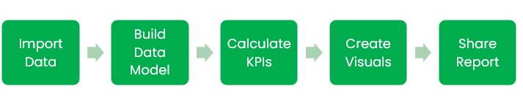
Figure 16. Steps for building an interactive report. (Image source: created by author)

Image description: The image shows a simple workflow diagram for a data analysis process. It consists of five connected steps arranged from left to right: Import Data, Build Data Model, Calculate KPIs, Create Visuals, and Share Report, illustrating the typical sequence for creating and delivering a data report or dashboard.

Step 1: Importing Data with Power Query
Power BI connects to a wide range of data sources, including Excel files, CSV files, databases, SharePoint, and web APIs. Power Query is the built-in data transformation layer where you can: import data from Excel using queries; clean and reshape data (remove duplicates, rename columns, split fields, unpivot tables); and assess data quality using column profiling tools that display error rates, empty values, and value distributions. Apply correct data formatting for dates, currency, and numeric fields to ensure consistent display and calculation.
Step 2: Building a Data Model
A well-structured data model is essential for accurate KPI calculations. The data model is often referred to as the star schema (a central fact table surrounded by dimension tables for date, facility, category, etc.). See an example of Star Schema in Figure 17. Define relationships between tables specifying cardinality (preferably one-to-many) and cross-filter direction.

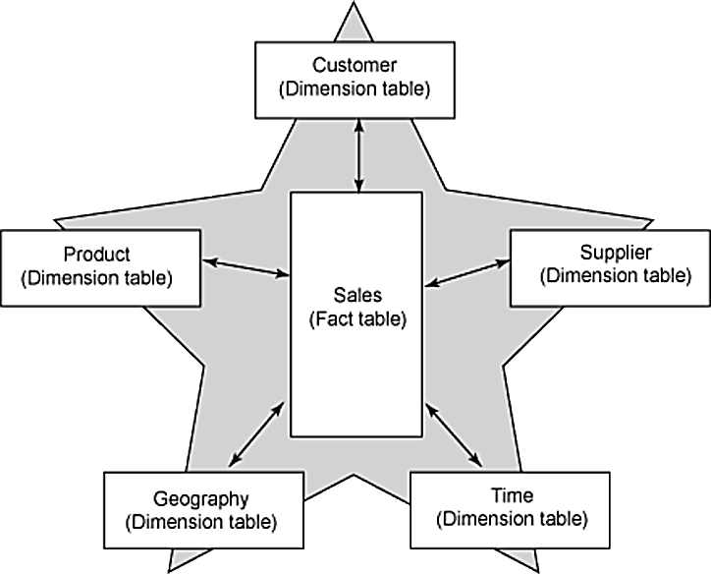
Figure 17. Example of Star Schema (Source: Gallo, Bonis, Berilli, 2010)

Image description: The image shows a star schema data model used in data warehousing. In the center is a Sales fact table, which is connected to several dimension tables: Customer, Product, Supplier, Geography, and Time. The diagram illustrates how the central fact table links to surrounding dimension tables to organize and analyse sales data.

Step 3: Calculating KPIs with DAX
DAX (Data Analysis Expressions) is the formula language of Power BI. It enables calculated columns and measures for KPI calculations such as emissions intensity per revenue, year-over-year percentage change, target variance, and rolling averages. Key functions include CALCULATE (modifies filter context), SUMX (iterates rows), DIVIDE (safe division), and time intelligence functions such as SAMEPERIODLASTYEAR.
Step 4: Creating a Report
Add visuals to the report canvas, including column and bar charts for emissions comparisons by facility or year; line charts for trend analysis; pie charts for part-to-whole composition; KPI cards for headline metrics; waterfall charts to explain changes from baseline to current period; and tables for detailed data. Use slicers and filter panels to allow users to interact with the data. Apply conditional formatting to highlight values above or below thresholds (e.g., orange for off-track KPIs). Configure visual interactions so that selecting a value in one chart filters related visuals. Use bookmarks to create guided navigation paths or saved views for different audiences.

Step 5: Publishing and Sharing via Power BI Web Service
Once a report is complete, publish it to the Power BI web service (app.powerbi.com). From there, you can share the report or dashboard with specific users or groups, configure row-level security (RLS) to restrict data access by role, and set up automatic data refresh schedules to keep the dashboard current.

Additional reading:
  - Microsoft Power BI documentation: https://learn.microsoft.com/en-us/power-bi/
  - DAX Guide reference: https://dax.guide/

Key Takeaways:
- Creating an interactive report includes 5 steps: importing data, building a data model, calculating KPIs, creating visuals and sharing the report
- In Power BI, Power Query is used for the first step of importing and cleaning data: clean and validate data before it enters the model to avoid errors downstream.
- A star schema data model with clearly defined relationships enables fast, accurate KPI calculations across filters and hierarchies.

Quick Check:
- Which Power BI feature is used to restrict data access so that a regional manager only sees data for their own region?
  - Power Query filter
  - Slicer
  - Row-Level Security (RLS)
  - Bookmark

- True or False: Power Query is the tool for importing and cleaning data.

Answer key: 1. c; 2. True

Topic 3.3: Communicating Sustainability Performance to Stakeholders
Short introduction:
Communicating sustainability performance effectively is both an art and a science. Organizations must combine robust ESG data with strategic storytelling, tailored dashboards, and insight-driven explanations to build trust, inform decisions, and strengthen social license to operate.
Theory & Knowledge:
StakeholderOriented Dashboard Customisation
ESG dashboards are powerful tools that help organisations track KPIs, visualise progress, and communicate performance. But dashboards only succeed when they are purpose-built for the stakeholder groups that use them.

Why Customisation Matters
Different stakeholders have different:
- Objectives
- Information needs
- Technical understanding
- Decision-making responsibilities
A single generic dashboard cannot effectively meet all these needs. Therefore, dashboards must be segmented and adapted for each audience. See Table 1 for key stakeholder groups and their needs.

Table 10. Key Stakeholder Groups and Their Needs (source: Author)
Key Stakeholder | Needs | Dashboard design
Executives and Board Members | - Need high-level aggregated KPIs  - Want risk oriented and financial impact insights  - Prefer concise visuals with trend lines and predictive indicators | - Materiality summary  - Risk heatmaps  - High-level GHG progress vs targets  - Strategic scenario modelling
Investors and Analysts | - Require accurate, auditable metrics  - Want benchmarking and comparability across sectors  - Seek transparency on data quality and assumptions | - Granular emissions data  - Financial ESG linkage metrics (e.g., carbon cost curves)  - Historical and forecasted performance
Operational Managers | - Need day today metrics  - Require data at facility, process, or department level  - Prefer actionable details | - Realtime energy and waste data  - Threshold alerts  - Performance-by-site breakdowns
Customers and the General Public | - Need accessible, nontechnical summaries  - Respond to storytelling and visuals  - Want to understand the company's impact | - Simple icons, infographics  - Emphasis on positive outcomes and initiatives  - Accessible, visually appealing layouts

Principles of Effective ESG Dashboard Customisation
- Materiality alignment: dashboards should emphasise the ESG issues most critical to the stakeholder.
- Modularity: build dashboards using interchangeable components and filters.
- Clarity: avoid unnecessary metrics that clutter the view.
- Interactivity: allow stakeholders to drill down where needed.
- Role-based access: ensure the right information is accessible to the right users.

Check out this video by Adam Finer on general tips to building an effective dashboard:

Video 10. Building an effective dashboard (https://www.youtube.com/watch?v=nCrD5g8d3ow)

Data Storytelling Techniques for ESG Communication
Data storytelling is the bridge between complex sustainability data and meaningful understanding. It combines narrative + visuals + context, transforming raw numbers into compelling messages that resonate with stakeholders.

Why Storytelling Matters in Sustainability Reporting
Sustainability data alone does not drive action—stories do. Storytelling:
- Builds emotional and cognitive engagement
- Helps stakeholders understand "why it matters"
- Demonstrates organisational commitment
- Promotes transparency and trust.

Components of ESG Data Storytelling
Narrative
A clear storyline that explains:
- The challenge (e.g., rising emissions)
- The organisational response
- The progress achieved
- The next steps or commitments
Example:
"In 2025, our emissions increased by 8% due to expanded operations. Recognising this challenge, we invested in renewable energy systems that reduced emissions by 12% the following year."

Visuals
Effective visuals simplify complexity:
- Trend lines
- Before/after comparisons
- Maps for supply-chain or biodiversity impacts
- Stacked bars for energy mix
- Sankey diagrams for material flows
Context
Stakeholders need to know:
- Benchmarks
- Industry averages
- Regulatory expectations
- Long-term targets
Without context, even accurate data is easily misinterpreted.
Translating Complex ESG Data into Actionable Insights
Raw sustainability data is not enough—leaders require clear interpretations that support decisions.

Turning Data into Insights: A Practical Framework
- Measure: Collect reliable data (energy usage, emissions, injuries, etc.)
- Analyse: Identify trends, hotspots, anomalies
- Interpret: Explain the meaning and implications
- Recommend: Suggest actions, strategies, or interventions

Additional reading:
- Nussbaumer Knaflic, C. (2015). Storytelling with Data. Wiley.

Key Takeaways:
- Effective ESG communication requires tailored dashboards for each stakeholder group.
- Data storytelling combines narrative, visuals, and context to make complex ESG data actionable and credible for diverse audiences.
- Always provide interpretation alongside data—stakeholders should never have to guess what a metric means or what action it implies.

Quick Check:
- Which of the following best describes the “Context” component of ESG data storytelling?
a) The visual design choices used in charts
b) The raw emissions figures from the ERP system
c) Benchmarks, regulatory thresholds, and long-term targets that frame the data
d) The narrative arc of the annual report

- True or False: Presenting only positive ESG results to external stakeholders is an accepted best practice in transparency-focused sustainability communication.

Answer key: 1) c; 2) False

Topic 3.4: Dashboard Evaluation and Performance Review
Short introduction:
A technically complete dashboard is not necessarily a useful one. This topic provides structured frameworks for evaluating dashboard usability, compliance alignment, and KPI effectiveness—equipping learners with the tools to continuously improve their ESG reporting tools.
Theory & Knowledge:
Part I: Assessing Usability and Clarity
Usability: What “Good” Looks Like
A usable dashboard should allow a first-time user to answer the top 3 business questions in ≤ 30 seconds each, with ≤ 2 interactions (e.g., a filter change and one click), and ≤ 5% error rate in interpretation or workflow.
Core principles:
- Clarity of purpose: The dashboard’s title and subtitle declare the intended decisions or questions it supports.
- Information hierarchy: The most important KPIs and alerts are visible above the fold; secondary details are layered via tabs, drill-through, or expandable sections.
- Perceptual optimization: Appropriate chart types, colour scales, and preattentive attributes (contrast, size, position) are used to make patterns pop.
- Consistency & predictability: Controls and components behave the same across pages and versions; naming is consistent.
- Accessibility: Visuals and interactions meet WCAG standards (contrast, focus order, keyboard navigation, alt text).
Check table 11 for how to evaluate dashboard usability.

Table 11.A 10-Dimension Usability & Clarity Rubric (Score Each 1–5) (Source: Author)
# | Dimension | What to Check | 1 –  Poor | 3 -Adequate | 5 –  Excellent
1 | Purpose & Audience Fit | Does the dashboard clearly state who it’s for and what decisions it supports? | Unclear | Somewhat clear | Unambiguously stated
2 | Task Efficiency | Can users answer top questions quickly with minimal interaction? | >90s & >4 steps | 30–90s & ≤3 steps | ≤30s & ≤2 steps
3 | Information Hierarchy | Are primary KPIs surfaced and secondary details well-organized? | Cluttered | Mixed | Crisp hierarchy
4 | Labelling & Terminology | Are titles, axis labels, and descriptions precise and jargon-free? | Ambiguous | Mixed clarity | Clear, consistent
5 | Chart-Data Fit | Do chart types match data (trend, distribution, part-to-whole, ranking)? | Frequent mismatches | Occasional | Optimal choices
6 | Visual Encoding | Are colour, size, and position used to reveal patterns without confusion? | Misleading encodings | Acceptable | Highly effective
7 | Interactivity & Filters | Are filters intuitive, relevant, and non-destructive to context? | Confusing | Usable | Intuitive and robust
8 | Responsive Layout | Does it render well on target devices (desktop/mobile/wallboard)? | Breaks | Acceptable | Seamless
9 | Performance (Latency) | Time to load and to apply filters | >5s | 2–5s | <2s
10 | Accessibility | Contrast, keyboard nav, alt text, focus order | Fails | Partially compliant | Fully compliant

Scoring guidance:
- 40–50: Excellent, production-ready
- 30–39: Acceptable with targeted improvements
- 20–29: Needs moderate redesign
- <20: Major overhaul recommended
You can use this scoring every time you create a dashboard.

Key Takeaways:
- A high-quality dashboard enables fast, accurate understanding (usability), conforms to governance and legal requirements (compliance), and drives decisions and outcomes (KPI effectiveness).
- The 10-dimension usability rubric provides structured, objective tool for evaluating and improving ESG dashboards.
Quick Check:
- True or False: A KPI needs to drive decisions to be effective.

- Adding understandable titles to visuals is an example of which usability dimension?
- Performance
- Labelling & Terminology
- Chart-Data Fit
- Responsive Layout

Answer key: 1) True; 2) b

Module 3: Conclusion and Self-Assessment
Module Summary:
Module 3 explored the full pipeline from raw ESG data to actionable insight through five interconnected topics. Topic 3.1 established that effective data visualization requires respecting human perception (pre-attentive attributes, Gestalt principles, cognitive load), selecting the right chart type for the analytical task (compare, trend, distribution, part-to-whole, relationship), and maintaining integrity through zero-based axes, consistent scales, disclosed sources, and accessible color palettes.
Topic 3.2 provided a practical step-by-step guide to building interactive dashboards in Power BI—from importing and cleaning data in Power Query, through building star schema data models, creating report visuals and filters, writing DAX measures for KPI calculations, and publishing and sharing reports securely via the Power BI web service.
Topic 3.3 addressed the challenge of communicating sustainability performance to diverse stakeholders, covering stakeholder-oriented dashboard customization, data storytelling (combining narrative, visuals, and context), and best practices for clear and honest ESG presentation.
Topic 3.4 completed the module with evaluation framework: the 10-dimension usability rubric for assessing dashboard clarity and interaction design.
Together, these four topics equip learners with both the technical and the communicative competences required to design, build, and maintain credible ESG dashboards for diverse organizational needs.

Module Knowledge Quiz
- Which pre-attentive attribute provides the most accurate visual channel for quantitative comparisons?
a) Colour hue
b) Area/size
c) Position on a common scale
d) Shape

- How many KPIs should a Tier 1 Headline KPI layer typically contain?
a) 50–100
b) 20–40
c) ≤12
d) 1–3

- True or False: In Power BI, the star schema places multiple fact tables at the center with dimension tables surrounding them.

- What is the usability target time for a first-time user to answer top business questions?
a) ≤5 minutes per question
b) ≤90 seconds per question
c) ≤30 seconds per question
d) ≤10 minutes per question

- Which chart type best shows Scope 3 emissions distributed across 8 supply-chain categories?
a) Line chart
b) Scatter plot
c) 100% stacked bar chart
d) Box plot

- True or False: Titles and labels on a chart are important to provide context to the user.

Knowledge quiz answer key: 1) c; 2) c; 3) False; 4) b; 5) c; 6) True

References:
Books and Academic Publications
- DAMA International (2024). DAMA® Data Management Body of Knowledge (DAMA-DMBOK®). Second edition revised. Technics Publications.
- McKinsey & Company (2019). Five ways that ESG creates value. McKinsey Quarterly.
Industry Reports and Specifications
- European Financial Reporting Advisory Group (EFRAG) (2023). European Sustainability Reporting Standards (ESRS) 1: General Requirements.
- European Financial Reporting Advisory Group (EFRAG) (2024). Implementation Guidance 1 (IG 1): Materiality Assessment Implementation Guidance. Official Final Version.
- European Union (2022). Directive (EU) 2022/2464 of the European Parliament and of the Council (Corporate Sustainability Reporting Directive – CSRD).
- European Union (2026). Directive (EU) 2026/470 of the European Parliament and of the Council. Available at: EUR-Lex.
- Global Reporting Initiative (GRI) (2021). GRI 3: Material Topics 2021. Global Sustainability Standards Board.
- Global Reporting Initiative (GRI) (2021). GRI 305: Emissions Standard.
- European Securities and Markets Authority (ESMA). Electronic Reporting (ESEF/XBRL) Technical Guidelines.
- MSCI ESG Research (2023). ESG 101: What are ESG Ratings and Metrics?
Online Resources and Tools
- The Data Governance Institute. Web materials and Data Governance Framework. Available at: datagovernance.com (Accessed: February 2025).
- XBRL International (2023). iXBRL: The Standard for Digital Business Reporting. Available at: xbrl.org/ixbrl.

